**Q. Time To Be Healthy**

The interns at 99X Technology have come up with a game in which to make the employees of companies - in general - to be more physically engaging and active.

The game is conducted as follows: Every morning the staff will receive an email with the number of floors they have to visit, points will be given for travelling each cubicle in the floor starting from the Start cubicle and the ending in the End cubicle. The person who gets the most number of points will win the game. If a person wins continuously three times, they will be rewarded.

Chillie is a software engineer and is interested in winning this game. He saw an interesting pattern in the game and thought of developing a program which will help him to identify exactly which cubicles he need to travel and the maximum points that can be gained in order to win the competition.

He received the first email with following content:

Number of floors: 4  
Number of cubicles in each floor: 5  
End cubicle: 4th floor 3rd cubicle  
Points :  
1st floor 3rd cubicle: 5  
1st floor 5th cubicle: 2  
2nd floor 1st cubicle: 2  
2nd floor 3rd cubicle: 6  
3rd floor 2nd cubicle: 7  
3rd floor 5th cubicle: 2  
4th floor 4th cubicle: 9

Cubicles that cannot travelled: 2nd floor 2nd cubicle 2nd floor 4th cubicle

Starting point will be your cubicle. Points will not be given for it. Cubicles with no points will be given 0 points.

After receiving the email he noted down the information in a grid as given below: (Chille is in the first floor 2nd cubicle and he noted down the cubicles that cannot be travelled in # )

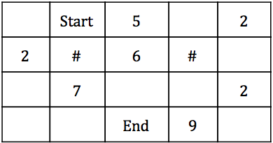

Chillie’s goal is to find a path to go from the start to end earning the maximum points. Also he can only travel either to ****left, right or down**** and ****he cannot travel diagonally. (Each cubicle can be travelled only once and the end will always be in the last floor)****

****Input Format****

First line will consist ****m****, ****n**** integers such that m is the number of floors and n is the number of cubicles  
The rest of the ****m**** lines will consist of a table as shown above with the relevant information (S will be the start point,E will be the End point and # will represent the blocking points.)

****Constraints****

2 < ****m , n**** < 100

****Output Format****

The output should be a single line including the ****maximum number of points**** he can gain when going from the start to end.

****Sample Input 0****

4,5 0S5022#6#00700200E90

****Sample Output 0****

22

****Explanation 0****

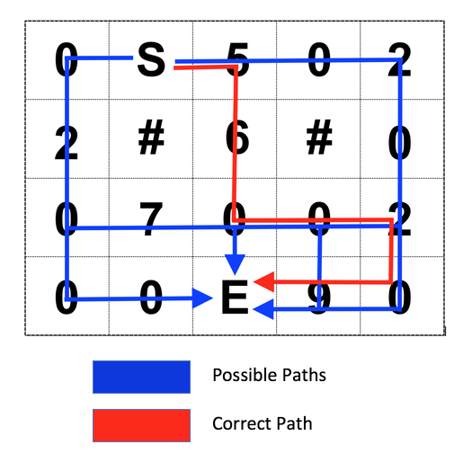

****Sample Input 1****

3,30S14#0E32

****Sample Output 1****

6

**Contest ends in 5 hours**

**Submissions:**

[0](https://www.hackerrank.com/contests/bethem-challenge-code-breaker/challenges/time-to-be-healthy/leaderboard)

**Max Score:**

150

**Difficulty:**

Medium

**Rate This Challenge:**

More

****Current Buffer**** (saved locally, editable)

[Java 8](https://www.hackerrank.com/contests/bethem-challenge-code-breaker/challenges/javascript:void(0))

1

import java.io.*;

2

import java.util.*;

3

​

**Q. F18A/E Super Hornet**

****Please note that you will not be granted any marks for this question on HackerRank. The question will be evaluated manually and 20% of the Final score will depend on this question. Read the rules of the competition for more information regarding the final score.****

The USS Nimitz is a Nimitz class aircraft carrier currently anchored at an unknown location in the Mediterranean sea. The ship has around 50 F18A/E Super Hornets in its bays. Assume that each fighter jet has the fuel capacity to fly exactly half way across the world in a large circle. The F18A/E Super Hornet is a very advanced jet and has the ability to refuel inflight without losing speed or spilling jet fuel. The USS Nimitz has an unlimited stock of jet fuel and is the only source of fuel for these jets. What is the fewest number of aircraft necessary to get 1 jet across the world keeping in mind that all of the jets must return back to the ship safely?

Your task is to write a code to generate your answer. We will be evaluating your code manually therefore if you are unable to code the answer please explain your approach ***as a comment*** and submit.

****\*\*If you are unable to code the answer explain the approach you have used as follow:****  
       If you select the language as python:

‘’’This is the approach i used (Write your approach here)’’’

****Additional Information:****

* Ignore extra fuel consumption as a result of acceleration, evaporation of fuel.
* Since we need to have all jets return safely to the ship, you cannot give all fuel away to the other jet.
* Refueling is an extremely fast process.

****Input Format****

No input

****Constraints****

-

****Output Format****

Single integer representing the fewest number of aircraft necessary to get 1 jet across the world  
****If you are unable to code the answer submit your approach as a comment.****

**Contest ends in 5 hours**

**Submissions:**

[1](https://www.hackerrank.com/contests/bethem-challenge-code-breaker/challenges/f18ae-super-hornet/leaderboard)

**Max Score:**

0

**Difficulty:**

Medium

**Rate This Challenge:**

More

****Current Buffer**** (saved locally, editable)

**Q. Fortran language**

We at 99X Technology are interested in looking at how well you can adapt into any programming language.

Your task to solve the below problem using the ****Fortran language****. (Please note that you cannot use any other language for this problem)

Given an array of integers, your task is print whether the number is odd or even.

****Input Format****

The first line contains an integer ****N****, denoting the size of the array.   
The second line contains ****N**** space-separated integers representing the array's elements.

****Constraints****

0 < ****N**** < 10000

****Output Format****

Print whether the number is odd or even

****Sample Input 0****

62 3 8 9 10 12

****Sample Output 0****

Even Odd Even Odd Even Even

**Contest ends in 4 hours**

**Submissions:**

[2](https://www.hackerrank.com/contests/bethem-challenge-code-breaker/challenges/fortran-language/leaderboard)

**Max Score:**

100

**Difficulty:**

Medium

**Rate This Challenge:**

More

****Current Buffer**** (saved locally, editable)

**Q. Largest Value**

Given ****five**** positive integers, You have to use exactly ****four**** of the five integers and calculate a value by adding two numbers together and subtracting two numbers from it.

Find the ****Largest value**** that can be calculated as mentioned above.

****Input Format****

A single line of five space-separated integers.

****Constraints****

Each integer is in the inclusive range [1,10 9 ].

****Output Format****

Print a single long integer denoting the largest value that can be calculated as mentioned above (The output can be greater than a 32 bit integer.)

****Sample Input 0****

1 5 3 2 4

****Sample Output 0****

6

****Explanation 0****

We add 5 and 4 together and substrate 1 and 2 from it. Then we have 6 that is the maximum value that can be calculated by adding two integers together and subtracting another two integers from it.

5 + 4 - 1 -2 = 6

**Contest ends in 4 hours**

**Submissions:**

[5](https://www.hackerrank.com/contests/bethem-challenge-code-breaker/challenges/largest-value/leaderboard)

**Max Score:**

50

**Difficulty:**

Easy

**Rate This Challenge:**

More

**Q. Decryption**

To enter the code breaker competition you will have to decrypt a set of words we have already encrypted using the following encryption algorithm.

When a ****plaintext**** and a key ****N**** is provided, each letter of the plaintext will be incremented sequentially till N letters and the incrementing sequence will repeat again.

For an example consider the word:****DOTITUDE**** and the key (N)=****3****  
Then the encrypted text would be:****EQWJVXEG****

As the key given is ****3****, letter D is incremented by 1, O is incremented by 2, T is incremented by 3 and again I is incremented by 1 , T is incremented by 2 and so on.

Your task is to decrypt the encrypted words we will be providing.

****Input Format****

****First line**** will consist the encrypted word  
The ****second line**** will be the Key (N)

****Constraints****

0 < ****N**** < 27  
Encrypted word only consist with uppercase and lowercase characters

****Output Format****

Decrypted word (Plaintext)

****Sample Input 0****

EQWJVXEG3

****Sample Output 0****

DOTITUDE

****Sample Input 1****

BDDFfhHJ2

****Sample Output 1****

ABCDefGH