**WAD ASSIGNMENT**

**1] Illustrate the need Sails.js Package**

Sails.js is a powerful MVC framework for Node.js designed to build scalable web applications, especially APIs. Here's why Sails is needed:

1. **MVC Architecture**: Sails follows the Model-View-Controller pattern, which helps organize code cleanly and maintainably.
2. **Built-in ORM (Waterline)**: It abstracts database interaction, allowing developers to work with various databases (MySQL, MongoDB, PostgreSQL, etc.) using a single query language.
3. **Auto-generated REST APIs**: Sails can automatically create RESTful APIs for models, speeding up backend development.
4. **Real-time Features with WebSockets**: Sails supports WebSocket out of the box, making it great for real-time apps like chat, dashboards, etc.
5. **Scalability and Extensibility**: Built on Express, it supports middleware and plugins, enabling flexible and scalable development.
6. **Configuration over Code**: With conventions and predefined structures, it reduces boilerplate and increases productivity.
7. **Built-in Policies and Authentication**: Sails allows defining access control and authentication flows easily.
8. **Reusable Blueprints**: You can rapidly prototype applications using Sails’ blueprints without writing redundant code.

**2] Implement small application which will make use of mentioned**

**Package**

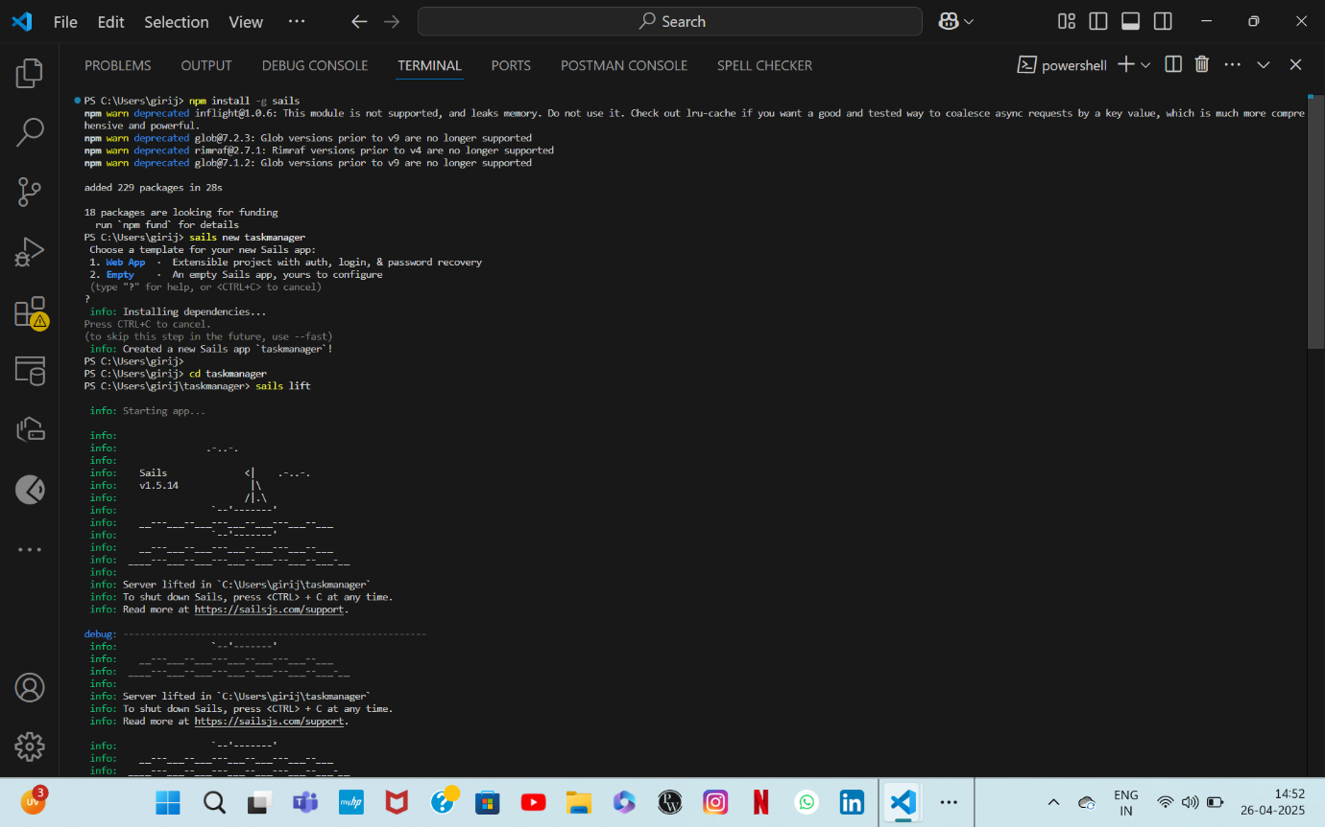

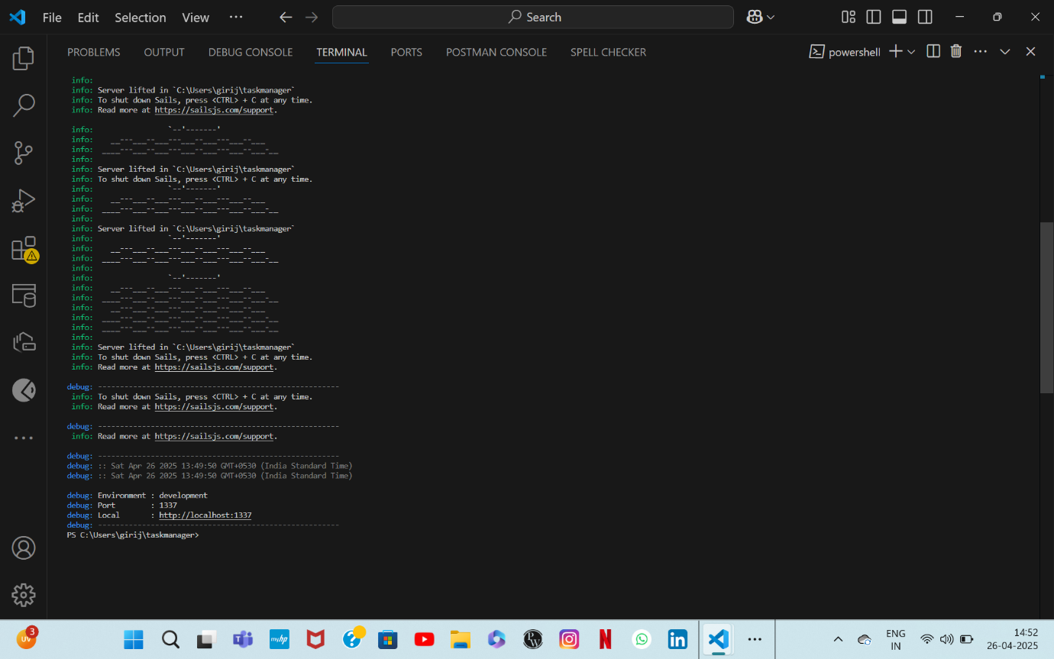

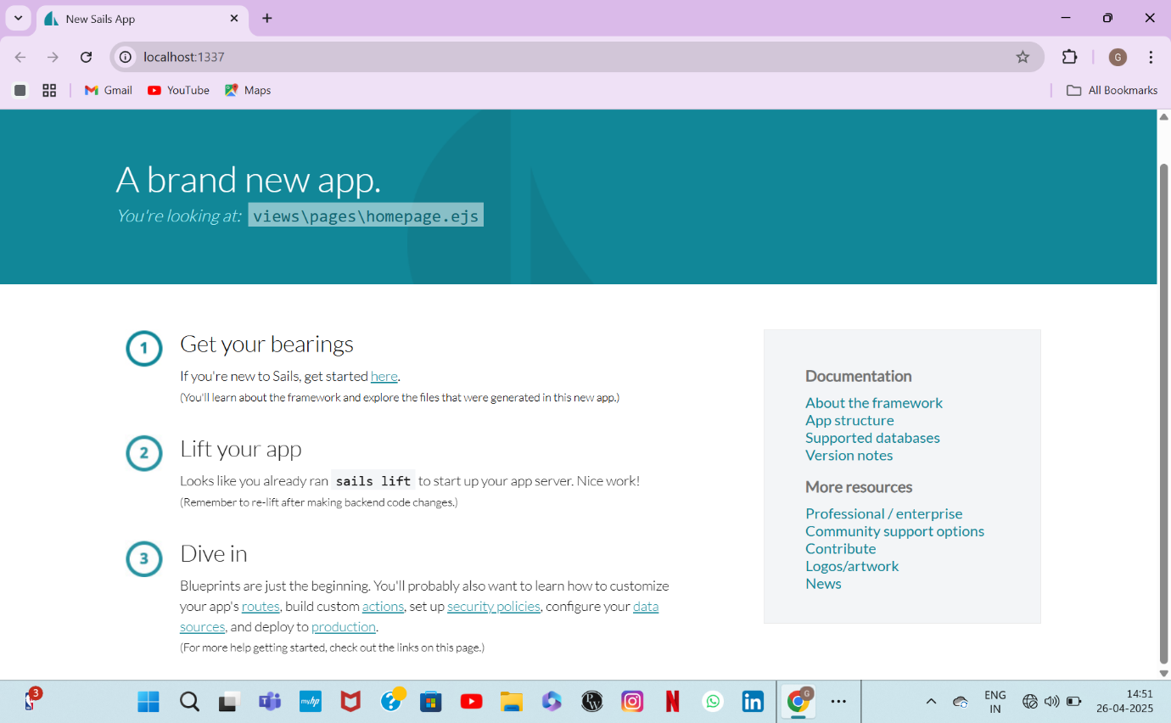

**Q.3) Illustrate the need for code of ethics**

The Code of Ethics is important in web application development and software engineering because:

* Promotes Trust: Following ethical guidelines builds trust with users and stakeholders.
* Professional Conduct: Encourages developers to act responsibly, respectfully, and legally.
* Privacy and Security: Ensures that users’ data is handled securely and their privacy is respected.
* Quality Assurance: Motivates developers to deliver reliable, bug-free, and high-quality products.
* Fairness: Promotes fairness, equality, and non-discrimination in software design and implementation.
* Legal Compliance: Helps avoid legal issues by ensuring that the software adheres to regulations and standards.
* Social Responsibility: Encourages software that benefits society and avoids harm.

Examples of well-known codes of ethics include ACM Code of Ethics and IEEE Code of Ethics.