import pandas as pd
import matplotlib.pyplot as plt
from google.colab import drive
drive.mount('/content/drive')
Drive already mounted at /content/drive; to attempt to forcibly remount, call drive.mount("/content/drive", force_remount=True).
df = pd.read_csv("/content/drive/MyDrive/Iris.csv")
num = df.drop(["Id", "Species"], axis=1)
# 1. Bar Chart
plt.figure()
num.mean().plot(kind="bar")
plt.title("Bar Chart - Mean of Iris Features")
plt.xlabel("Features")
plt.ylabel("Mean Value")
plt.show()
# 2. Line Chart
plt.figure()
plt.plot(num["SepalLengthCm"])
plt.title("Line Chart - Sepal Length")
plt.xlabel("Index")
plt.ylabel("Value")
plt.show()
# 3. Histogram
plt.figure()
plt.hist(num["PetalLengthCm"], bins=15)
plt.title("Histogram - Petal Length")
plt.xlabel("Value")
plt.ylabel("Frequency")
plt.show()
# 4. Scatter Plot
plt.figure()
plt.scatter(num["SepalLengthCm"], num["PetalLengthCm"])
plt.title("Scatter Plot - Sepal vs Petal Length")
plt.xlabel("Sepal Length")
plt.ylabel("Petal Length")
plt.show()
# 5. Box Plot
plt.figure()
plt.boxplot(num.values, labels=num.columns)
plt.title("Box Plot - Feature Distribution")
plt.xlabel("Features")
plt.ylabel("Values")
plt.show()
# 6. Heatmap
plt.figure()
corr = num.corr()
sns.heatmap(corr, annot=True, cmap="coolwarm")
plt.title("Heatmap - Correlation Matrix")
plt.show()
# Optional: Pair Plot
sns.pairplot(df, hue="Species")
plt.show()
# Optional: K-Means Cluster Plot
kmeans = KMeans(n_clusters=3, random_state=42)
clusters = kmeans.fit_predict(num)
plt.figure()
plt.scatter(num["PetalLengthCm"], num["PetalWidthCm"], c=clusters, cmap="viridis")
plt.title("Cluster Visualization (K-Means)")
plt.xlabel("Petal Length")
plt.ylabel("Petal Width")
plt.show()
# Optional: Facet Plot
g = sns.FacetGrid(df, col="Species")
g.map(plt.scatter, "SepalLengthCm", "PetalLengthCm")
plt.show()
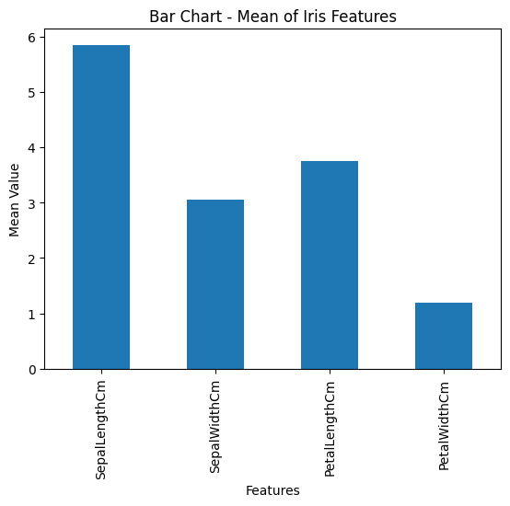
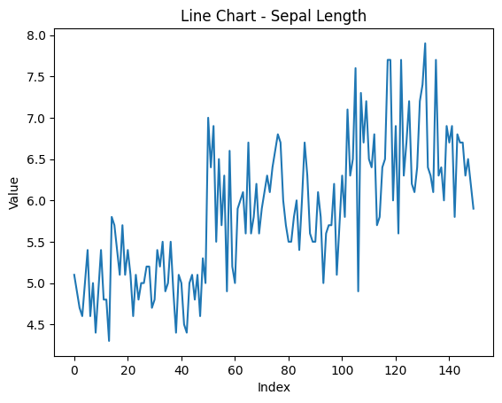
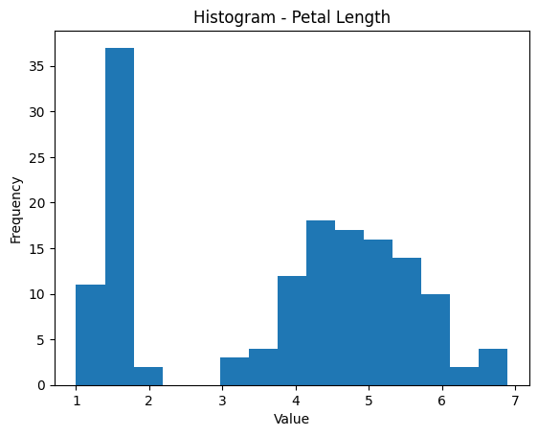
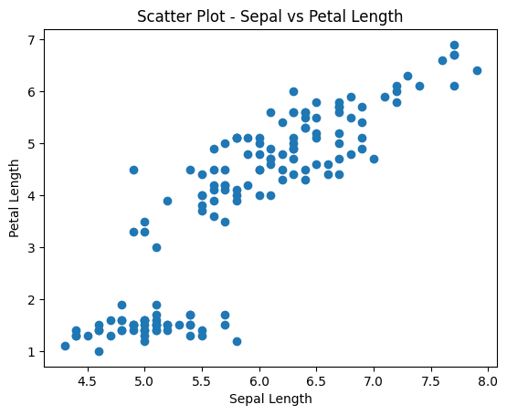
/tmp/ipython-input-2616973547.py:35: MatplotlibDeprecationWarning: The 'labels' parameter of boxplot() has been renamed 'tick_labels' since Matplotlib 3.9; support for the old name will be dropped in 3.11.
plt.boxplot(num.values, labels=num.columns)
