

APPLICANT NAME: PARUS GIRI

REG NO: 20BCE0822

TASK: 1

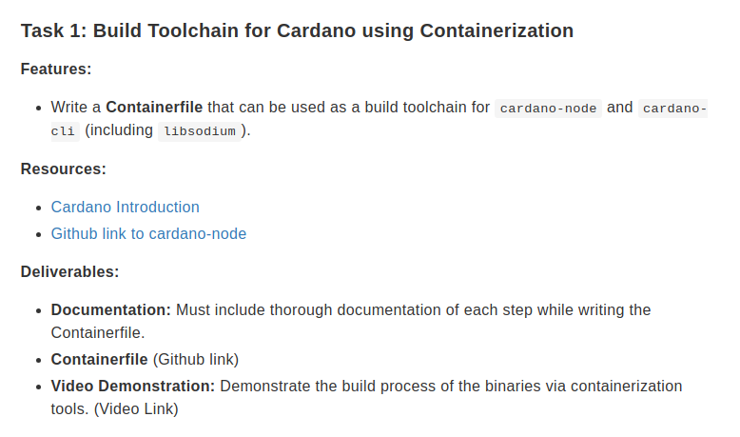

Note – Comments in this document are (##) and in more detailed for documentation purposes, while the source file has shorter comments. Also, the video is not uploaded as image wasn’t successfully built, after an hour of execution either my VSCode would crash or my laptop would restart.

Understanding of the task

While cardano has their own docker image that can be pulled, we are supposed to use the source code to create a docker image using a dockerfile which has all dependencies installed. In order to do this, I went through the official documentation of cardano as provided and their github repo. After learning a little about what cardano-node and cardano-cli are, I went on to write the dockerfile using cardano’s installation page ().

Dockerfile

FROM ubuntu:latest ## used ubuntu base image to build upon

RUN apt-get update -y
RUN apt-get upgrade -y

RUN apt-get install automake \ ##Downloaded necessary operational system dependencies
build-essential \
pkg-config \
libffi-dev \
libgmp-dev \
libssl-dev \
libtinfo-dev \
libsystemd-dev \
zlib1g-dev \
make \
g++ \
tmux \
git \
jq \
wget \
curl \
libncursesw5 \
libtool \
autoconf \
cabal-install -y

# #Installed GHCUP (Haskell Toolchain Installer), GHC and Cabal from the official haskell website

RUN curl --proto '=https' --tlsv1.2 -sSf https://get-ghcup.haskell.org | sh \
&& echo 'export PATH="/root/.ghcup/bin:$PATH"' >> ~/.bashrc \
&& /bin/bash -c "source /root/.ghcup/env && ghcup install ghc 8.10.7 && ghcup set ghc 8.10.7 && ghcup install cabal 3.6.2.0 && ghcup set cabal 3.6.2.0"

ENV PATH="/root/.ghcup/bin:${PATH}" ## setting environment variables for other run commands to access

# Set the working directory
WORKDIR /root/cardano-src

# Clone the repositories
RUN git clone https://github.com/input-output-hk/libsodium ; cd libsodium ; git checkout dbb48cc ; ./autogen.sh ; ./configure ; make ; make install

RUN git clone https://github.com/bitcoin-core/secp256k1 ; cd secp256k1 ; git checkout ac83be33 ; ./autogen.sh ; ./configure --enable-module-schnorrsig --enable-experimental ; make ; make check ; make install

RUN git clone https://github.com/input-output-hk/cardano-node.git

ENV LD_LIBRARY_PATH=/usr/local/lib

# Set the working directory to cardano-node
WORKDIR /root/cardano-src/cardano-node

# # Fetching the latest tags to make sure we use updated versions
RUN git fetch --all --recurse-submodules --tags \
&& git checkout master

# # Faced issues in the timestamp format from the cloned cabal.project file, hence made changes ##and supplied it externally
COPY ./cabal.project /root/cardano-src/cardano-node/

RUN cabal update

RUN cabal configure --with-compiler=ghc-8.10.7

RUN cabal update \
&& cabal build all \
&& mkdir -p $HOME/.local/bin \
&& cp -p "$(./scripts/bin-path.sh cardano-node)" $HOME/.local/bin/ \
&& cp -p "$(./scripts/bin-path.sh cardano-cli)" $HOME/.local/bin/ \
&& curl -O -J https://book.world.dev.cardano.org/environments/preview/config.json \
&& curl -O -J https://book.world.dev.cardano.org/environments/preview/db-sync-config.json \
&& curl -O -J https://book.world.dev.cardano.org/environments/preview/submit-api-config.json \
&& curl -O -J https://book.world.dev.cardano.org/environments/preview/topology.json \
&& curl -O -J https://book.world.dev.cardano.org/environments/preview/byron-genesis.json \
&& curl -O -J https://book.world.dev.cardano.org/environments/preview/shelley-genesis.json \
&& curl -O -J https://book.world.dev.cardano.org/environments/preview/alonzo-genesis.json \
&& curl -O -J https://book.world.dev.cardano.org/environments/preview/conway-genesis.json \
&& cardano-node run \
--config $HOME/cardano-src/testnet/config.json \
--database-path $HOME/cardano-src/testnet/db/ \
--socket-path $HOME/cardano-src/testnet/db/node.socket \
--host-addr 127.0.0.1 \
--port 1337 \
--topology $HOME/cardano-src/testnet/topology.json

Output -

The docker image after multiple blocks and resolutions, though did not throw errors up until the last step, it did not successfully create the docker image. After over an hour of execution and compilations the code either the code editor would crash or the system itself would reboot.

Possible resolutions -

I could try to use a cloud platform to run it on a VM, maybe one with more power as well.

