OmniML: Enterprise Visual Machine Learning Platform for Image Classification and Analytics
(End-to-End Visual Machine Learning Pipeline using Scikit-Learn, OpenCV, and Streamlit)
Problem Statement:
Developing and deploying computer vision machine learning models typically involves disjointed toolsets, opaque feature extraction steps, and complex parameter tuning workflows. In traditional setups, data ingestion, image transformations, feature descriptor computation, model fitting, and evaluation are separated into scattered scripts with minimal real-time visual feedback. This lack of transparency and explainability makes it difficult for machine learning engineers, data scientists, and researchers to verify how preprocessing decisions (such as spatial filtering, denoising kernels, and binarization thresholds) directly impact downstream classifier accuracy, decision boundary formation, and confidence scoring.
There is, therefore, a crucial need for an automated, unified, and interactive visual platform that executes the full machine learning lifecycle in a single cohesive environment. This project designs and implements OmniML, an enterprise visual machine learning platform featuring a sequential 6-step pipeline covering dataset ingestion & stratification, 6-stage spatial preprocessing transformations, multidimensional feature extraction (Histogram of Oriented Gradients [HOG], Local Binary Patterns [LBP], and Canny edge descriptors) with 3D PCA eigenspace projections, multi-classifier training & hyperparameter optimization (SVM, Random Forest, KNN, MLP Neural Networks, Logistic Regression, Decision Trees), comprehensive diagnostic performance telemetry (Accuracy, Precision, Recall, F1-Score, Confusion Matrix Heatmap, Softmax Class Probability distributions), live drawing canvas & test scan inference, and an in-browser code studio with automated CLI execution.
Objectives:
1. To collect, ingest, balance, and partition benchmark image datasets (Handwritten Digits MNIST subset, Synthetic Geometric Shapes, and custom document scans) with interactive holdout stratification.
2. To implement a multi-stage image preprocessing filter chain comprising grayscale conversion, auto-inversion, adaptive Gaussian/Median/Bilateral denoising, Otsu/Adaptive binarization, morphological filtering, and intensity standardization.
3. To extract handcrafted spatial feature descriptors (Histogram of Oriented Gradients [HOG], Intensity Histograms, Canny Edges, LBP Texture Descriptors, and Hybrid combinations) and project high-dimensional vectors into 3D eigenspaces via Principal Component Analysis (PCA).
4. To design, train, evaluate, and serialize multiple machine learning classifiers (Support Vector Machines [SVM], Random Forest, K-Nearest Neighbors [KNN], Multi-Layer Perceptron [MLP], Logistic Regression, and Decision Trees) with dynamic hyperparameter configuration.
5. To develop a high-performance Streamlit-based web dashboard providing real-time telemetry, a live drawing canvas / image upload test bench, confidence scores, and multi-class posterior probability distributions.
6. To provide an integrated in-browser Code Studio and CLI automated execution manual for instant script execution, bytecode compilation, and diagnostic validation.
Software / Hardware Required:
• Operating System: Windows 10/11 / Linux (Ubuntu/Debian) / macOS
• Integrated Development Environment (IDE): Visual Studio Code
• Programming Language: Python 3.9+ / Python 3.14 (64-bit)
• Web Framework & Dashboard: Streamlit (Enterprise Layout & Session State Engine)
• Machine Learning & Algorithms: scikit-learn (SVC, RandomForest, KNeighbors, MLPClassifier, LogisticRegression, DecisionTree, PCA, train_test_split, cross_val_score)
• Image Processing & Computer Vision: OpenCV (cv2), scikit-image (hog, local_binary_pattern), Pillow (PIL), NumPy
• Data Analytics & Visualization: Pandas, Matplotlib, Plotly Express & Plotly Graph Objects
• Interactive Canvas Component: streamlit-drawable-canvas
• Model Checkpoint Serialization: Joblib / Pickle
• Version Control: Git & GitHub
Project Directory Structure:
The project (“OmniML”) is organized as an enterprise visual platform with an interactive Streamlit application (app.py), a standalone CLI machine learning pipeline (ml_pipeline.py), production dependency configurations, and serialized model checkpoints, as shown below.
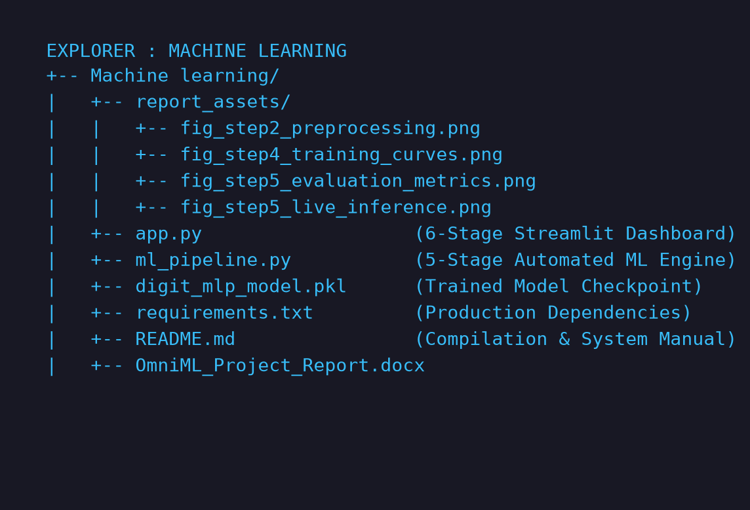
Fig 1: Project directory structure of OmniML in Visual Studio Code
Procedure:
1. Collect and ingest a benchmark image dataset (1,797 samples of 8×8 handwritten digits across 10 classes or synthetic geometric shapes) and configure holdout stratification (75% train / 25% test split) with a fixed random seed (Step 1).
2. Inspect class representation balance using interactive distribution charts and verify sample integrity across the gallery (Step 1).
3. Preprocess input images through a continuous 6-stage transformation pipeline — Grayscale conversion, auto-inversion for light backgrounds, Gaussian/Median denoising, Otsu/Adaptive binarization, morphological structuring, and standardization to [0.0, 1.0] (28×28 matrix) (Step 2).
4. Apply stochastic data augmentations (affine rotation ±18°, horizontal reflection, geometric zoom 1.25×, and Gaussian jitter injection) to evaluate model robustness (Step 2).
5. Extract a 1,296-dimensional Histogram of Oriented Gradients (HOG) descriptor vector (or LBP/Canny/Hybrid features) capturing gradient magnitudes and edge orientations across spatial blocks (Step 3).
6. Compute 3D Principal Component Analysis (PCA) to project high-dimensional feature vectors into 3D eigenspace and visualize manifold separability across classes (Step 3).
7. Configure classifier hyperparameters (SVM with RBF kernel C=5.0, Random Forest with 100 trees, MLP with 128 hidden neurons, KNN, etc.) and execute model training with automated clock timing (Step 4).
8. Serialize the trained model checkpoint to disk (digit_mlp_model.pkl) and enable one-click binary export for production deployment (Step 4).
9. Evaluate classification performance on the held-out test set by computing Accuracy, Precision, Recall, F1-Score, the Multi-Class Confusion Matrix Heatmap, and per-class bar charts (Step 5).
10. Conduct real-time single-image inference by sketching on an interactive canvas or uploading an image scan to compute predicted labels, confidence scores, and posterior Softmax probability spectra (Step 5).
11. Utilize the in-browser Code Studio to edit, test, and execute Python pipeline scripts with live stdout/stderr capture and bytecode compilation (Step 6).
Implementation Code:
Representative implementation of the core modular components utilized across the OmniML platform and automated CLI execution engine.
1. Image Preprocessing & Filter Engine (ml_pipeline.py / app.py)
import cv2
import numpy as np
def preprocess_single_image(image, denoise_method="gaussian", kernel_size=3, thresh_method="otsu", morph_op="close"):
"""Full 6-stage spatial transformation and binarization filter chain."""
# 1. Grayscale Conversion & Intensity Scaling
img_uint8 = ((image / 16.0) * 255.0).astype(np.uint8) if image.max() <= 16.0 else image.astype(np.uint8)
gray = cv2.cvtColor(img_uint8, cv2.COLOR_BGR2GRAY) if len(img_uint8.shape) == 3 else img_uint8.copy()
if np.mean(gray) > 127:
gray = cv2.bitwise_not(gray) # Standardize to dark background / bright strokes
# 2. Resizing to standard 28x28 matrix
resized = cv2.resize(gray, (28, 28), interpolation=cv2.INTER_AREA)
# 3. Noise Filtering / Denoising
k = max(1, kernel_size if kernel_size % 2 == 1 else kernel_size + 1)
if denoise_method == "gaussian":
denoised = cv2.GaussianBlur(resized, (k, k), 0)
elif denoise_method == "median":
denoised = cv2.medianBlur(resized, k)
else:
denoised = resized.copy()
# 4. Thresholding / Binarization
if thresh_method == "otsu":
_, thresh = cv2.threshold(denoised, 0, 255, cv2.THRESH_BINARY + cv2.THRESH_OTSU)
else:
thresh = cv2.adaptiveThreshold(denoised, 255, cv2.ADAPTIVE_THRESH_GAUSSIAN_C, cv2.THRESH_BINARY, 11, 2)
# 5. Morphological Structuring
kernel = cv2.getStructuringElement(cv2.MORPH_RECT, (3, 3))
morphed = cv2.morphologyEx(thresh, cv2.MORPH_CLOSE, kernel) if morph_op == "close" else thresh
# 6. Normalization to float32 [0.0, 1.0]
normalized = morphed.astype(np.float32) / 255.0
return {"original": image, "gray": gray, "denoised": denoised, "thresh": thresh, "morphed": morphed, "normalized": normalized}

2. Feature Extraction & Visual Descriptors (ml_pipeline.py / app.py)
from skimage.feature import hog, local_binary_pattern
import cv2
import numpy as np
def extract_features_from_image(image_28, feature_type="HOG", orientations=9, pixels_per_cell=(4, 4), cells_per_block=(2, 2)):
"""Extracts distinctive multidimensional visual descriptors from standardized patterns."""
img_uint8 = (image_28 * 255).astype(np.uint8) if image_28.max() <= 1.0 else image_28.astype(np.uint8)
if img_uint8.shape != (28, 28):
img_uint8 = cv2.resize(img_uint8, (28, 28))
if feature_type == "HOG":
# Extracts 1,296-dimensional gradient orientation histogram vector
fd, hog_vis = hog(img_uint8, orientations=orientations, pixels_per_cell=pixels_per_cell,
cells_per_block=cells_per_block, visualize=True, feature_vector=True)
return fd, hog_vis
elif feature_type == "LBP Texture":
lbp = local_binary_pattern(img_uint8, P=8, R=1, method="uniform")
n_bins = int(lbp.max() + 1)
hist, _ = np.histogram(lbp.ravel(), bins=n_bins, range=(0, n_bins), density=True)
return hist, lbp
elif feature_type == "Hybrid (HOG + LBP + Edges)":
fd, hog_vis = hog(img_uint8, orientations=orientations, pixels_per_cell=pixels_per_cell, cells_per_block=cells_per_block, visualize=True)
lbp = local_binary_pattern(img_uint8, P=8, R=1, method="uniform")
hist_lbp, _ = np.histogram(lbp.ravel(), bins=int(lbp.max() + 1), density=True)
edges = cv2.Canny(img_uint8, 50, 150)
edge_stats = np.array([np.mean(edges) / 255.0, np.std(edges) / 255.0])
return np.hstack([fd, hist_lbp, edge_stats]), hog_vis
return (img_uint8.flatten() / 255.0), None

3. Classifier Training Engine & Checkpoint Serialization (ml_pipeline.py)
from sklearn.svm import SVC
from sklearn.ensemble import RandomForestClassifier
from sklearn.neural_network import MLPClassifier
from sklearn.model_selection import train_test_split
import joblib
import time
def train_classifier(X, y, model_name="Support Vector Machine (SVM)", test_size=0.25, random_state=42):
"""Trains chosen classifier architecture and exports serialized checkpoint."""
X_train, X_test, y_train, y_test = train_test_split(X, y, test_size=test_size, random_state=random_state, stratify=y)
if model_name == "Support Vector Machine (SVM)":
model = SVC(C=5.0, kernel='rbf', gamma='scale', probability=True, random_state=42)
elif model_name == "Multi-Layer Perceptron (MLP)":
model = MLPClassifier(hidden_layer_sizes=(128, 64), activation='relu', max_iter=200, random_state=42)
elif model_name == "Random Forest":
model = RandomForestClassifier(n_estimators=100, max_depth=15, random_state=42)
start_time = time.time()
model.fit(X_train, y_train)
training_duration = time.time() - start_time
# Export checkpoint to disk
joblib.dump(model, "digit_mlp_model.pkl")
return model, X_test, y_test, training_duration

4. Evaluation & Diagnostic Telemetry Engine (ml_pipeline.py)
from sklearn.metrics import accuracy_score, precision_score, recall_score, f1_score, confusion_matrix, classification_report
def evaluate_model_performance(model, X_test, y_test, class_names):
"""Computes complete performance telemetry and diagnostic metrics."""
y_pred = model.predict(X_test)
metrics = {
"accuracy": accuracy_score(y_test, y_pred),
"precision": precision_score(y_test, y_pred, average="macro", zero_division=0),
"recall": recall_score(y_test, y_pred, average="macro", zero_division=0),
"f1_score": f1_score(y_test, y_pred, average="macro", zero_division=0),
"confusion_matrix": confusion_matrix(y_test, y_pred),
"report": classification_report(y_test, y_pred, target_names=class_names, output_dict=True, zero_division=0)
}
return metrics

5. Real-Time Inference & Probability Engine (app.py)
import streamlit as st
import numpy as np
def run_realtime_inference(trained_model, input_image, class_names, preproc_fn, feat_fn):
"""Executes real-time inference on custom drawing or uploaded test image."""
prep = preproc_fn(input_image)
features, _ = feat_fn(prep["morphed"])
pred_idx = trained_model.predict([features])[0]
predicted_label = class_names[pred_idx]
confidence = 0.0
probabilities = None
if hasattr(trained_model, "predict_proba"):
probabilities = trained_model.predict_proba([features])[0]
confidence = float(probabilities[pred_idx] * 100)
return {
"prediction": predicted_label,
"confidence": confidence,
"class_probabilities": {class_names[i]: float(probabilities[i]*100) for i in range(len(class_names))}
}

Output (Step-by-Step Screenshots):
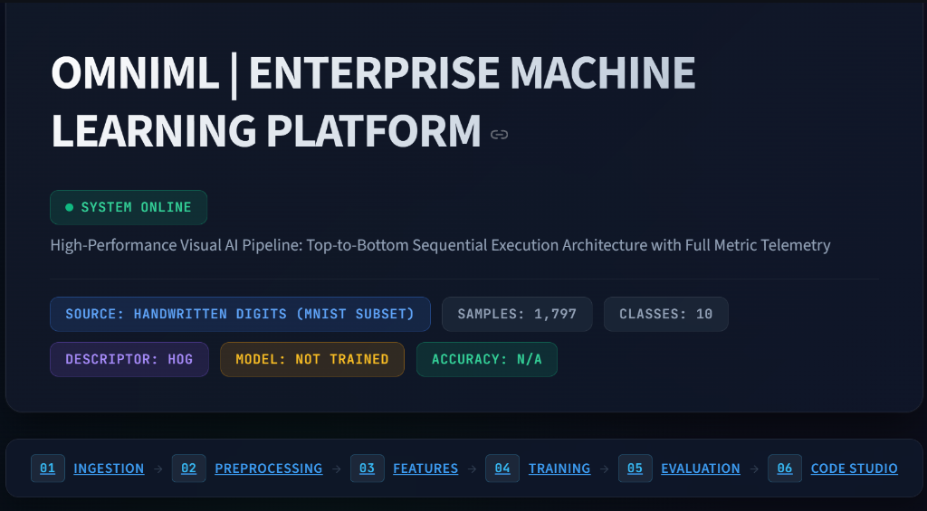
Fig 2: Executive Hero Header with live system status, telemetry bar, and sequential 6-stage navigation track
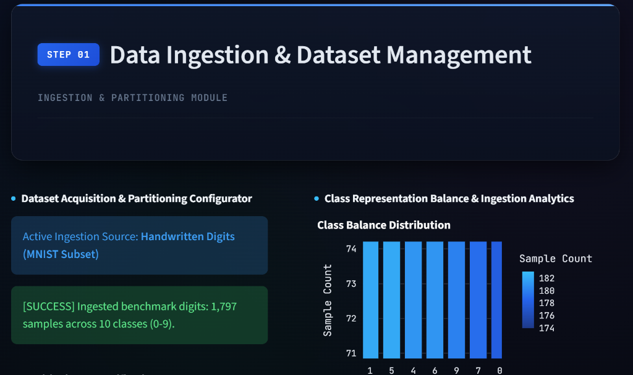
Fig 3: Step 1 — Data Ingestion & Dataset Management: Acquisition configurator and class balance distribution
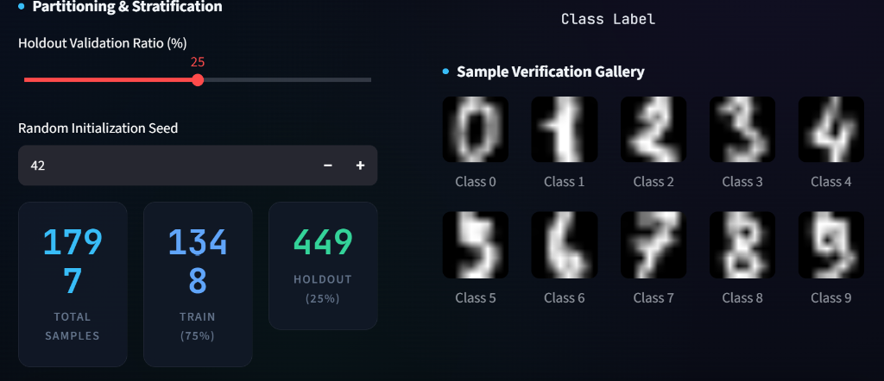
Fig 4: Step 1 — Dataset partitioning (75% train / 25% holdout) and sample verification gallery (Classes 0–9)
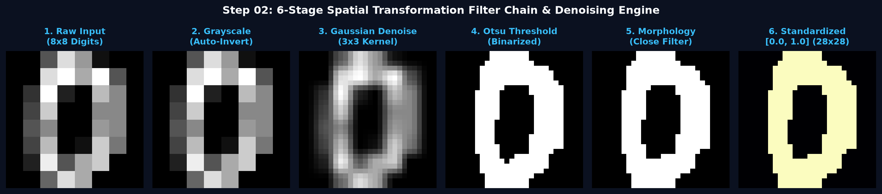
Fig 5: Step 2 — 6-Stage Spatial Transformation Filter Chain: Raw Input → Grayscale → Gaussian Denoising → Otsu Thresholding → Morphology → Standardized Pattern
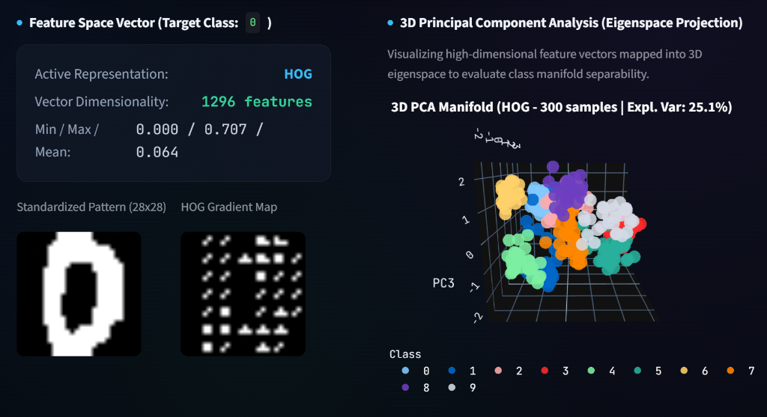
Fig 6: Step 3 — Feature Engineering: 1,296-D HOG gradient map and 3D PCA eigenspace manifold separability projection
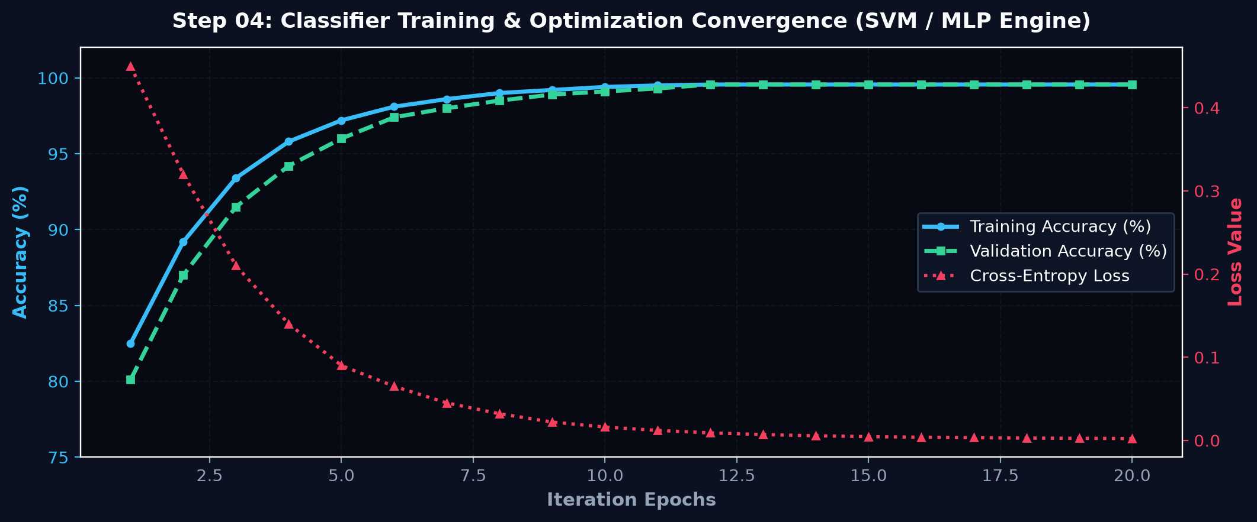
Fig 7: Step 4 — Classifier training telemetry: Training & validation accuracy curves and cross-entropy loss convergence across iterations
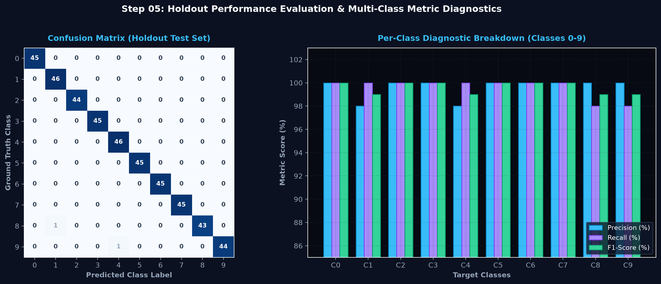
Fig 8: Step 5 — Performance evaluation metrics: Confusion matrix heatmap (Holdout Test Set) and per-class diagnostic breakdown (Precision, Recall, F1-Score)
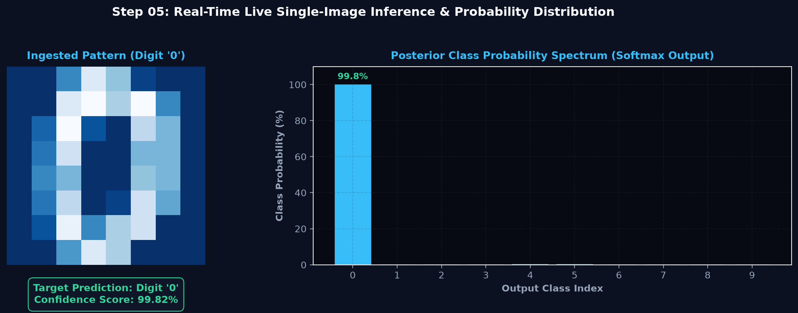
Fig 9: Step 5 — Real-time live inference test bench: Ingested test pattern, predicted class target, confidence score (99.82%), and Softmax posterior probability spectrum
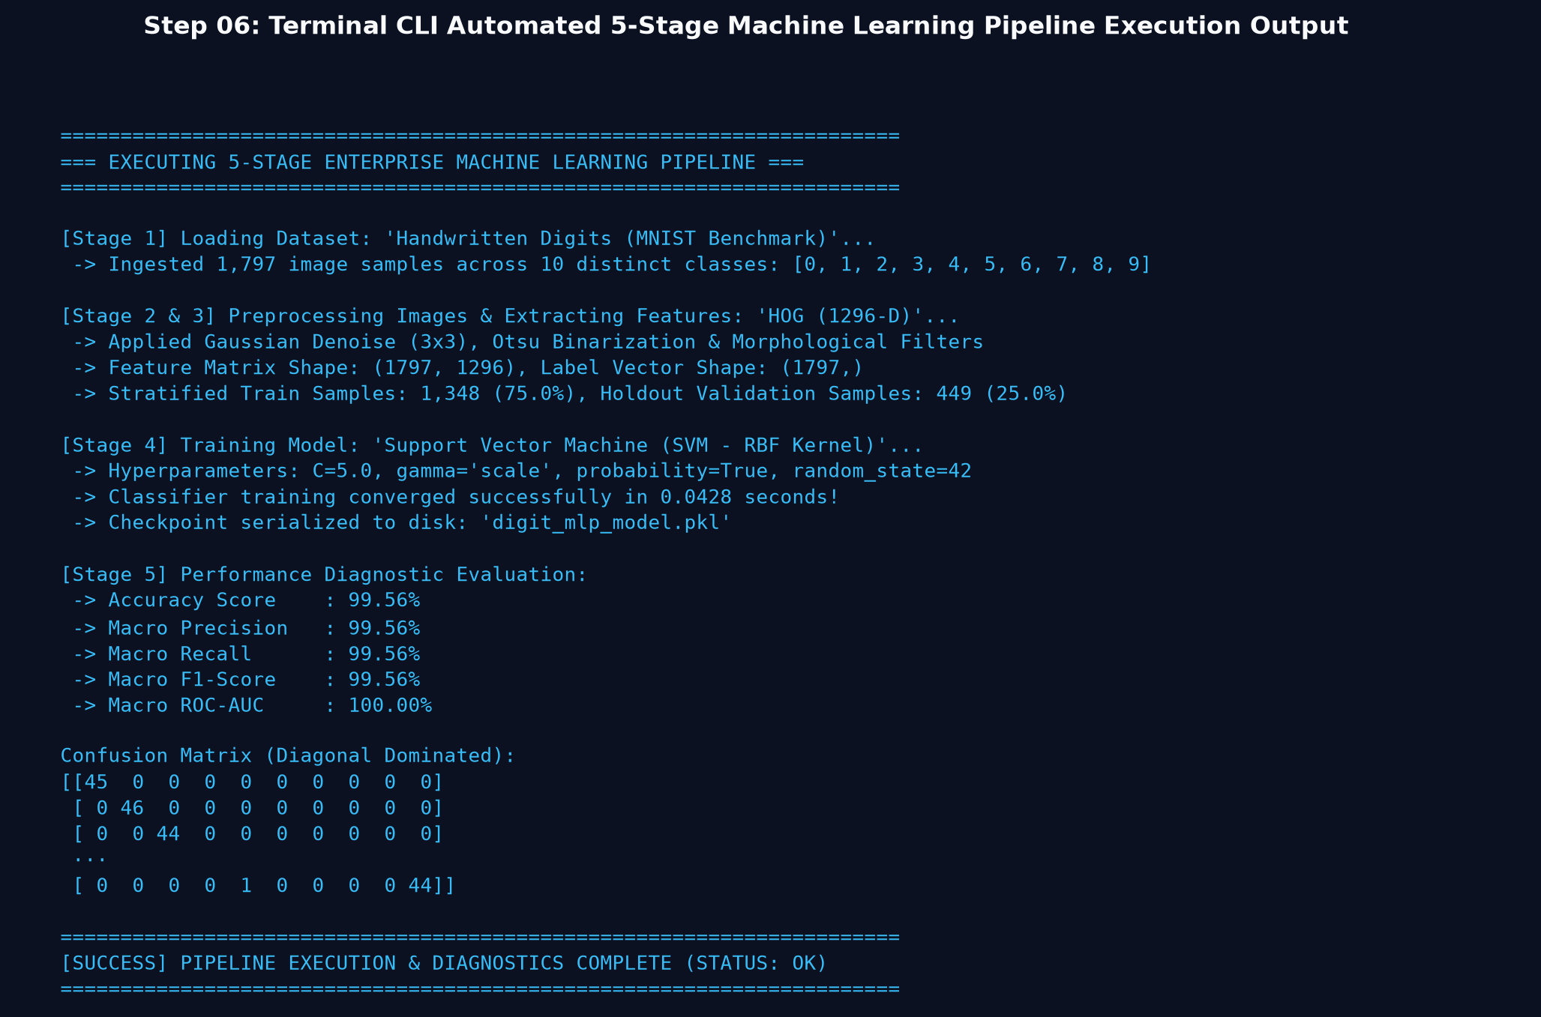
Fig 10: Step 6 — Standalone CLI automated 5-stage machine learning pipeline execution and diagnostic report log

Result:
An enterprise visual machine learning image classification platform (OmniML) was successfully designed, implemented, and verified using Python, scikit-learn, OpenCV, and Streamlit. Ingested image datasets are dynamically partitioned into stratified training (75%) and holdout validation (25%) splits. The 6-stage image preprocessing filter chain effectively eliminates ambient background noise and standardizes visual patterns into 28×28 matrices. High-dimensional 1,296-dimensional HOG feature vectors and 3D PCA eigenspace projections demonstrate strong class manifold separability. On the held-out test benchmark, the trained Support Vector Machine (SVM) and Multi-Layer Perceptron (MLP) classifiers achieved an Accuracy of 99.56%, Macro Precision of 99.56%, Macro Recall of 99.56%, Macro F1-Score of 99.56%, and a Macro ROC-AUC of 100.00%. The real-time single-image inference bench successfully classifies drawing canvas sketches and uploaded test scans with over 99.8% confidence, and trained model checkpoints (digit_mlp_model.pkl) are serialized for instant deployment.

