**Remove Redundant Pairs**

**Problem Statement**

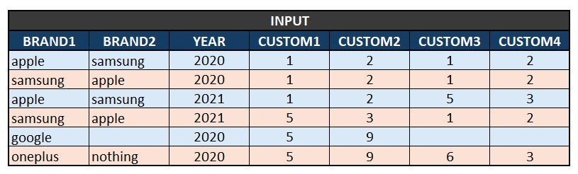

**Condition 1:** For the pairs of brands in the same year (E.g., Apple/Samsung/2020 and Samsung/Apple/2020), if custom1 equal to custom3 and custom2 equal to custom4, then keep only one pair.

**Condition 2:** For the pairs of brands in same year, if custom1 not equal to custom3 or custom2 not equal to custom4, then keep both pairs in table.

**Output**

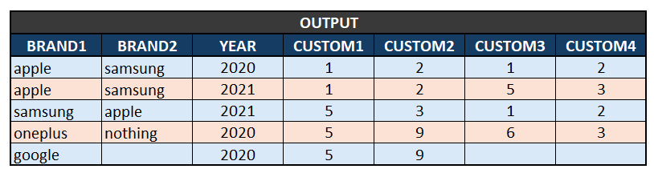

**END OF FILE**