**Build All Ski-Slopes**

**Problem Statement**

A ski resort company is planning to construct a new ski slope using a pre-existing network of mountain huts and trails between them. A new slope has to begin at one of the mountain huts, have a middle station at another hut connected with the first one by a direct trail, and end at the third mountain hut which is also connected by a direct trail to the second hut. The altitude of the three huts chosen for constructing the ski slope has to be strictly decreasing.

You are given two SQL tables, mountain_huts and trails, with the following structure:

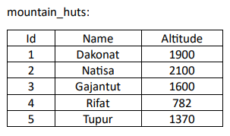 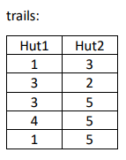

1. Each entry in the table trails represents a direct connection between huts with IDs hut1 and hut2.

2. Create a query that finds all triplets (startpt, middlept, endpt) representing the mountain huts that may be used for construction of a ski slope.

**Note:**

* All trails are bidirectional and there are no self-trails.
* For two huts there is at most one trail connecting them.
* Output returned by the query can be ordered in any way

**Output**

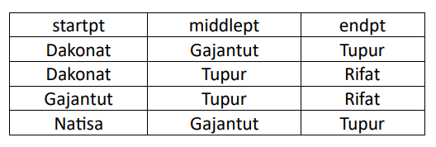

**END OF FILE**