**Web Design Basics**

**4 Important Aspects: -**

1. Colour Theory
2. Typography
3. User Interface
4. User Experience

**Points on Colour Theory**

* Colour Wheel & Mood of Colours

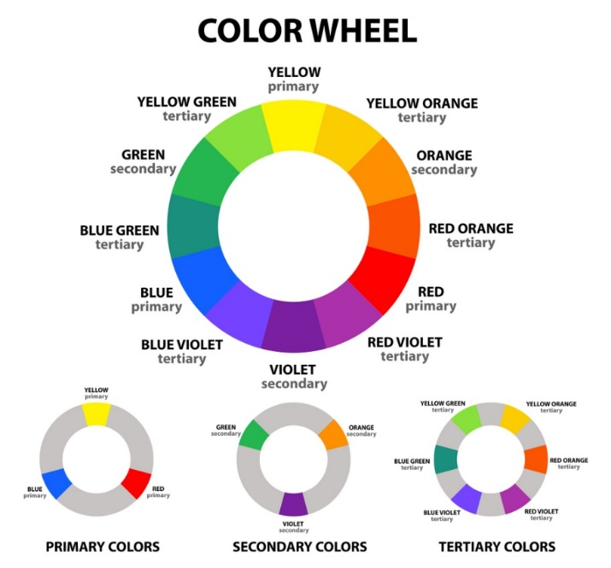

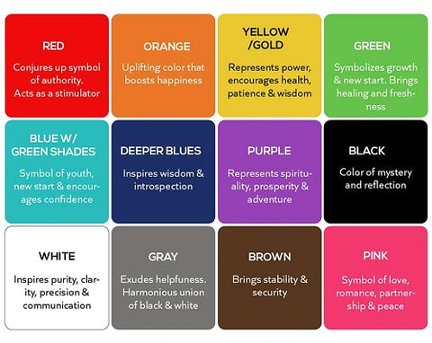

* Complementary colour palette **pops out** and hence best suited for Logos, Headings & other highlighting elements. But you should avoid using complementary colours in regular text and simple text background because it makes it harder to read.
* Analogous colour palette **harmonious** and hence best suited for background and Nav element combinations means background of Parent – Child Elements. But not suited for Logos and Headings as they not pop out or stand out.

Some websites for choosing colour palettes or creating your own:

[Adobe Colour Wheel](https://color.adobe.com/create/color-wheel)

[Colour Hunt](https://colorhunt.co/)

**Points on Typography**

* Emotions of Fonts

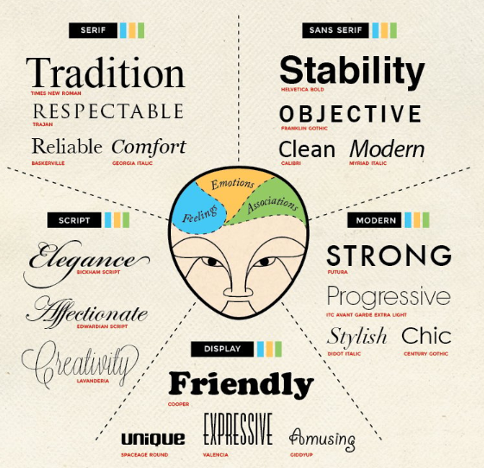

* Don’t use too much fonts in website, stick to **max** 3 to 4 fonts.
* Choose the fonts on basis of **similarity in mood** – all the fonts should match the mood of website & for **creating contrast** use two different families but for the main text prefer **sans-serif** > serif > any other font.
* For differentiating heading and main text choose fonts of different weights. E.g., display – sans-serif combination.
* Limit the characters of **single line** **to < 64 characters**.
* In a section or container avoid using more than 2 fonts.

For choosing fonts: [Google Fonts](https://fonts.google.com/)

**Points on User Interface**

* **Hierarchy**: Heading must pop out or stand out, Button sizes – **Primary Buttons** are **bigger** and **Secondary Buttons** have **smaller** size than primary buttons, all **parent-child** relationship containers must be recognized.

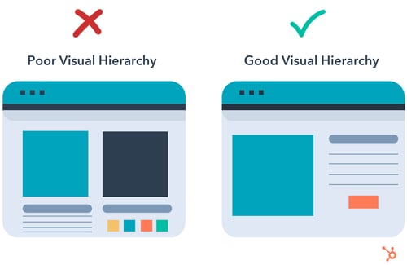

* **Layout**: A good website must have a standard well organised Layout not just random containers placed here and there. Line Length < 60-64 characters and all elements have their proper layout placement like navbar, sidebar, body, article, F-Layout, Z-Layout websites etc.

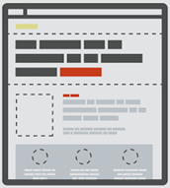

* **Alignment**: A professional website have minimum number of alignment points.

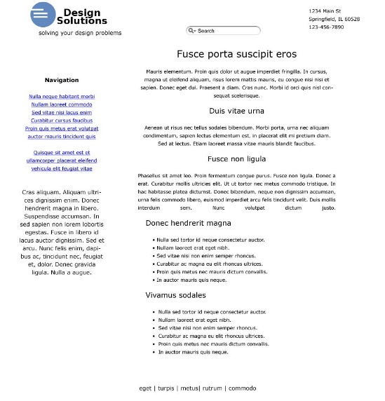 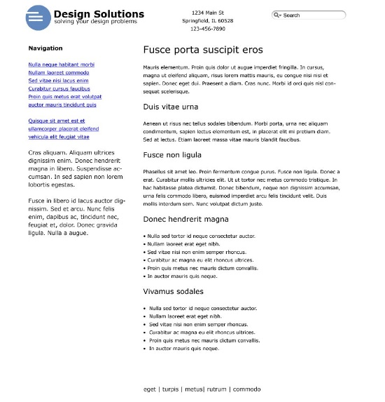

You can see in this example as right one has less no. of alignment points and it looks more professional.

* **White space**: Important Elements and containers must stand out? Other than colours and typography white space plays a crucial role in achieving this by making them separate them from others. Hence, just **space out the important elements** and containers their **visibility priority must be number 1.**



As you can see left one has more able to convey message with professionality, this is used by big companies like Apple, Google etc.

* **Audience:** Make your website according to the target audience. **Don’t make Professional websites for children and vice versa.**

**Points on User Experience**

* **Simplicity**: Keep your website simpler and easier to understand. This also gives more information to the reader/user.

**Bad Website Looks Like**



You can’t get any information from such sites.

* **Consistency**: Your website must remain consistent throughout the session. It must not be the case that your navbar is changing in every single webpage of that website or footer size changes or colour scheme and typograph suddenly changes unless it is directed to do so.
* **All Platform Design**: Your website should be accessible all the devices with same type of user experience. You must design websites according to different screens. **Mobile First Trend** which supports that your website must provide good user experience on both mobile as well as pc or tab.

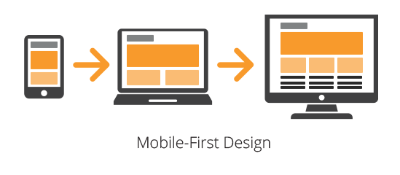

* **Reading Patterns**: Use the commonly used website theme specific layout for websites like

**F Layout** – for Blog websites, Crypto websites etc. and **Z Layout** – for Social Media websites or Video Streaming like Netflix related websites.

* **Must Not Trick User:** Do not use bad practices just to earn money by ad-clicks or any other source.