POONAM GUPTA

*Designation*

*Results-oriented Software Test Automation Engineer with 4.8 years of experience in Software Testing.*

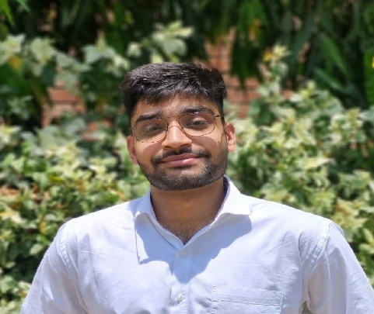

GIRIRAJ

*DATA SCIENTIST - TRAINEE*

Results-driven Data Scientist with deep expertise in mathematical modeling & AI/ML strategies.

|  |  |  |  |  |
| --- | --- | --- | --- | --- |
|  | **PROFESSIONAL SKILLS:**    **Primary**: Python, SQL(PostgreSQL), Data Science, LLMs, LangChain, GenAI, Vector Databases (Pinecone), Machine Learning, Deep Learning, Statistics  **Secondary**:C++, C, R, DBMS, OOPs, OS  **Tools**: pyTorch, Git & GitHub, Power BI, Python libraries like pandas, numpy, scipy, scikit-learn, matplotlib, seaborn etc., Tensorflow, Keras | |  | | --- | | **WORK EXPERIENCE:**  **Research, Netaji Subhas University of Technology**  *Feb, 2024 – Aug, 2024*   * Published research paper at Region 10 Symposium, IEEE, 2024 on “*Depression detection by using wearable sensors*”   *eCF Paper Id: TENSYMP2024-391*   * Developed ML-based health monitoring system achieving **92**% accuracy. * Implemented ethical design for collecting mental & emotional data. | | **SUMMARY OF KEY PROJECTS**  **Project 1: Dynamic Pricing System**  Client Description:   * Aimed at businesses in the e-commerce, hospitality, and travel sectors seeking optimized pricing strategies. The client required an intelligent system to improve revenue generation and inventory management.   Project Duration: 3 Months  Project Description:   * Developed an intelligent dynamic pricing system leveraging machine learning and optimization techniques to improve revenue and inventory management   Role: Machine Learning Developer   * Designed and implemented predictive models to optimize pricing strategies. * Integrated optimization algorithms for revenue enhancement.   Technologies used: Python, Pandas, Scikit-learn, TensorFlow, SQL, Optimization.  Key activities:   * Developed machine learning models to forecast pricing dynamics. * Implemented optimization layers to enhance inventory utilization by **170.83%.** * Analysed and processed data to increase booking efficiency by **41 slots**. | |
|  | **CORE COMPETENCIES:**    Data Science, ML, DL, Algorithms, Statistics, Generative AI, LLMs, Time-Series Analysis |
|  | **EDUCATION:**    Bachelors of Technology with a major in Computer Science Engineering (Artificial Intelligence) from Netaji Subhas University of Technology (NSUT)  **GPA: 8.4 / 10**  **Graduation Year: 2024** |
|  | **PREVIOUS INSTITUTIONS:**  Netaji Subhas University of Technology (NSUT), New Delhi, India |
|  |  |

|  |
| --- |
| **Project 2: Two-Tower Search-Item Retrieval Model**  Client Description:   * Focused on enhancing search and recommendation systems for an e-commerce platform with a large user base. The client required scalable solutions to improve query-item retrieval accuracy.   Project Duration: 3 Months  Project Description:   * Built a Two-Tower neural network-based retrieval model to enhance query-item retrieval accuracy for e-commerce search and recommendation tasks.   Role: Machine Learning Developer  Technologies used: Python, TensorFlow, Keras, Amazon Open-Source Datasets, SQL.  Key activities:   * Trained neural networks with open-source datasets to improve retrieval accuracy. * Enhanced embedding with personalized signals. * Validated and demonstrated scalability for large-scale query-item retrieval systems.   **Project 3: Vishleshan – The Analysis Competition**  Client Description (**IIM Raipur**):   * Organized by a reputed institution for data enthusiasts to solve complex analytical problems. The competition provided raw datasets to extract meaningful insights for decision-making   Project Duration: 1 Month  Project Description:   * Conducted data engineering and analysis to extract actionable insights using advanced Python techniques.   Role: Data Analyst & Engineer  Technologies used: Python, Pandas, NumPy, Matplotlib, Seaborn, LSTM, Scikit-Learn.  Key activities:   * Manipulated and transformed raw data to uncover trends and insights. * Designed visualizations to support data-driven decision-making. * Implemented the LSTM Algorithm to find the trends of Stock Market data to find insights. |
|  |