Machine 1 : Ip address

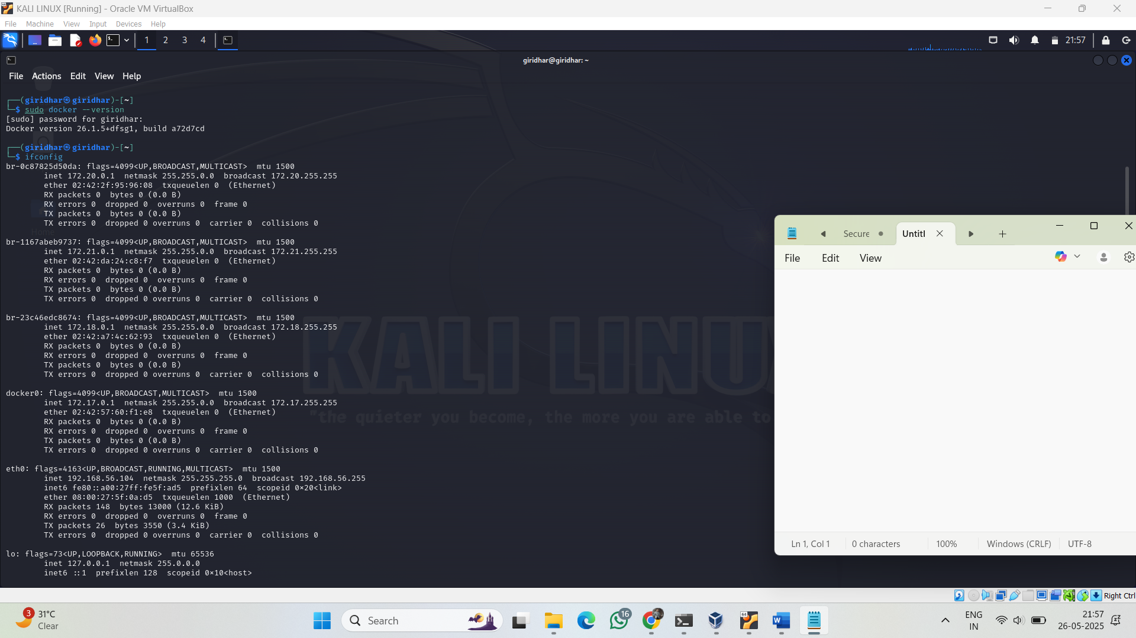

Machine 2: Ip address

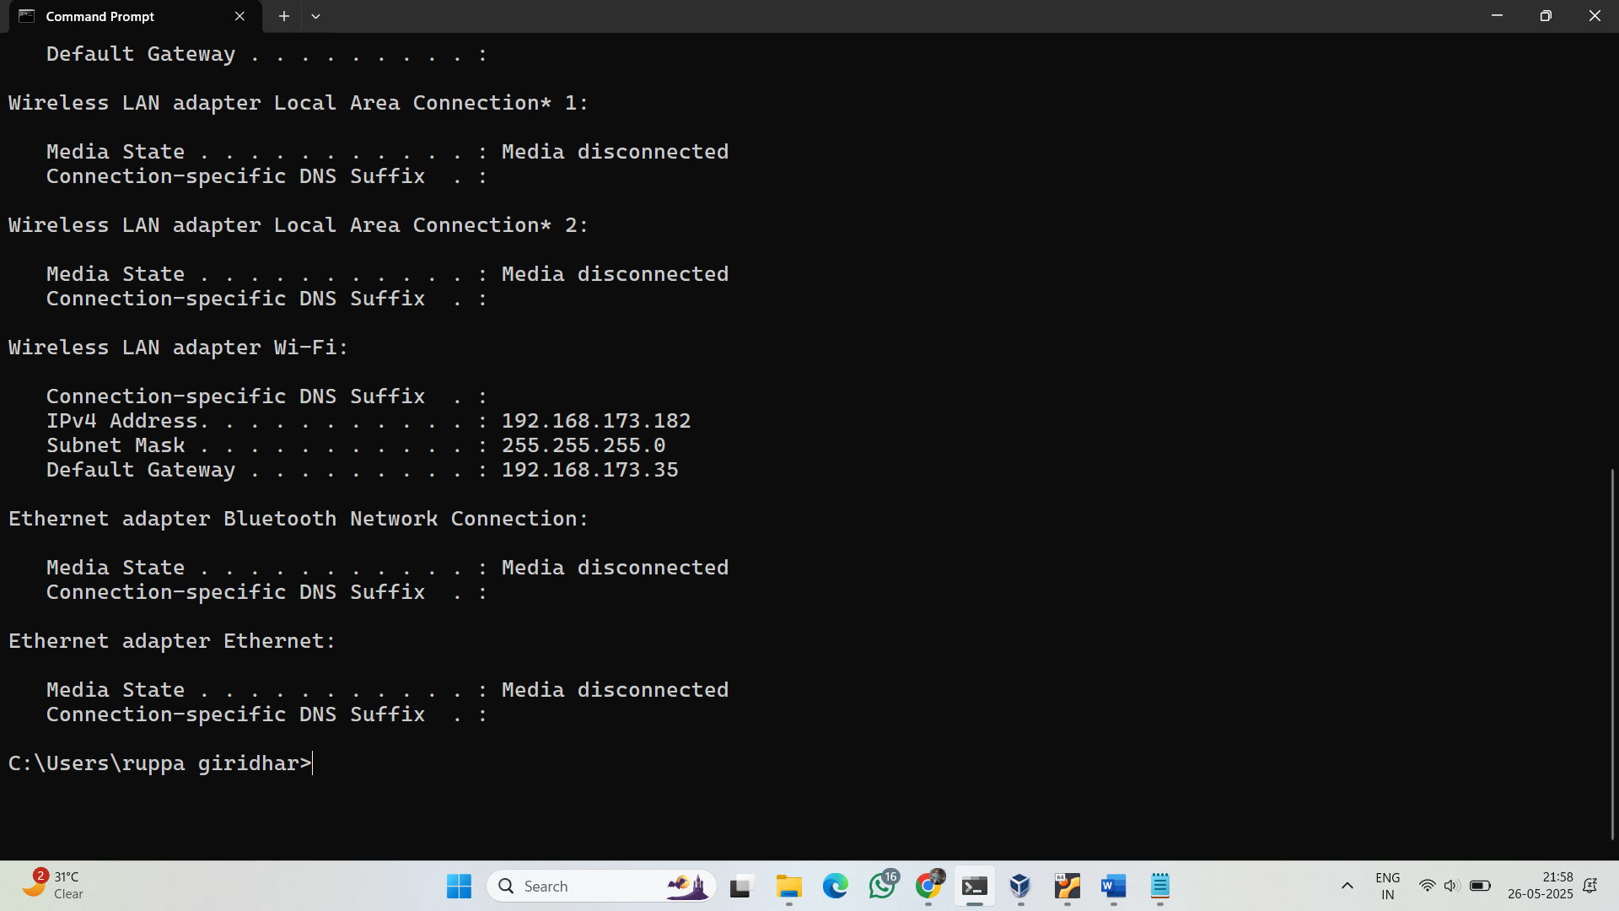

**Step 3: Run TCP SYN Scan**

nmap -sS 192.168.172.0/24

* -sS = SYN Scan (stealthy and fast)
* 192.168.172.0/24 = Scans all 254 hosts on your subnet

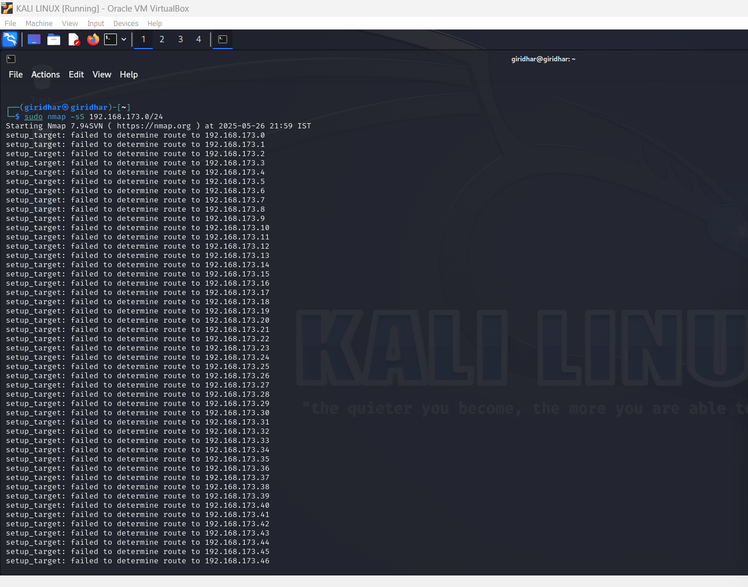

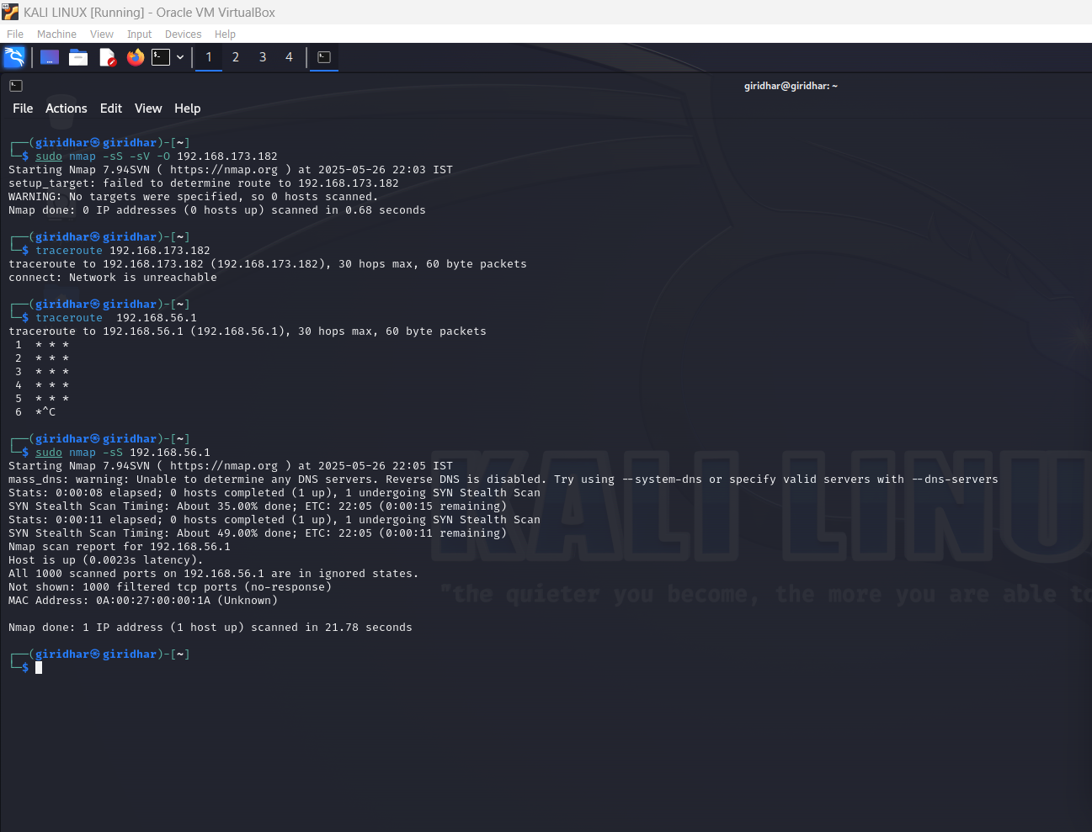

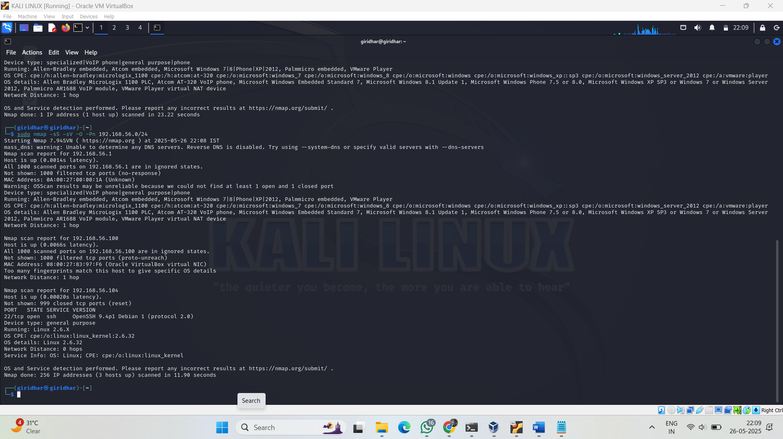

REPORT

