GenieOne –
- AI coworker interface for business teams which has access across the organization specific context (the Genie Ontology)
- The conversational application and interface that business users open to ask questions, create reports, and take actions across data sources.
- GenieOne has features like retrieve from documents, Connectors, Scheduled Tasks, Custom MCP tools, Custom Skills and Genie Agents.
- GenieOne can be added as MCP for other tools like Claude etc,.
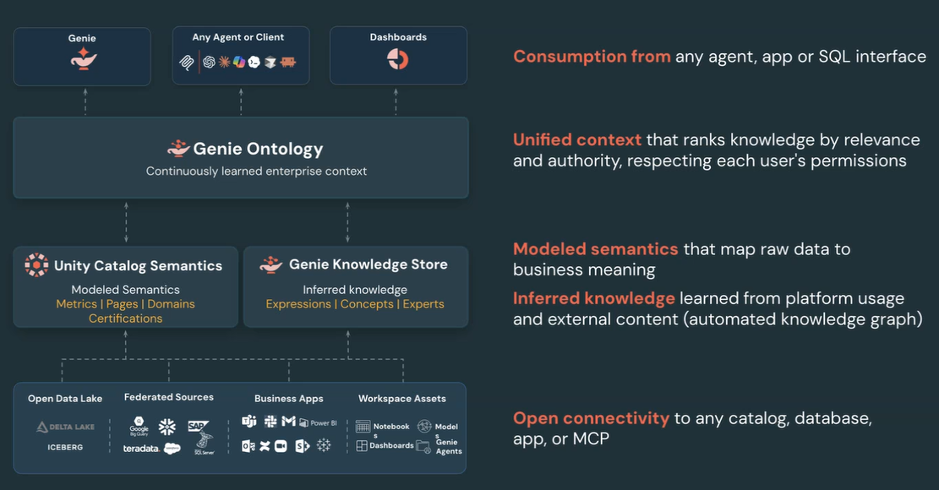

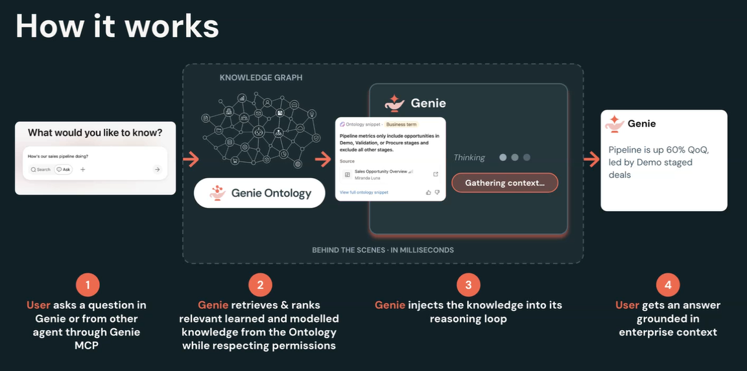

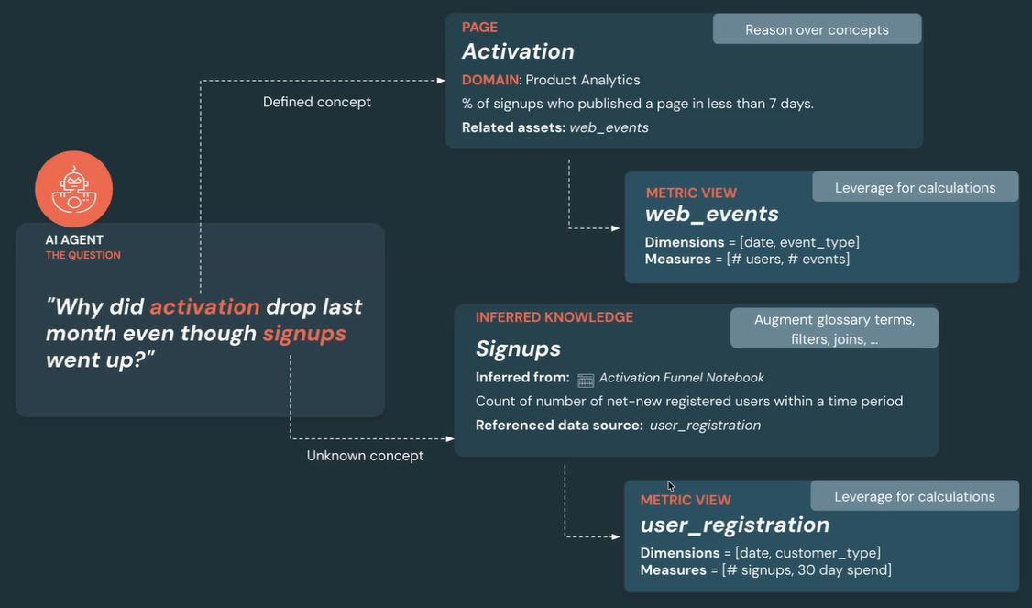
AgentBricks –
- A full-scale enterprise developer platform used to build, evaluate, and govern AI agents.
- Covers broad infrastructure needs, integrating deeply with the lakehouse for memory, Unity Catalog for unified data and AI governance, and Model Context Protocol (MCP) for tool connections.
- Supports multiple frontier models (OpenAI, Anthropic, Gemini, etc.) and various underlying agent frameworks—including LangGraph, CrewAI, and Omnigent.
Omnigent – OpenSource platform.
- An open-source "meta-harness" created by Databricks that sits directly on top of specific agent harnesses and SDKs (like Claude Code, Codex, and Pi).
- Focused narrowly on orchestration, sandboxing, cost limits, and real-time collaboration across different coding assistants or custom agent sessions.
- You can use Omnigent as a component inside your broader Agent Bricks workflow to manage how different agents talk to each other and share active terminal or web sessions.
- https://github.com/omnigent-ai/omnigent

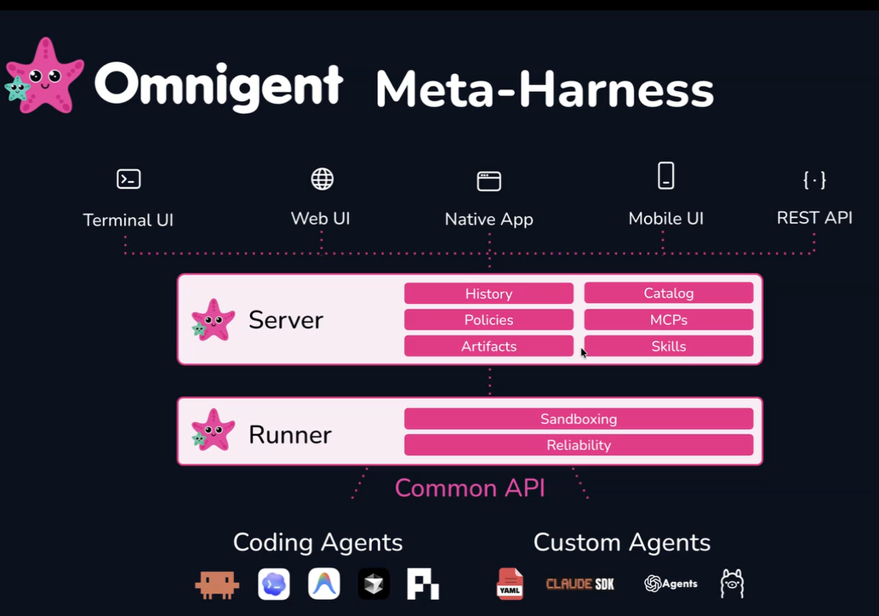
Meta-Harness: It is an orchestration and governance layer that sits above individual AI agent harnesses, allowing different tools like Claude Code, Codex, and Pi to operate together as an interchangeable fleet under a single interface
  - Unifies Multiple Agents: Combines distinct AI runtimes so you can switch tasks or route them to the best model (e.g., using Claude Code for logic and Codex for code review) within one session.
  - Provides a Control Plane: Manages system-wide governance, including stateful cost caps, security policies, secret isolation, and audit trails.
  - Distinguishes from MCP: Unlike Model Context Protocol (MCP) which connects an agent to tools, a meta-harness connects the user to multiple agents
Databricks Apps
- Most of the apps will be developed by citizen developers.
- Genie App Builder (Similar to Lovable) which build apps by context aware leveraging the genie ontology. Uses AppKit SDK and custom skills.
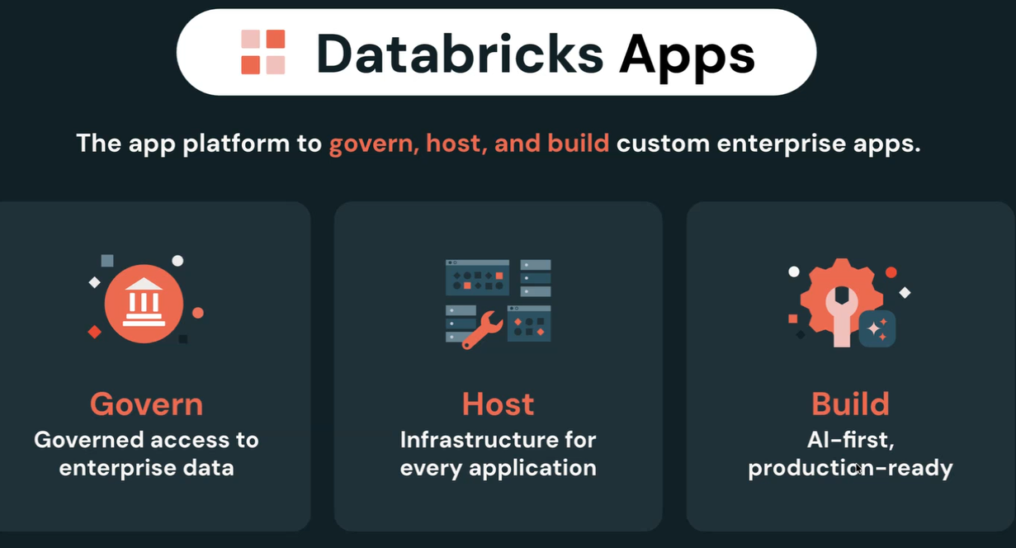
LakeHouse RT - Real Time.
- Reyden : Auto-scales for lower TCO, High Throughput (Queries Per Second -QPS). High Concurrency.
Lakebase DR –
- Fully managed Postgres based database.
- Separation of storage and compute
- Modern developer experience built for AI. Can branch out the data like git code.
- Lakehouse integration and enterprise readiness.
- Fully managed, cross-cloud disaster recovery (DR).
- Resiliency, Availability
LTAP –
- Unifies OLTP (Transactional) and OLAP (Analytical)

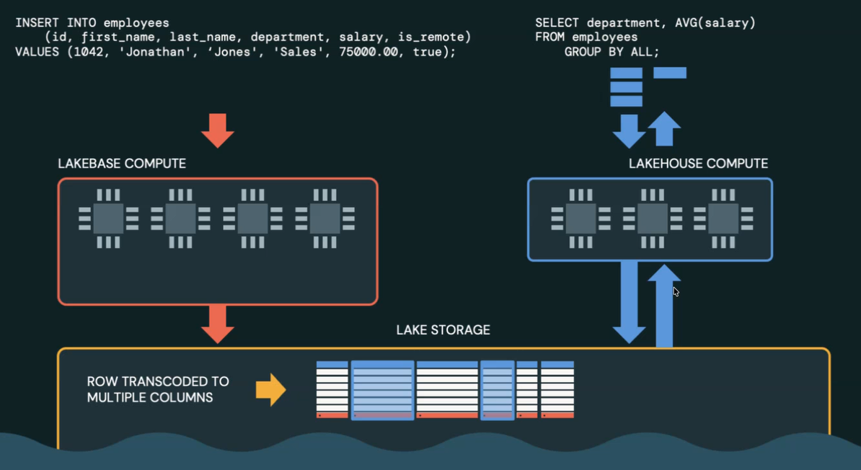

Unity AI Gateway -
- Unified Governance for your entire AI estate.
- Setting the connections, controlling the cost, applying guardrails, add policies etc,.

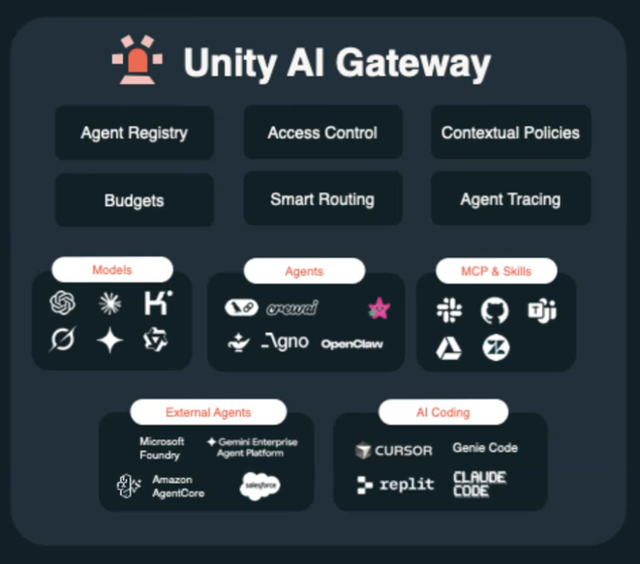

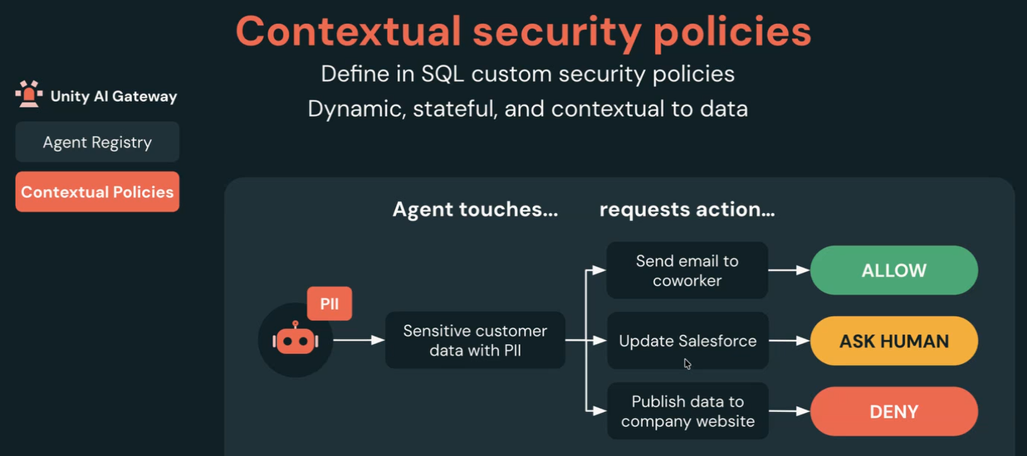

Agent: Combination of Planning, LLM Model, Memory and Tools

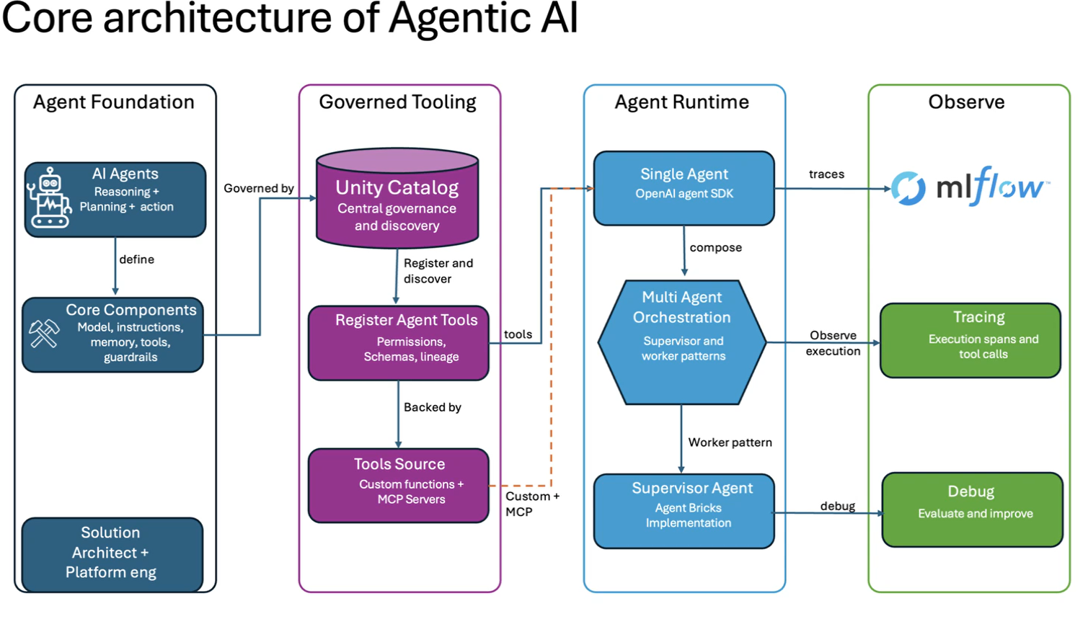

RBAC – Role based access control
ABAC – Attribute based access control

As part of tool creation, we can create functions within unity-catalog with desired permissions and policies using ABAC.

