NAME: P.GIRISH KUMAR
REGISTRATION NUMBER:23MIS0673
(AGILE FAT)

Creating folder in vs code and git hub repository
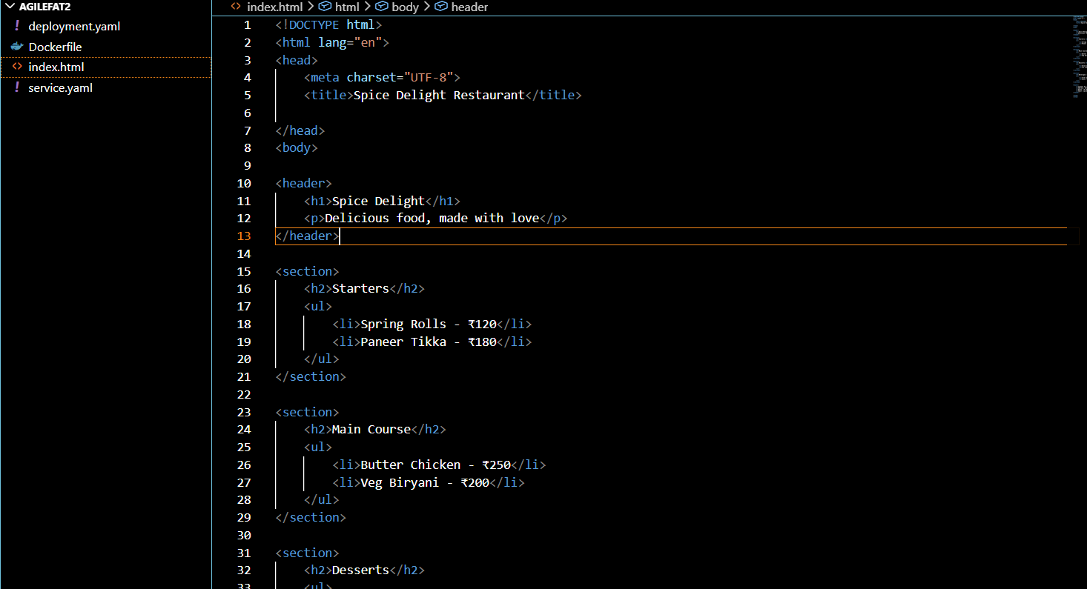
Gitcommands to push into github
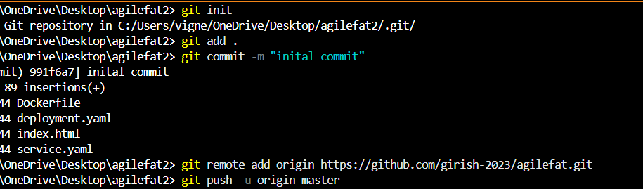
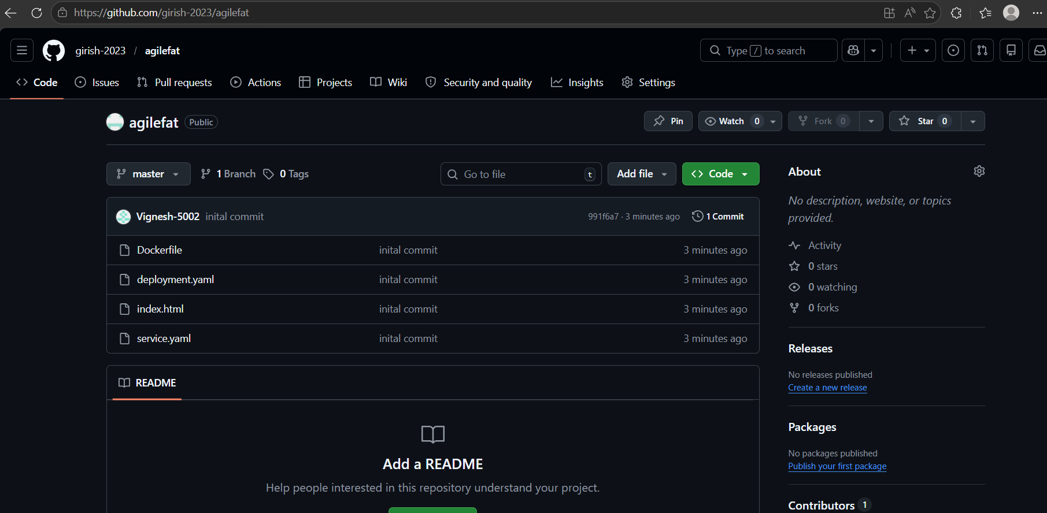
Second commit changes:
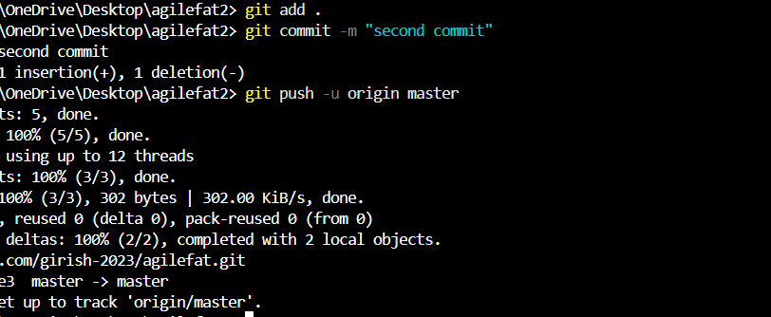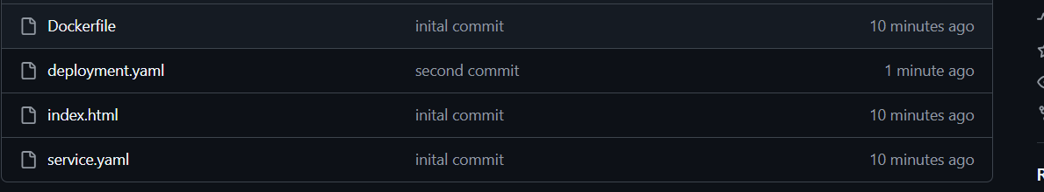

Creating pipeline in Jenkins
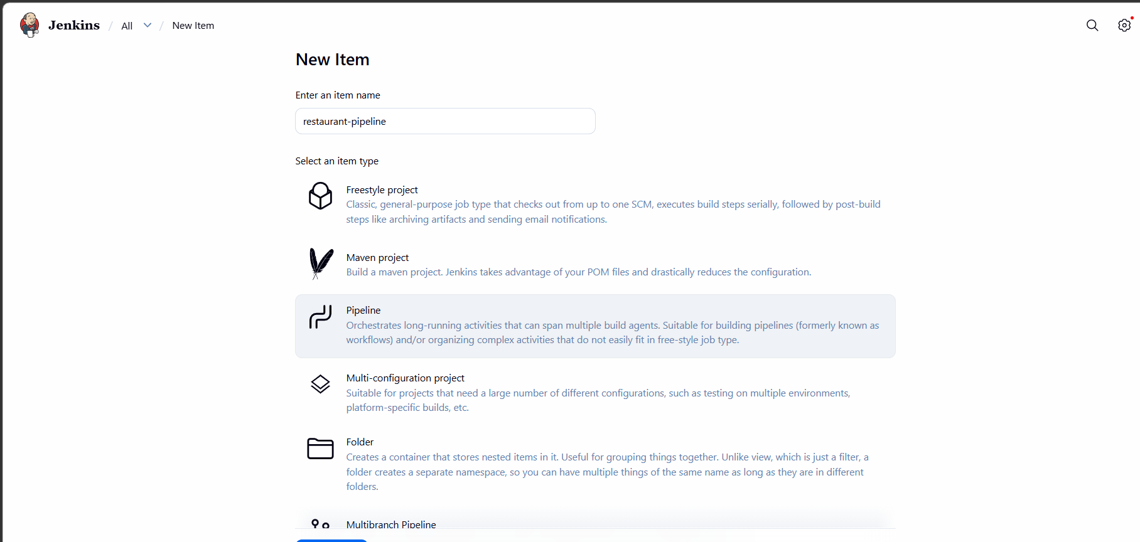
Docker file: 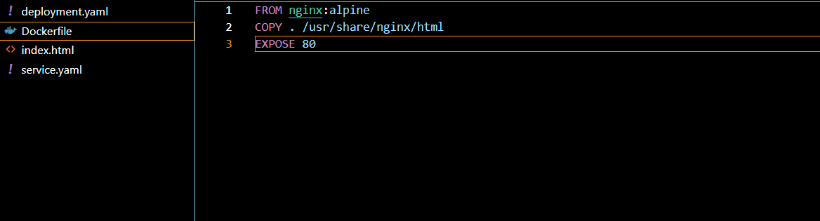
jenkins pipeline build and deploy using docker and kubernetes:
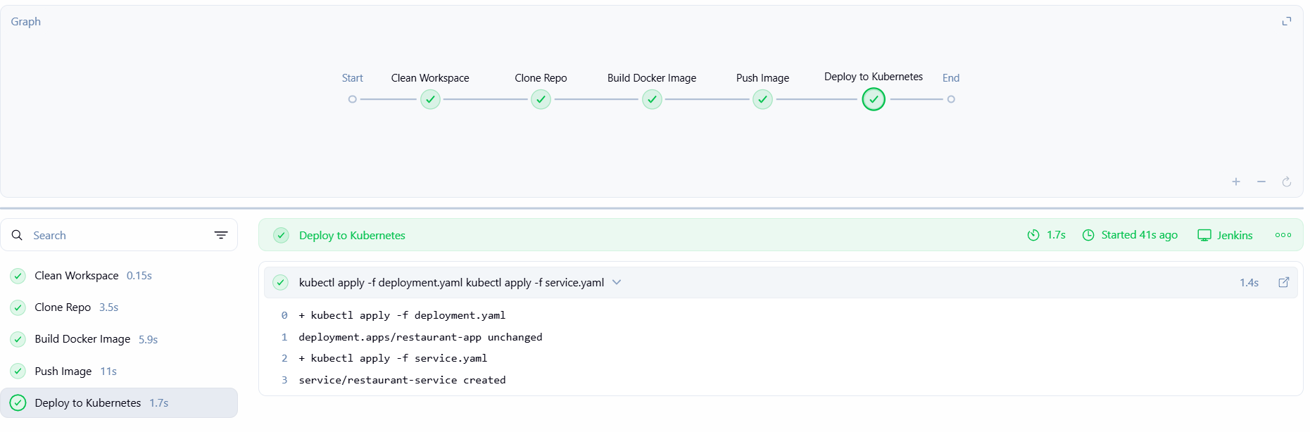
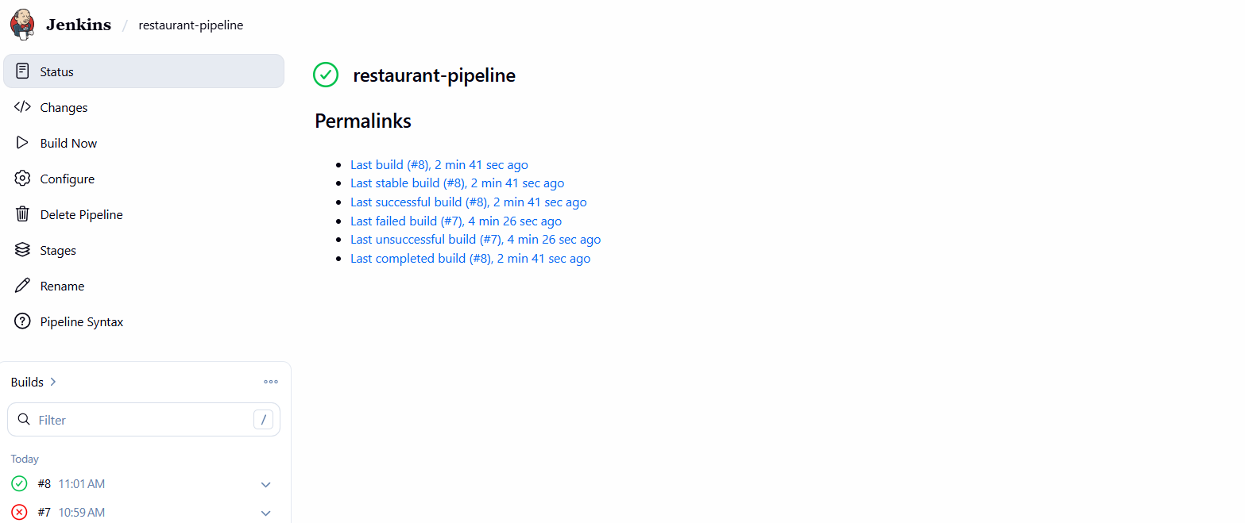
PIPELINE SCRIPT:
pipeline {
agent any

environment {
DOCKER_IMAGE = 'girish2023/restaurant-menu:v1'
}

stages {

stage('Clean Workspace') {
steps {
cleanWs()
}
}

stage('Clone Repo') {
steps {
git 'https://github.com/girish-2023/agilefat.git'
}
}

stage('Build Docker Image') {
steps {
sh 'docker build -t $DOCKER_IMAGE .'
}
}

stage('Push Image') {
steps {
withCredentials([usernamePassword(
credentialsId: 'dockerhub',
usernameVariable: 'USER',
passwordVariable: 'PASS')]) {

sh '''
echo $PASS | docker login -u $USER --password-stdin
docker push $DOCKER_IMAGE
'''
}
}
}

stage('Deploy to Kubernetes') {
steps {
withCredentials([file(credentialsId: 'kubeconfig', variable: 'KUBECONFIG')]) {
sh '''
kubectl apply -f deployment.yaml
kubectl apply -f service.yaml
'''
}
}
}
}
}
CONSOLE OUTPUT IN JENKINS:
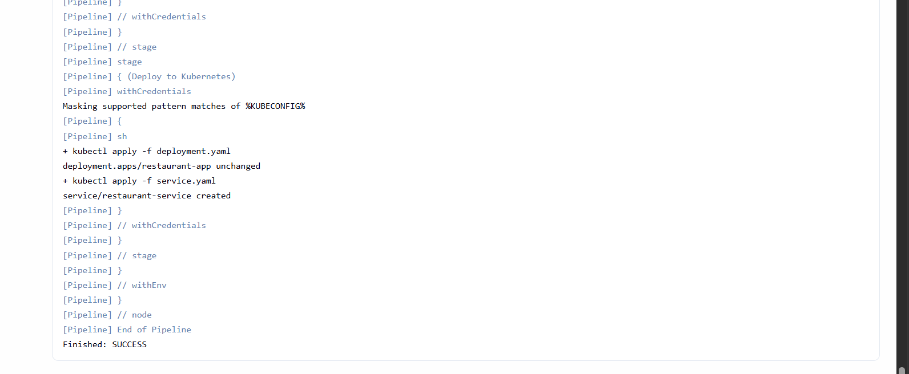

Kubernetes deployment
