IOCL Vehicle Tracking System
Version 1.0

Document History
Ver.  No. | Release Date | DCR Ref. | Description of Change | Authored/ Revised By | Reviewed By | Approved By
1.0 | 28-Aug-2015 |  |  | Arvind Mohan Gupta

Table of Contents
Overview 4
Type of GPS Devices 4
Components 4
System Architecture 4
Communication (Listener, parser) 5
Sample Raw message 5
Web Application 5
Standalone (schedulers, automated emails) 6
Trip data 6
Menu System,Privilege and Creation 7
Menu System 7
Menu Privilege 9
Menu Creation 9
Users Types 9
Login Page and DashBoard Flow 9
Exceptions (SAP Exceptions, Trip Exceptions) 11
SAP Exceptions 11
Trip Exceptions 11
Reports (VMU Status Report, Monthly Billing Report, NRD Report, Exception Report, Letter To Transporter Report) 11
VMU Status Report 11
Monthly Billing Report(Monthly vehicle status report) 13
NRD Report 14
NRD and VMU Status mapping 15
Exception Report 15
Letter To Transporter Report 15
Important Tables 17
Important Procedures 18
Route Creation/Updation Process 18
Schedulers (Cron Scripts, Quartz and Events) 19
Cron 19
Quartz 19
Events 19
Abbreviations 20

Overview
A Vehicle tracking system(VTS) make use of GPS device. GPS device has capability to locate individual vehicle based on latitude and longitude, data collected by device can be viewed on map via internet or some specialized software. Apart from location it can also give you other information about vehicle like fuel amount, engine temperature, altitude, door open/close, tire pressure, cut off fuel, battery status, GSM area code/cell code decoded, stationary vehicle, route deviation (driver takes different route), free wheel, over speed and harsh breaking etc.

Type of GPS Devices
In our VTS we are using 2 type of devices.
- EFK, made/customize by EFKON.
- QLPL, made/customize by other vendors.

Components
We have divided IOCL VTS in three components.
- Communication (Listener, parser)
- Web Application
- Standalone (schedulers, automated emails)

System Architecture
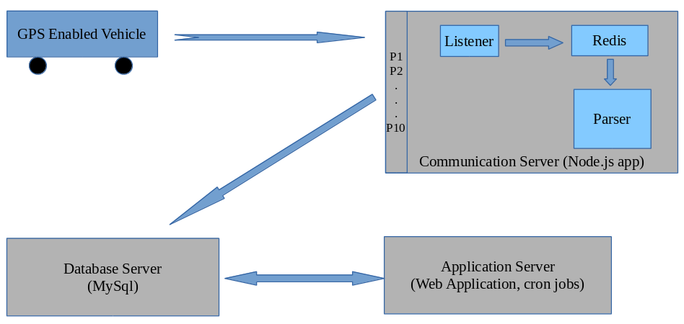

Communication (Listener, parser)
- Every GPS enabled Vehicle sends a message in every 30 seconds to communication server.
- Communication server has 10 ports to manage traffic/request load from 8124 to 8134.
- Communication server has 3 components
  - listener
  - Redis
  - Parser
- Listener written in Node.js, listen incoming message in raw message and push it to Redis, Redis is a temporary storage and also store db table(ETRK_IN_OBU_MSGS).
- Parser is also written in Node.js, fetche raw message from Redis, parse and store in database table(ETRK_IN_MSGS). During the parsing incoming raw messages passes through number of validations(e.g whether vehicle, GPS device is in our db or not, invalid packet, etc), if any validation fails parser logs an entry in db table(ETRK_GPRS_ERROR).

Sample Raw message
$IS,EFK1410099,41,00,0,00481331,22,404,011,00a6,c329,10,2583,410,30,ED,00,0897,000,094951,A,2832.3410,N,07703.5301,E,0.010,297.2,270815,00000*2E

Web Application
Web application is used for following purpose.
- Tracking (Consignment Tracking, Journey logs, Live Tracking and Route Deviation)
- Management of state offices, supply locations, transporter, sim, devices, vehicle, users, user category, product, consumer, routes and landmarks.
- Reporting, there are tow types of reports in web application.
  - Live Report
  - MIS Report
In this section you can get On-demand reports based of different search criteria to evaluate the business, daily activity or problems that arise, make decisions, and track progress.

In Live Report section yo can get all activity report of a vehicles; like speed violation, stoppage, distance traveled etc.
In MIS Report, you can have Trip report,Closed/Open trip report, Exception report, Monthly report and also you can send transporters.
- Maintenance (Device maintenance, Update software and device up-gradation).
- Tools, control user menu access, task scheduling, Geo-fence creation, OTA commands, raw message and report are part of this section.

To develop web application we have used following Software/Tools/Plug-in and Technologies.
Software/Tools
- JDK 1.6.0_45
- iReports 5.5
- JBoss 4.0.5 GA
- Toad 6.7 for MySql
Technologies
- Struts
- Spring
- Hibernate
- Jasper Reports
- Param Query(grid plug-in)
- Quartz Scheduler
Database
We are using MySql as database in our application.

Standalone (schedulers, automated emails)
These are java files used for various purpose like automated reports, schedulers and emails. To run these files we create Shell Scripts(*.sh), which run through cron tab and Quartz Scheduler.

Trip data
All invoice.txt data will be saved in db table(IOCL_INVOICE_RAW).
We make request to IOCL FTP on each 10 min. by executing trip.sh.
First search new data in invoice.txt, if not found then search in invoicefull.txt. We store all invoice data in a db table(IOCL_INVOICE_RAW_TRACK) for tracking purpose.
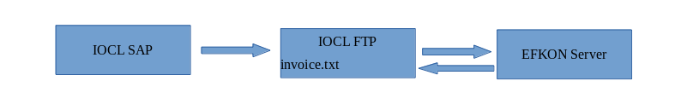
There is a specific type of delivery, which we have to process “DDP”.
Column name is : IIR_DELIVERY_TYTPE.

Menu System,Privilege and Creation

Menu System
We have divided this application into 5 menu items(top level menu). Each menu item plays a vital role in managing and controlling whole application.
Following are main menu items and it's sub menu items.
- Tracking
  - Live Tracking
  - Journey Log
  - Consignment Tracking
  - Route Deviations
- Manage
  - State Office
  - Supply Location
  - Transporter
  - Sim
  - Device
  - Vehicle
  - User Category
  - User
  - Product
  - Customer
  - Route
  - Landmark
- Reports
  - Live Reports
    - Alert report
    - Distance report
    - Distance traveled report
    - Speed violation report
    - Stoppage report
  - MIS Reports
    - Summary of Exception Report
    - Trip Report
    - SAP Exception Report
    - User Activity
    - Exception Summarized Report
    - Exception Detailed Report
    - VMU Status Report
    - Day wise Trip Statistic Report
    - RO/CO Supply Details Report
    - Letter to Transporter on Deviation
    - Open Trips Report
    - Monthly Reporting Status
    - Idle Closed Trips
- Tools
  - User Menu Access Control
  - Enable Deleted Records
  - View Raw Message
  - View Error Raw Message
  - Send OTA Command to VMU
  - Create Geofence
  - NRD Dashboard
  - New Raw Message
  - Scheduler Tasks
  - Deviation Letter Summary
  - Application/VMU Parameters
  - OTA Command
- Maintenance
  - NRD Maintenance
  - Sensor Memory Status
  - EFK Device Maintenance
All main menu items are stored in db table (ETRK_MENU_MST). And it's sub items are stored in db table (ETRK_SUB_MENU_MST).

Menu Privilege
Each user belongs to a category and that category has a set of accessible menu and sub menu items, to perform view, add, edit, delete actions. We are using db table (ETRK_USER_MENU_ACCESS_CONTROL).

Menu Creation
To create a main menu item, we have to make entries in db directly. Following are steps.
- Go to ETRK_MENU_MST table.
- Make an entry, it will appear in main menu as per specified order. e.g. “Test Menu”
- Create an menu item under “Test Menu” . e.g. “Free wheeling”
- Now “Free wheeling” will appear in “User Menu Access Control”, and you can set user access and privilege.

Users Types
In our application we have 4 type of users.
Shippers, are user who send the product to destination. (Filling station/Depot)
Transporters, are user whose truck is carrying the product to destination.
Consumer, are destination users.
EFKON(Admin), Admin users, has control on everything.
For user types, we are using “ETRK_USER_TYPE_MST”

Login Page and DashBoard Flow
To set privilege, access, view, add, edit, delete and reporting purpose we have a Login section. Here user has to login with their user id and password, based on user category, user will see some or all options. We are validate user in db table (ETRK_CUSTOMER_USER_MST).
Admin user has a, after successful login admin will be taken to Dashboard(refer to image below).
Dashboard shows latest update of the day(current day). Following summery are there.
- Active vehicles, this is total no. of vehicles includes tracked, untracked and parked.
- Tracked vehicles, no. of vehicles getting tracked.
- Untracked/parked vehicle, vehicles not getting tracked and stationary state.
- Vehicle without VMU/Inactive, vehicles without GPS device.
- Vehicles under maintenance.
- Total consignment, total no. of consignment including open/closed.
- Active consignment, Open consignment.
- Off route vehicle, no. of vehicles going out of specified route.
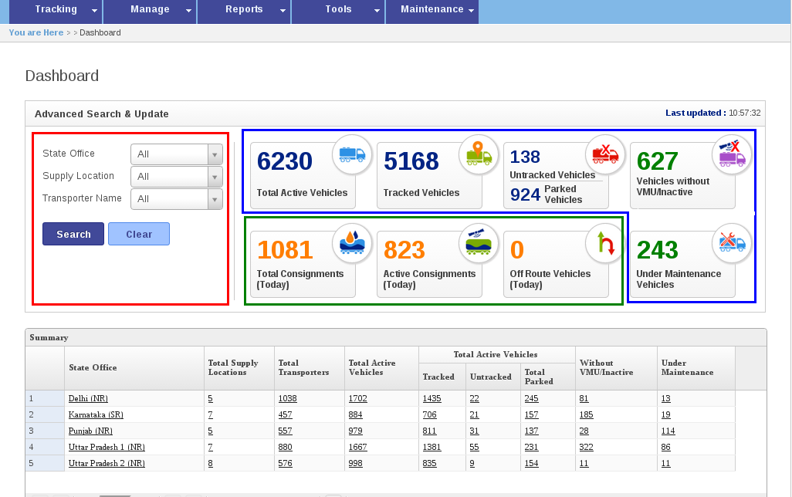
We have advance search option to search state office, supply location or transporter wise or in combination. In search state office, supply location and transporters in drop-down are populating from file. When page load, system look for list in text file, if not found in text file only then system hit the db table (ETRK_PET_STATE_OFFICE, ETRK_SUPPLY_LOC_MST, ETRK_PET_TRANSPORT_MST ). These text file get update automatically by scheduler (Quartz Scheduler).

Exceptions (SAP Exceptions, Trip Exceptions)
There are 2 types of exception in application.

SAP Exceptions
- No Product, when product is not added our database.
- No Consumer, when consumer is not added our database.
- No Vehicle, when vehicle is not in added database.

Trip Exceptions
- Over speed, when vehicle exceeds speed limit. Ideal speed is 50 Km/h.
- Halt exception, if vehicle stops more then specified time, this is halt exception. There are distance bracket.
Distance(Km) | Allowed stoppage time (min)
0 – 50 | 0 min.
50 – 100 | 15 min
100 – 200 | 30 min

if vehicle stop before 50 Km that will be halt exception, vehicle stops more then 15 min between 50 – 100 Km it will be halt exception.
- Route deviation, if vehicle deviates from route and stops more then 5 min. it will be route deviation. If vehicle deviates but do not stop, it will not be considered as route deviation.

Reports (VMU Status Report, Monthly Billing Report, NRD Report, Exception Report, Letter To Transporter Report)

VMU Status Report
This report is used to track device status. We have set various device status. All information is saving in db table.
Following are device status and meaning.
VMU Status | Meaning | Monthly reporting status
P | Device is reporting
I | Device carrying invoice
S | Parked state
N | Device not reporting
C | In-active/not in system
DT | Down time
PI | Device is reporting and carrying invoice | Y
P- | Device is reporting and no invoice | Y
S- | Parked state and no invoice | Y
SI | Parked state and invoice | N
N- | Non reporting
C* | not in system | -

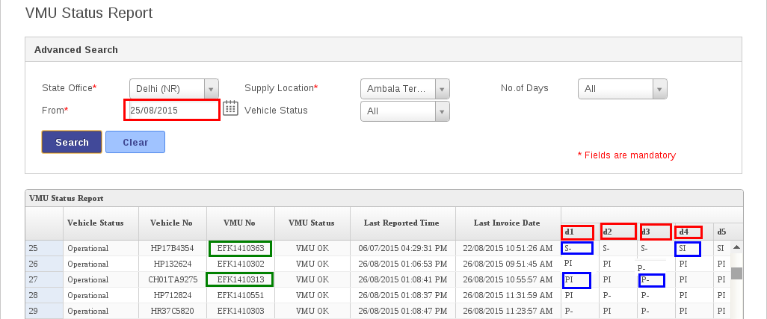
Search date(from ), day
VUM No.
Vehicle status
When we search VMU status report, it search from back date. e.g. I have searched from 25/08/2015(Red box). in the report (table), it showing device status on d1, d2, d3, … d1 = 24/08/2015, d2 = 23/08/2015, d3 = 22/08/2015 and so on. On d1, VMU/device No. EFK1410363 was in Parked state and no invoice (S-), on d4, it was in Parked state and invoice (SI). On d2, VMU/device No. EFK1410313, Device is reporting and carrying invoice (PI), on d3, Device is reporting and no invoice (P-).

Monthly Billing Report(Monthly vehicle status report)
Creation process of this report is manual, follow below steps.
- Run /home/app/monthly_status/IOCLMonthlyStatusReport/monthlystatusreport.sh.
- An excel sheet will generate.
- Match/verify generated exl file with VMU report of that month.
- And upload this file to server location; 10.101.10.23/user/local/jboss/server/maruti/log/billing/.
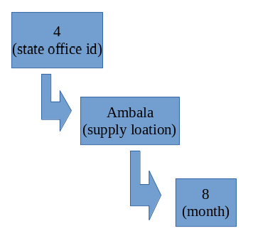

- Create a folder e.g. 9 (for September) and put the file. Now it will reflect in “Monthly Status Report”.
In this report there are 3 status.
Status | Meaning
Y | Vehicle is reporting
N | Vehicle is no reporting
- | not in system

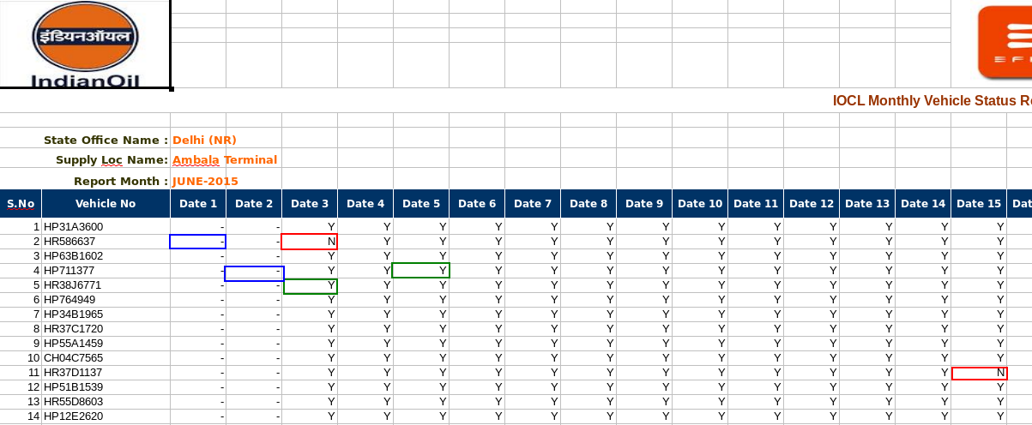
NRD Report
This report is related to non reporting devices report.
In NRD Report 2 files are execution,
1. nrdtab.sh
2. nrdProcessing.sh
nrdtab.sh, gathers all information about devices, are reporting or not. And information will store in db table (IOCL_NRD_TAB_POPULATE , IOCL_DAILY_NRD_STATUS_NEW) and it will update db table (IOCL_DAILY_VEH_STATUS), there are 4 status in NRD report.
Status | Meaning
P | Vehicle in parking state
N | Vehicle not reporting
NR | Device never reported
R | Device is reporting

nrdProcessing.sh, executes in every 5 min, it calls a procedure (IOCL_PROC_NRD_PROCESSING) which updates status in
(IOCL_DAILY_NRD_STATUS_NEW) .
QLPL, device does not send message, if vehicle is in parking for 30 min.
EFK, device send message continuously. So to track a vehicle in “parking state”, controller goes to last 15 min records and look for 30 continues records, if record found OK, if not found, again controller goes back to next 15 min record. If seed of vehicle is less then 5 Km/h, it will consider vehicle in parked state.

NRD and VMU Status mapping
NRD Status | VMU Status
R | P (Reporting)
N
NR
P (Parked State) | Q/E (QMPL Parked/EFK Parked.)

Exception Report
4 types of exception report are there.
IOCLStateOffExcepDailyRpt.sh, in this report there are count of exception for each supply location to state office.
IOCLSupplyLocExcepDailyRpt.sh, in this report there are count of exception for each vehicle to supply location.
IOCLStateOffExcepDailySTATEBreakupRpt.sh, these are detailed report of exception for each supply to state office.
IOCLStateOffExcepDailySUPPLYBreakupRpt.sh, these are detailed report of exception for each vehicle to supply location.

Letter To Transporter Report
This report will be send to transporters with all deviation/exception committed by their vehicles.
It includes, Route deviation, Halt deviation, Over speed, Vehicles have not reporting for more than 10 days, Vehicles have taken supplies but their trips are open even after more than two days. We generate and store data in db table (IOCL_LETTER_TRANSPORTER_NEW) using (IOCL_PROC_GENERATE_TO_TRANSPORTER_WITH_START_END) stored procedure. All exception in letter will be fetched from db table (IOCL_EXCEPTION_SCHEDULER_NEW).

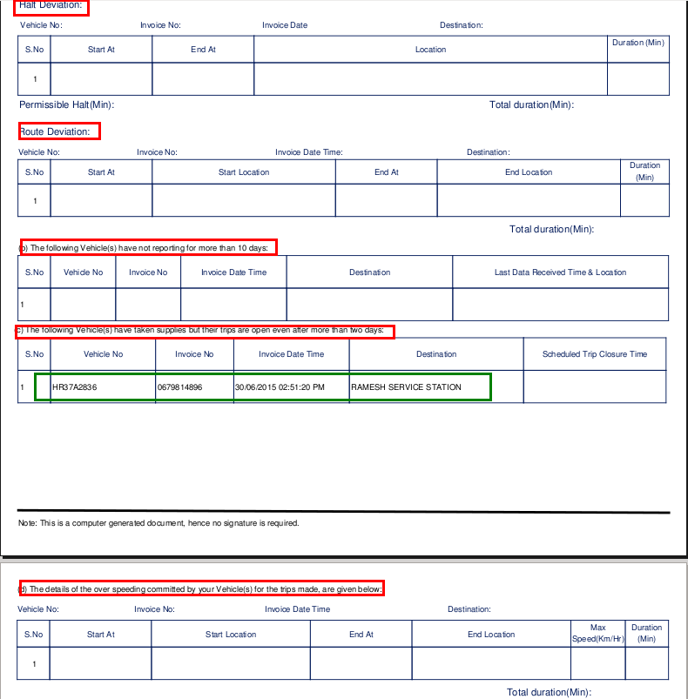

In above screen short all types of deviation are there. If no exception occurred, there will not be any entry in the table.

Important Tables
Table | Purpose
ETRK_IN_OBU_MSGS | Listener store raw message in this table(before storing in redis)
ETRK_IN_MSGS | After parsing of message all data stores in this table.
ETRK_OBU_MSG_NEW | Before parsing raw message stores in this table.
ETRK_GPRS_ERROR | If any validation fails during parsing, information will be store in this table.
ETRK_MENU_MST | Main menu items store in this table.
ETRK_SUB_MENU_MST | sub menu items store in this table.
ETRK_USER_MENU_ACCESS_CONTROL | Menu access privilege store in this table.
ETRK_USER_TYPE_MST | User type store in this table.
ETRK_CUSTOMER_USER_MST | This table is used for login purpose.
ETRK_PET_STATE_OFFICE | State office master table
ETRK_SUPPLY_LOC_MST | Supply location master table
ETRK_PET_TRANSPORT_MST | Transporters master table
ETRK_SIM_MST | Device sim card master table
ETRK_VEHICLE_MST | List of vehicles(Vehicle master table)
ETRK_PET_CONSUMER_MST | Consumers master table
IOCL_ROUTE_MST | IOCL Route master table
IOCL_LANDMARK_MST | IOCL Landmark master table
IOCL_CONTACTS | IOCL Contacts master table
IOCL_LETTER_TRANSPORTER_NEW | Stores letter to transporter data.
IOCL_DAILY_NRD_STATUS_NEW | This table is used for storing NRD data
IOCL_DAILY_VEH_STATUS | This table is used to store updated status on vehicle (NRD status).
IOCL_INVOICE_RAW | All invoice.txt data will be saved in this table.
IOCL_INVOICE_RAW_TRACK | invoice.txt data will be saved in this table for tracking purpose.

Important Procedures
Procedures | Purpose
IOCL_PROC_NRD_PROCESSING | This stored procedure is used for NRD processing.
IOCL_PROC_GENERATE_TO_TRANSPORTER_WITH_START_END | This stored procedure is used for generation letter to transporter on deviation data.

Route Creation/Updation Process
To create/update route, we use journey logs.
Initially admin create a route and set its status “Not Loaded”. There are 4 status of a route.
- Not Loaded
- Pending
- Accepted
- Rejected
1. Then we execute following Query to fetch RouteId, GroupNo, SupplyCode and ConsumerCode
SELECT B.ESLM_SUPPLY_LOC_CODE,A.* FROM IOCL_ROUTE_MST A, ETRK_SUPPLY_LOC_MST B WHERE IRM_ROUTE_STATUS = 'NotLoaded' and A.IRM_DEPOT_NAME = B.ESLM_SUPPLY_LOC_NAME order by IRM_ROUTE_ID ASC;
2. create a “router.txt” file, and put the data fetched from above query. Data should be in specific order.
Route_id,Group_no,supply_plant_code,Consumer_code, consumer code should start with 0000 e.g. 0000109995
Everything should be comma separated AND in single quotes.
e.g. '1496','7025','1251','0000109325',

'1497','7023','1251','0000109372'.
3. Login in to machine
10.101.10.23
Paste routes.txt at cd /home/app/IOCL_VTS_JOURNEY_HIST/

Run
cd bin
sh create_journey_csv.sh
A new file with name New_Routes.csv will be generated with journey history.
This csv file will be given to a third party vendor, they will create a map on a special server “postgres” and make route status “Pending”. Now state officer will review the map and make status “Accepted /Rejected”.

Schedulers (Cron Scripts, Quartz and Events)
we are using 3 type of scheduler to automate tasks.
- Cron
- Quartz
- Events

Cron
We are using cron tab to fetch Trip data, Exception reports, Letter to transporter on deviation database
NRD Reports.

Quartz
We are using quartz scheduler at application level to update state office, supply location and transporters in drop-down, populating from file, send letter to transporter on deviation email. These files are located in “/views/dump/alltextfiles/” folder.

Events
There are 6 events in our database but we are using only tow events.
To view the events in database run following query.
SHOW EVENTS;
we are using these events for mapping between VMU and NRD.
IOCL_EVT_SCHLR_NRD_PARKED_PROCESSING_EFK, this table is used to map only EFK devices and call OCL_PROC_PARKED_PROCESSING_EFK_NEW stored procedure.
IOCL_EVT_SCHLR_NRD_PARKED_PROCESSING_QLPL, this table is used to map only QLPL devices and call IOCL_PROC_PARKED_PROCESSING_QCQ_NEW stored procedure.

Abbreviations
Abbreviation | Meaning
VTS | Vehicle Tracking System
GPS | Global Positioning System
FTP | File Transfer Protocol
NRD | Non Reporting Device
GSM | Global System for Mobile
Trip | Journey from supply location to consumer.
VMU | Device

