Botree Chat — Architecture Overview
Natural-language analytics over the Bisk Farm distribution database
July 2026
1. What it is
Botree Chat lets business users ask questions about FMCG distribution data in plain English — “show me geography wise sales with brand” — and get back a grounded answer: a short summary, the complete result table, the exact SQL that ran, and a CSV download. An LLM translates the question to SQL, but every query passes through a deterministic safety gate and role-based row scoping before it touches the database, and every attempt is audited. The database is accessed strictly read-only.
2. Technology stack
Layer | Technology | Role
Frontend | Next.js, React, TypeScript | Chat UI built on assistant-ui with streaming responses; Tailwind CSS + Radix UI; CSV export; voice input
Backend | Python 3.12, FastAPI, Uvicorn | REST + SSE streaming API; JWT auth (PyJWT + bcrypt); per-user rate limiting; structlog logging
NL → SQL | sqlglot, custom pipeline | SQL parsed to an AST and validated against a SELECT-only whitelist; automatic LIMIT cap; RBAC predicates injected per user role
App database | PostgreSQL + pgvector, SQLAlchemy 2, Alembic | Users, chat threads, audit log, and the two-tier query cache (exact + semantic via vector similarity)
Analytics database | MySQL (Bisk Farm), PyMySQL + DBUtils pool | Read-only reporting database; reached directly or through an SSH tunnel
AI services | Cloudflare Workers AI | Llama 3.1 for SQL generation and answer summaries; BGE embeddings for the semantic cache; Whisper for speech-to-text (provider swappable to Anthropic Claude)
Runtime & quality | Docker, pytest | Containerized deployment; 280+ fully offline automated tests
3. Why these technologies
Technology | Why we use it
Next.js | One framework gives us the chat UI and a secure server-side proxy, so auth tokens never reach browser JavaScript.
React | Component-based UI that re-renders smoothly as answers stream in, token by token.
TypeScript | Type errors are caught at build time instead of in front of a user.
assistant-ui | Production-ready chat components (threads, streaming, message actions) instead of months building them from scratch.
Tailwind CSS | Utility-class styling keeps the whole UI consistent without maintaining custom CSS.
Radix UI | Accessible, keyboard-friendly UI primitives (dialogs, tooltips, sidebar) out of the box.
Python | The native language of the AI/data ecosystem — every library we depend on is first-class in Python.
FastAPI | Async-first API framework with built-in request validation and native SSE streaming for live answers.
Uvicorn | Fast ASGI server that runs FastAPI’s async code and holds many live streaming connections cheaply.
SQLAlchemy 2 (async) | One typed data layer for all application queries — readable, portable, and easy to test.
Alembic | Versioned, repeatable database schema migrations instead of hand-run SQL scripts.
PostgreSQL + pgvector | One reliable database for both app state and vector similarity search — no separate vector store to operate.
PyMySQL + DBUtils | Pooled, read-only client connections to the existing MySQL reporting database.
sqlglot | Parses generated SQL into a syntax tree, letting us verify a query is safe before it runs, not after.
PyJWT + bcrypt | Battle-tested standards for signing login tokens and hashing passwords.
structlog | Structured, machine-searchable logs with a request id on every line — debugging production is grep, not guesswork.
Cloudflare Workers AI | Managed LLM, embeddings, and speech-to-text behind one simple API — no GPU infrastructure to run.
Docker | The same containerized runtime in development and production — eliminates environment drift.
pytest | 280+ fully offline tests keep every change verifiable in seconds, with no network or credentials needed.

4. System architecture
Three zones: the browser client, the FastAPI application server, and the data and AI services it consumes. The frontend never talks to a database or an LLM directly — everything goes through the backend, where safety, scoping, and auditing are enforced.
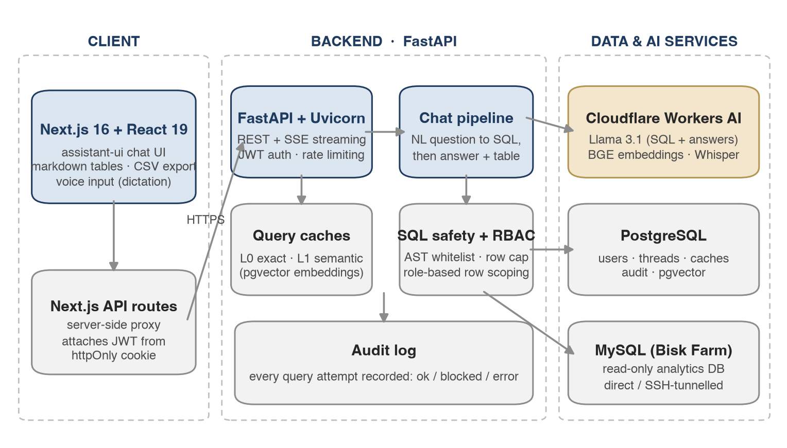
- Auth — The Next.js server proxies every API call, attaching the user's JWT from an httpOnly cookie — tokens are never exposed to browser JavaScript.
- Data — Two databases with distinct jobs: PostgreSQL owns application state (users, threads, caches, audit); MySQL is the untouched, read-only source of business data.
- AI — The LLM is a swappable provider behind one interface — Cloudflare-hosted Llama today, Anthropic Claude with a one-line config change.
5. What happens when a user asks a question
Eight steps from question to answer. Repeated questions short-circuit at step 3: the cached SQL template is reused, skipping the LLM entirely — faster and cheaper, while RBAC scoping and execution still run per user.
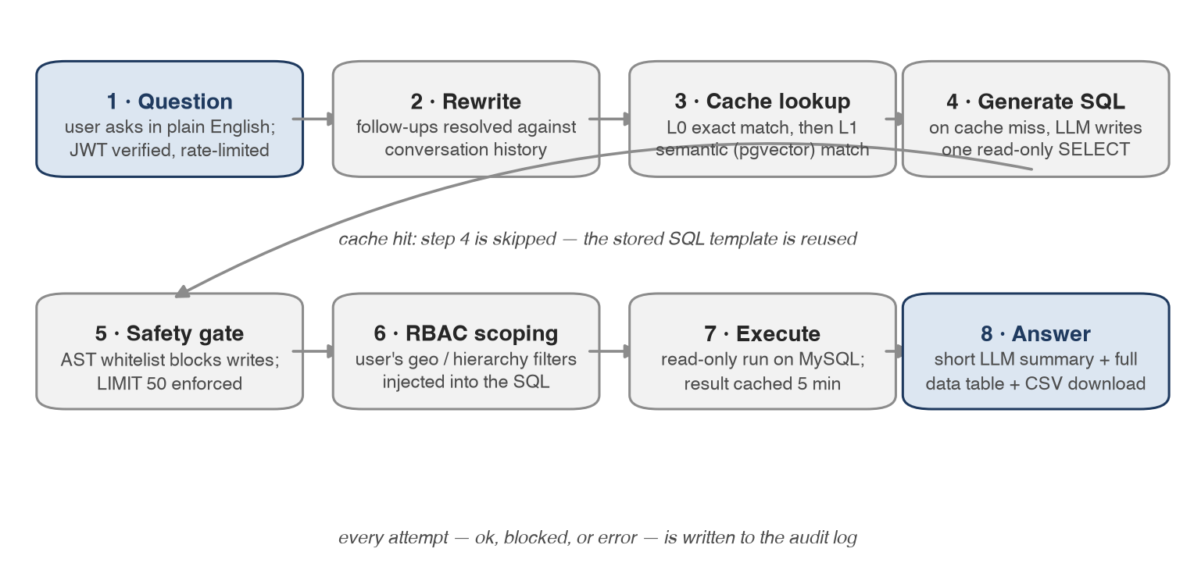
6. Safety and governance, in brief
- Read-only by construction — The AST-based gate only lets a single SELECT through — INSERT, UPDATE, DELETE, and DDL are structurally impossible, regardless of what the LLM produces.
- Row-level security — Geography and sales-hierarchy filters are injected into every query from the user's profile. Two users asking the same question see only their own data.
- No hallucinated numbers — Totals in answers are computed deterministically in code, and the full result table is rendered from the actual rows — the LLM only words the summary.
- Complete audit trail — Every attempt — successful, blocked, or failed — is recorded with the user, the SQL, row counts, token usage, and timing.

