SDMA Application Migration Strategy

WebAppBuilder to Experience Builder - RPAS Data Loader Widget
Document Version: 1.0
Date: December 16, 2025
Focus Area: RPAS Data Loader Widget (RPAS Elevation & TLS Elevation)

Executive Summary: This document outlines the migration strategy for the RPAS Data Loader Widget from ESRI WebAppBuilder to Experience Builder, incorporating the new FME Flow-based backend architecture to replace the existing Jenkins + Python automation.
Key Changes
- Frontend: WebAppBuilder → Experience Builder Custom Widget
- Backend: Jenkins + Python Scripts → FME Flow + Webhook
- Processing: Maintained geoprocessing logic with improved automation
- Integration: Webhook-based communication with FME Flow

- Existing Architecture

Widget Components:
- RPAS Elevation - LAS file upload calling geoprocessing service
- TLS Elevation - TLS file upload calling geoprocessing service

Current Workflow:
User Upload → Widget Validation → File Staging → Jenkins Polling (5 min)
→ Python Processing → Transformation → MTD Publishing → Email Notification

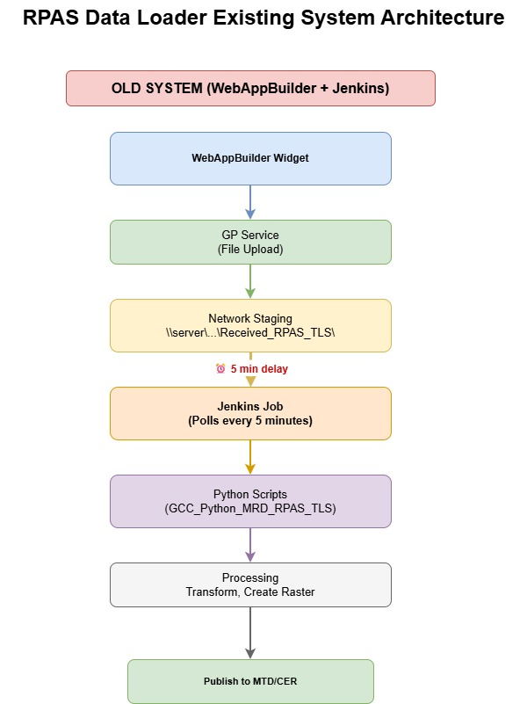
Key Systems:
- WebAppBuilder custom widget (frontend)
- Jenkins jobs (MRD - RPAS TLS Autorun)
- Python scripts (GCC_Python_MRD_RPAS_TLS)
- ArcGIS Geoprocessing Services
- Network file shares (staging locations), and SDE Mosaic Dataset (MTD)
- Central Elevation Repository (CER)

- Proposed Architecture
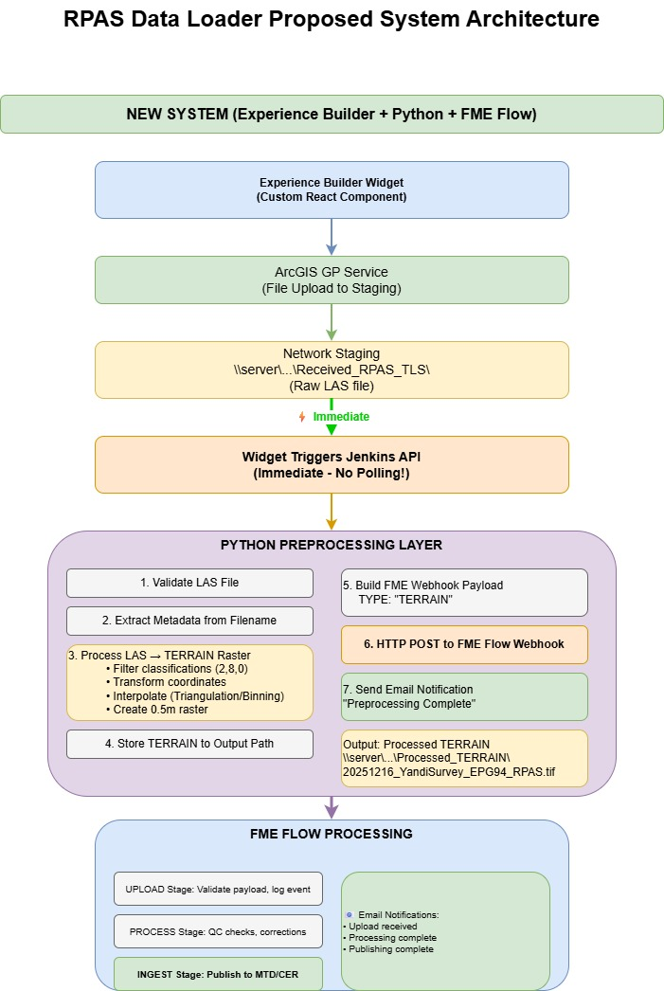
2.2 Technology Stack
Frontend:
- ArcGIS Experience Builder
- Custom React-based widget
- ArcGIS JavaScript API 4.x
- File upload component
Backend:
- FME Flow (replaces Jenkins + Python)
- ArcGIS Server (Geoprocessing Services)
- Network file shares (staging)
- SDE Database (MTD/CER)
Integration:
- RESTful webhook (HTTP POST)
- JSON payload
- Email notifications (SMTP)

3. Detailed Component Design
3.1 Experience Builder Custom Widget
3.1.1 Widget Structure
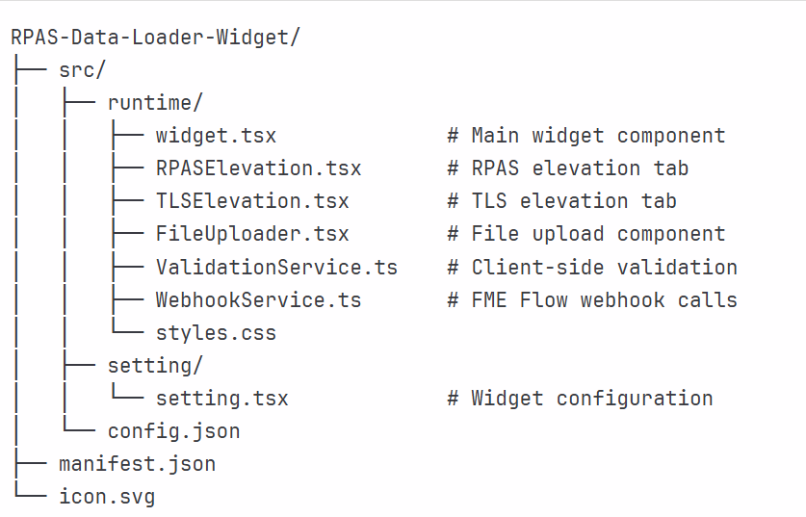
3.1.2 User Interface Components
Tab 1: RPAS Elevation and Tab 2: TLS Elevation
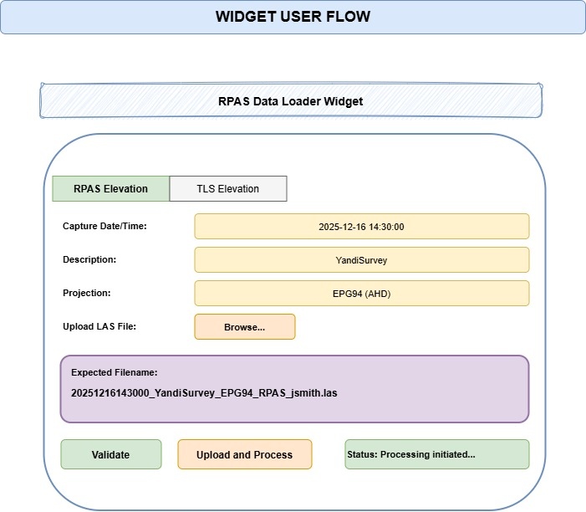
3.1.3 Validation Rules (Client-Side)
File Naming Convention:
interface FileNamingParams {
datetime: string; // YYYYMMDDhhmmss - 14 digits
description: string; // No spaces, alphanumeric, max 100 chars
projection: string; // From approved list
captureMethod: string; // RPAS or TLS
userId: string; // Valid company email prefix
}
// Naming pattern
const fileNamePattern = /^(\d{14})_([A-Za-z][A-Za-z0-9]{0,99})_(CPG94|EPG94|ER94|NP94|PHG94|WB94|YAN94|MGA50|MGA51)_(RPAS|TLS)_([a-zA-Z0-9]+)\.las$/;
Validation Checks:
- DateTime is valid 14-digit format
- DateTime is before current time
- Description contains no spaces or special characters
- Description starts with letter (not number)
- Description ≤ 100 characters
- Projection matches approved list
- Capture method is RPAS or TLS
- User ID matches current user
- File extension is .las
- File size is reasonable (< 5GB)
Approved Projections:
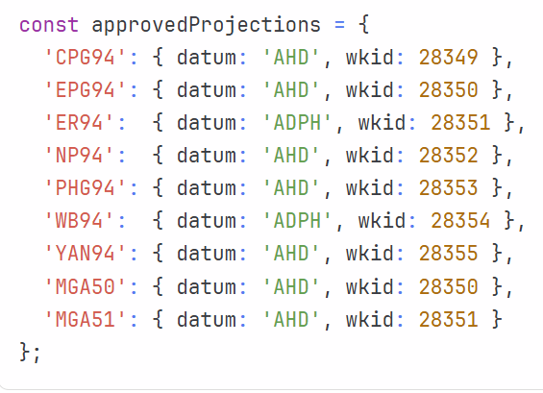

3.2 File Processing Workflow
3.2.1 Widget Processing Steps
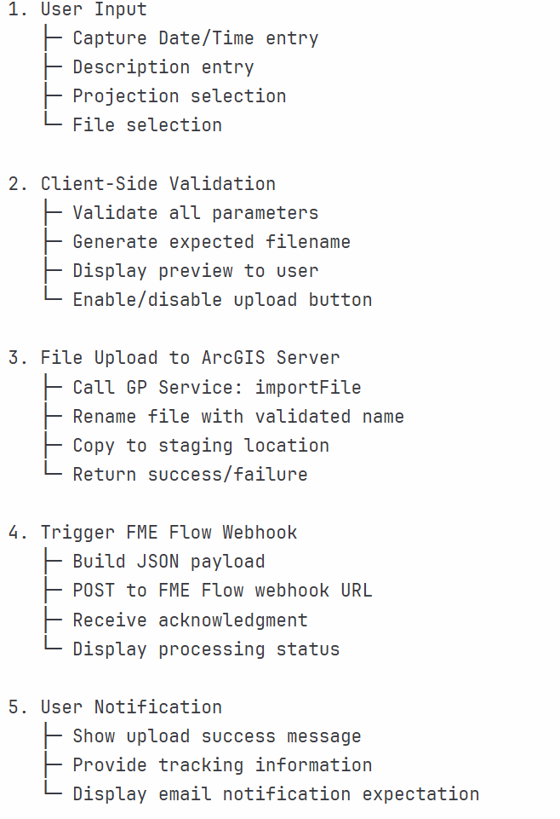
3.2.2 FME Flow Webhook Payload
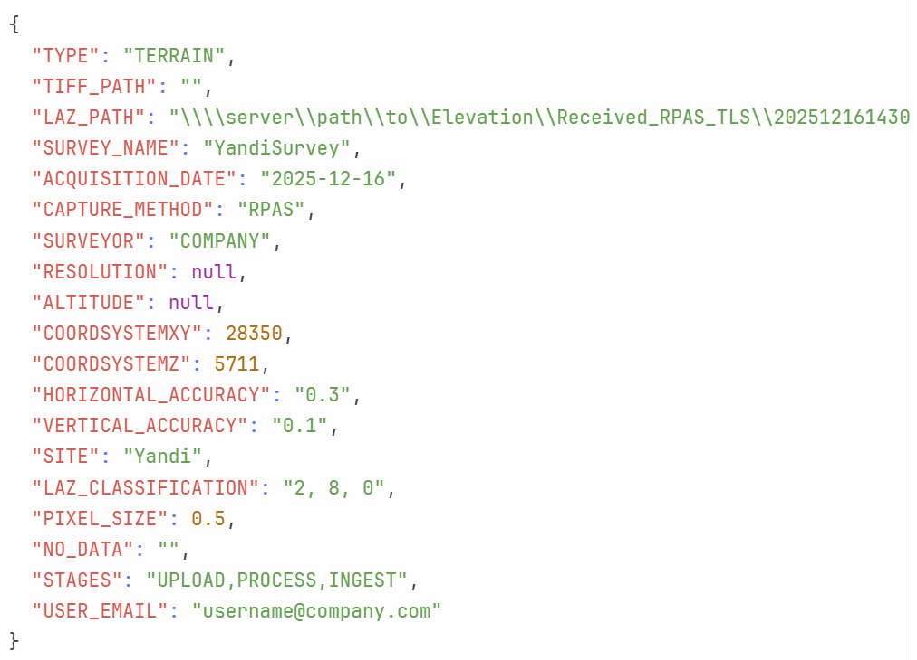
Field Mapping:
Widget Input | JSON Field | Notes
Capture DateTime | ACQUISITION_DATE | Convert to YYYY-MM-DD
Description | SURVEY_NAME | From filename
Projection | COORDSYSTEMXY | Map to WKID
Projection | COORDSYSTEMZ | Map height datum to WKID
Capture Method | CAPTURE_METHOD | RPAS or TLS → RPAS/Terrestrial Survey
User ID | USER_EMAIL | Append @company.com
File Path | LAZ_PATH | Full UNC path
- | SURVEYOR | Default: "BHP"
- | HORIZONTAL_ACCURACY | Default: "0.3"
- | VERTICAL_ACCURACY | Default: "0.1"
- | LAZ_CLASSIFICATION | Default: "2, 8, 0"
- | STAGES | Default: "UPLOAD,PROCESS,INGEST"

3.3 FME Flow Processing: ??
3.3.2 Error Handling
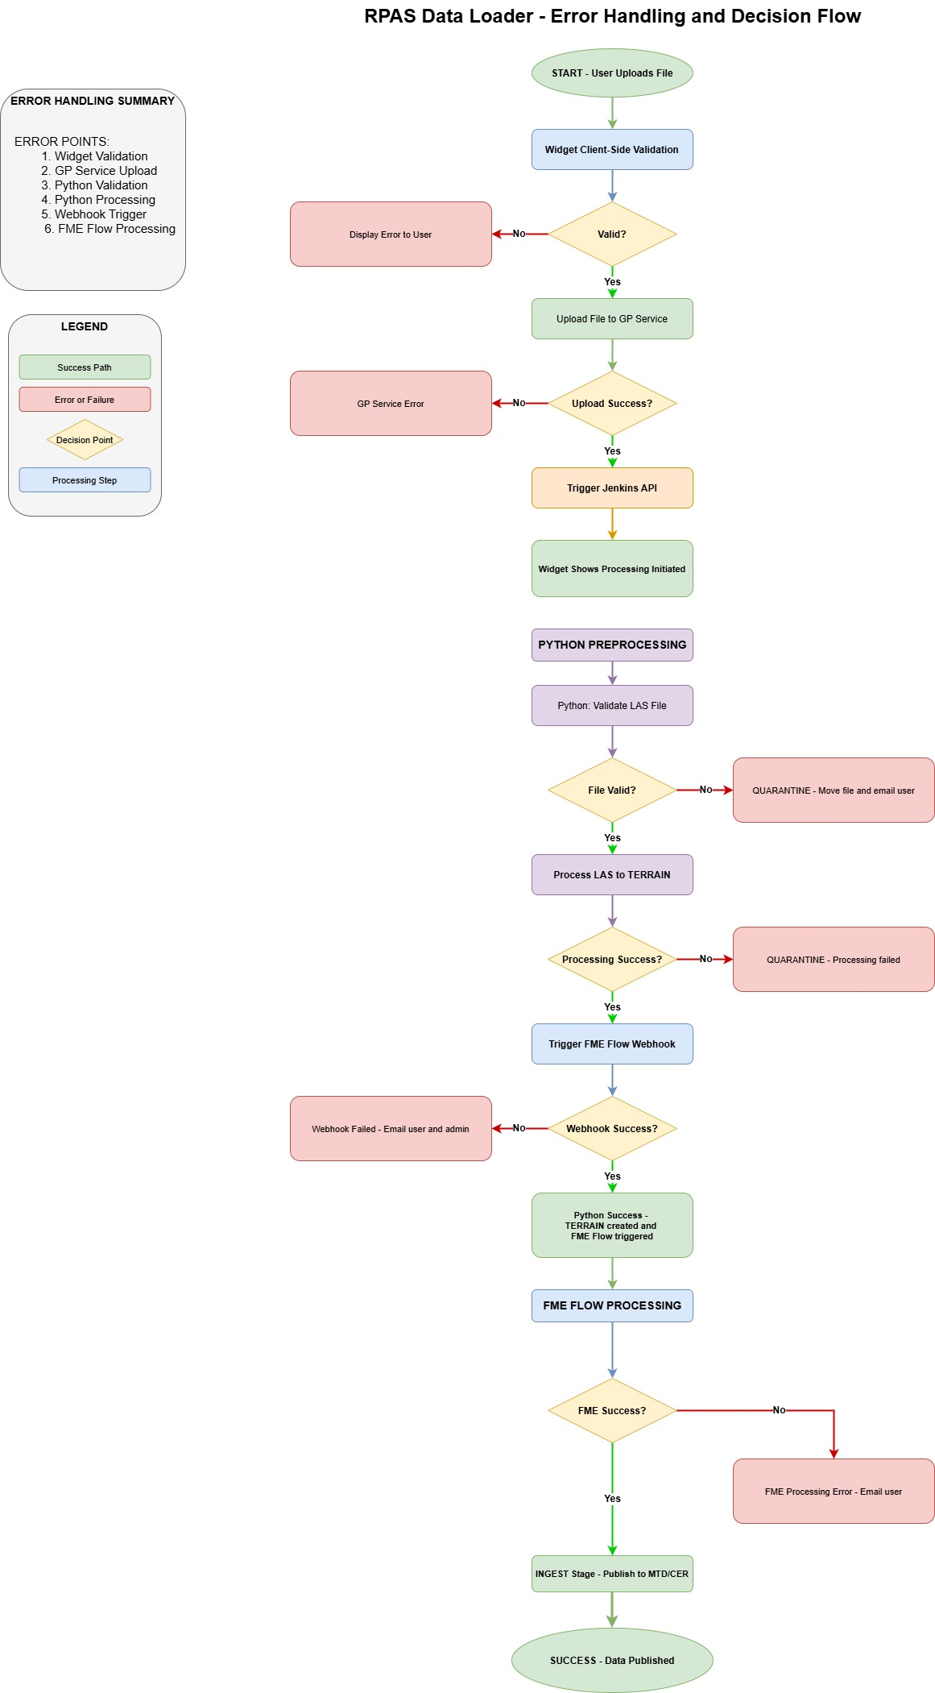
Appendices
Appendix A: Approved Projections Reference
Code | Name | Horizontal Datum | Vertical Datum | WKID | Z-WKID
CPG94 | Cape Lambert Grid 1994 | GDA94 | AHD | 28349 | 5711
EPG94 | Eastern Pilbara Grid 1994 | GDA94 | AHD | 28350 | 5711
ER94 | East Ridge 1994 | GDA94 | ADPH | 28351 | 5112
NP94 | Newman Point 1994 | GDA94 | AHD | 28352 | 5711
PHG94 | Port Hedland Grid 1994 | GDA94 | AHD | 28353 | 5711
WB94 | West Basin 1994 | GDA94 | ADPH | 28354 | 5112
YAN94 | Yandi Grid 1994 | GDA94 | AHD | 28355 | 5711
MGA50 | MGA Zone 50 | GDA94 | AHD | 28350 | 5711
MGA51 | MGA Zone 51 | GDA94 | AHD | 28351 | 5711

Appendix B: File Naming Examples
Valid Examples:
- 20251216143000_YandiSurvey_EPG94_RPAS_pathgi.las
- 20251201000000_W55BCracking_EPG94_TLS_pathgi.las
- 20250531235959_EastRidge2024_ER94_RPAS_pathgi.las
Invalid Examples:
- 2025-12-16_YandiSurvey_EPG94_RPAS_jsmith.las (wrong date format)
- 20251216143000_Yandi Survey_EPG94_RPAS_jsmith.las (space in description)
- 20251216143000_55YandiSurvey_EPG94_RPAS_jsmith.las (starts with number)
- 20251216143000_YandiSurvey_INVALID_RPAS_jsmith.las (invalid projection)

Appendix C: Email Notification Templates
Upload Success:
Subject: RPAS/TLS Upload Started - [SurveyName]
Dear [UserName],
Your RPAS/TLS survey file has been successfully uploaded and processing has begun.
Survey Details:
- Survey Name: [SurveyName]
- Capture Date: [AcquisitionDate]
- Capture Method: [CaptureMethod]
- Projection: [Projection]
File: [Filename]
You will receive additional notifications when processing is complete.

Regards,
WAIO Geomatics Team

Processing Success:
Subject: RPAS/TLS Processing Complete - [SurveyName]
Dear [UserName],
Your RPAS/TLS survey has been successfully processed.
Processing Results:
- Raster created: [OutputPath]
- Pixel size: [PixelSize]m
- Extent: [Extent]
- Statistics: [Statistics]
The data is now ready for publishing to the Master Terrain Dataset.
Regards,
WAIO Geomatics Team

Publishing Success:
Subject: MTD Publishing Complete - [SurveyName]
Dear [UserName],
Your RPAS/TLS survey has been successfully published to the Master Terrain Dataset.
MTD Details:
- Dataset: IO SDI PUBLISH.PLANNING.MTD
- Name: [Name]
- Acquisition Date: [AcquisitionDate]
- View in Web Map: [WebMapURL]
The data is now available for use in SDMA and other applications.

Regards,
WAIO Geomatics Team

Processing Failure:
Subject: RPAS/TLS Processing Failed - [SurveyName]
Dear [UserName],
Unfortunately, your RPAS/TLS survey processing has failed.
Error Details:
- File: [Filename]
- Error: [ErrorMessage]
- Quarantine Location: [QuarantinePath]

Please review the error and resubmit your file. If you need assistance,
contact WAIO Geomatics at geomatics@company.com.

Regards,
WAIO Geomatics Team

Document Control: Version: 1.0 Author: Girish Pathak
Date: December 16, 2025 Status: Draft for Review

