Sonarqube authentication Jenkins server

Step1: install sonar qube plug-in

Step2: geneate token in sonarqube ,

To generate token click on ADMin -🡪 click security, then generate token

Step3: Authentication of sonar qube token in Jenkins

For that click on credentials after that click on global

After that select credential type as “ secret text”

In that text give token details.

**Step4: manage Jenkins and configure system page**

In that section default is look this

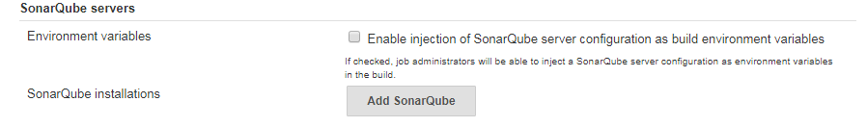

Click on Add SonarQube , then it will open the below screen

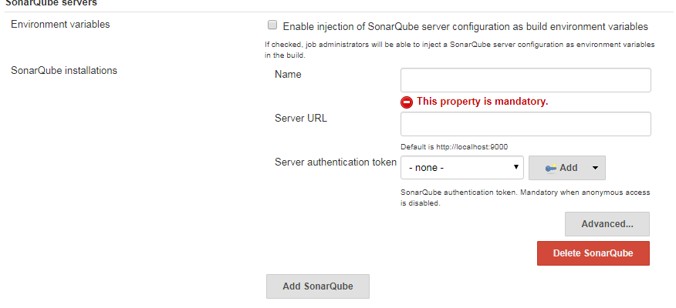

Note: That Image “ name” section is very important . why because of that what ever name passing in that field we have to tell that in JenkinsFile.

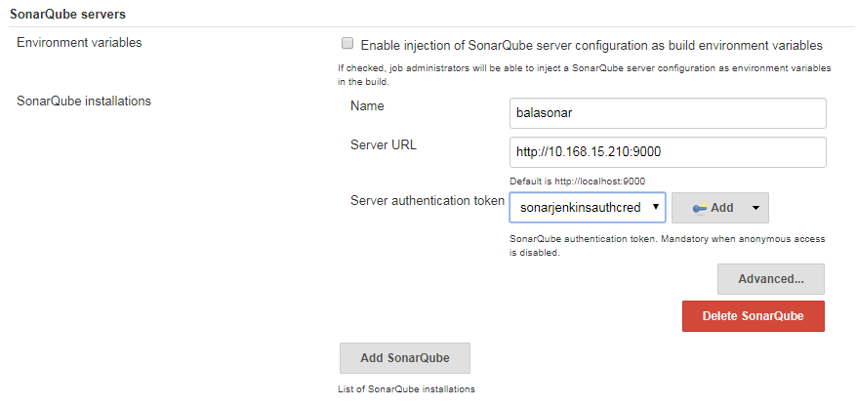

After that click on save.

Last step: create Jenkins job , type as pipeline.

In that pipeline script section tell jenkisnfile look like below content

node {

stage('SCM') {

git 'https://github.com/spring-projects/spring-petclinic.git'

}

stage ('build the packages') {

sh 'mvn package'

}

stage('SonarQube analysis') {

// performing sonarqube analysis with "withSonarQubeENV(<Name of Server configured in Jenkins>)"

withSonarQubeEnv('balasonar') {

// requires SonarQube Scanner for Maven 3.2+

sh 'mvn org.sonarsource.scanner.maven:sonar-maven-plugin:3.2:sonar'

}

}

}

The above Jenkins file is also available in the below link

<https://github.com/BALABHASKARARAO/Sonarqube/blob/master/jenkinsfileForSonarpush>