Anushka – Day to Day progress
3-5-26

Category-wise Sales Performance

category_sales = df.groupby('category')['total_sales'].sum()
plt.figure(figsize=(8,5))
category_sales.plot(kind='bar')
plt.title("Sales by Product Category")
plt.xlabel("Category")
plt.ylabel("Total Sales")
plt.show()
OUTPUT:
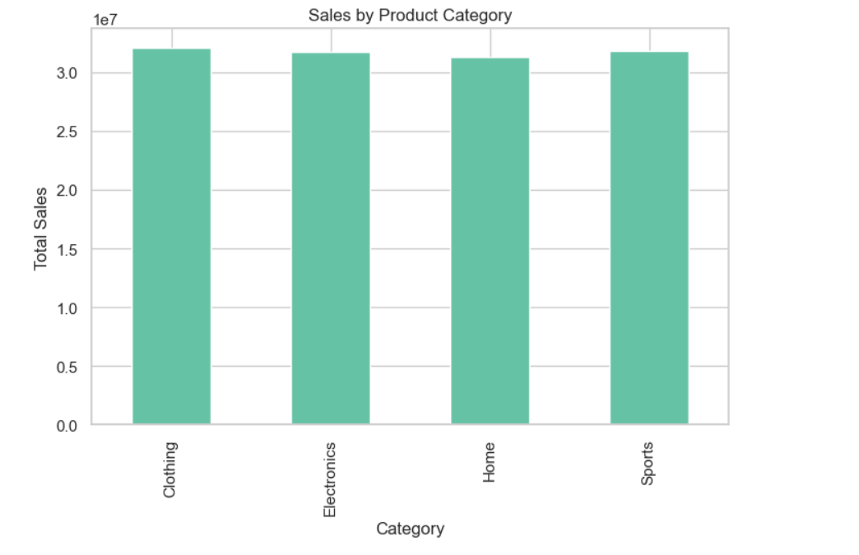
Order Value Distribution

plt.figure(figsize=(8,5))
plt.hist(df['total_sales'], bins=30)
plt.title("Distribution of Order Value")
plt.xlabel("Order Value")
plt.ylabel("Frequency")
plt.show()

Output
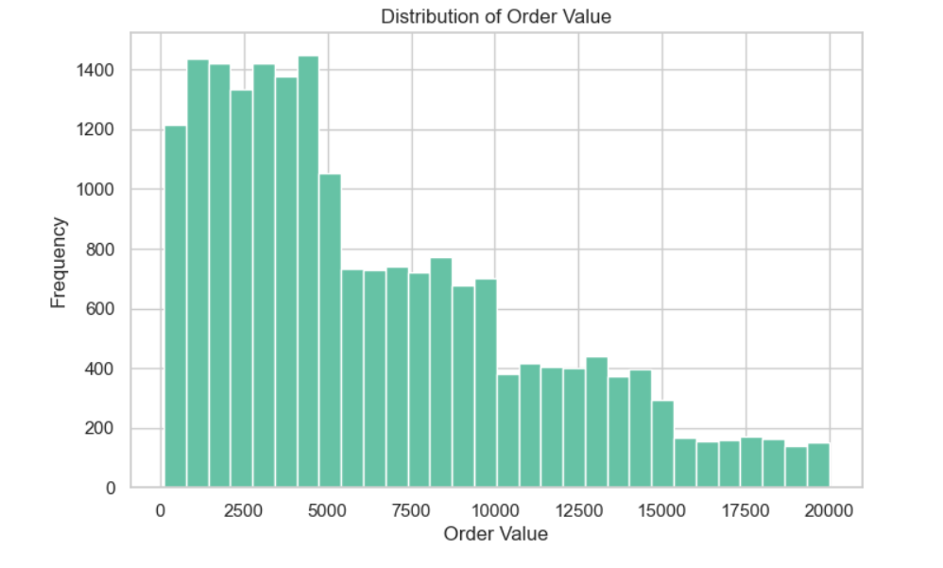
Top 10 Customers by Spending
top_customers = df.groupby('customer_id')['total_sales'] \
.sum().sort_values(ascending=False).head(10)

plt.figure(figsize=(10,5))
top_customers.plot(kind='bar')
plt.title("Top 10 Customers by Total Spending")
plt.xlabel("Customer ID")
plt.ylabel("Total Sales")
plt.xticks(rotation=45)
plt.show()

output:
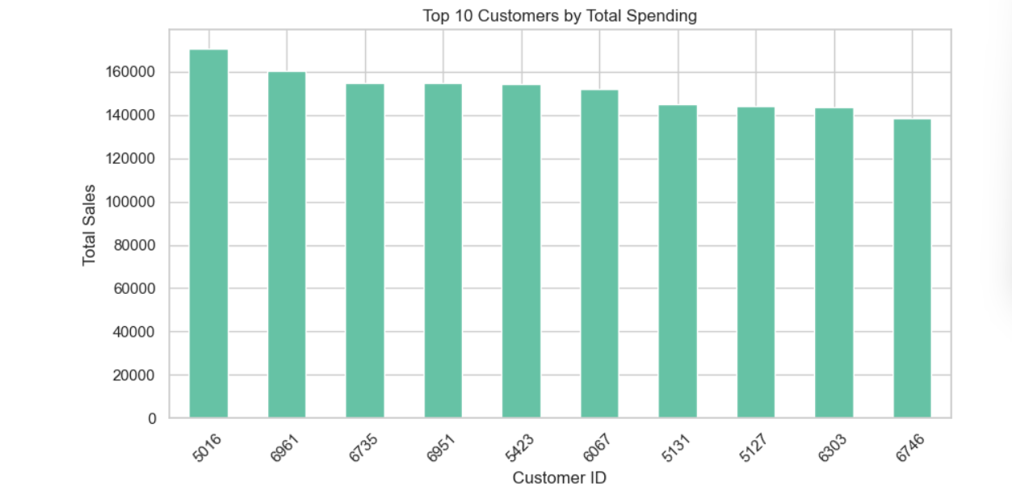
Quantity vs Total Sales (Scatter Plot)

plt.figure(figsize=(8,5))
plt.scatter(df['quantity'], df['total_sales'])
plt.title("Quantity vs Total Sales")
plt.xlabel("Quantity Sold")
plt.ylabel("Total Sales")
plt.show()
output:
