RETAIL ANALYSIS
Week 1: Initial EDA
- Sales distribution analysis
  - Used the cleaned dataset given by one of my teammates
  - Analyzed the sales distribution using Histogram to know on which side the data lies.
  - I used matplotlib initially to build the chart and later used seaborn to make the visuals more elegant so that the insights can be seen better.
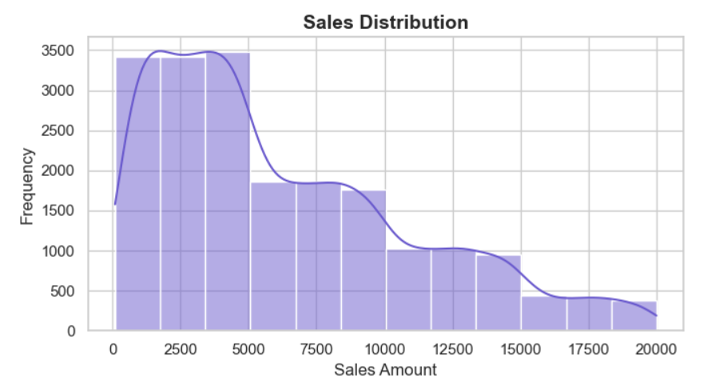
- Channel-wise sales comparison
  - According to the dataset there are three categories in sales channel i.e., App, Online and Store.
  - The bar chart shows us the sales per channel and we can conclude that all three channels have almost similar sales.
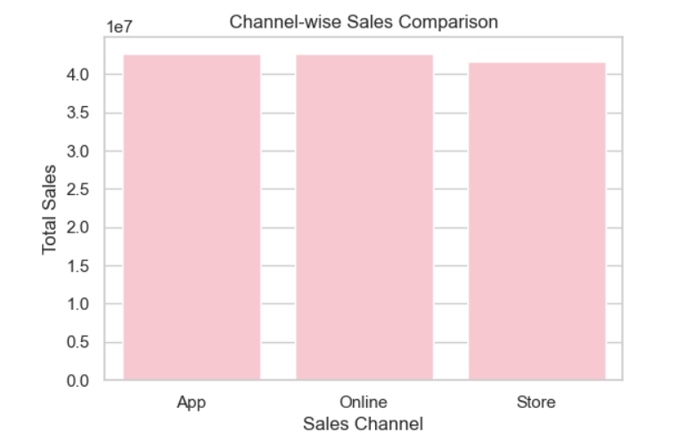
- Order frequency analysis
  - This visual is similar to the above, but it tells us the frequency of each channel rather than sales.
  - The frequency here represents the number of orders per channel.
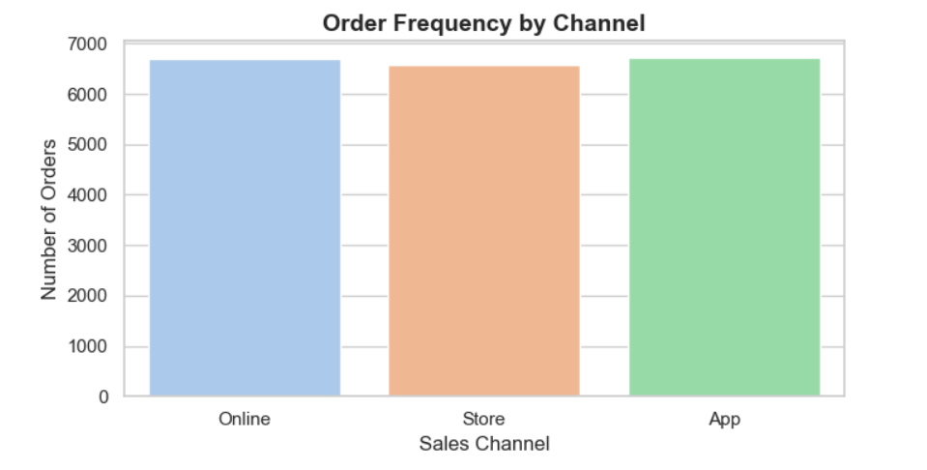
Week 2: Trend & Category Analysis
- Monthly & yearly sales trends
  - In this dataset, the data is provided from the year 2022 to 2024.
  - The maximum number of sales are from April, 2024.
  - The minimum number of sales are from February, 2022.
  - This analysis helps us understand the trends better and make accurate predictions of what to sell in the future.
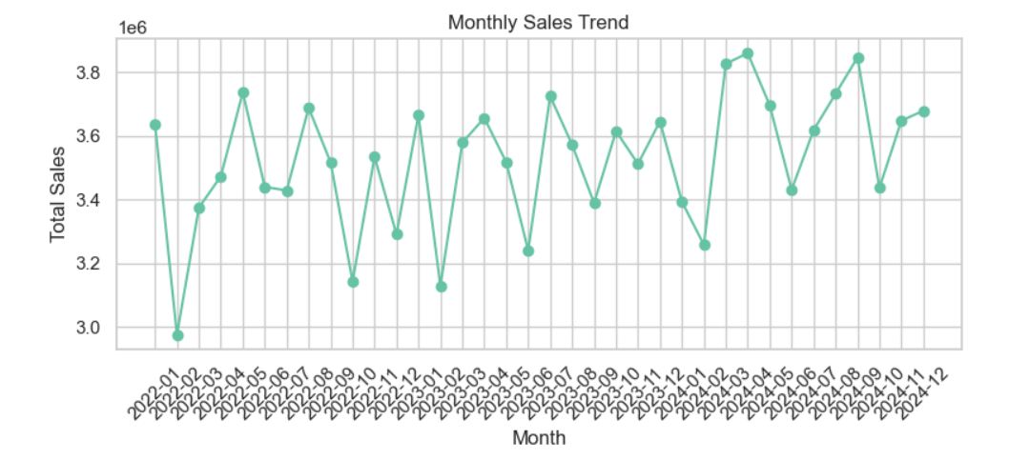
- Product category performance
  - It is a simple pie chart that shows the percentage per category.
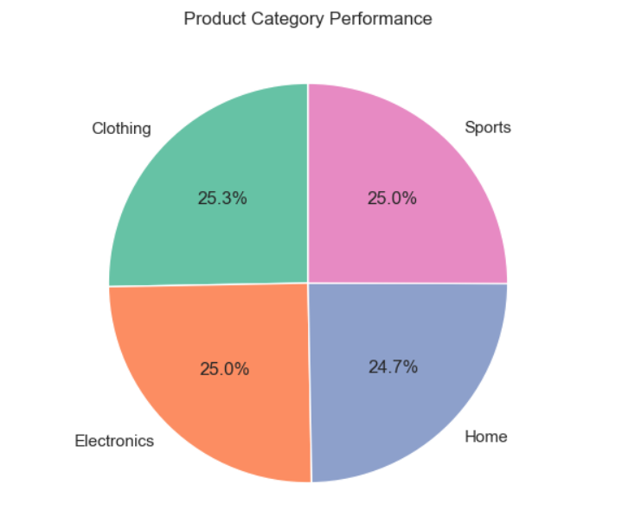
- City-wise sales comparison
  - This horizontal bar graph shows us the highest sales per city.
  - Mumbai has the maximum number of sales.
  - And Delhi has the minimum number of sales.
  - This chart helps us analyze the number of sales and plan the production accordingly in the near future.
