## ***Wentworth Institute of Technology***

## ***Comp650***

## ***Senior Project in Computer Science***

## ***Summer 2010***

## ***Final Project Design Specification***

# Group Members

## Gregory LeBlanc

## Norman Maclennan

## Stephen Failla

# Project Title

## Athena

# Date of Submission

## Monday, July 12, 2010

# Summary of Proposal

## The primary purpose of Athena is to provide a secure and powerful instant messaging tool to both personal and business clients, largely to preserve the quality and integrity of transmission and exchange of data. While the standard Athena framework has been developed and implemented in Version 1.0 released in the spring of 2010, Athena’s engineers have several important features to add to the initial design. Due to Athena’s emphasis on professional business communication, the ability to have encrypted group chat sessions will be implemented in the next version. Also, the ability to encrypt and transfer data files and/or images to online clients via the secure server will also be implemented in the new version.

## In addition to these major requirements, the interface and visual configuration of Athena will be improved, and data encryption, transfer, and reliability will be made more efficient and streamline. Real-time client status updates will be added to the contact list, and several UI enhancements will be made throughout the development stage of the next version. Also, additional user preferences may be added to the next version as well, pending future agreement between Athena engineers on the discussion of requirement priority within the Preference Interface. No instant messaging application available today has the dynamic blend of user functionality and personalization combined with powerful data security that Athena will have upon its next version release.

## No changes to the original proposal for Athena have been made. All research and analysis for the Athena 1.1 design can be referenced in the Software Specification for Athena 1.1.

# Summary of Design

### Description of Components

## The following components will be inherited from the initial version of Athena. All features and implemented changes for the Athena 1.1 design will be subordinate components of the following fundamental components:

## Front End User Interface

## Database

## Internal Methods

## The requirements specified for Athena 1.1 will be subordinate components of one or more of these fundamental structures. For example, the Group Chat Interface will be a subordinate component of the Communication Interface, which is a fundamental architecture of the front end user interface. The group chat interface will also contain detailed internal methodology relating to AES encryption that will be a series of subordinate modules of the internal methods design structure.

## AES encryption will be a subordinate component of the internal methods for Athena, as an addition to the RSA encryption discussed and described in Athena 1.0. The AES encryption methodology will allow the group chat interface function more efficiently between users, allowing for faster data encryption and decryption, and a higher level of security in group chat rooms. The AES encryption will also be implemented in file and image transfer when it becomes an active component of Athena 1.1.

## All other specified components will follow this structure as outline and described in the initial version of Athena. The idea of a single window interface and a collection of essential software architectures is the core of Athena design, and the components discussed for development in Athena 1.1 will follow this established design method.

### Description of Data Structures

## Athena will utilize Java’s hash table data structures to store key value data pairs. This will allow the server to correctly identify the socket, data stream, and availability corresponding to a specific user name. The Java socket structure will be used primarily for inter-computer communication, using Java’s *DataOutputStream* class to transfer user message data through a particular socket. More information on the use of this class is explained in the comments for source code for the software.

## The software will integrate a single database to store user account information. All other information generated by users will be temporary and dynamically linked to active communication sessions. When a session is terminated by a user, all account-unrelated information will be terminated.

### Description of Algorithms

## All internal methods and functions responsible for data structure and component manipulation can be referenced in detail in the Java source code documentation for the software. All algorithms used for Athena 1.1 are inherited from the initial version of the software. Any new methodology documentation will be part of the source code package that can be referenced on the Athena web site.

### Interface Design

## Much of the interface design for Athena 1.1 will be inherited from Athena 1.0. Because all new design requirements in the proposal for Athena 1.1 are subordinate components, they can be implemented on top of Athena’s current fundamental system structures:

## Communication Interface

## Preferences Interface

## Communication Interface Menu

## The communication interface will have appropriate aesthetic changes corresponding to new components. New subordinate windows will be added to the interface window structure of Athena 1.0. Detailed interface design can be referenced in the Interface Views section of this document.

# Review of Project Plan

## No changes to the design plan for Athena 1.1 have been made at this time. All requirements are on schedule unless otherwise specified.

# Data Structure Relationship Diagram

## 

# Component Class Diagram



# Interface Views

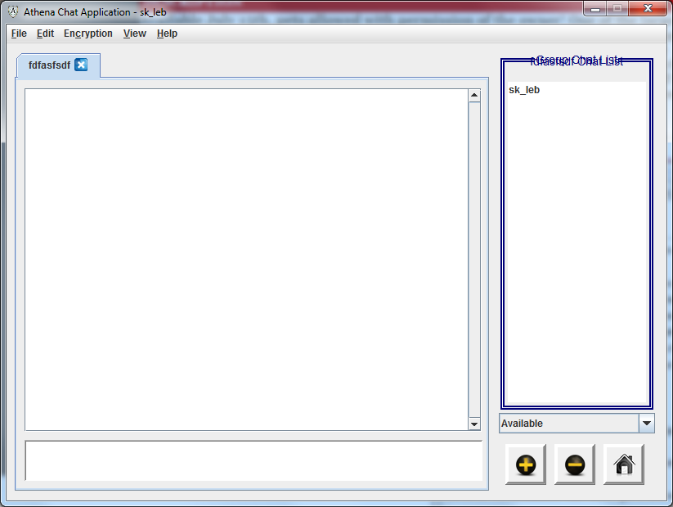

*Figure A:*

*Group Chat Interface window with group chat contact list*

*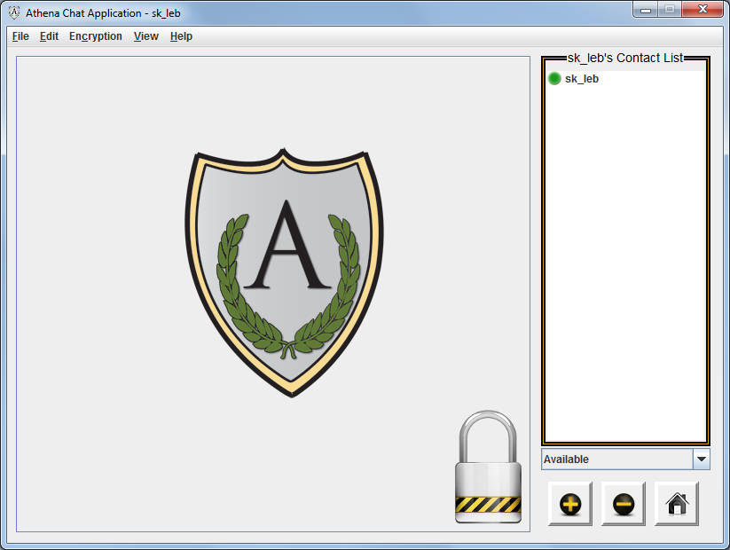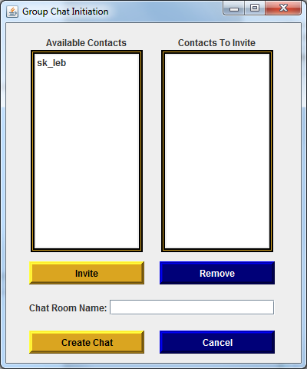Figure B: Communication Interface with Home List button Figure C: Group Chat Initiation Setup Interface*