|  |  |
| --- | --- |
| QP CODE: | Q0701 |
| QP TITLE: | Analyst |

|  |
| --- |
| OVERVIEW |

|  |  |
| --- | --- |
| Test Duration | 140 minutes |
| Duration - SSC/N0701 | 140 minutes |
| Duration - SSC/N0702 |
| Duration - SSC/N0703 |
| Duration - SSC/N9001 |
| Duration – SSC/N9002 |
| Duration – SSC/N9003 |
| Duration – SSC/N9004 |
| Duration – SSC/N9005 |
| Natural Language Options | English (Single language assessment at a time)  Can be translated to vernacular languages as well. |
| Distribution of Marks | As mentioned in the Qualification Pack |
| Pass Criteria | To be finalized |
| Technology tools / Platforms Tested (Mandatory) | |
| 1. NA |  |
|  |  |
| Technology tools / Platforms Tested (Select any one) | |
| 1. NA |  |
|  |  |
| Infrastructure Requirements | As per standard list provided to Assessment Centers |
| QP Specific Infrastructure Requirements (if any) – Not Applicable specific to QP | |
|  |  |

|  |
| --- |
| SAMPLE QUESTIONS |

SSC/N0701 (Support requirements and As-Is analyses for IT projects)

Q1. Type: Theory (Basic knowledge of role and responsibilities); PC Tested: PC 1; Level: Easy

In order to understand the working of an organization for which a ERP system is being designed, an analyst must:

A. Look at only current work and document flow in the organization

B. Take inputs on requirements from top level and middle level management only

C. Interview Top management, Middle management, Line managers as well as clerks who will enter data and use the system

D. Take inputs only from clerical and middle level staff who have long experience in the organization and will be users of the system

Correct Answer: C

Q2: Type: Theory(UML diagram); PC Tested: PC 3; Level: Difficult

Murli has designed an activity diagram of the Railway Reservation System. The diagram has three actors Requestor, Booking Clerk and Bank Payment. The activity performed by each of the actor is as below  
i) Requestor – Submits the reservation form  
ii) Booking Clerk:”  
a. Checks train and class entered by the requestor  
b. Checks Availability of the seats  
c. Checks the waiting list in case the seats are not available  
d. Confirms seat and provides the list to the user  
e. Updates the list of seats available

iii) Bank Payment – Facilitates payment in case of confirmed and waitlisted seats

However, the diagram given above has a missing condition. Identify the missing condition from the following list of conditions.

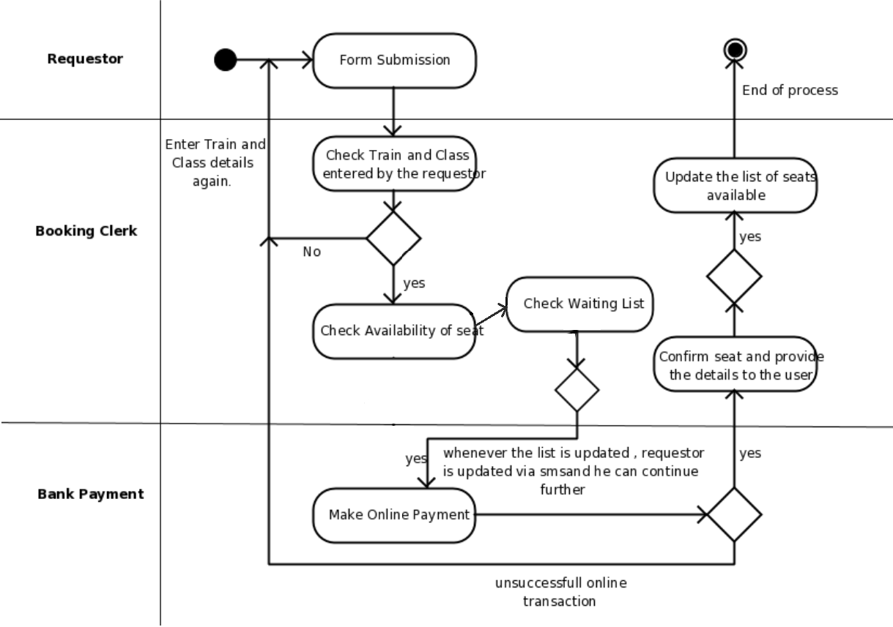  
A. If the payment fails – Mark the transaction as unsuccessful

B. If a seat is reserved – Update the list of available seats

C. If the seats are available - Redirect to the online payment page

D. If the train and class is not present – Re-enter the train and class details again

Correct Answer: C

Q3. Type: Skill (Situation judgement); PC Tested: PC 5; Level: Moderate

Suppose a seller of a used product sells his product to a buyer and puts into the contract of sale the statement: "The buyer accepts the product AS IS, WITH ALL FAULTS." In which of the following As-Is situations, the buyer may get the refund from the seller?

1. If the buyer can show that there was some fraud involved

2. If there is a promised warranty period and seller is trying to breach it

3. If there is a feature missing in the product that the buyer expected it to have

Options:

A: 1, 2 and 3

B: Only 2

C: Both 1 and 2

D: Both 1 and 3

Correct Answer: C

Q4: Type: Skill (Sequence Diagram) PC Tested: PC6 Level: Moderate

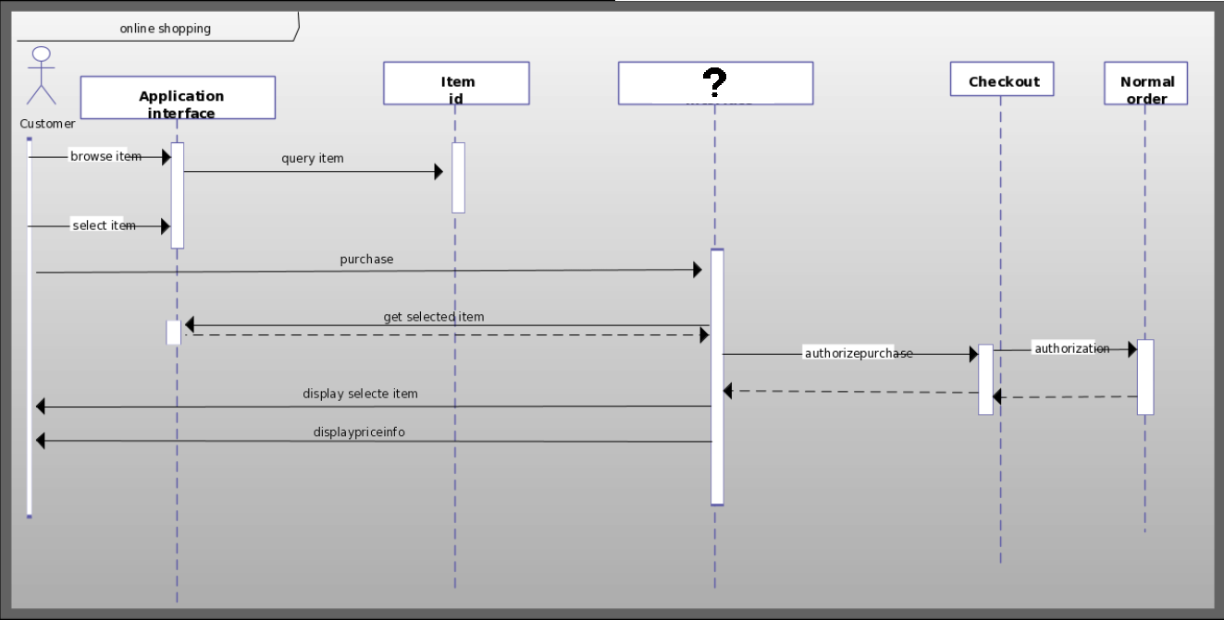Consider the below sequence diagram of an online shopping process. Which of the following interfaces can be placed in the blank object box to mark the completion of all the sequences of the process?

A. Authorization Interface

B. Payment Interface

C. Delivery Interface

D. Order Tracking Interface

Correct Answer: B

Q5. Type: Skill(SDLC Model); PC Tested: PC 7; Level: Easy

An iterative process of system development in which requirements are converted to a working system that is continually revised through close work between an analyst and user is called

A. Waterfall modelling

B. Iterative modelling

C. Spiral modelling

D. None of the mentioned options

Correct Answer: C

Q6. Type: Skill(UML diagram); PC Tested: PC 8; Level: Moderate

Consider the following situation:   
A company realizes IT projects and each such project is executed by a team of employees.   
Which of the following would be a suitable conceptual UML diagram for the given situation?

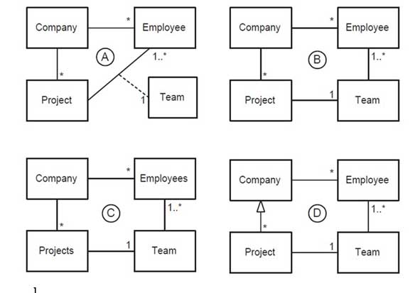

A. Diagram A

B. Diagram B

C. Diagram C

D. Diagram D

Correct answer: B

Q7. Type: Skill (As-Is analysis); PC Tested: PC 10; Level: Easy  
Question: Which of the following statements is true regarding “Buyer beware” situation?

A: It is a legal term used to disclaim some implied warranties for an item being sold

B: It is the situation where the buyer refuses to accept the product of the seller without any agreement

C: It is the situation where the buyer should take the time to examine the item before accepting it, or obtain expert advice

D: It is the situation where the buyer is claiming the refund because the product is covered under the seller's warranty

Correct Answer: C

SSC/N0702 (Support preparation of To-Be situations and roadmaps for IT projects)

Q1. Type: Theory PC Tested: PC 1; Level: Easy

An IT analyst uses CASE (Computer Aided Software Engineering) Tools while working on a project in his organization. Which of the following options do you think, are the reasons behind using CASE tools?

i)Improve productivity of their software engineers.

ii)Reduce time to develop applications

iii)Improve documentation

iv)Automate system analysis

A. i and ii

B. i and iii

C. i, ii, and iii

D. ii and ii

Correct Answer: C

Q2. Type: Skill (Requirement Categorization); PC Tested: PC 2; Level: Easy

Sameer has designed SDLC- V model for the development of a product. In the figure below identify the processes A and B to complete the development life cycle.

1. A – Validation, B – Verification
2. A – Verification, B – Validation
3. A – Verification, B – Verification
4. A – Validation, B – Validation

Correct Answer: B

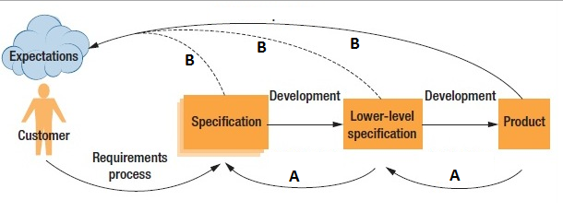

Q3. Type: Skill(Use Case Diagram) PC Tested: PC 3; Level: Moderate

Consider the scenario of Financial Trading Management System. In an ideal Financial Trading Management system, four actors are responsible for different Use cases.

* Trading Manager (Sets limits to transactions)
* Accounting System (Updates accounts)
* Trader (Analyses risks, Deals with pricing and captures deals)
* Salesperson (finally sells the product as per the pricing set by the Trader).

Out of the below four diagrams, which is the accurate Use case representation of Financial Trading Management System?

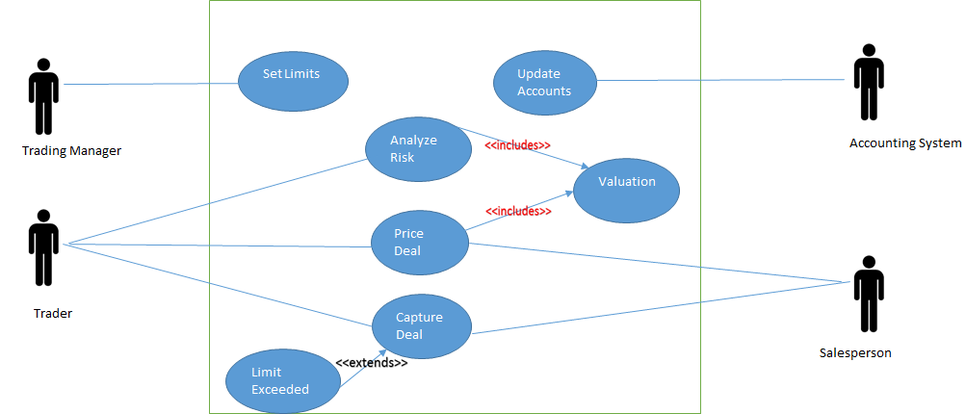A.

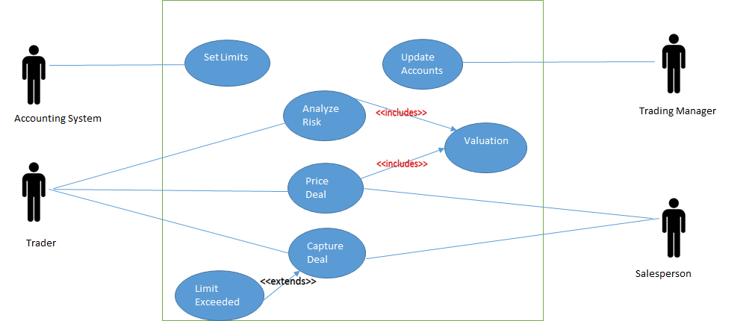B.

C. 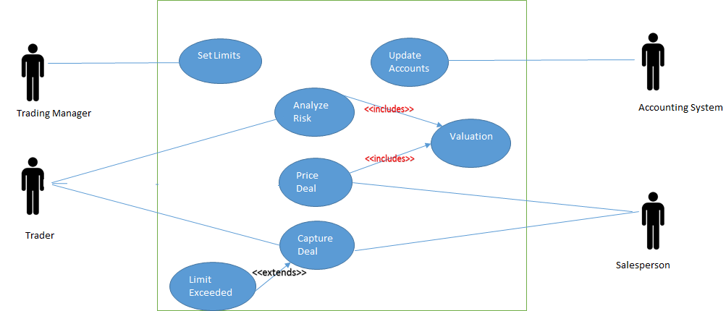

D. 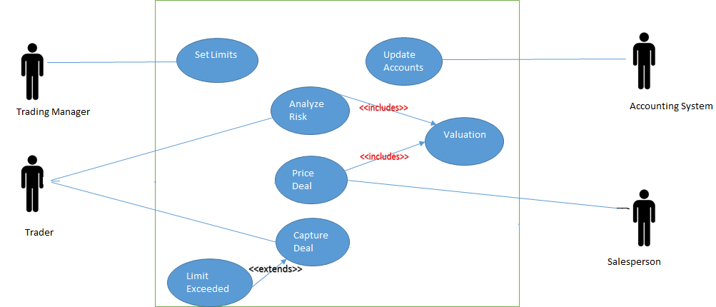

Correct Option: A

Q4 Type: Skill (State Charts) PC Tested: PC 4; Level: Difficult

Nikhil is trying to capture the dynamic behaviour of an Order Management System and makes a State Chart diagram of the system. Which among the following is the correct representation of State Chart diagram of an Order management system?

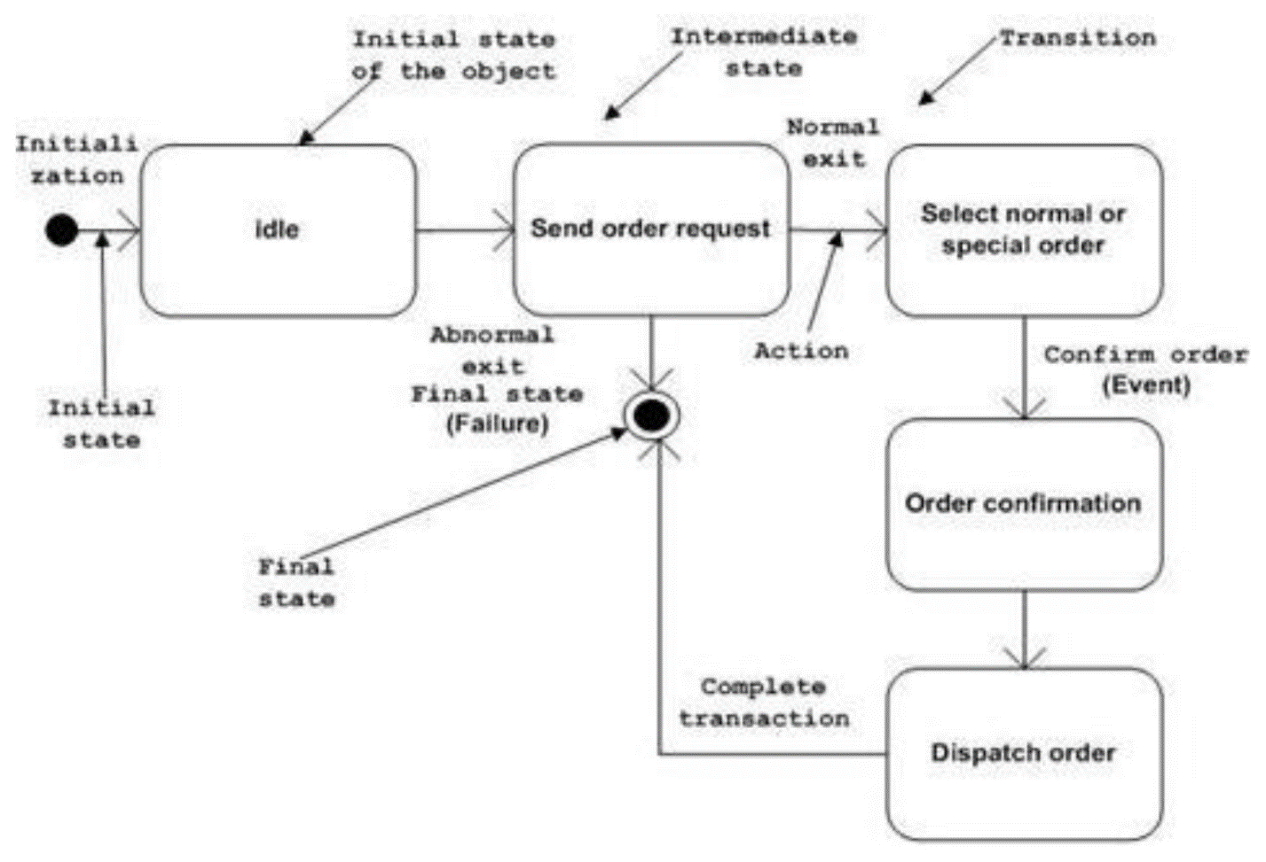A.

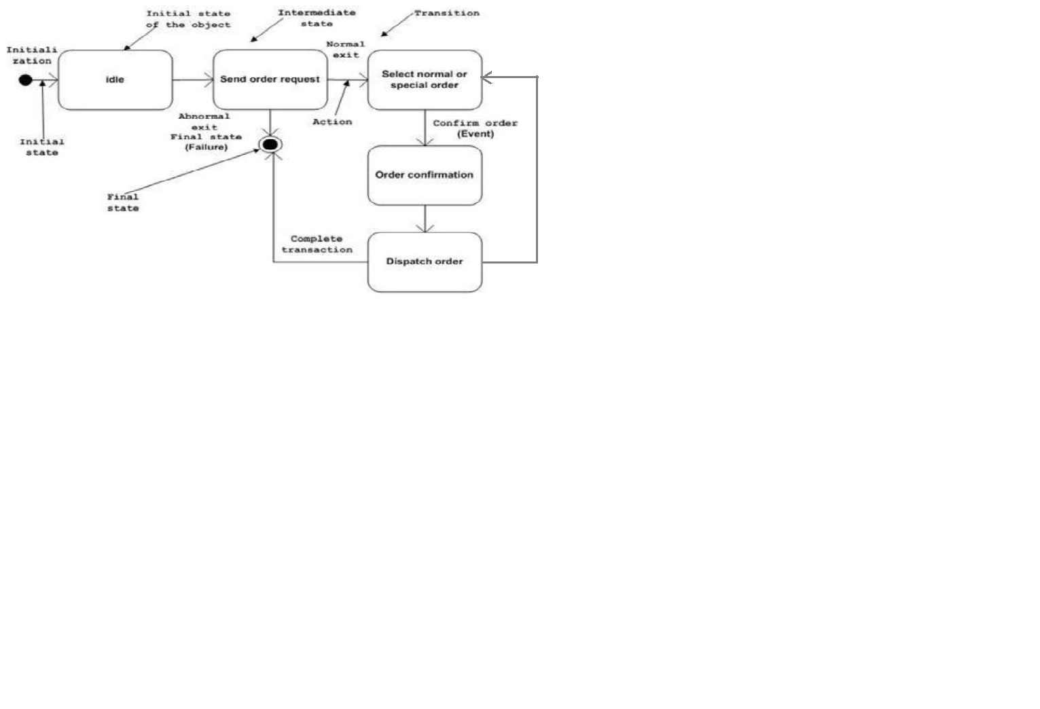B.

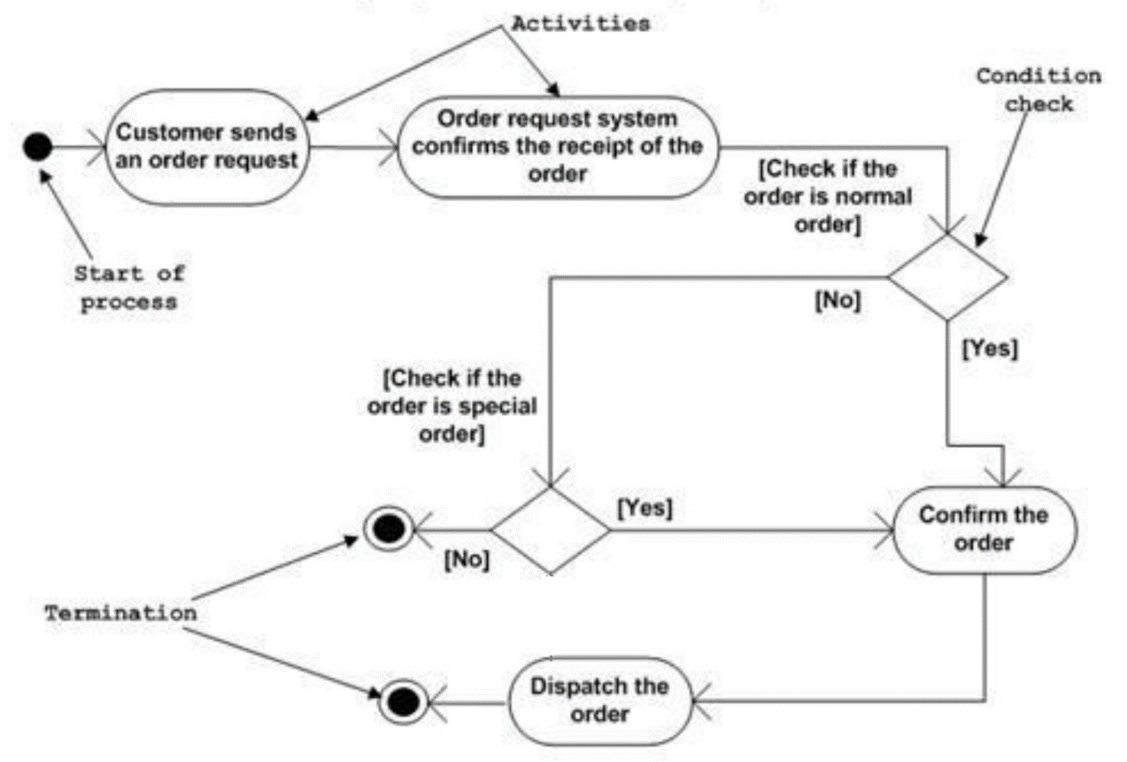C.

D.

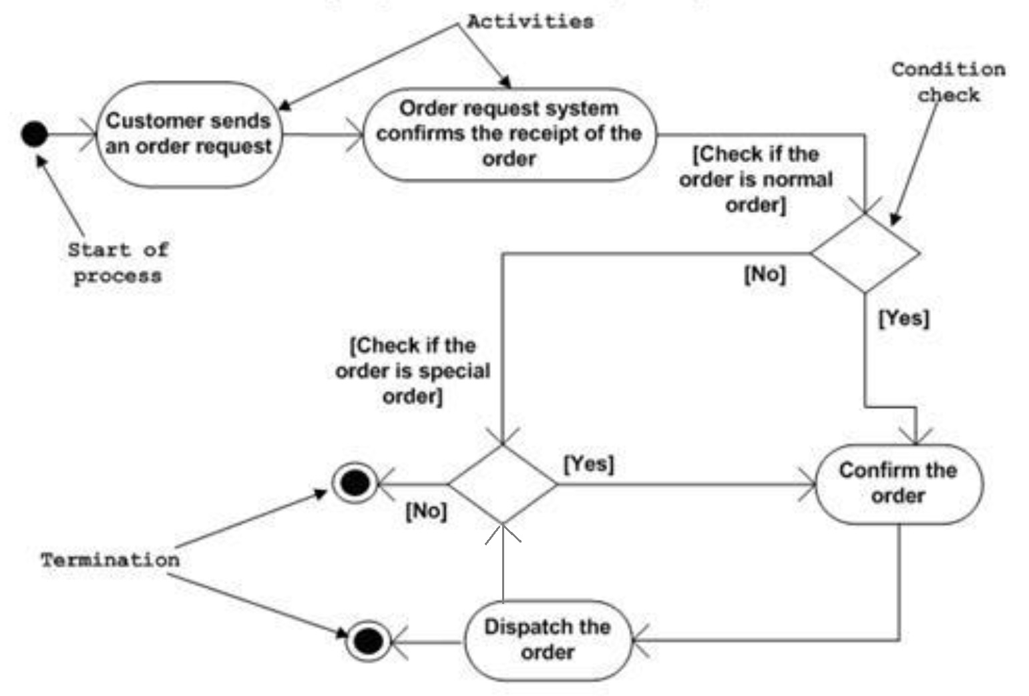

Correct Answer: A

Q5. Type: Theory (To-Be situations); PC Tested: PC 5; Level: Easy

Question: “Product Details” page of an e-commerce website contains the information about the products, their features and the customer feedback about the product. Which of the following permissions can be given to the customer to make the website more useful?

A: Customer should be given the permissions to edit their comments anytime

B: Customer should be given the permissions to remove the comment of another customer

C: Customer should be given the permissions to add and delete any product from the website

D: Customer should be given the permissions to update the product cost in the website

Correct Answer: A

Q6. Type: Skill (Situation judgement); PC Tested: PC 6; Level: Moderate

Question: What login features are appropriate to implement if a client needs a website structure that requires both “administrators” and “customers” to log into the website?

1. Assigning different links for admins and customers to log into the website. [Eg: www.abc.com/adminlogin.php and www.abc.com/customerlogin.php]

2. Having two different buttons on the home page which will open two different login pages for the admins and the customers.

3. Developing a single login page by which the customers and the admins can log into the website with different credentials.

A: Only 3

B: Only 1 and 2

C: All 1, 2 and 3

D: Only 2 and 3

Correct Answer: C

Q 7. Type: Theory (Flowcharts) PC Tested: PC7 Level: Easy

Recruitment process of an organization is represented with the help of the following Flow Chart Diagram. In the recruitment process, after the applications are received, the applicants are split into List **A** and List **B**. Which according to you is the most appropriate categorization of A and B?

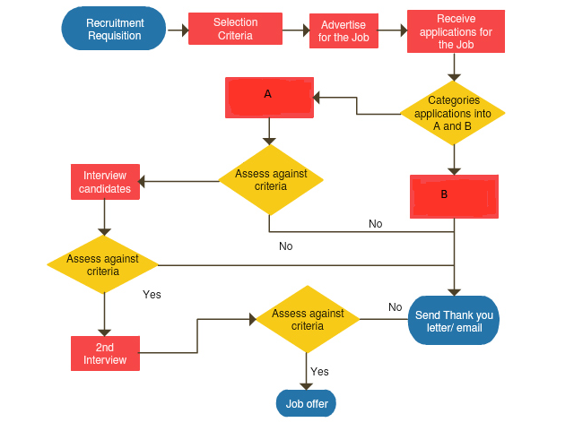

A. List A: Candidates suitable for Job, List B: Candidates not suitable for Job  
B. List A: Candidates not suitable for Job, List B: Candidates suitable for Job  
C. List A and List B: Candidates suitable for Job  
D. List A and List B: Candidates not suitable for Job

Correct Answer: A

SSC/N0703 (Create documents for knowledge sharing)

Q1. Type: Skill PC Tested: PC2 Level: Easy

Being an employee of an organization, you are asked to document the process of vendor payments in the company that involves information and document flow across several teams. For getting information on all such transactions for creating the document, you should:

Ops. A. Search online for information related to the company’s processes

B. Access existing documents by requesting appropriate permissions

C. Ask your colleagues for relevant documents

D. Use best estimations and approximations to create information you don’t have.

Correct answer: B

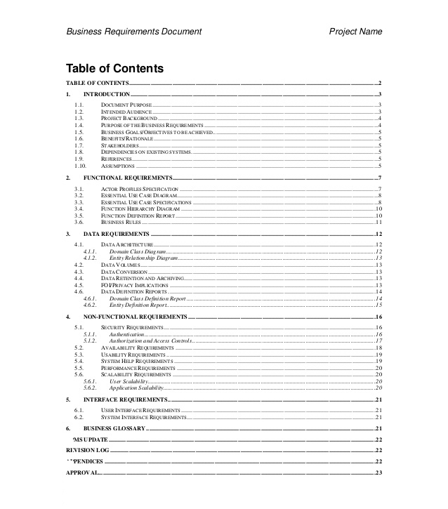Q2. Type: Skill PC Tested: PC4 Level: Moderate  
Consider the sample table of contents from a Business Requirement Document. There is an error in the table, choose the most suitable option from the below list that best describes the error?

A. Foreword is not present

B. Project Scope is not present

C. Literature Review is not present

D. No error, table is complete

Correct answer: B

Q3. Type: Skill PC Tested: PC5 Level: Moderate

Kartik is working on a product requirement from a large Indian bank and he needs to record and track the relationship of the project requirements to the design, documentation, development, testing and release of the product. Choose the most useful document from the list of documents that will solve Kartik’s problem?

A. Functional Requirement Specification Document

B. Feasibility Study Document

C. Project Proposal Document

D. Requirement Traceability Matrix

Correct answer: D

Q4. Type: Skill (MS Word) PC Tested: PC5 Level: Easy

Consider the following snapshot of the Font and Formatting Toolbar in Microsoft Word. Which of the following tools, highlighted in numbered Red Boxes, is used for text indentation.



1. 1
2. 2
3. 3
4. 4

Correct Answer: D

Q5. Type: Skill PC Tested: PC6 Level: Easy

While developing a knowledge sharing document, an analyst should have access to:

I. Pre-defined organizational templates

II. Reliable resources documenting organizational processes and guidelines

III. Utility tools required for process documentation and flowcharting

IV. Confidential documents including customer contracts

1. All of the mentioned options
2. I, II & IV only
3. II & III only
4. I, II and III only

Correct answer: D

Q6. Type: Theory PC Tested: PC8 Level: Moderate

Department of Computer Science in a popular Indian Engineering College has floated a project proposal to replace the computer server installed in the department. Below is an excerpt from the project proposal document. Identify the most suitable section head from the below list of sections for these statements?

*“The server is used by the Computer Science department to support both its research and its teaching activities. It is used by researchers to track, record, and analyze data on various facets of software life cycle. All students in the department are taught how to use the software and many of their assignments are required to be done using this server.”*

A. Risk Management Plan

B. Desired Impact and Project Outcome

C. Background/Situation Analysis

D. Project Objectives

Correct answer: C

Q7. Type: Theory PC Tested: PC9 Level: Easy

Consider the following document updates entered by an IT Analyst in chronological sequence and answer the question that follows:

|  |  |  |
| --- | --- | --- |
| File Name | Version | Date Modified |
| Process_Doc | 1.0 | 14-Jan-16 |
| Process_Doc | 1.1 | 15-Jan-16 |
| Process_Doc | 1.2 | 20-Jan-16 |
| Process_Doc | 1.3 | 17-Jan-16 |
| Process_Doc | 2.0 | 23-Jan-16 |

Which of the given entries has a logical error with respect to the ‘Date Modified’?

A. Process_Doc 2.0

B. Process_Doc 1.1

C. Process_Doc 1.0

D. Process_Doc 1.3

Correct answer: D

SSC/N9001 (Manage your work to meet requirements)

Q1. Type: Theory PC Tested: PC2 Level: Moderate

Among the following points what should an office employee follow to ensure tidiness around his/her work area?

I. Establish daily, weekly and monthly cleaning procedures.

II. Implement a paper recycling program.

III. Have snacks and refreshments at the workspace.

Choose the correct answer from the options given below.

A. Only (I)

B. Only (I) and (II)

C. Only (II) and (III)

D. All (I), (II) and (III)

Correct Answer: B

Q2. Type: Theory (Situational Judgement) PC Tested: PC2 Level: Easy

On a Monday morning, you enter the office and see that there is a lot of litter on the office floor. What will be the most appropriate response?

A. Ignore the litter and do your job

B. Scold the cleaner for not doing his job

C. Call the cleaner and ask him to clean the office immediately and warn him not to repeat such mistakes

D. Clean the office by yourself

Correct Answer: C

Q3. Type: Theory (Work Management) PC Tested: PC3 Level: Moderate

Of all the following jobs what would be the correct order of priority for an office employee?

I. Work on a new assignment that your boss has given you to complete in 3 days.

II. Complete a report which is due in 4 hours.

III. Work on a monthly report that is to be discussed in a week.

Choose the correct answer from the options given below.

A. I - II – III

B. III - II – I

C. I - III – II

D. II -I- III

Correct answer: D

Q4. Type: Theory (Statement and Conclusion) PC Tested: PC6 Level: Difficult  
Below are given statements followed by three conclusions. Take the given statements to be true, even if they contradict commonly known facts, and determine the conclusion(s) that logically follow(s) from the statements.  
Statement(s):  
I. All jackals are tigers.

II. No tiger is lion.

III. Some lions are caterpillars.   
Conclusions:

I. Some caterpillars are jackals.

II. Some lions are jackals.

III. Some tigers are jackals.  
 A. Only conclusion I and conclusion II follow.

B. Only conclusion I and conclusion III follow.

C. Only conclusion II and conclusion III follow.

D. Only conclusion III follows.  
Correct answer: D

Q5. Type: Theory (Quant – Time and Work) PC Tested: PC5 Level: Moderate

Aditi can complete a certain project in the same time in which Bhavani and Chandan together can do it. If Aditi and Bhavani together could do it in 10 days and Chandan alone in 50 days, then Bhavani alone could do it in:

A. 20 days

B. 25 days

C. 30 days

D. 15 days

Correct Answer: D

SSC/ N9002 (Work effectively with colleagues)

Q1. Type: Theory (Statement and Conclusion) PC Tested: PC2 Level: Moderate

In the following question, a statement followed by two conclusions is given. You have to choose a conclusion that follows the statement.

Statement:  
The manager humiliated Mukul in the presence of his colleagues.

Conclusions:

I. The manager did not like Mukul.

II. Mukul was not popular with his colleagues.

A. Only conclusion I follows.

B. Only conclusion II follows.

C. Both conclusion I and conclusion II follow.

D. Neither conclusion I nor conclusion II follows.

Correct answer: D

Q2. Type: Theory (Verbal Ability) PC Tested: PC4 Level: Moderate

Which of the phrases given below should replace the underlined phrase to make the sentence grammatically correct?

Preeti is tired as she is working since 6 o'clock in the morning.

A. she was working

B. she has been working

C. she have been working

D. she will be working

Correct answer: D

Q3. Type: Theory (Verbal Ability) PC Tested: PC4 Level: Easy

Fill in the blank(s) with the most suitable option.

The manager tried to avoid _____ him.

A. meet

B. met

C. meeting

D. to meet

Correct answer: C

Q4. Type: Theory (Situational Judgement) PC Tested: PC5 Level: Moderate

Sheetal and Bhavnish are assigned a project together. Bhavnish was unable to complete his part of work on time due to which Sheetal was unable to complete the remaining work on time. Bhavnish was given a warning from their manager for the same. What should he do?

A. He should talk to the manager and apologize for his mistake

B. He should blame Sheetal for the delay as the remaining work was assigned to her

C. He should try to talk to Sheetal and convince her to take the blame on both of them

D. He should ignore the warning given by his manager

Correct answer: A

Q5. Type: Theory (Situational Judgement) PC Tested: PC7 Level: Easy

One of your team members is lazy and has a laid back attitude. What should you do to make him an active team player?

A. You should scold him in front of other team members so that he gets embarrassed

B. You should talk to him and motivate him to work hard in order to have professional growth in the organization

C. You should ask your manager to terminate him for some days

D. You should ask other team members to timely humiliate him

Correct answer: B

SSC/ N9003 (Maintain a healthy, safe and secure working environment)

Q1. Type: Theory PC Tested: PC1 Level: Easy

Which of the following should NOT be practiced in an office?

A. 

B. 

C. 

D. 

Correct answer: B

Q2. Type: Theory(Visual Reasoning) PC Tested: PC3 Level: Difficult

In the following question, a set of five images marked (A), (B), (C), (D), (E) is given followed by four answer options. You are required to select the option which represents three out of the five images which when fitted into each other would form a complete square.  
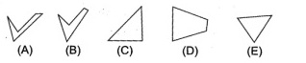

A. ACE

B. ABD

C. BCE

D. CED

Correct answer: A

Q3. Type: Theory PC Tested: PC2 Level: Easy

You notice that one of your colleagues is in a lot of stress because of being constantly bullied by another colleague. What should be the appropriate response from your part?

A. Report the issue to the higher authority

B. You should ignore the matter as you have no role to play in it

C. You should discuss the matter with your colleagues

D. You should confront the bully by yourself

Correct answer: A

Q4. Type: Theory PC Tested: PC4 Level: Moderate

What is the correct course of action to deal with hazards at workplace?

I. Spot the hazard

II. Make the changes

III. Assess the risks

Choose the correct answer from the options given below.

A. I - II – III

B. III - II – I

C. I - III- II

D. III - II – I

Correct answer: C

Q5. Type: Theory PC Tested: PC6 Level: Moderate

You are joining a new company and on the first day you find that there are no fire exits from the office. Among the following points what is/are the most appropriate thing to do:

I. Go to your supervisor and tell him about the problem and the necessity of fire exits.

II. Search other exit ways that would be helpful during emergencies and inform about it to everyone.

III. Register a complaint against the security department.

Choose the correct answer from the options given below:

A. Only (I)

B. Only (I) and (II)

C. Only (II) and (III)

D. All (I), (II) and (III)

Correct answer: B

SSC/ N9004 (Provide data/information in standard formats)

Q1. Type: Theory PC Tested: PC1 Level: Moderate

You are required to submit a daily report in a tabular format. Which of the following applications is most appropriate to create such tables?

A. Adobe Photoshop

B. Notepad

C. Corel Draw

D. MS Excel

Correct answer: D

Q2. Type: Theory(Data Interpretation) PC Tested: PC3 Level: Moderate

The diagram given below shows the percentage distribution of the total expenditures of a salaried man under various expense heads during a month. Please answer the question below based on the graph. 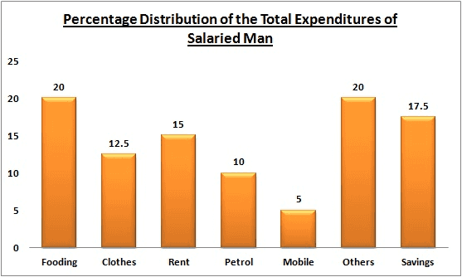  
If the expenditure on rent is 2.10 thousand, then the difference between the expenditure on clothes and petrol is:

A. 3500

B. 1400

C. 350

D. 35

Correct answer: C

Q3. Type: Theory(Data Interpretation) PC Tested: PC5 Level: Difficult

Consider the following table that shows the percentage distribution of population of five states A, B, C, D and E on the basis of poverty line and also on the basis of gender and answer the question that follows. 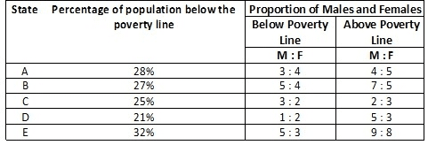

If the population of males below poverty line for state A is 2.4 million and that for state C is 1.5 million, then the total populations of states A and C are in ratio:

A. 2 : 3

B. 2 : 1

C. 2 : 5

D. 2 : 7

Correct answer: B

Q4. Type: Theory PC Tested: PC6 Level: Easy

Which of the following program can open a file with an .html extension?

A. Photoshop

B. Adobe reader

C. Mozilla Firefox

D. MS Access

Correct answer: C

Q5. Type: Theory PC Tested: PC7 Level: Moderate

Which department is to be contacted regarding the issues related to database of a website?

A. Analysis department

B. Design department

C. Development department

D. Content department

Correct answer: C

SSC/ N9005 (Develop your knowledge, skills and competence)

Q1. Type: Theory(Situational Judgement) PC Tested: PC1 Level: Moderate

You are stuck with some technical issues at an early stage of an important project, in such a case to ensure the completion of project in the timelines you will:

A. leave the assignment by giving excuses and get it assigned to someone else

B. complete the assignment by managing the issues on your own

C. go through the books and surf the internet to resolve the issues

D. get the help from your team members and seniors who are well versed with such issues

Correct answer: D

Q2. Type: Theory PC Tested: PC3 Level: Moderate

The assessment test of employees of a company gives all the information EXCEPT:

A. their performance

B. level of their knowledge

C. their skill set

D. their co-operation with team members

Correct answer: B

Q3. Type: Theory(Situational Judgement) PC Tested: PC6 Level: Moderate

Consider a technology that you are interested in learning but you do not have the opportunity to apply this technology as a part of your current work. Which of the following is the most suitable course of action that you can take in this case?

A. Learn by working on the technology during your free time

B. Consider employment opportunities in that domain with your learning goals

C. Ignore your interests and learning goals and stick to your work

D. Discuss with your manager if there is any requirement related to the technology

Correct answer: D

Q4. Type: Theory PC Tested: PC7 Level: Easy

To get a report on performance of employees, the testing criteria should NOT consist of:

A. knowledge of employee

B. professional development of employee

C. range of skills of an employee

D. salary of an employee

Correct answer: D

Q5. Type: Theory PC Tested: PC8 Level: Moderate

In your company, there is a policy to test the performance of all the employees every 6 months. By looking at your evaluation, you come to know about some of your weak areas. What would you do then?

A. Claim that the evaluation is false and incorrect

B. Analyze your weak areas and try to improve on them

C. Ask for a re-evaluation

D. Blame your colleagues for your bad performance

Correct answer: B