|  |  |
| --- | --- |
| QP CODE: | Q0504 |
| QP TITLE: | Media Developer |

|  |
| --- |
| OVERVIEW |

|  |  |
| --- | --- |
| Test Duration | 130 minutes |
| Duration - SSC/N0501 | 130 minutes |
| Duration - SSC/N0503 |
| Duration - SSC/N9001 |
| Duration – SSC/N9002 |
| Duration – SSC/N9003 |
| Duration – SSC/N9004 |
| Duration – SSC/N9005 |
| Natural Language Options | English (Single language assessment at a time)  Can be translated to vernacular languages as well. |
| Distribution of Marks | As mentioned in the Qualification Pack |
| Pass Criteria | To be finalized |
| Technology tools / Platforms Tested (Mandatory) | |
| 1. Sound Forge | 1. Adobe Premiere |
| 1. Adobe After Effects | 1. Combustion |
| Technology tools / Platforms Tested (Select any one) | |
| 1. NA |  |
|  |  |
| Infrastructure Requirements | As per standard list provided to Assessment Centers |
| QP Specific Infrastructure Requirements (if any) – Not Applicable specific to QP | |
|  |  |

|  |
| --- |
| SAMPLE QUESTIONS |

SSC/ N0501 (Contribute to the design of software products and applications)

Q1. Type: Skill(JQuery); PC Tested: PC 4; Level: Difficult

Suppose in your JQuery project you need to create an animation. For this purpose, you create an HTML page using the following code.

<button>Start Animation</button>

<div style="background:#00FF00;height:100px;width:200px;position:absolute;">HELLO</div>

Now if you want to create the following animation (shown in the snapshots below) on the above HTML page using JQuery. Which of the following codes will you use in the <script> tag?

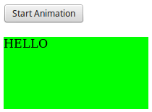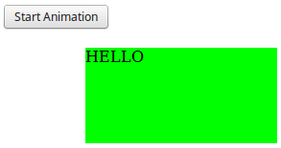

Options:

A:

$(document).ready(function(){

$("button").click(function(){

var div = $("div");

div.animate({left: '100px'}, "slow");

div.animate({fontSize: '3em'}, "slow");

});

});

B:

$(document).click(function(){

$("button").click(function(){

var div = $("div");

animate({left: '100px'}, "slow");

animate({font: '3em'}, "slow");

});

});

C:

$(document).ready(function(){

$("button").click(function(){

var div = $("div");

start.animate(left:{'100px'}, "slow");

start.animate(fontSize: {'3em'}, "slow");

});

});

D:

$(document).ready(function(){

button.click(function(){

var div = $("div");

div.animate(left:{'100px'}, "slow");

div.animate(font:{'3em'}, "slow");

});

});

Correct Answer: A

Q2. Type: Skill (Code Analysis); PC Tested: PC 6; Level: Moderate

Question: During code analysis phase, you need to validate all the branches of the following code logic ensuring that no branch leads to abnormal behavior by decision coverage testing. In such a situation, how many tests are required for the following code for 100% decision coverage?

if width > length

then

biggest_dimension = width

if height > width

then

biggest_dimension = height

end_if

else

biggest_dimension = length

if height > length

then

biggest_dimension = height

end_if

end_if

Options:

A: 3

B: 4

C: 2

D: 1

Correct Answer: B

Q3. Type: Skill(UML); PC Tested: PC 7; Level: Easy

Question: If you need to capture the functional requirements of an “Online Shopping Website” using use-case diagram. Which of the following cannot be used as a use case?

Options:

A: View Items

B: Registered customer

C: Make purchase

D: Customer registration

Correct Answer: B

Q4. Type: Skill(WordPress); PC Tested: PC 4; Level: Moderate

Question: You are working on a web development project using WordPress and you need to install plugins directly from the admin area. In which of the following ways can you do this?

Options:

A: Log in to the WP account > Add Plugins > Browse > Install

B: Log in to the WP admin area > Plugins > Add New > Choose file > Install

C: Log in to the WP admin area > Manage Plugins > Upload > Choose file > Install

D: Log in to the WP account > Plugins > New Plugins > Choose file > Install

Correct Answer: B

Q5. Type: Skill(JavaScript); PC Tested: PC 5; Level: Moderate

Question: After reviewing your project, your project manager instructs you to play an instance of an audio clip 'audio' repeatedly using JavaScript. For this purpose, which of the following functions will you use?

Options:

A: audio.loop()

B: audio.repeat()

C: audio.play()

D: audio.continue()

Correct Answer: A

Q6. Type: Theory (Database Design); PC Tested: PC 3; Level: Easy

Question: In the 2-tier architecture of a DBMS system, which of the following tier is entirely independent of the database in terms of operation, design, and programming?

Options:

A: Presentation tier

B: Database (Data) tier

C: Application tier

D: User tier

Correct Answer: C

Q7. Type: Theory(Joomla); PC Tested: PC 6; Level: Moderate

Question: Consider a situation when the standard library is not available for Joomla execution. In such a situation, which of the following PHP directives is important in order to define an alternate compression library?

Options:

A: zlib.output_compression

B: extension_dir

C: expose_php

D: zlib.output_handler

Correct Answer: B

SSC/N0503 (Develop media content and graphic designs for software products and applications)

Q1. Type: Theory (General Media); PC Tested: PC 3; Level: Easy

Question: In your web designing project, you need to use an audio file that has the ability to maintain excellent sound fidelity at very small file sizes, as the total project size is very limited. Which of the file formats will you prefer in such a situation?

Options:

A: WAV

B: MP3

C: MPEG

D: AIFF

Correct Answer: B

Q2 Type: Skill(Adobe After effect ) PC Tested: PC 3 Difficulty: Moderate

Suppose you are creating text using 'Adobe after effect' to display the text in a visually interesting yet clear manner in your project. Now, if you need to create the following bounding box for the text to fit inside. Which of the following ways can you do this?

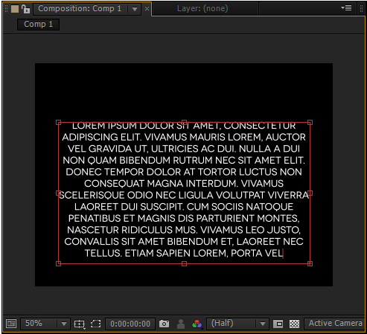

A. Click on Type Tool -> Select Text tool -> Draw a rectangle inside the composition -> Type text

B. Click on Type Tool -> Select Rectangle pattern -> Draw a rectangle inside the composition -> Type text

C. Click on Edit Text -> Select Text tool -> Select Rectangle pattern -> Draw a rectangle inside the composition -> Type text

D. Click on Edit Text -> Select Text tool -> Draw a rectangle inside the composition -> Type text

Correct Answer: A

Q3. Type: Skill (Adobe Premiere); PC Tested: PC 4; Level: Moderate

Question: Consider video production using the Adobe Premiere Pro workflow. The following LIST I contains the tools used in video production and LIST II contains the roles of the tools in video production.

Match the following two lists.

LIST I:

1. Adobe Story

2. Adobe OnLocation

3. Premiere Pro Speech recognition

4. Adobe Prelude

LIST II:

A. Used to capture footage and attach any relevant metadata from the script to that footage

B. Used to create script

C. Used to import, log, select, and export tapeless media

D. Used to match the audio to the dialogue from the script in the metadata

Options:

A: 1-B, 2-A, 3-D, 4-C

B: 1-C, 2-B, 3-D, 4-A

C: 1-A, 2-B, 3-D, 4-C

D: 1- C, 2- B, 3-A, 4-D

Correct Answer: A

Q4. Type: Theory(Adobe Dreamweaver); PC Tested: PC 5; Level: Difficult

Question: You are designing a website using Adobe Dreamweaver in windows operating system. In the review phase, you need to validate your HTML code. Choose the correct sequence for the following steps involved in the validation process.

1. Click ‘Edit’ in the main menu at the top of the page and then choose 'Preferences' from the context menu

2. Click the check box beside the HTML libraries that you want to check your code against for instance HTML 4.0 or HTML 2.0

3. Click on the 'Validator' in the category options list

4. Set validator preference

5. Once the HTML validator is configured, select “Edit” in the main menu, and then tap on validator to start validation

6. You can also define the types of errors that you want to include in the validation by choosing the applicable check boxes.

Options:

A: 4-1-3-2-6-5

B: 3-4-1-2-5-6

C: 4-2-1-3-6-5

D: 3-4-2-1-6-5

Correct Answer: A

Q5. Type: Theory(SRS) PC Tested:PC1 Level: Easy

You are working on a website development project. The client demands for a feature in the website, that allows the customer to mail directly to the management. You will consider this requirement, as which of the following types?

Options:

A. Functional Requirement

B. Non-Functional Requirement

C. Basic Requirement

D. UI Requirement

Correct answer: A

Q6. Type: Theory (General Media); PC Tested: PC 6; Level: Moderate

Question: Suppose you have created an image in a HTML document and you want to restrict further modifications in the image after publishing. Which of the following attributes will you use inside <img> tag for the same?

Options:

A: SD

B: ALT

C: LOCK

D: MD

Correct Answer: D

Q7. Type: Theory (Sound Forge Pro); PC Tested: PC 6; Level: Easy

Question: Sound Forge Pro is highly recommended for all kinds of audio editing purpose. For which of the following features of Sound Forge Pro, it is used as a standard audio editing software?

1. Effects processing

2. One-touch recording

3. Precise audio editing

4. Precisely synchronize audio and video frame by frame

Options:

A: Only 1 and 2

B: Only 1, 2 and 3

C: All 1, 2, 3 and 4

D: Only 2 and 3

Correct Answer: C

SSC/N9001 (Manage your work to meet requirements)

Q1. Type: Theory PC Tested: PC2 Level: Moderate

Among the following points what should an office employee follow to ensure tidiness around his/her work area?

I. Establish daily, weekly and monthly cleaning procedures.

II. Implement a paper recycling program.

III. Have snacks and refreshments at the workspace.

Choose the correct answer from the options given below.

Ops.

A. Only (I)

B. Only (I) and (II)

C. Only (II) and (III)

D. All (I), (II) and (III)

Correct Answer: B

Q2. Type: Theory (Situational Judgement) PC Tested: PC2 Level: Easy

On a Monday morning, you enter the office and see that there is a lot of litter on the office floor. What will be the most appropriate response?

Ops. A. Ignore the litter and do your job

B. Scold the cleaner for not doing his job

C. Call the cleaner and ask him to clean the office immediately and warn him not to repeat such mistakes

D. Clean the office by yourself

Correct Answer: C

Q3. Type: Theory (Work Management) PC Tested: PC3 Level: Moderate

Of all the following jobs what would be the correct order of priority for an office employee?

I. Work on a new assignment that your boss has given you to complete in 3 days.

II. Complete a report which is due in 4 hours.

III. Work on a monthly report that is to be discussed in a week.

Choose the correct answer from the options given below.

Ops. A. I - II – III

B. III - II – I

C. I - III – II

D. II -I- III

Correct answer: D

Q4. Type: Theory (Statement and Conclusion) PC Tested: PC6 Level: Difficult

Below are given statements followed by two conclusions. Take the given statements to be true, even if they contradict commonly known facts, and determine the conclusion/s that logically follow/s from the statements.

Statements:

I. Some pants are trousers.

II. All the trousers are jeans.

Conclusions:

I. All the jeans are trousers.

II. Some pants are definitely jeans.

Ops. A. Only conclusion I follows

B. Only conclusion II follows

C. Either conclusion I or conclusion II follows

D. Neither conclusion I nor conclusion II follows

Correct answer: B

Q5. Type: Theory (Quant – Time and Work) PC Tested: PC5 Level: Moderate

Amardeep was allotted a project which she would have completed in 5 days. But she asked for help of her team member Shreya so that they could complete the project within the deadline of 3 days. Determine the number of days that Shreya would have taken to complete the same project alone.

Ops. A. 5 days

B. 5(1/2) days

C. 7 days

D. 7(1/2) days

Correct Answer: D

SSC/ N9002 (Work effectively with colleagues)

Q1. Type: Theory (Statement and Conclusion) PC Tested: PC2 Level: Moderate

Which of the given conclusions logically follow(s) from the given statements?

Statement:

Akshay informed the client that the deadline of the project will not be met due to lack of manpower.

Conclusions:

I. The process followed by Akshay's team was not efficient.

II. There were not enough members in the Akshay's team.

Ops. A. Only conclusion I follows.

B. Only conclusion II follows.

C. Both conclusion I and conclusion II follow.

D. Neither conclusion I nor conclusion II follows.

Correct answer: B

Q2. Type: Theory (Verbal Ability) PC Tested: PC4 Level: Moderate

Which of the phrases given below should replace the underlined phrase to make the sentence grammatically correct?

Preeti is tired as she is working since 6 o'clock in the morning.

Ops. A. she was working

B. she has been working

C. she have been working

D. she will be working

Correct answer: D

Q3. Type: Theory (Verbal Ability) PC Tested: PC4 Level: Easy

Fill in the blank(s) with the most suitable option.

Sir, would you _____ if I send you the presentation tomorrow?

Ops. A. hate

B. agreed

C. mind

D. might

Correct answer: C

Q4. Type: Theory (Situational Judgement) PC Tested: PC5 Level: Moderate

Sheetal and Bhavnish are assigned a project together. Bhavnish was unable to complete his part of work on time due to which Sheetal was unable to complete the remaining work on time. Bhavnish was given a warning from their manager for the same. What should he do?

Ops. A. He should talk to the manager and apologize for his mistake

B. He should blame Sheetal for the delay as the remaining work was assigned to her

C. He should try to talk to Sheetal and convince her to take the blame on both of them

D. He should ignore the warning given by his manager

Correct answer: A

Q5. Type: Theory (Situational Judgement) PC Tested: PC7 Level: Easy

One of your team members is lazy and has a laid back attitude. What should you do to make him an active team player?

Ops. A. You should scold him in front of other team members so that he gets embarrassed

B. You should talk to him and motivate him to work hard in order to have professional growth in the organization

C. You should ask your manager to terminate him for some days

D. You should ask other team members to timely humiliate him

Correct answer: B

SSC/ N9003 (Maintain a healthy, safe and secure working environment)

Q1. Type: Theory PC Tested: PC1 Level: Easy

Which of the following should NOT be practiced in an office?

Ops. A. 

B. 

C. 

D. 

Correct answer: B

Q2. Type: Theory(Visual Reasoning) PC Tested: PC3 Level: Difficult

Which one of the following images is most unlike the other three?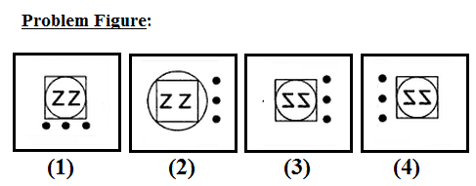

Ops. A. (1)

B. (2)

C. (3)

D. (4)

Correct answer: B

Q3. Type: Theory PC Tested: PC2 Level: Easy

You notice that one of your colleagues is in a lot of stress because of being constantly bullied by another colleague. What should be the appropriate response from your part?

Ops. A. Report the issue to the higher authority

B. You should ignore the matter as you have no role to play in it

C. You should discuss the matter with your colleagues

D. You should confront the bully by yourself

Correct answer: A

Q4. Type: Theory PC Tested: PC4 Level: Moderate

What is the correct course of action to deal with hazards at workplace?

I. Spot the hazard

II. Make the changes

III. Assess the risks

Choose the correct answer from the options given below.

Ops. A. I - II – III

B. III - II – I

C. I - III- II

D. III - II – I

Correct answer: C

Q5. Type: Theory PC Tested: PC6 Level: Moderate

You are joining a new company and on the first day you find that there are no fire exits from the office. Among the following points what is/are the most appropriate thing to do:

I. Go to your supervisor and tell him about the problem and the necessity of fire exits.

II. Search other exit ways that would be helpful during emergencies and inform about it to everyone.

III. Register a complaint against the security department.

Choose the correct answer from the options given below:

Ops. A. Only (I)

B. Only (I) and (II)

C. Only (II) and (III)

D. All (I), (II) and (III)

Correct answer: B

SSC/ N9004 (Provide data/information in standard formats)

Q1. Type: Theory PC Tested: PC1 Level: Moderate

You are required to submit a daily report in a tabular format. Which of the following applications is most appropriate to create such tables?

Ops. A. Adobe Photoshop

B. Notepad

C. Corel Draw

D. MS Excel

Correct answer: D

Q2. Type: Theory(Data Interpretation) PC Tested: PC3 Level: Moderate

Study the following graph and determine the percentage decrease (approximate) in number of work related fatal accidents from year 1975 to 2010.

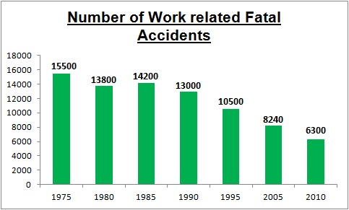

Ops. A. 25%

B. 37%

C. 59%

D. 73%

Correct answer: C

Q3. Type: Theory(Data Interpretation) PC Tested: PC5 Level: Difficult

Consider the following table that shows the percentage distribution of population of five states A, B, C, D and E on the basis of poverty line and also on the basis of gender and answer the question that follows. 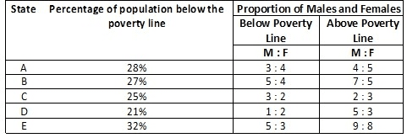   
What will be (approximately) the female population above poverty line for the state B if the male population below poverty line for state B is 3.15 million?

Ops. A. 6 million

B. 6.2 million

C. 6.39 million

D. 6.5 million

Correct answer: C

Q4. Type: Theory PC Tested: PC6 Level: Easy

Which of the following program can open a file with an .html extension?

Ops. A. Photoshop

B. Adobe reader

C. Mozilla Firefox

D. MS Access

Correct answer: C

Q5. Type: Theory PC Tested: PC7 Level: Moderate

Which department is to be contacted regarding the issues related to database of a website?

Ops. A. Analysis department

B. Design department

C. Development department

D. Content department

Correct answer: C

SSC/ N9005 (Develop your knowledge, skills and competence)

Q1. Type: Theory(Situational Judgement) PC Tested: PC1 Level: Moderate

You are stuck with some technical issues at an early stage of an important project, in such a case to ensure the completion of project in the timelines you will:

Ops. A. leave the assignment by giving excuses and get it assigned to someone else

B. complete the assignment by managing the issues on your own

C. go through the books and surf the internet to resolve the issues

D. get the help from your team members and seniors who are well versed with such issues

Correct answer: D

Q2. Type: Theory PC Tested: PC3 Level: Moderate

The assessment test of employees of a company gives all the information EXCEPT:

Ops. A. their performance

B. level of their knowledge

C. their skill set

D. their co-operation with team members

Correct answer: B

Q3. Type: Theory(Situational Judgement) PC Tested: PC6 Level: Moderate

Consider a technology that you are interested in learning but you do not have the opportunity to apply this technology as a part of your current work. Which of the following is the most suitable course of action that you can take in this case?

Ops. A. Learn by working on the technology during your free time

B. Consider employment opportunities in that domain with your learning goals

C. Ignore your interests and learning goals and stick to your work

D. Discuss with your manager if there is any requirement related to the technology

Correct answer: D

Q4. Type: Theory PC Tested: PC7 Level: Easy

To get a report on performance of employees, the testing criteria should NOT consist of:

Ops. A. knowledge of employee

B. professional development of employee

C. range of skills of an employee

D. salary of an employee

Correct answer: D

Q5. Type: Theory PC Tested: PC8 Level: Moderate

In your company, there is a policy to test the performance of all the employees every 6 months. By looking at your evaluation, you come to know about some of your weak areas. What would you do then?

Ops. A. Claim that the evaluation is false and incorrect

B. Analyze your weak areas and try to improve on them

C. Ask for a re-evaluation

D. Blame your colleagues for your bad performance

Correct answer: B