ODS-CRM-Data-Transformation Document

Reference and Source Documentation

|  |  |  |  |  |  |
| --- | --- | --- | --- | --- | --- |
| S. No | Document | Author | Reviewer | Version | Date |
| 1 | Initial Version | Girisha Hanbal Raju | Gopinath Pabbisetti | 0.1 | 06/07/2023 |
| 2 | Second Version | Jerald | Girisha Hanbal Raju | 0.2 | 07/07/2023 |
| 3 | Third Version | Vishnuprasad Bhat | Girisha Hanbal Raju | 0.3 | 07/07/2023 |

Point of Contact

|  |  |  |  |
| --- | --- | --- | --- |
| SPOC | Name | Designation | Email ID |
| Delivery | Ram Babu Doddy | Associate Vice President | rambabud@maveric-systems.com |
| Escalation | Kishan Sundar | Sr. Vice President | kishans@maveric-systems.com |

Table of Contents

1 Introduction 4

2 Stages of Migration and Reconciliation Activities 4

3 Data flow diagram of Data Migration 5

4 Validation of Migration and Reconciliation 6

5 Database Table Reference 6

6 Report Generation 7

7 Supporting Document 7

# Introduction

Data from Mambu application is transformed and stored in ODS database. The ODS Data is then migrated to CRM Database by running the batch. The purpose of this document is to describe the process of data migration from Mambu ODS data source to CRM database and reconcile the migrated data.

# Stages of Migration and Reconciliation Activities

Everyday post business hours, Job - mambu_to_mig_customerdb_0.2.py is scheduled, which includes following stages of data migration:

Stage 1: This job is scheduled to run once the transformed mambu data is migrated to ODS DB.

1. This is run on daily basis.

Stage 2: SP_Migration will migrate the data from ODS into CRM Tables based on business logic.

Stage 3: SP_Reconciliation will then reconcile the migrated data.

1. When the batch is run first time, **From_date and To_Date** validation parameters will not be considered. Entire migrated data will be conciliated.
2. In subsequent executions, reconciliation would be based on **From_date** and **To_Date**
3. Reconciled data is loaded into **Batch_Duration Table in Customer Schema**.
4. During the reconciliation, session oriented temporary tables is created.
5. Data is validated based on the Hash_tag_values generated on group of columns in ODS and CRM Tables.
6. After validating the records, check sum results are created. These results are stored in **checksum_crm_ods** Table.

# Data flow diagram of Data Migration

# Validation of Migration and Reconciliation

|  |  |
| --- | --- |
| **Migration Validation Tables** | |
| **Tables** | **Description** |
| Batch_duration | Tracking the batch load duration |
| Audit_details | Auditing all the CRM table counts |
| Crm_mig_count | Migrated record count |

|  |  |
| --- | --- |
| **Reconcile Validation Tables** | |
| **Tables** | **Description** |
| Crm_mig_count | Migrated record count |
| Ods_recon_count | Reconciliation Count |
| Crm_final_rcon_tab_temp | Mismatched records |

# Database Table Reference

|  |  |  |  |  |
| --- | --- | --- | --- | --- |
| **Database Tables** | |  | | |
|  | |  | | |
| **ODS Transaction data** | |  | | |
| **ODS Tables** | **Loaded Temp ODS Table** |  | | |
| clients | temp_clients |  | | |
| clients_addresses | temp_clients__addresses |  | | |
| clients_custom_fields | temp_clients__custom_fields |  | | |
| clients_id_documents | temp_clients__id_documents |  | | |
|  |  |  | | |
|  |  |  |  |
|  |  |  |  |
| **Business logic transformations** | |  |  |
| **Temporary ODS Tables used** | **Temporary CRM Tables** |  |  |
| ODS_party | party |  |  |
| ODS_address | address |  |  |
| ODS_consent_details | consent_details |  |  |
| ODS_contact | contact |  |  |
| ODS_party_status | party_status |  |  |
| ODS_relationship | relationship |  |  |
| ODS_system_integration_status | system_integration_status |  |  |
| ODS_occupation | occupation |  |  |
| ODS_kyc_details | kyc_details |  |  |
| ODS_asset_details | asset_details |  |  |
| ODS_device_details | device_details |  |  |
| ODS_external_system_response | external_system_response |  |  |
| ODS_referral_promotion | referral_promotion |  |  |
|  |  |  |  |
|  |  |  |  |
| **Checksum Results (Based on Hashtag values)** | |  |  |
| **ODS_Checksum_tables** | **CRM_Checksum_tables** |  |  |
| chksum_ods_party | chksum_CRM_party |  |  |
| chksum_ods_address | chksum_CRM_address |  |  |
| chksum_ods_consent_details | chksum_CRM_consent_details |  |  |
| chksum_ods_contact | chksum_CRM_contact |  |  |
| chksum_ods_party_status | chksum_CRM_party_status |  |  |
| chksum_ods_relationship | chksum_CRM_relationship |  |  |
| chksum_ods_system_integration_status | chksum_CRM_system_integration_status |  |  |
| chksum_ods_occupation | chksum_CRM_occupation |  |  |
| chksum_ods_kyc_details | chksum_CRM_kyc_details |  |  |
| chksum_ods_asset_details | chksum_CRM_asset_details |  |  |
| chksum_ods_device_details | chksum_CRM_device_details |  |  |
| chksum_ods_external_system_response | chksum_CRM_external_system_response |  |  |
| chksum_ods_referral_promotion | chksum_CRM_referral_promotion |  |  |

By comparing the hashtag value for each row results will **Checksum_CRM_ODS** Table.

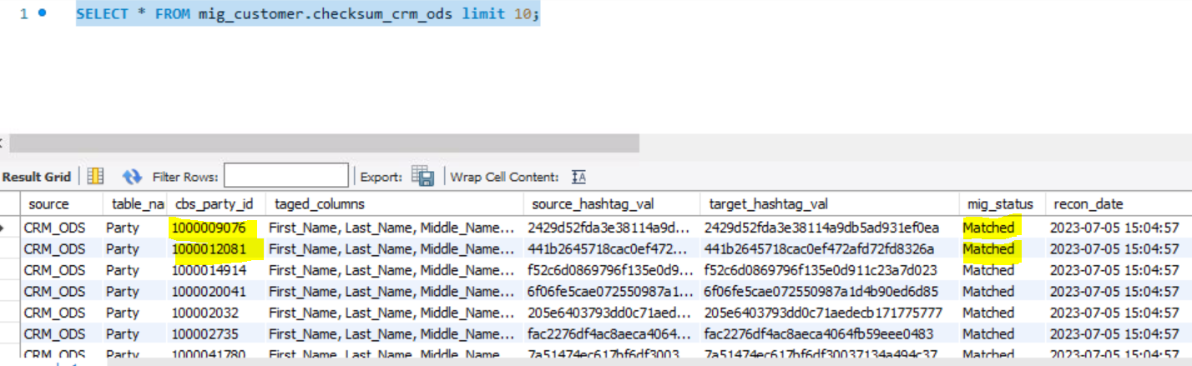

# Report Generation

Mismatched Records send to Aws S3 Bucket for validation.

# Supporting Document

