ODS To CRM-Data-Transformation Document

Reference and Source Documentation

|  |  |  |  |  |  |
| --- | --- | --- | --- | --- | --- |
| S. No | Document | Author | Reviewer | Version | Date |
| 1 | Initial Version | Girisha Hanbal Raju | Gopinath Pabbisetti | 0.1 | 06/07/2023 |
| 2 | Second Version | Jerald | Girisha Hanbal Raju | 0.2 | 07/07/2023 |
| 3 | Third Version | Vishnuprasad Bhat | Girisha Hanbal Raju | 0.3 | 07/07/2023 |

Point of Contact

|  |  |  |  |
| --- | --- | --- | --- |
| SPOC | Name | Designation | Email ID |
| Delivery | Ram Babu Doddy | Associate Vice President | rambabud@maveric-systems.com |
| Escalation | Kishan Sundar | Sr. Vice President | kishans@maveric-systems.com |

Table of Contents

1 Introduction 4

2 Data flow diagram of Data Migration 5

3 Validation of Migration and Reconciliation 6

4 Database Table Reference 6

5 Report Generation 11

6 Supporting Document 11

# Introduction

After collecting data from Mambu application, it is transformed and stored in the ODS database. To migrate the ODS data to the CRM database, we run a batch process. The purpose of this document is to detail the process of migrating data from Mambu ODS data source to the CRM database, as well as to ensure that the migrated data is reconciled.

Stages of Migration and Reconciliation Activities.

Everyday after business hours, the **mambu_to_mig_customerdb_0.2.py** job is scheduled to run

and the job includes several stages of data migration, ensuring that our customer database is up-to-date and accurate. Our team is committed to keeping our data safe and secure, and this regular data migration process is just one of the ways we ensure the integrity of our systems.

**Stage 1:** Once the transformed Mambu data has been successfully migrated to the ODS DB, the

Job will be scheduled to run on a daily basis.

**Stage 2:** SP_Migration() will migrate the data from ODS into CRM Tables based on business logic

**Stage 3:** SP_party_matrix() will update the party_matrix_id based on migrated data into party table.

**Stage 4:** SP_Reconciliation() will then reconcile the migrated data.

1. When running the batch for the first time, the migration will include all the data without any validation based on the from date, to date, event type, or no of days. The entire migrated data will be reconciled during this process. In subsequent executions, reconciliation would be based on **From date, To_date, Event_type,** and **no_of days.**
2. The reconciled data has been successfully loaded into the **Batch_Duration** Table in the Customer Schema. As part of the reconciliation process, session-oriented temporary tables were created to ensure accuracy and efficiency.
3. The data validation process takes into consideration the **hashtag values** generated on a group of columns in both ODS and CRM tables. This ensures that the data is accurate and free of errors, providing reliable information for business decision-making.
4. Once you have validated the records, the next step is to generate the checksum results. These results will be saved in the **checksum_crm_ods** Table.

# Data flow diagram of Data Migration

# Validation of Migration and Reconciliation

|  |  |
| --- | --- |
| **Migration Validation Tables** | |
| **Tables** | **Description** |
| Batch_duration | Tracking the batch load duration |
| Audit_details | Auditing all the CRM table counts |
| Crm_mig_count | Migrated record count |

|  |  |
| --- | --- |
| **Reconcile Validation Tables** | |
| **Tables** | **Description** |
| Ods_recon_count | Reconciliation Count |
| Crm_final_rcon_tab_temp | Mismatched records |

# Database Table Reference

|  |  |  |  |  |
| --- | --- | --- | --- | --- |
| **Database Tables** | |  | | |
|  | |  | | |
| **ODS Transaction data** | |  | | |
| **ODS Tables** | **Loaded Temp ODS Table** |  | | |
| clients | temp_clients |  | | |
| clients_addresses | temp_clients__addresses |  | | |
| clients_custom_fields | temp_clients__custom_fields |  | | |
| clients_id_documents | temp_clients__id_documents |  | | |
|  |  |  | | |
|  |  |  |  |
|  |  |  |  |
| **Business logic transformations** | |  |  |
| **Temporary ODS Tables used** | **CRM Tables** |  |  |
| ODS_party | party |  |  |
| ODS_address | address |  |  |
| ODS_consent_details | consent_details |  |  |
| ODS_contact | contact |  |  |
| ODS_party_status | party_status |  |  |
| ODS_relationship | relationship |  |  |
| ODS_system_integration_status | system_integration_status |  |  |
| ODS_occupation | occupation |  |  |
| ODS_kyc_details | kyc_details |  |  |
| ODS_asset_details | asset_details |  |  |
| ODS_device_details | device_details |  |  |
| ODS_external_system_response | external_system_response |  |  |
| ODS_referral_promotion | referral_promotion |  |  |
|  |  |  |  |
|  |  |  |  |
| **Checksum Results (Based on Hashtag values)** | |  |  |
| **ODS_Checksum_tables** | **CRM_Checksum_tables** |  |  |
| chksum_ods_party | chksum_CRM_party |  |  |
| chksum_ods_address | chksum_CRM_address |  |  |
| chksum_ods_consent_details | chksum_CRM_consent_details |  |  |
| chksum_ods_contact | chksum_CRM_contact |  |  |
| chksum_ods_party_status | chksum_CRM_party_status |  |  |
| chksum_ods_relationship | chksum_CRM_relationship |  |  |
| chksum_ods_system_integration_status | chksum_CRM_system_integration_status |  |  |
| chksum_ods_occupation | chksum_CRM_occupation |  |  |
| chksum_ods_kyc_details | chksum_CRM_kyc_details |  |  |
| chksum_ods_asset_details | chksum_CRM_asset_details |  |  |
| chksum_ods_device_details | chksum_CRM_device_details |  |  |
| chksum_ods_external_system_response | chksum_CRM_external_system_response |  |  |
| chksum_ods_referral_promotion | chksum_CRM_referral_promotion |  |  |

**Validations:**

1. Reconciliation process:

* Automated process.
* The automated process has been triggered through a **MySQL event batch**. This will streamline the workflow and ensure that everything is running smoothly. With this process in place, we can focus on other important tasks and let the system do its work efficiently. It's great to have technology that can help us save time and effort.
* When generating reconciliation, you can choose between a **full or incremental approach**. The full approach includes newly created records, while the incremental approach includes both newly created and modified records. It really depends on what you need for your specific situation. If you need a complete overview of all data, then the full approach is the way to go. However, if you only need to see the changes since the last report, then the incremental approach is more efficient. Either way, our system will provide you with accurate and reliable data to help you make informed decisions.
* Manual Process

To run reconciliation for migrated records, you can provide the necessary parameters for the desired time frame. For instance, if you want to check data for the last 30 days, you can execute the **Sp_reconciliation** procedure as follows.

Connect Production/UAT environment schema.

UAT Environment: customerdb

Prod Environment: Partydb

SP_Reconciliation`(IN FromDate DATE, 🡪 From date

 IN ToDate DATE, 🡪 To date

**call SP_Reconciliation('2022-08-01','2023-08-10');**

1. Process of validation of reconciliation records.

* Validation of Reconciliation records.

created a table to keep track of the consolidated and reconciled records. This will help to ensure that all the data is accurate and up-to-date. You can refer to the table for easy access to the information.

**SELECT * FROM customerdb.ods_recon_count;**

* The records in each CRM table and ODS table were compared, and a unique hashtag value was generated by grouping a set of table columns with respect to the CBS_Party_ID. This ensures that the data is organized and easily searchable for future reference. Let me know if you need further assistance with your CRM or ODS table.

Table reference: **Checksum_CRM_ODS**

Mismatched and mismatched are identified by the column **MIG_STATS** column and hashtag columns.

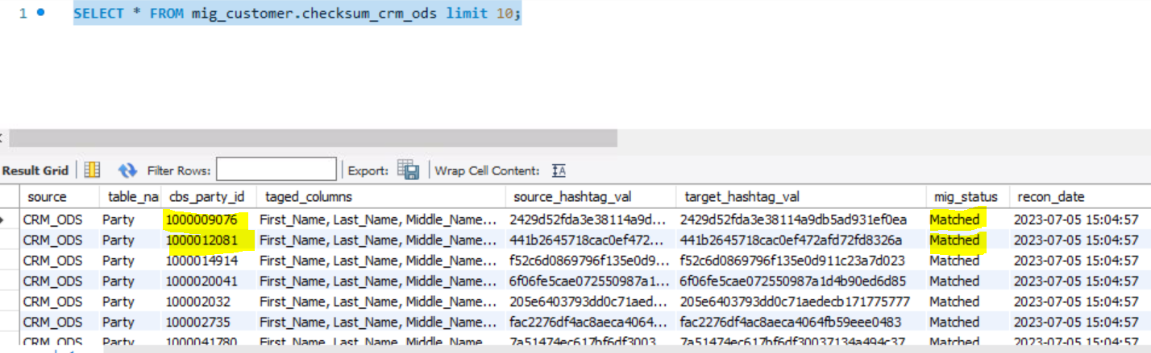

* Mismatched records inserted to crm_final_rcon_tab_temp

It was found that there were some mismatched records in the **CRM_Table** column of the **crm_final_rcon_tab_temp**. To validate these records, a manual check was conducted. This helped in identifying and rectifying the discrepancies in the data. The process was time-consuming, but it was necessary to ensure the accuracy and integrity of the data. Now, the **CRM_Table** column in **crm_final_rcon_tab_temp** is error-free and ready to be used for further analysis.

* **CRM_Table**: **Party**

1. Retrieved the CBS_Party_ID from the cbs_party_id column in the crm_final_rcon_tab_temp table.
2. Execute the sql statement to retrieve party_id

Select party_id, cbs_party_id from party where cbs_party_id=’6681582710’;

1. Select * from party where party_id =’2321049764’

Union

Select * from ods_party where party_id =’ ’2321049764’’

1. Find out the difference in column-wise.

To conduct a more in-depth analysis of various tables, it would be beneficial to refer to the tables specified in the Business Logic Transformations table. These tables can provide valuable insights and help to better understand the data at hand by using above mentioned queries in points 2 and 3.

**Detailed steps for migrated data & reconciliation counts :**

**Step 1 :** Total Matching Count

***ODS Staging Table :***



***CRM Staging Table :***



**Step 2 :** Distinct Matching Count

***ODS Staging Table :***

***CRM Staging Table :***

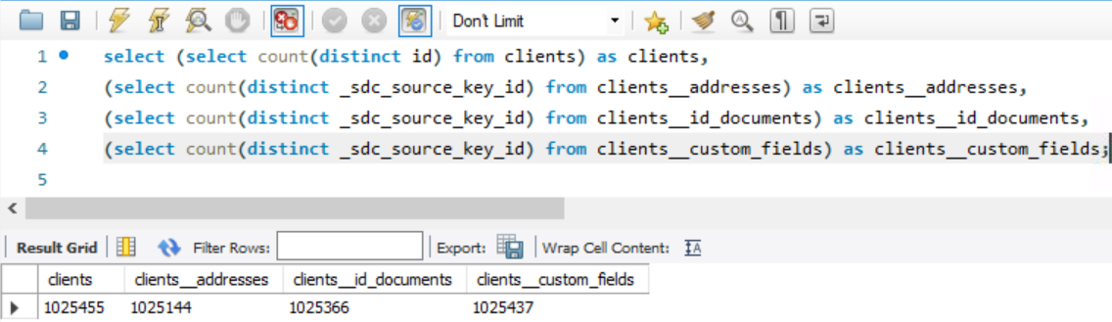

**Step 3 :** For first-time load migration, I deleted the last 100 customers from the ***clients*** table and intended to begin the incremental load when the full-load was finished.

**Step 4 :**  Full data load for first migration

***Batch Duration :***

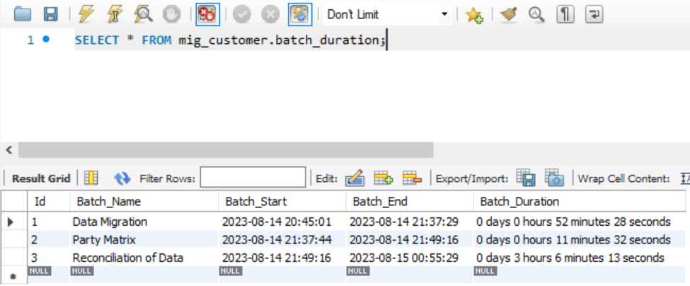

***Full-Load data Counts :***

***CRM Migrated Counts :***

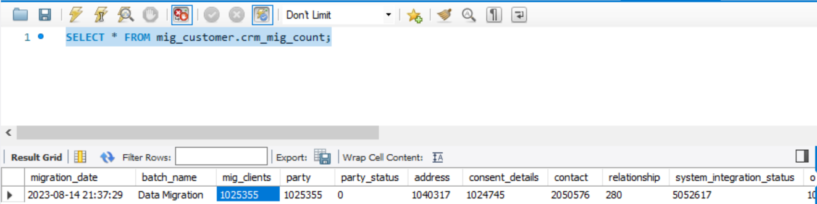

***CRM Reconciliation Counts :***

***Checksum_CRM_ODS*** *(Matched / Not-Matched)* ***Counts :***

**Step 5 :**  Incremental data load

***Batch Duration :***

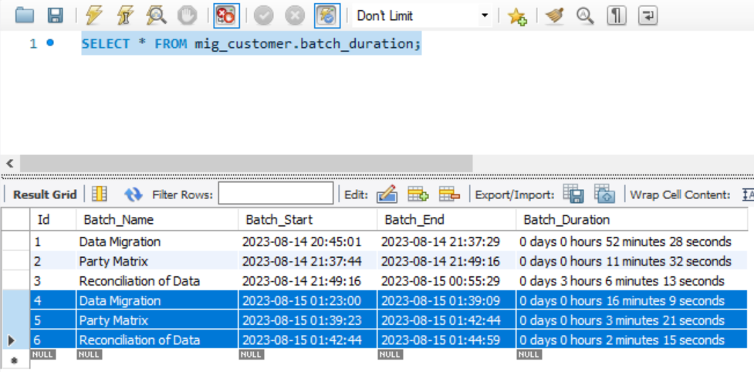

***Incremental data Counts :***

***CRM Migrated Counts :***

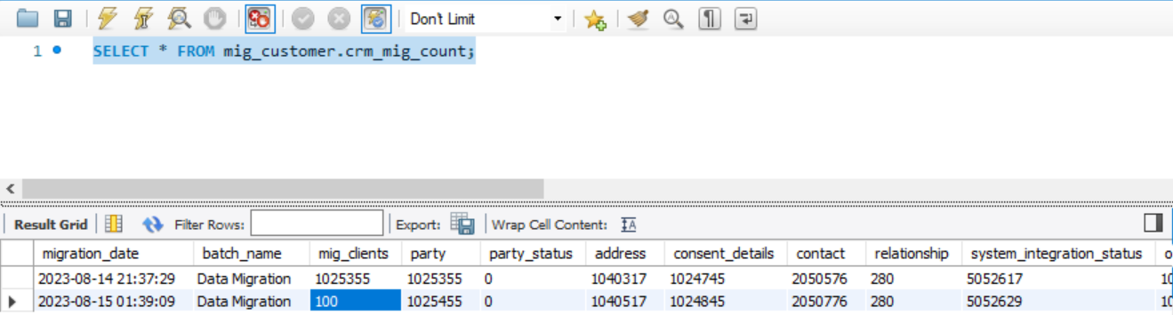

***CRM Reconciliation Counts :***

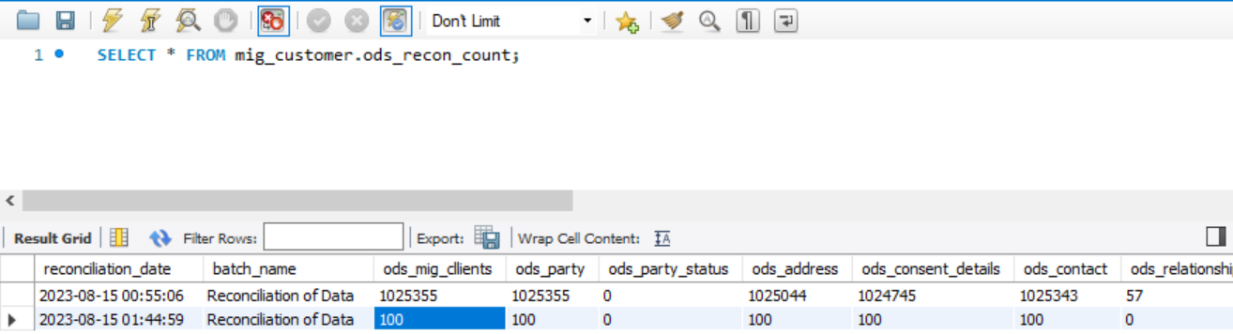

***Checksum_CRM_ODS*** *(Matched / Not-Matched)* ***Counts :***

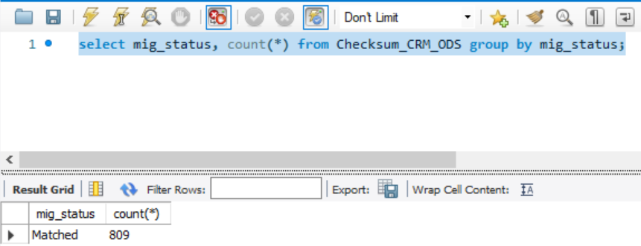

# Report Generation

Need to extract data from the Below tables.

* Select * from Crm_mig_count;
* Select * from Ods_recon_count;
* Select * from Checksum_CRM_ODS where mig_status<>’Matched’;
* Select * from Crm_final_rcon_tab_temp;

# Supporting Document

