SMART AGRICULTURE
ANALYTICS & MACHINE LEARNING
Project Report

Submitted by: [Student Name]
Department: Artificial Intelligence and Machine Learning
Institute: [College / University Name]
Academic Year: 2026–2027
Prepared using Python, SQLite, scikit-learn and Streamlit

Contents
- 1. Abstract
- 2. Introduction
- 3. Problem Statement and Objectives
- 4. Dataset and Database Design
- 5. Tools and Technologies
- 6. Methodology
- 7. Crop Recommendation Classification
- 8. Agricultural Yield Prediction
- 9. Unsupervised Learning and Anomaly Detection
- 10. Model Deployment Prototype
- 11. Results and Discussion
- 12. Limitations and Responsible Interpretation
- 13. Future Scope
- 14. Conclusion
- Appendix A. Key Dataset Fields
- Appendix B. Reproducibility Notes

1. Abstract
Smart Agriculture Analytics & Machine Learning is a data-driven project designed to explore agricultural recommendation and yield prediction using structured datasets. The project uses SQLite as a local data store and Python for data cleaning, feature engineering, exploratory analysis, model development and evaluation. A crop recommendation classification task predicts a crop label from soil and environmental features. A separate regression task estimates a numeric yield value from field-related features. Additional work includes clustering, anomaly detection, error analysis, model persistence and a Streamlit prototype.
The crop dataset contains 2,200 records across 22 classes, with 100 records per class. Initial cross-validation showed strong classification performance, while a later exploratory holdout experiment produced a high score for XGBoost. However, feature selection may have occurred before the split, so these results require a leakage audit before being treated as an unbiased estimate. Yield regression did not meaningfully outperform a simple DummyRegressor baseline. Therefore, the yield model is retained as an experimental prototype rather than a reliable forecasting system.

2. Introduction
Agriculture is influenced by multiple interacting factors, including soil properties, temperature, humidity, rainfall and crop-specific requirements. Data analytics can help examine these variables, identify patterns in recorded data and build predictive models. Machine learning provides a way to learn relationships from historical examples, while dashboards and lightweight applications can make results easier to inspect.
This project brings together a relational database, data preparation, exploratory analysis, supervised learning and a simple user interface. It is an educational and portfolio project; model outputs should not be treated as agronomic recommendations without independent validation and domain review.

3. Problem Statement and Objectives
The project investigates whether the available agricultural datasets can support two predictive tasks: (1) predicting a crop class from selected environmental and nutrient-related features, and (2) estimating a numeric yield value from field features. It also explores patterns in the crop data and identifies records that differ from the majority of observations.

Objectives
- Store and access the project datasets using SQLite.
- Inspect data quality and create cleaned and feature-engineered versions of the data.
- Build and compare classification models for crop-label prediction.
- Build and evaluate regression models for yield prediction.
- Explore clustering and potential anomaly detection without treating the output as ground truth.
- Save trained model pipelines and create a Streamlit interface for demonstration.
- Document model performance, limitations and next steps honestly.

4. Dataset and Database Design
The project database is stored locally at C:\Users\ADMIN\smart agricultural analytics\agriculture.db. The database includes original, cleaned, feature-engineered and selected tables. The selected tables are used as inputs for the main model experiments.
Dataset / table | Rows | Purpose
crop_recommendation_selected | 2,200 | Crop classification and unsupervised exploration
agri_yield_train_selected | 10,000 | Training and cross-validation for yield regression
agri_yield_test_selected | 2,000 | Generating yield predictions; no target column available

The crop dataset has 22 labels and is balanced: every class has 100 records, or approximately 4.55% of the dataset. The selected crop features are humidity, K, temperature, N, P_K_Ratio, NPK_Total, Temperature_Rainfall, rainfall, N_K_Ratio, Humidity_Rainfall, Temperature_Humidity and P. The target column is label.
The selected yield-training table contains 10,000 rows and a numeric target named yield. Its ten input features are NDVI_Temperature, OrganicMatter_Sand, Temperature_Rainfall, sand_pct, NDVI_Rainfall, soil_ph, organic_matter, Humidity_Rainfall, Temperature_Humidity and rainfall. The selected yield-test table contains 2,000 rows and the same inputs, but it has no yield target. As a result, test-set MAE, RMSE and R² cannot be calculated for that table unless the true outcomes become available.
The unit and exact real-world meaning of the yield target were not confirmed in the supplied project information. The report therefore refers to it simply as a numeric yield value and does not assume a unit such as kilograms per hectare.

5. Tools and Technologies
Tool / library | Role in the project
Python | Data processing, analysis, model training and predictions
SQLite | Local relational storage for original and processed datasets
pandas / NumPy | Tabular data manipulation and numerical operations
scikit-learn | Preprocessing, train/test splitting, model training and evaluation
XGBoost | Additional classification and regression model candidate
Matplotlib / plotting tools | Visual inspection of distributions and model errors
joblib | Saving trained model pipelines
Streamlit | Interactive demonstration application
Power BI (planned) | Interactive analytics dashboard for project presentation

6. Methodology
- Data inspection: review table schemas, row counts, missing values and duplicate records.
- Cleaning: create clean versions of source tables while preserving the original data.
- Feature engineering: create derived variables such as ratios and interaction features.
- Feature selection: prepare selected input tables for model development.
- Exploratory analysis: examine class balance, numeric distributions and relationships with the target.
- Supervised modelling: compare multiple classification and regression algorithms.
- Validation: use stratified holdout and cross-validation for classification, and K-fold validation for regression.
- Unsupervised exploration: run KMeans and inspect possible outliers with IsolationForest.
- Persistence and interface: save model pipelines and connect them to a Streamlit prototype.
A critical methodological consideration is leakage. If feature selection or any target-informed operation was performed using the full dataset before splitting, the resulting holdout score may be optimistic. A final evaluation should place all learned preprocessing and feature-selection steps inside the training folds, preserve an untouched test set, and document the exact procedure.

7. Crop Recommendation Classification
The classification task predicts the label column from twelve selected numeric features. The project compared Logistic Regression, Support Vector Machine, Decision Tree, Random Forest, K-Nearest Neighbours and XGBoost in different experiments. Numeric missing-value handling used a median imputer in the saved model pipeline.

Initial cross-validation results
Model | Mean CV accuracy
Random Forest | 0.989205 (98.92%)
XGBoost | 0.980114 (98.01%)
Decision Tree | 0.978977 (97.90%)
SVM | 0.976136 (97.61%)
Logistic Regression | 0.970455 (97.05%)

In a separate exploratory 80/20 holdout experiment, XGBoost achieved accuracy of 0.9954545 and weighted F1 of 0.9954432. Random Forest achieved accuracy of 0.9886364, Decision Tree 0.9840909, SVM 0.9795455, KNN 0.9772727 and Logistic Regression 0.9727273. This experiment selected the best model using the holdout weighted F1, so the holdout is not an independent final estimate. These values must be treated as preliminary until the feature-selection process is audited and the evaluation is rerun correctly.
The saved crop classifier was also evaluated on the same 2,200 rows on which it had been trained and returned 100% accuracy. This is an in-sample check, not a valid measure of performance on unseen data. It confirms that the saved pipeline can reproduce the training labels, but it does not demonstrate real-world generalisation.

8. Agricultural Yield Prediction
The regression task predicts the numeric yield target from ten selected features. Candidate models included Linear Regression, Random Forest Regressor, Gradient Boosting Regressor, XGBoost Regressor and Decision Tree Regressor. A DummyRegressor was included as a simple baseline.
Model | CV MAE | CV RMSE | CV R²
Dummy baseline | 378.8920 | 436.5174 | -0.0004
Linear Regression | 378.7503 | 436.6612 | -0.0011
Gradient Boosting | 380.0580 | 438.6452 | -0.0102
Random Forest | 384.7275 | 446.2336 | -0.0455
XGBoost | 384.8386 | 446.8623 | -0.0485
Decision Tree | 512.3598 | 626.8857 | -1.0635

Lower MAE and RMSE are preferable; R² values closer to 1 are generally better. The tested models did not meaningfully beat the Dummy baseline. A later tuning experiment found a Gradient Boosting configuration with learning_rate=0.03, max_depth=2 and n_estimators=100, with exploratory out-of-fold MAE 379.0517, RMSE 436.9624 and R² -0.0021. This also did not outperform the baseline. The tuned experiments used the same dataset for tuning and exploratory evaluation, so their scores are not independent final estimates.
The selected test table does not contain the true yield target. The persisted yield model can generate predictions for these rows, but those predictions cannot be scored without the corresponding actual values. The yield model is therefore an experimental demonstration and should not be presented as an accurate forecasting tool.

9. Unsupervised Learning and Anomaly Detection

Clustering
KMeans clustering was explored using the selected crop features, with label excluded from the clustering inputs and retained only for post-hoc interpretation. Feature scaling is important because the variables have different numeric ranges. Cluster profiles and cluster-by-label tables can help describe the groups, but a cluster is not automatically a real agricultural category or recommendation.

Anomaly detection
IsolationForest was applied to the crop features without using the label, with contamination set to 0.05 and random_state set to 42. The run marked 110 of 2,200 records as potential anomalies and 2,090 as normal. These are algorithmic flags, not confirmed data errors. They require inspection against data quality rules and agricultural domain knowledge before any record is removed.

10. Model Deployment Prototype
The project includes a Streamlit prototype with three pages: Crop Recommendation, Yield Prediction and Model Insights. Trained pipelines are saved with joblib so the app can load them without retraining on each launch. The crop page accepts the twelve selected features and returns a predicted label. The yield page accepts ten features and returns a numeric prediction. The insights page displays selected evaluation results and cautions about model limitations.
The interface is intended for demonstration. A production application would need validated input ranges, clear feature units, stronger evaluation, model versioning, logging, security review and domain validation. Predictions should be labelled as experimental until these checks are complete.

11. Results and Discussion
- The crop-label dataset is balanced, with 100 examples in each of 22 classes.
- Initial classification cross-validation scores were high, with Random Forest reaching approximately 98.92% mean accuracy.
- A separate preliminary holdout experiment reported 99.55% accuracy for XGBoost, but it needs a leakage audit and independent evaluation.
- A 100% training-set score for the saved crop classifier is not evidence of unseen-data performance.
- The yield regression models did not outperform the simple baseline in a meaningful way.
- Yield feature correlations with the target were all close to zero in the reported analysis; this indicates weak linear association in these features, but does not by itself prove that the target is random.
- Clustering and anomaly detection provide exploratory descriptions, not verified agronomic conclusions.

12. Limitations and Responsible Interpretation
- The source of the datasets and the real-world collection procedure should be documented in the final submission.
- The unit and operational definition of the yield target are not confirmed.
- The test yield dataset has no target values, preventing direct test-set evaluation.
- Feature selection may have used the full dataset before splitting; this must be audited to rule out leakage.
- A very high score on a balanced, potentially synthetic or curated dataset may not transfer to field conditions.
- The yield model has weak predictive performance and should not be used for operational decisions.
- Potential anomalies should not be deleted without independent verification.
- No explicit geographic coordinates or verified geographic identifiers were found in the inspected schemas; geographic claims or maps should not be fabricated.
- The current Streamlit app and persisted models are prototypes rather than production-ready agricultural systems.

13. Future Scope
- Audit feature selection and rerun classification with all learned steps inside cross-validation pipelines.
- Keep a final untouched test set and report its metrics only once after model selection.
- Investigate the yield target definition, source, units and data-generation process before further tuning.
- Collect or locate more informative yield predictors and additional verified training data.
- Evaluate models on an independent dataset from a different time period or location, if available.
- Build a Power BI dashboard with crop data exploration, yield analysis and model-performance pages.
- Add input validation, model metadata, clear warnings and reproducible environment instructions to the Streamlit app.
- Document dataset sources, licensing, assumptions and reproducible steps in the project repository.

14. Conclusion
This project demonstrates an end-to-end machine-learning workflow for agricultural data: SQLite-based storage, cleaning and feature engineering, exploratory analysis, classification, regression, unsupervised exploration, model persistence and a Streamlit interface. The crop classification experiments show promising preliminary performance, but a leakage audit and independent final evaluation are needed before making strong claims. The yield regression experiments show that the current features and models do not provide meaningful improvement over a simple baseline. Reporting this limitation is an important result of the project and helps define the next steps. The project is best presented as an educational analytics prototype with clearly stated evidence and limitations.

Appendix A. Key Dataset Fields
Dataset | Target | Selected inputs
Crop recommendation | label | humidity, K, temperature, N, P_K_Ratio, NPK_Total, Temperature_Rainfall, rainfall, N_K_Ratio, Humidity_Rainfall, Temperature_Humidity, P
Yield training | yield | NDVI_Temperature, OrganicMatter_Sand, Temperature_Rainfall, sand_pct, NDVI_Rainfall, soil_ph, organic_matter, Humidity_Rainfall, Temperature_Humidity, rainfall
Yield test | Not available | Same ten selected yield inputs; actual yield is absent

Appendix B. Reproducibility Notes
- Database path used in the project: C:\Users\ADMIN\smart agricultural analytics\agriculture.db
- Saved model artifacts: stage26_models/crop_classifier.joblib and stage26_models/yield_predictor.joblib.
- Crop saved model: median imputation followed by RandomForestClassifier(n_estimators=100, random_state=42), trained on the full selected crop table.
- Yield saved model: median imputation followed by GradientBoostingRegressor(n_estimators=100, max_depth=2, learning_rate=0.03, random_state=42), trained on the selected yield-training table.
- The saved model artifacts are candidate demonstration models; the crop model's training-set score and the yield model's weak validation performance must be described with the caveats in this report.
- Before submission, replace the cover placeholders, add verified dataset citations, and insert screenshots of the actual Streamlit app and any completed Power BI pages.

15. Visual Results and Plots
The following charts visualize numerical results already reported during project work. They are not generated from newly reloaded raw records; they use the confirmed metrics summarized in this report. The class-balance chart reflects the reported count of 100 records in each of the 22 crop classes.

15.1 Crop Dataset Class Balance
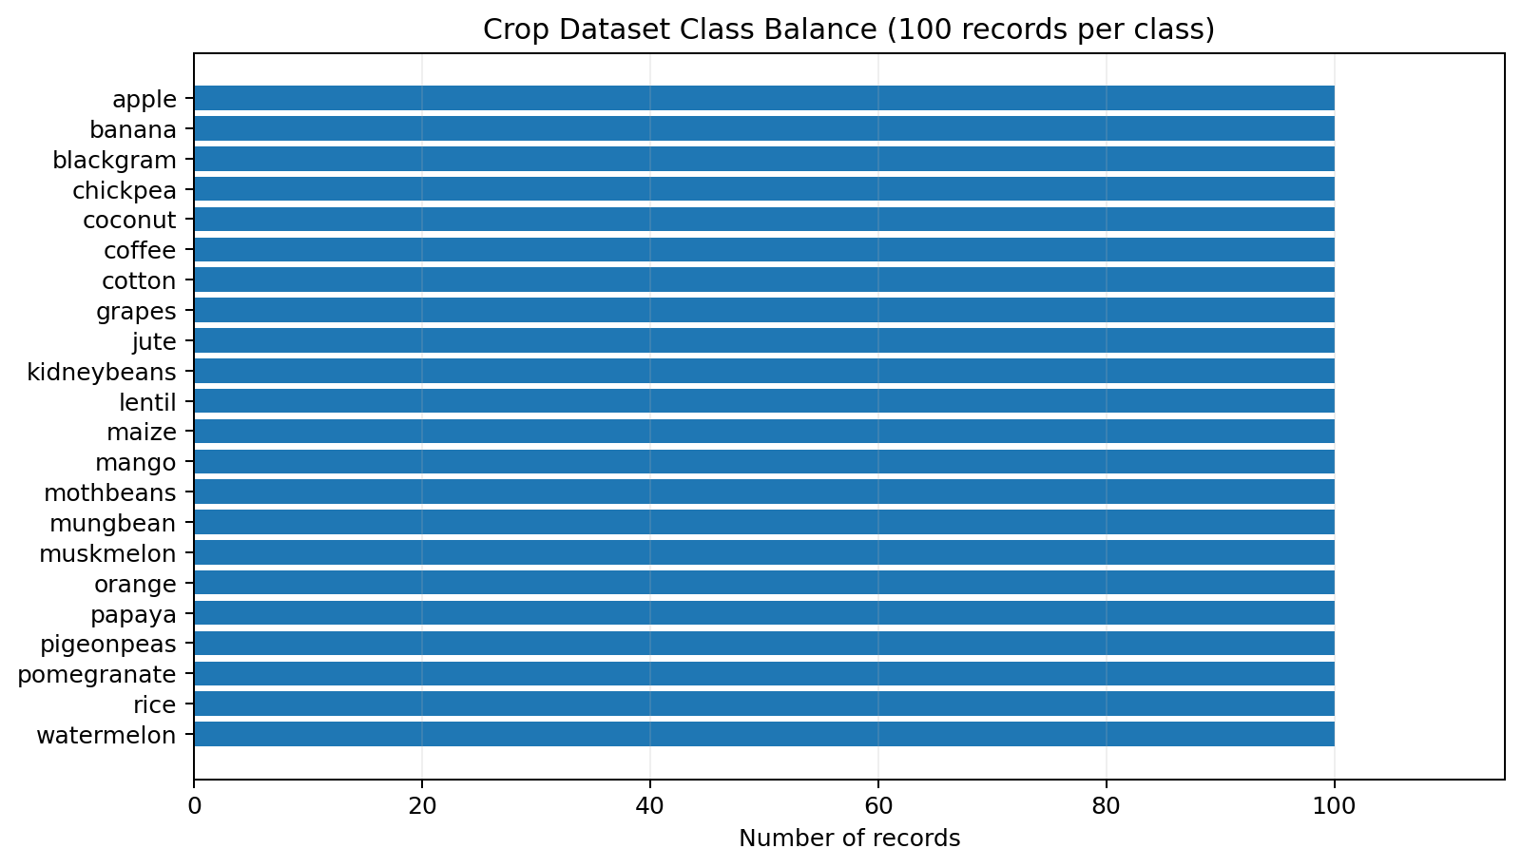
Interpretation: each of the 22 crop classes has 100 records, so the dataset is balanced by class count. A balanced label distribution is useful for comparing class-wise metrics, although it does not by itself prove that the dataset represents real-world crop frequencies.

15.2 Crop Classification Cross-Validation Accuracy
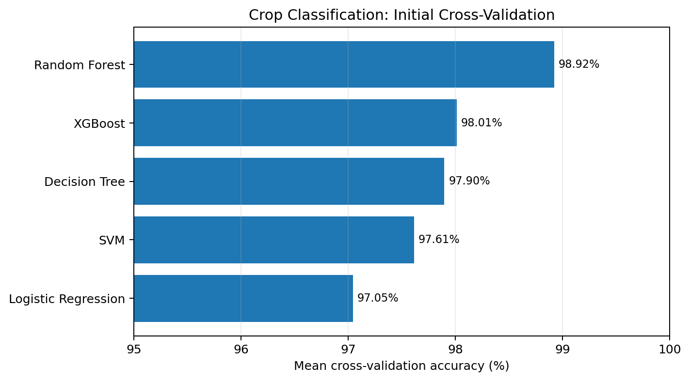
Interpretation: Random Forest achieved the highest initial mean cross-validation accuracy among the reported candidates at approximately 98.92%, followed by XGBoost at approximately 98.01%. These are reported initial results; the feature-selection leakage audit remains necessary before presenting them as final unbiased estimates.

15.3 Yield Regression MAE
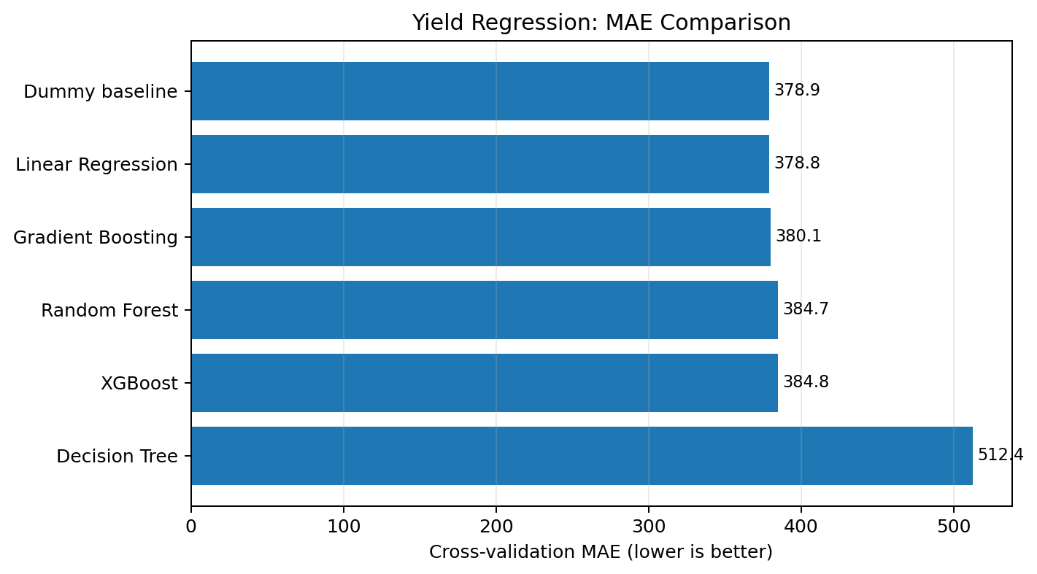
Interpretation: lower MAE is better. The Dummy baseline and Linear Regression have similar MAE values (about 378.9 and 378.8 respectively), while the other tree-based models have larger errors in this experiment. This supports the conclusion that the tested models did not provide meaningful improvement over the baseline.

15.4 Yield Regression R²
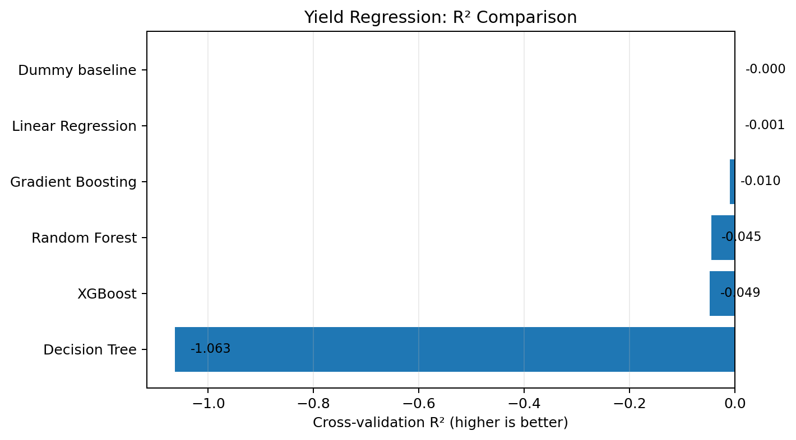
Interpretation: R² values near zero indicate performance close to a mean-based baseline under the reported evaluation, while negative values indicate worse performance than that reference for the evaluated folds. All listed regression candidates have R² at or below zero, and the Decision Tree result is substantially worse. These values do not establish why the target is difficult to predict.

15.5 Important Interpretation Notes
- The plots use previously reported evaluation metrics; they do not claim a new model run.
- The 100% crop classification score from evaluating the saved model on its training rows is not plotted as an evaluation result because it is an in-sample score.
- The preliminary XGBoost holdout result is discussed in the text but is not treated as a final unbiased estimate.
- No actual-versus-predicted yield test plot is included because the selected yield test table has no true yield target.
- No geographic map is included because verified geographic coordinates or identifiers were not found in the inspected schemas.

16. Additional Model Evaluation Plots
These six additional plots use numerical results already reported during the project. They do not represent a new training run. Dataset-dependent diagnostics such as feature histograms, a correlation heatmap, a true confusion matrix, PCA cluster scatter, and actual-versus-predicted yield require the underlying data or saved prediction outputs; they are not fabricated here.

16.1 Crop Classification Accuracy (Detailed View)
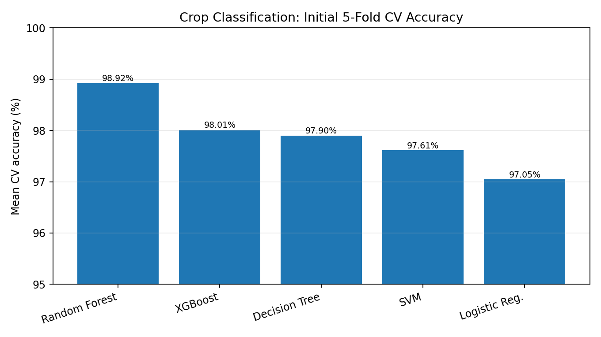
Random Forest has the highest reported initial mean CV accuracy (98.92%) among these candidates. Treat this as preliminary until feature-selection leakage is audited.

16.2 Random Forest Classification Metrics
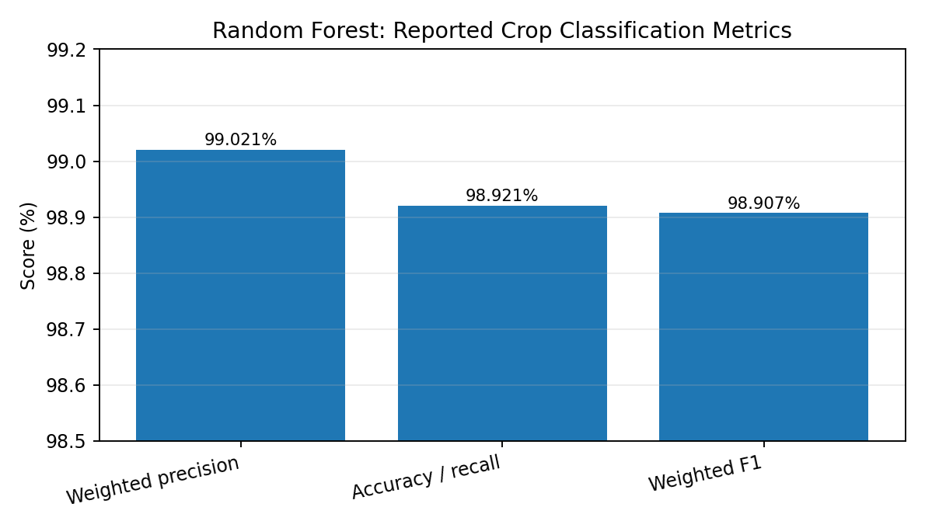
The reported weighted precision, accuracy/recall, and weighted F1 are all close to 99%. They summarize the reported evaluation and should not be interpreted as proof of real-world performance.

16.3 Yield Regression Error Comparison
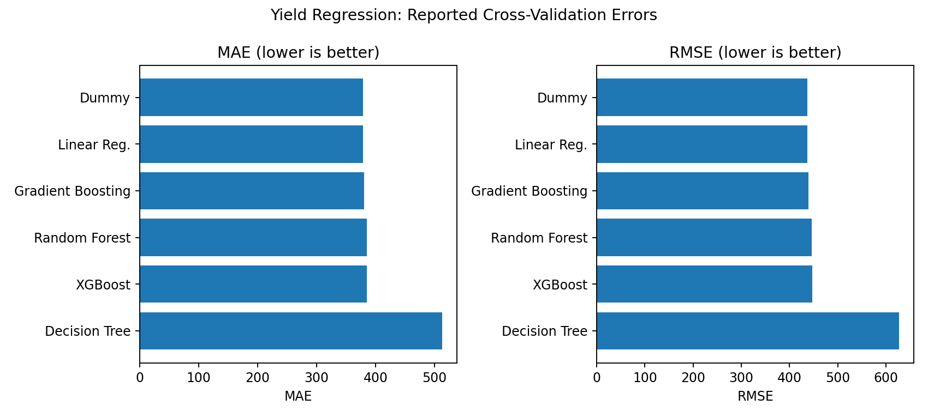
MAE and RMSE are shown in separate panels because their scales differ. Lower values are better. The Decision Tree has substantially higher errors in this reported experiment.

16.4 Yield MAE Change vs Dummy Baseline
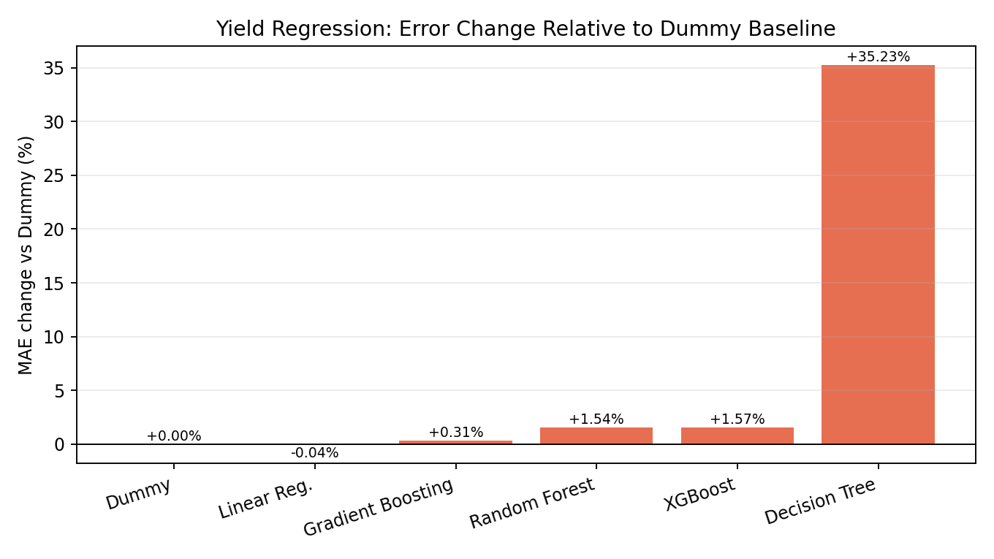
Negative values mean slightly lower MAE than the Dummy baseline; positive values mean higher MAE. The small difference for Linear Regression is not enough by itself to establish a meaningful improvement.

16.5 Tuned Yield Models: Exploratory OOF R²
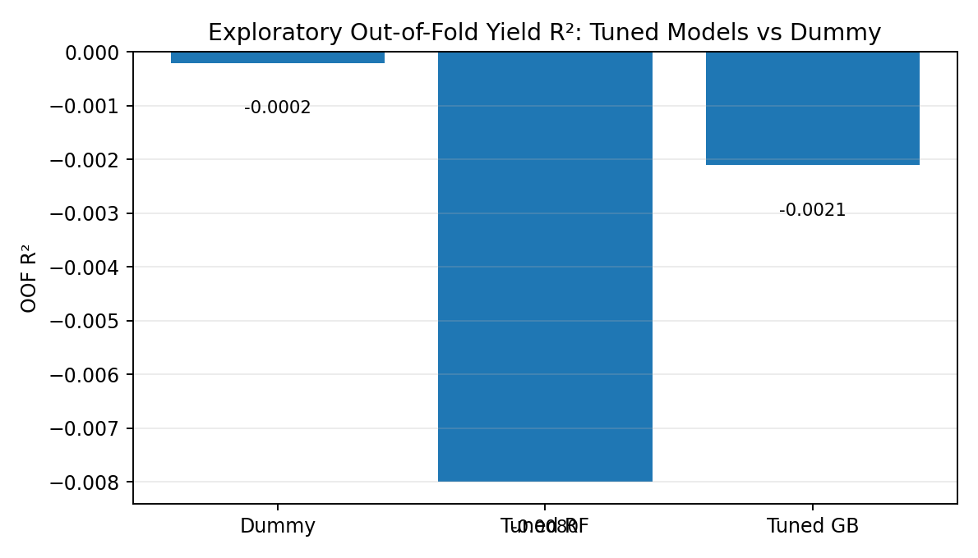
The tuned models remain below the Dummy baseline in the reported exploratory out-of-fold R² comparison. These are exploratory results, not an independent final test estimate.

16.6 Tuned Yield Models: Exploratory OOF MAE
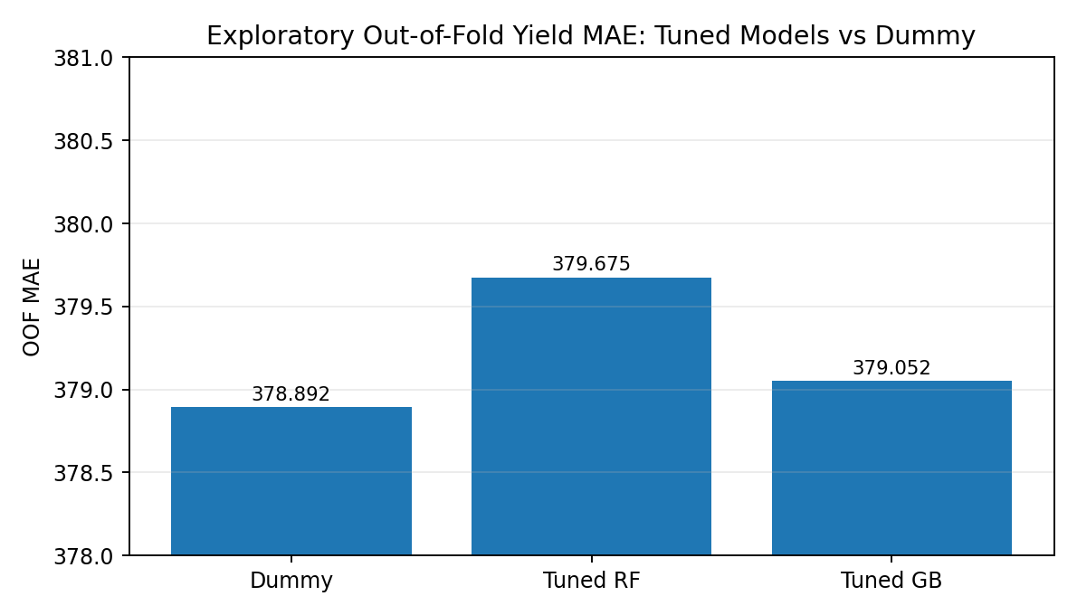
The tuned models do not beat the Dummy baseline MAE in these reported out-of-fold results. This supports reporting the regression task as unresolved rather than claiming successful yield prediction.

16.7 Further Data-Dependent Plots to Generate
The following would be valuable additions once the original SQLite database and the relevant validation predictions are available: (1) feature histograms for temperature, rainfall, humidity, soil pH, and organic matter; (2) a numeric-feature correlation heatmap; (3) a confusion matrix from held-out crop predictions; (4) PCA visualization of the fitted crop clusters; (5) actual-versus-predicted yield and residual plots from validation folds. These plots must be built from actual rows/predictions. The selected yield test table has no true yield column, so it cannot support a test-set actual-versus-predicted plot.

