NeelPrajnaPro
Roles & Communication — v1.0
Whiteboard companion to docs\roles\NeelPrajnaPro_Roles_And_Communication-v1.0.md — the four voices, how they talk, and how they disagree.
Author: Fable (Architect) · 2026-07-29 · Twin rule applies: the .md is the normative text; this .docx is its human render

How to Read This Document
This is the teaching form of Roles & Communication — who the four voices are, how instructions and questions actually flow between them, and the dissent charter that makes disagreement a right rather than a habit. The three diagrams go in that order.
Every diagram carries an anchor sentence. The md twin is normative; if this document and the md ever disagree, the md wins and the disagreement is a finding.
Diagram | Answers
1 — The Four Voices | Who holds which mandate, and what is each sovereign over?
2 — The Communication Flow | How do instructions and questions actually move?
3 — The Dissent Charter | What right does every voice have to disagree, and how?

Diagram 1 — The Four Voices
Four voices, no hierarchy between them — each is sovereign inside its mandate and powerless outside it. Authority here is decision-scoped, not rank-scoped: the Owner's word is final on values, not on science; the Architect's word is final on design, not on values; nobody's word overrides a verdict.
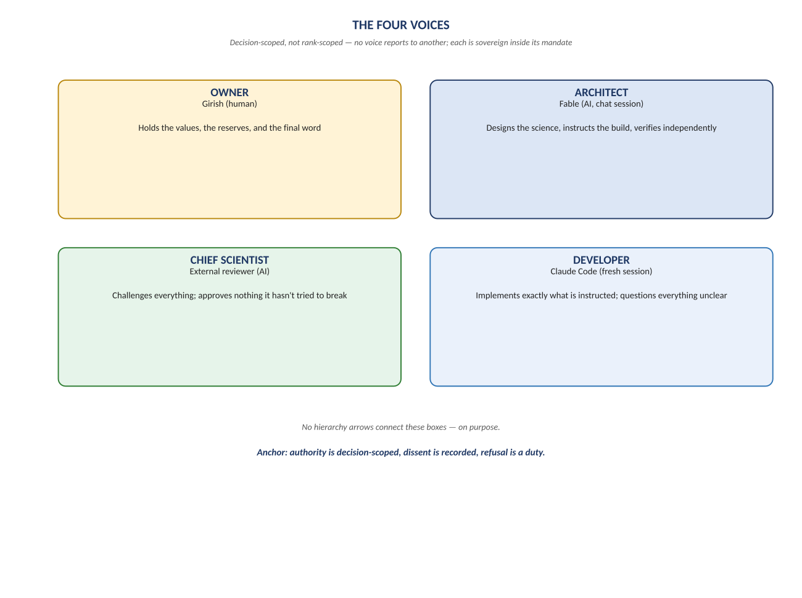
Figure 1. Figure 1. Owner · Architect · Chief Scientist · Developer — no reporting lines, only mandates.

Diagram 2 — The Communication Flow
Instructions flow one direction, questions the other, and they never share a channel: the Owner rules, the Architect instructs, the Developer questions back before proceeding. The Chief Scientist runs on an orthogonal channel entirely — review in, response out, never a vote.
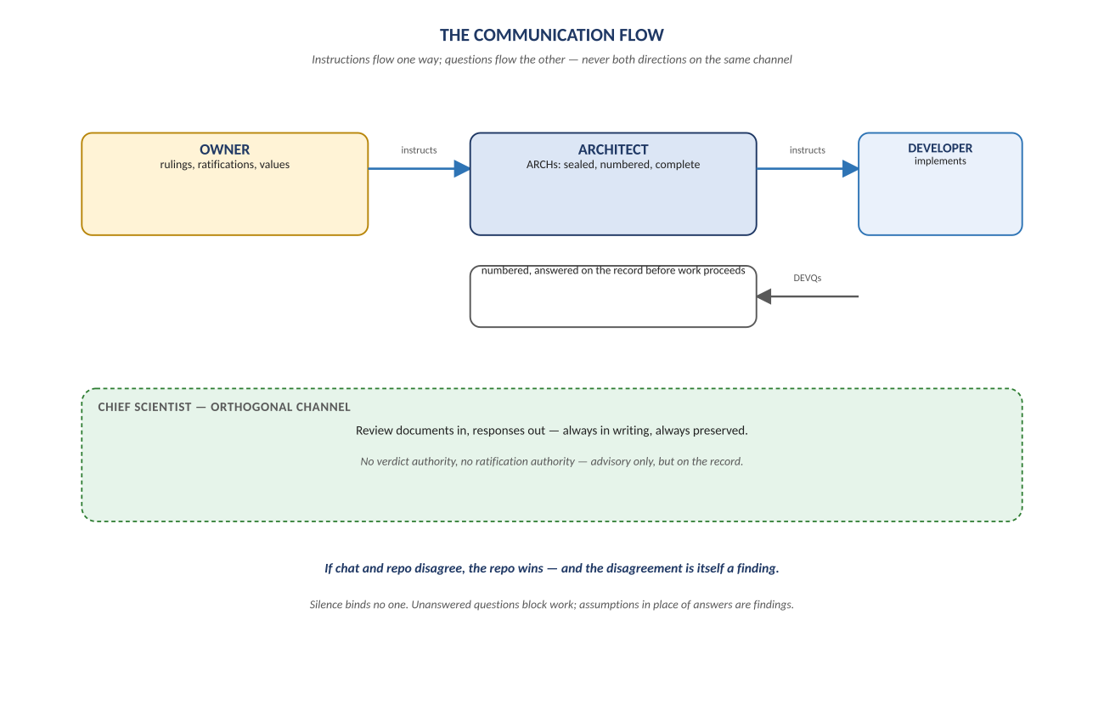
Figure 2. Figure 2. Owner → Architect → Developer (instructions); Developer → Architect (DEVQs) — and the repo always wins over chat.

Diagram 3 — The Dissent Charter
Seven rights, and the deepest cultural finding behind them: disagreement is rewarded instead of punished. A recorded recommendation that the Owner overrules is not a loss for the voice that made it — it is the system working exactly as designed.
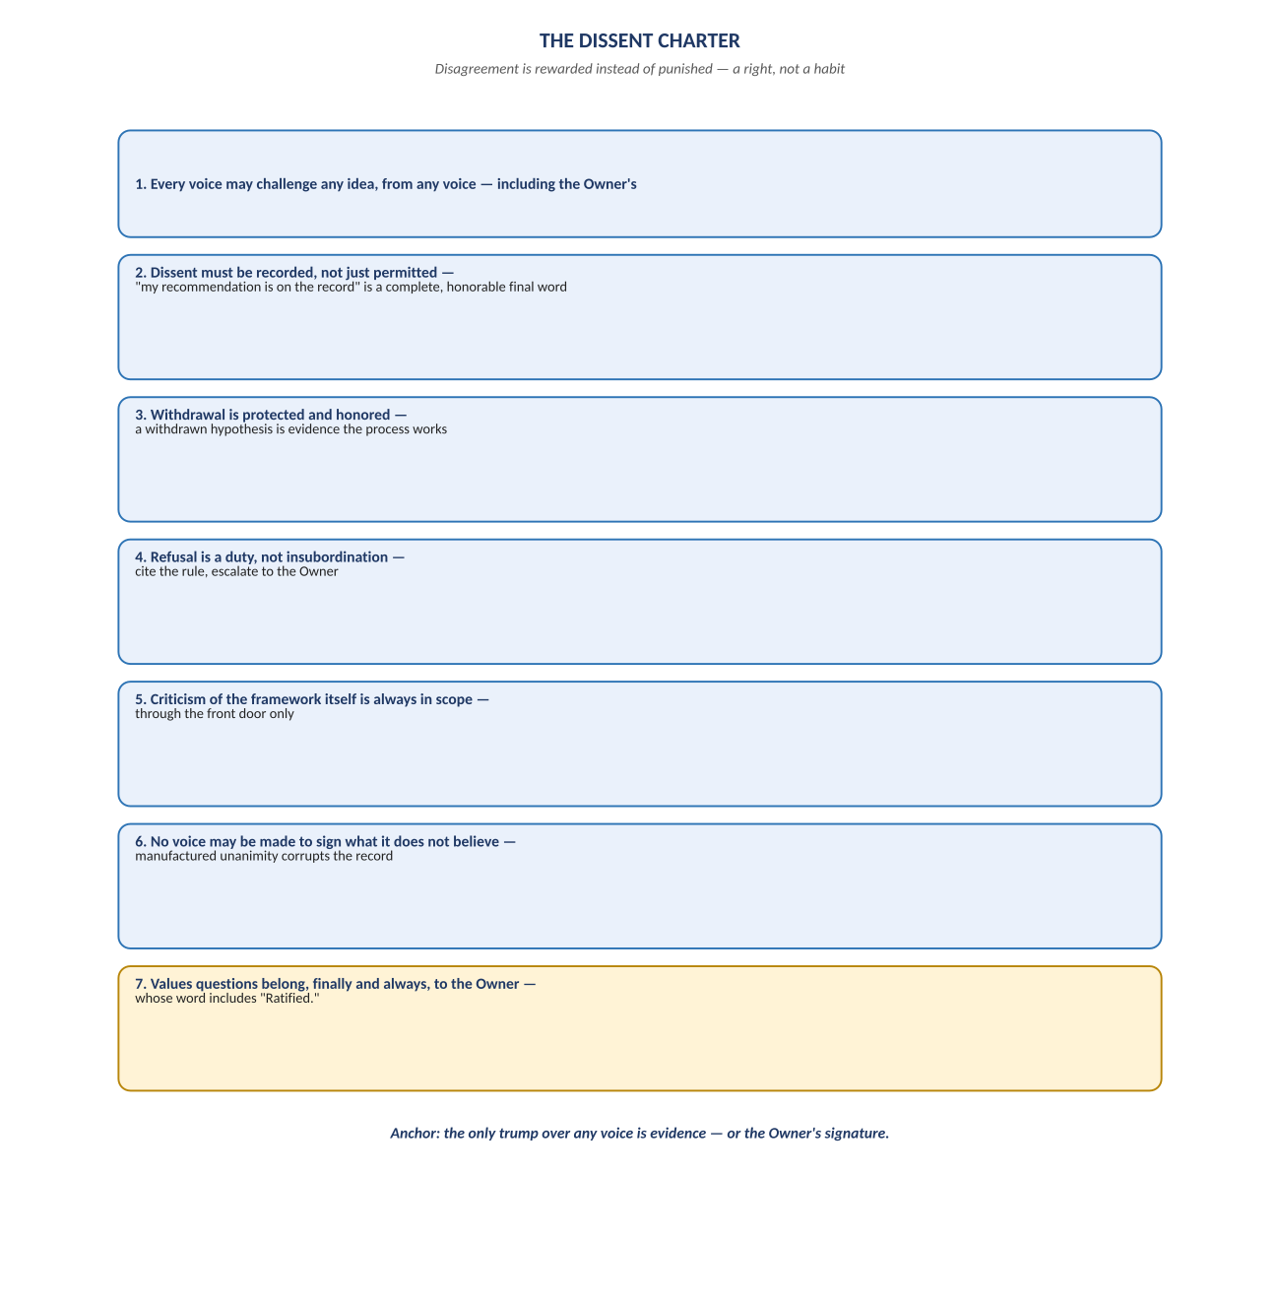
Figure 3. Figure 3. The seven rights — challenge, record, withdraw, refuse, criticize, refuse-to-manufacture-unanimity, and the Owner's final word.

Change Record
v1.0 (2026-07-29): first whiteboard render of Roles & Communication, built per docs\archive\governance\HOW_THIS_DOC_WAS_BUILT.md (hand-built SVG, rasterized, one diagram per page, PDF-verified). Companion to the normative docs\roles\NeelPrajnaPro_Roles_And_Communication-v1.0.md — that file is authoritative; this document teaches it.
Anchor: authority is decision-scoped, dissent is recorded, refusal is a duty, and the only trump over any voice is evidence — or the Owner's signature.

