NeelPrajnaPro
Constitution — v1.0
Whiteboard companion to docs\constitution\NeelPrajnaPro_Constitution-v1.0.md — RATIFIED 2026-07-29 — taught in four diagrams.
Author: Fable (Architect) · 2026-07-29 · Twin rule applies: the .md is the normative text; this .docx is its human render

How to Read This Document
This is the teaching form of the Constitution — the identity, principles, and permanent boundaries this ratified charter establishes. The four diagrams go in the order a reader needs them: first the twelve immutable principles that govern every claim, then the one boundary that keeps learning and acting in separate organs, then the six powers no automation may ever touch, and finally how the Constitution itself may — rarely, and at increasing cost — be changed.
Every diagram carries an anchor sentence. The md twin is normative and FROZEN on ratification; if this document and the md ever disagree, the md wins and the disagreement is a finding.
Diagram | Answers
1 — The Twelve Principles | What governs every claim, immutably?
2 — The Knowledge Publication Boundary | What may cross from execution to research, and back?
3 — Permanently-Human Powers | What no automation may ever touch?
4 — The Amendment Procedure | How, rarely, does the Constitution itself change?

Diagram 1 — The Twelve Principles
Twelve principles, immutable, govern every claim this programme ever makes — from P1's observations-before-interpretation to P12's boundaries-hold-under-convenience. The presumption is against amending any of them; the burden of proof is the proposer's.
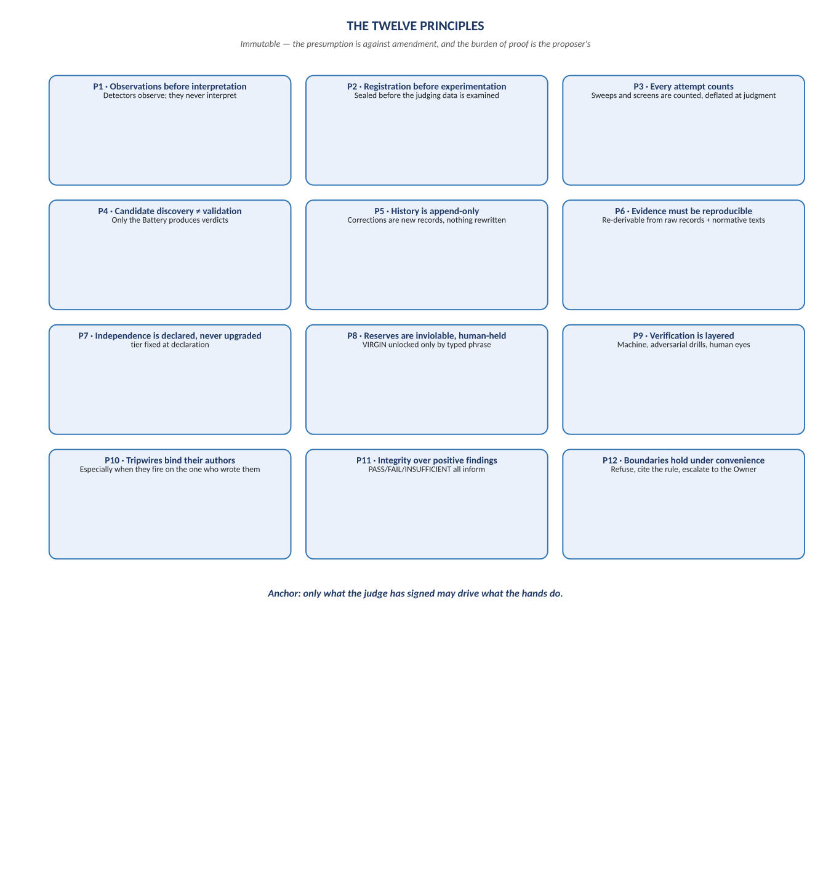
Figure 1. Figure 1. P1 through P12 — the twelve immutable principles, Section 2.

Diagram 2 — The Knowledge Publication Boundary
This is the constitutional fix for a real flaw the source documents carried: execution feedback enters only as observations, and only Battery-verdicted, sealed, dated beliefs may ever cross back out. No rolling statistic, no 'recent performance,' ever crosses either way.
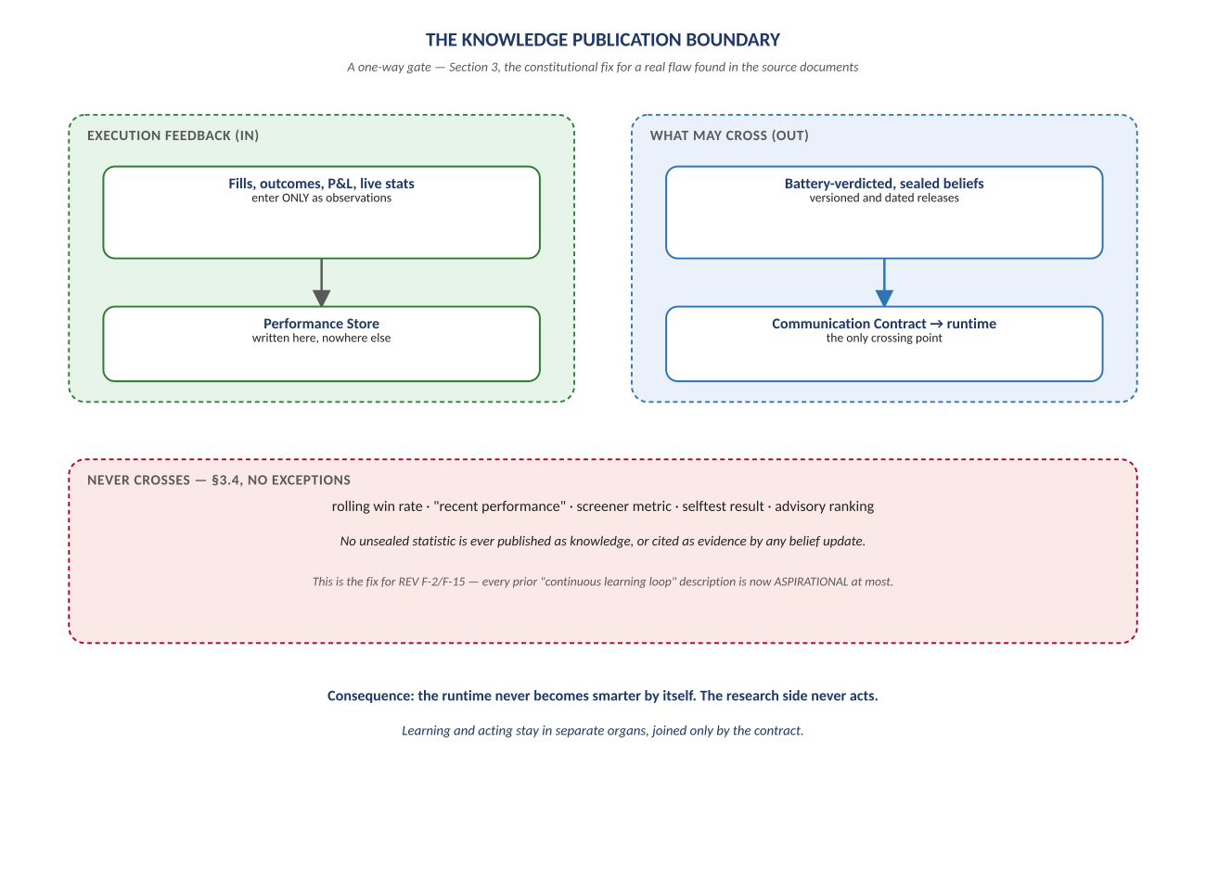
Figure 2. Figure 2. Execution feedback in as observations; only sealed beliefs out — Section 3.

Diagram 3 — Permanently-Human Powers
Six powers sit outside every autonomy envelope this programme will ever build, and stay there unless the Owner's own typed hand amends this section. An automation proposal that would touch one of these is refused by rule — it is not a case to be argued.
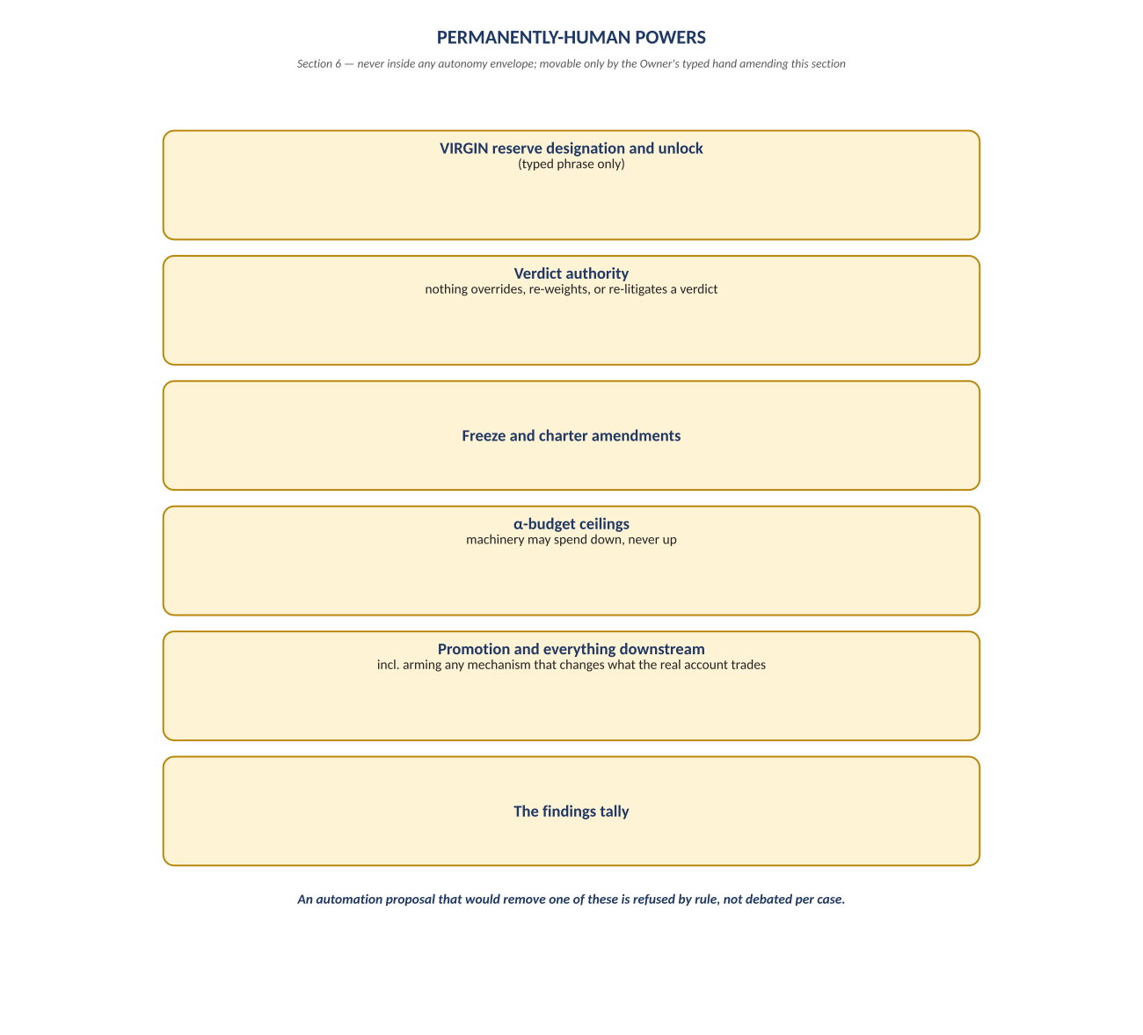
Figure 3. Figure 3. VIRGIN designation · verdict authority · freezes · α-budgets · promotion & arming · the findings tally — Section 6.

Diagram 4 — The Amendment Procedure
Three tiers, each demanding more than the last: a clarification needs only the Owner's read and OK; a substantive amendment needs an evidence-bearing ADR and a Chief Scientist review; a change to a Principle or to Sections 3 or 6 needs all of that, plus a recorded statement of why the old rule no longer serves. There is no vote, at any tier — the Owner ratifies alone.
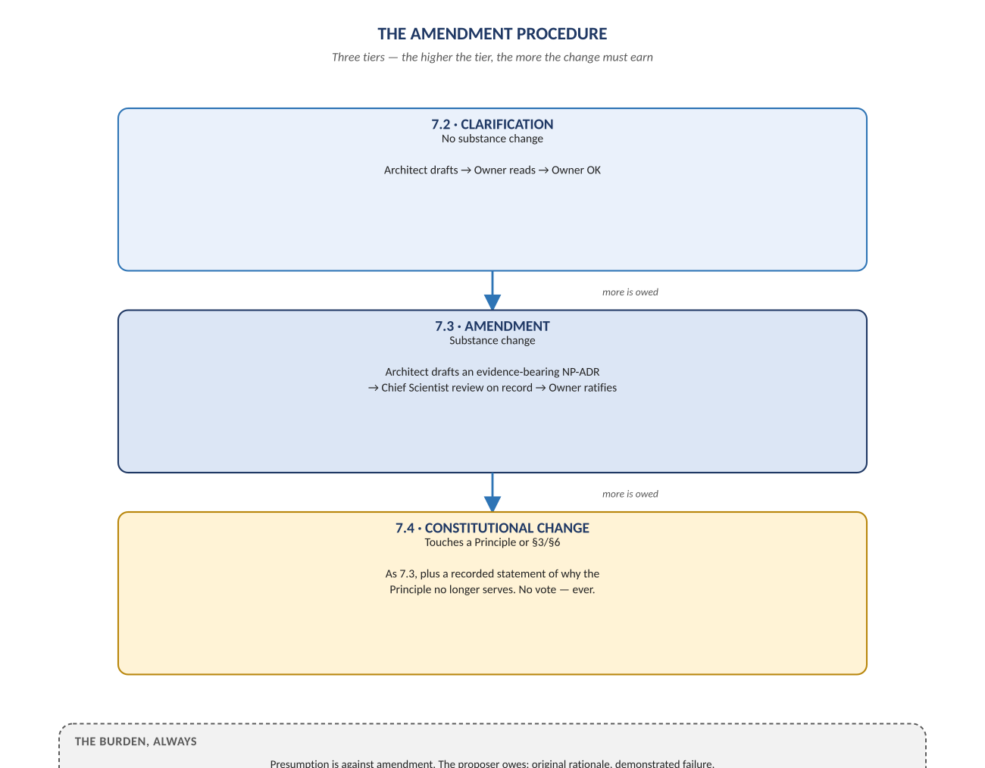
Figure 4. Figure 4. Clarification → Amendment → Constitutional Change — Section 7.

Change Record
v1.0 (2026-07-29): first whiteboard render of the Constitution, built per docs\archive\governance\HOW_THIS_DOC_WAS_BUILT.md (hand-built SVG, rasterized, one diagram per page, PDF-verified). Companion to the normative docs\constitution\NeelPrajnaPro_Constitution-v1.0.md — that file is authoritative and FROZEN on ratification; this document teaches it.
Anchor: only what the judge has signed may drive what the hands do.

