NeelPrajna Programme
Architecture Diagrams — Top-to-Bottom Views

Eight layered diagrams covering the Core Kernel, the NeelPrajna trading plug-in,
governance, the evidence pipeline, and the redesigned documentation tree
Visual Architecture Companion • July 2026

How to Read These Diagrams
Each diagram in this companion follows a strict top-to-bottom convention: the highest box is always the least specific / most upstream element (the market, the owner, the entry point), and each row below it is a step closer to a concrete outcome (an order, a verdict, a folder of files). Arrows always point in the direction information or authority actually flows — a bidirectional relationship is drawn as two separate arrows in opposite directions, never a single double-headed one, so the two directions can carry different object types without ambiguity.
The diagrams are grouped to match the two prior analysis volumes and the documentation redesign delivered earlier in this engagement: Diagrams 1–3 cover the Core/Book split and its contract; Diagrams 4–5 cover the live NeelPrajna trading plug-in as built; Diagram 6 covers governance; Diagram 7 covers the evidence pipeline that makes autonomous discovery safe; Diagram 8 covers the redesigned documentation tree itself.
CORRECTED 2026-07-29: Diagrams 2 and 7 originally used component names and a pipeline shape abstracted from the Platform Architecture document, before the real F:\QRF Kernel repository (a separate, ten-sprint, Generation-1-closed codebase) had been read. Both are now regenerated against the real qrf/kernel/ source. Diagram 3 is annotated as a design sketch, not yet implemented, with a pointer to the concrete first integration step proposed in NeelPrajna_QRF_Integration_Path.docx.

Diagram 1 — Programme Architecture (Top-Down)
The full programme in one view: a single Observation Engine feeds both organs, Core and Book A communicate continuously in both directions, and every trade eventually returns as feedback into the Core's knowledge base. The Chief Scientist Principle sits at the bottom because it is the outcome every layer above it exists to protect, not a precondition to read first.
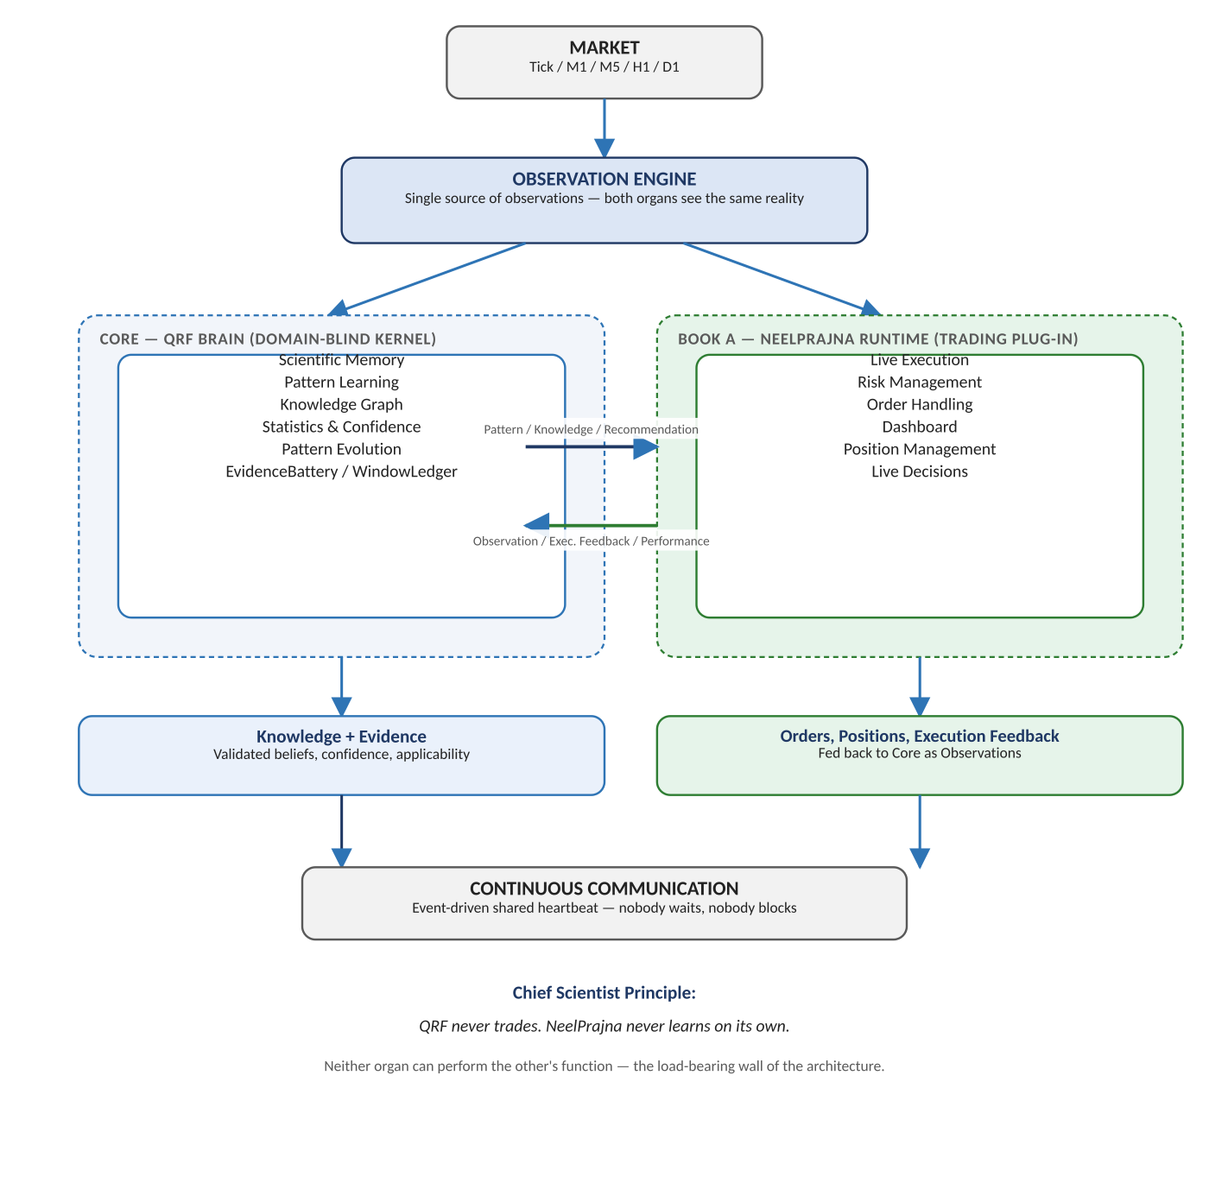
Figure 1. Market → Observation Engine → Core / Book A → feedback loop.

Diagram 2 — Core Kernel Components
CORRECTED 2026-07-29: the original version of this diagram used component names abstracted from the Platform Architecture document. The real F:\QRF repository (a separate, ten-sprint, Generation-1-closed codebase) has since been read directly, and the diagram below now uses the real module paths — qrf/kernel/records/store.py, battery/battery.py, protocol/windows.py, and so on — with the EvidenceBattery highlighted as the only component permitted to issue a Verdict, exactly as its real code enforces.
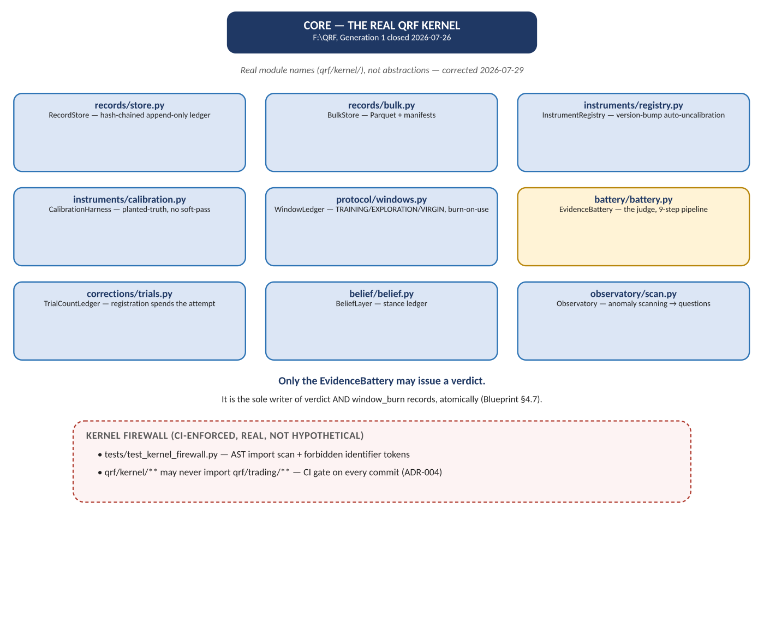
Figure 2. The real qrf/kernel/ module tree and the CI-enforced firewall — corrected against F:\QRF, not the abstract Platform Architecture sketch.

Diagram 3 — The Communication Contract
NOTE ADDED 2026-07-29: this diagram remains a design sketch, not a built contract — there is no implemented Communication Contract between the real QRF Kernel and NeelPrajna today. Six object types, three flowing down from Core to Book A and three flowing up, plus the two prohibitions that would keep each side from depending on the other's internals. See NeelPrajna_QRF_Integration_Path.docx for the concrete, buildable first step toward making this real: porting one NeelPrajna hypothesis (H-07) into the actual Kernel.
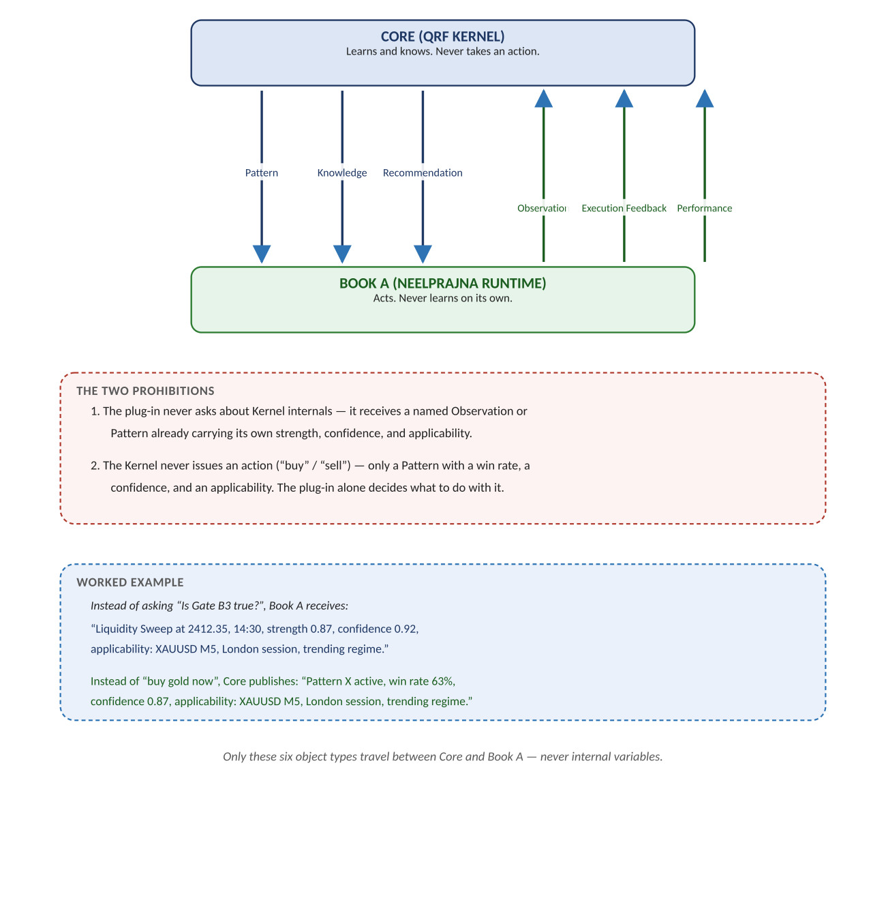
Figure 3. The six-object contract as designed — not yet implemented; see the Integration Path document for the real first step.

Diagram 4 — Book A: The Four-Layer MQL5 Refactor
ADR-001's layering, shown as a literal top-to-bottom stack with a strict downward-only include rule. This is the pattern the Platform Architecture later generalizes at the whole-programme level in Diagrams 1–3 — the same discipline, first proven inside one Application Book.
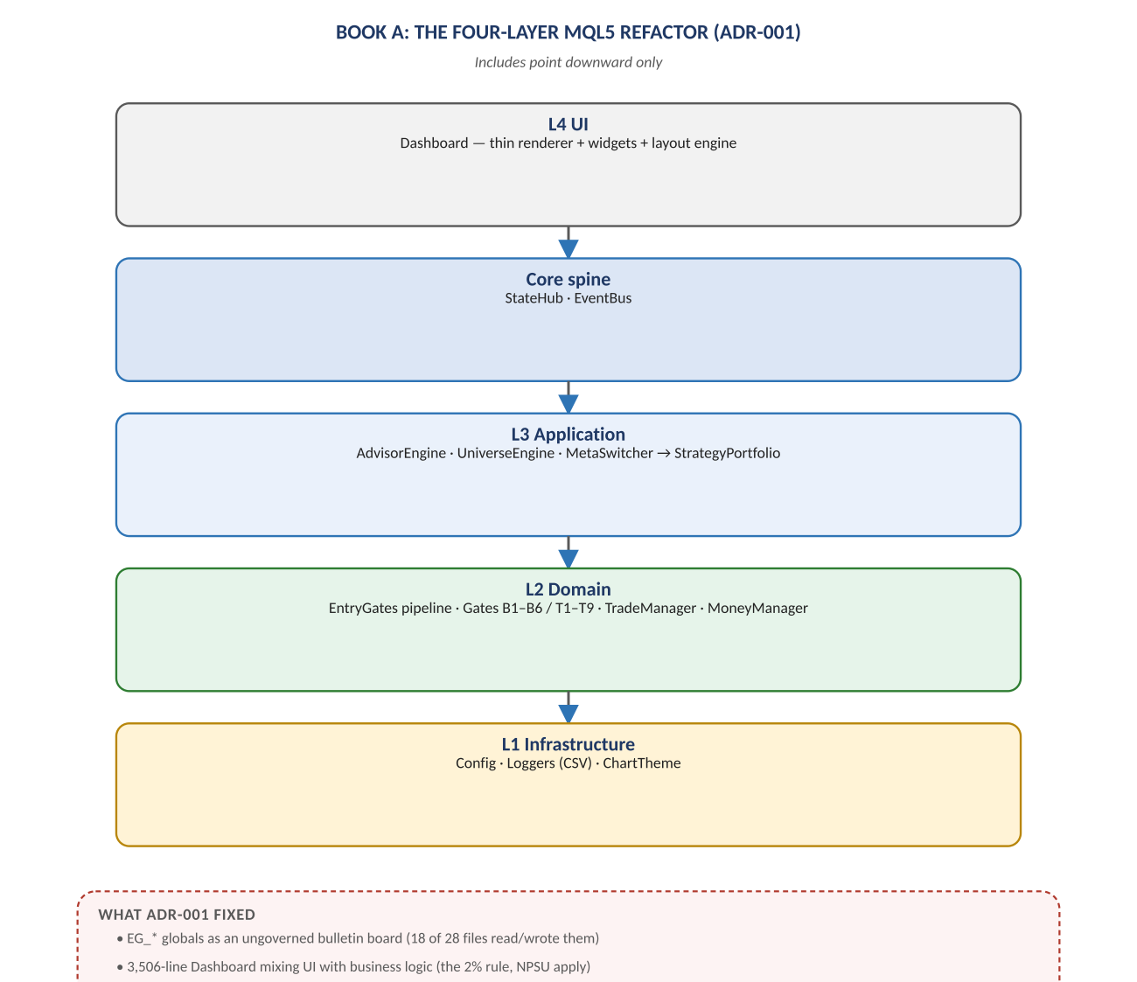
Figure 4. UI → Core spine → Application → Domain → Infrastructure, includes point downward only.

Diagram 5 — NPSU: The Shadow-Universe Research Subsystem
NPSU's own top-to-bottom pipeline: from the shared market feed, through up to 63 virtual universes and four independent layers of verification, to an advisory ranking, and finally to the one gate — human one-click apply — that may ever touch the real account. The standing rule at the bottom was written directly in response to a real failure (see the Lesson Register, LR-004).
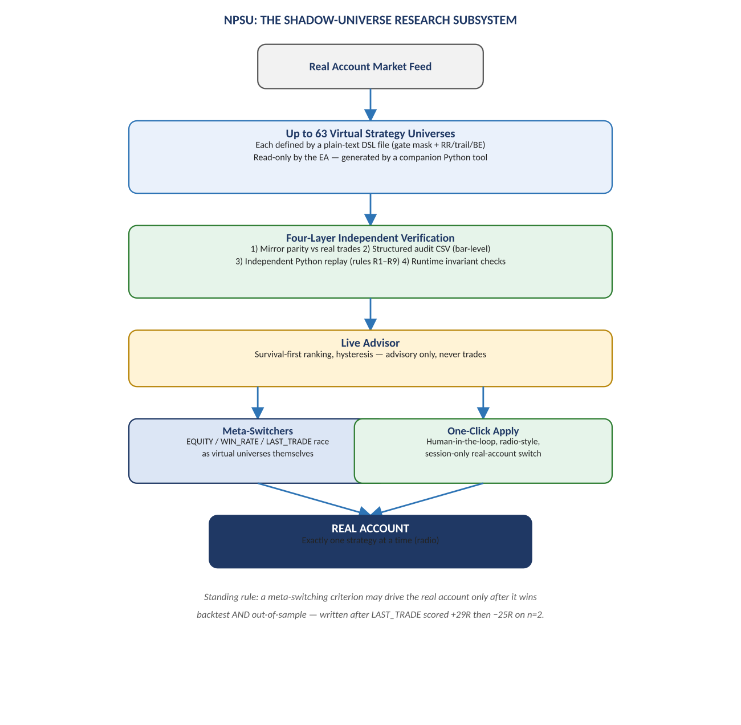
Figure 5. Market feed → virtual universes → verification → advisor → human-gated real account.

Diagram 6 — Governance: Supervisor / Runner Trust Split
The owner sits at the top, not because governance is decorative, but because every level of autonomy below it is only as trustworthy as the frozen Supervisor the owner reviewed once. The autonomy ladder and the seven invariants are shown beneath as the concrete mechanism that makes the top-level governance claim actually true in practice.
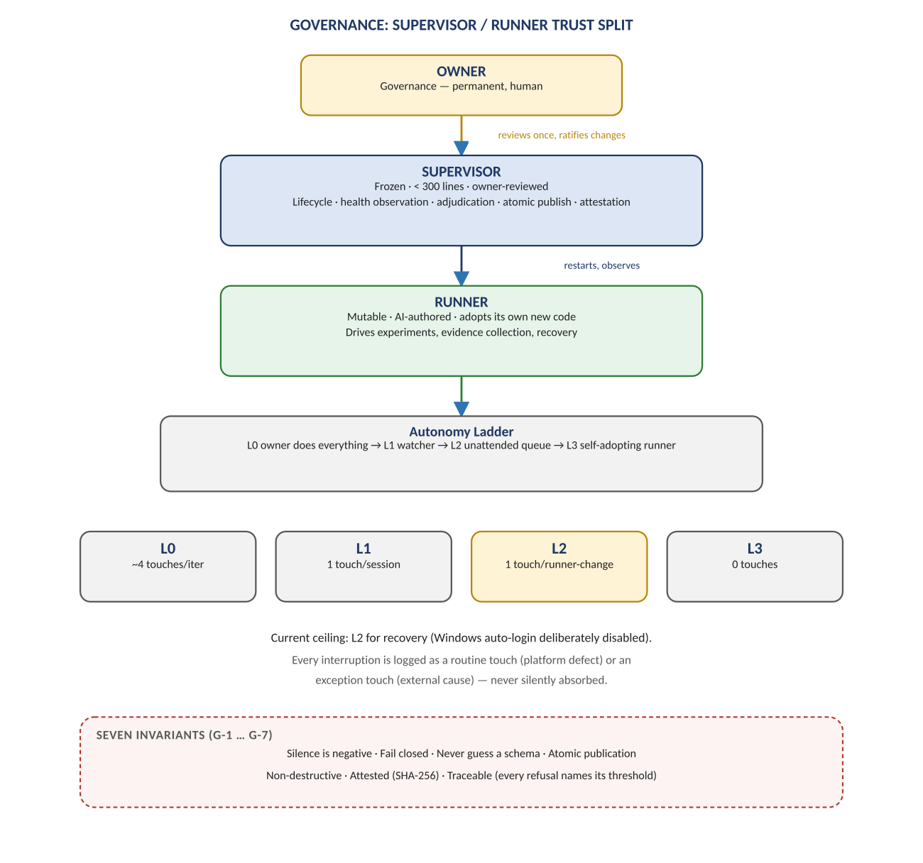
Figure 6. Owner → frozen Supervisor → mutable Runner → autonomy ladder → seven invariants.

Diagram 7 — The Evidence Pipeline
CORRECTED 2026-07-29: the original version of this diagram sketched a five-path pipeline in the abstract. The real F:\QRF Battery (qrf/kernel/battery/battery.py) implements a more specific and more defensive nine-step version, shown below exactly as the code enforces it: a type check on the simulator, a selftest gate re-verified on every run, window checks that refuse contaminated or already-burned data, anchored walk-forward splits, an audited simulator, a claim-matched placebo, trial-count correction, a tri-state verdict, and an atomic write of the verdict together with its window burn.
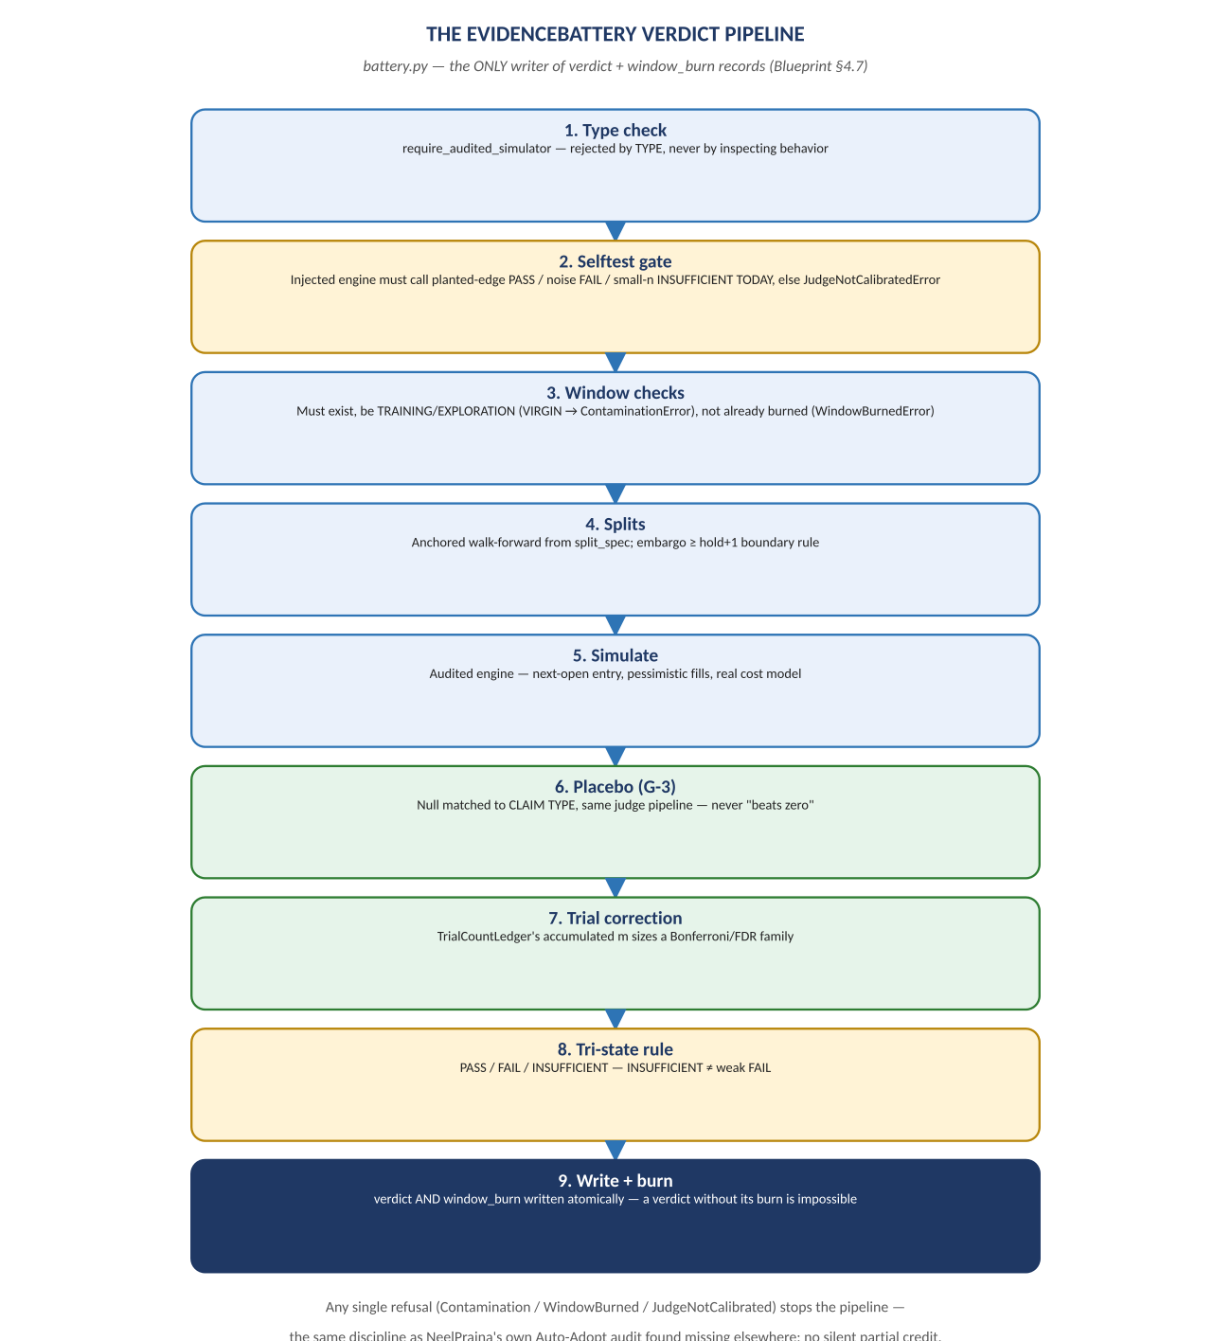
Figure 7. The real nine-step EvidenceBattery pipeline — corrected against battery.py, not the abstract five-path sketch.

Diagram 8 — The Redesigned Documentation Tree
The documentation architecture delivered earlier in this engagement, drawn the same way as every other diagram in this companion: one entry point at the top, six folders beneath it, each with a single owner and a single question it answers. This is the only diagram in this set describing files rather than running systems — included here because it is itself part of the architecture, not separate from it.
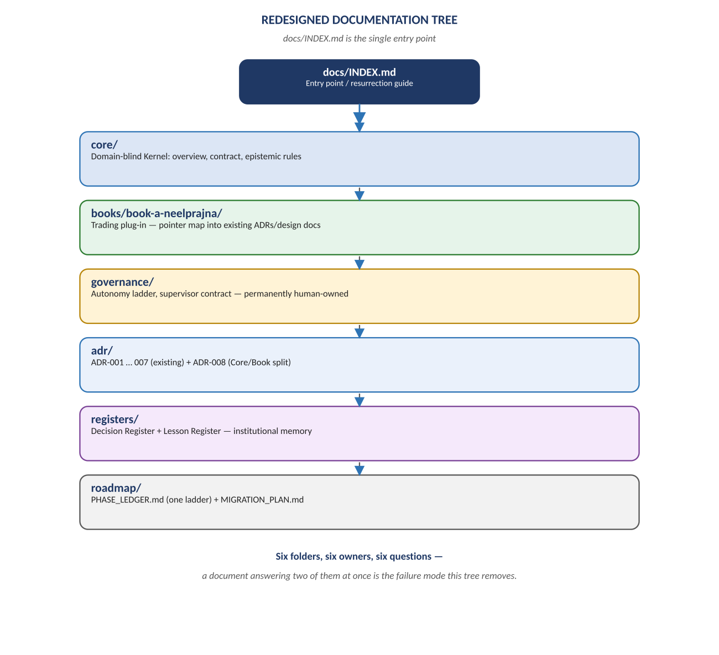
Figure 8. docs/INDEX.md and the six folders it points to.

