NeelPrajna
Deep Audit Addendum: Auto-Adopt Runtime & Meta-Switchers

A feature omitted from the earlier existing-implementation diagram set:
the EA's own ability to switch the real account's strategy at runtime
Audit Addendum • Sourced from AdvisorEngine.mqh / MetaSwitcher.mqh • July 2026

1. What was missed, and why it matters
The earlier “Existing Implementation” diagram set covered NPSU's shadow universes, its four-layer verification, and — in the governance diagram — the general autonomy ladder. It did not give a dedicated diagram to a specific, already-shipped feature: InpADV_AutoAdopt, the input the person flagged directly from the live dashboard dropdown. This is a real gap, not a cosmetic one, because this single input is the one place in the entire codebase where the EA is permitted to change what the real account trades without a human clicking anything.
The screenshot supplied shows the dropdown exactly as implemented: option 4 (“manual — decide from the Python reports”) is the default NONE state, and options 1–3 (win rate, account value, last trade) are the three live auto-adopt criteria. The enum values in AdvisorEngine.mqh confirm this precisely — including the seemingly reversed numbering, which is not a UI bug: NONE is enum value 0 but is labelled “4” in its own comment, matching the order the dropdown displays them in.
ADV_AUTO_NONE = 0, // 4: manual — decide from the Python reports (default)
ADV_AUTO_WINRATE = 1, // 1: highest win rate (tiebreak: net R)
ADV_AUTO_EQUITY = 2, // 2: highest account value (net R)
ADV_AUTO_LASTTRADE = 3 // 3: best last trade — whoever is in form right now

2. The core finding: two switching paths, two different safety levels
AdvisorEngine.mqh implements two genuinely separate mechanisms that are easy to conflate because they share the same ranking criteria and the same universes. Reading the source closely (ADV_OnBar) shows they are not one feature with two settings — they are two independent code paths with materially different safety properties.
- Path A — Auto-Adopt (_ADV_AutoAdopt). Runs on every single bar, unconditionally — even when the advisory module itself is disabled. Once a universe clears warm-up (InpADV_AutoWarmup trades) and the cooldown timer (InpADV_AutoCooldownMins) has elapsed, it is applied to the real account immediately, on the very first qualifying evaluation. There is no hysteresis in this path at all.
- Path B — Advisory Recommendation (the InpADV_Enabled branch). Requires an eligibility bar (InpADV_MinTrades window trades, plus an out-of-sample validated=1 flag by default) and, critically, requires a challenger to win InpADV_ConfirmEvals (default 3) consecutive evaluations before the recommendation changes — and even then it only ever produces a recommendation. It never touches the real account itself; a human must click apply.
Put plainly: the safety mechanism most people would assume protects the real account — hysteresis against a single noisy window — only protects the human-facing recommendation. The mechanism that can actually move real capital has no such protection; it is guarded only by a trade-count warm-up and a cooldown timer, both of which can be satisfied by variance rather than genuine edge.

3. Diagram — Auto-Adopt Runtime & Meta-Switchers
The diagram below traces both paths from the shared entry point (ADV_OnBar, called every M1 bar) through to the one place they converge: Portfolio_ApplyStrategy, the same radio-style, session-only real-account switch a human's one-click apply uses. It also shows where the three meta-switchers sit — racing as virtual participants under the identical criteria, but structurally barred from ever being an Auto-Adopt candidate themselves.
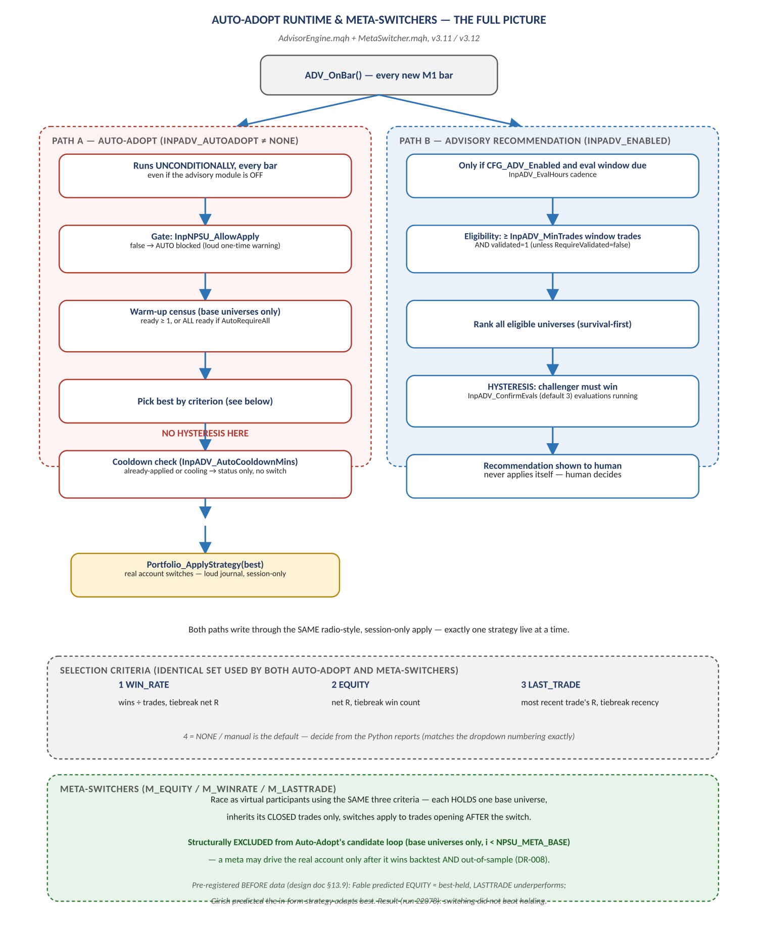
Figure 9. ADV_OnBar → Auto-Adopt (no hysteresis) / Advisory (hysteresis) → shared apply path → meta-switchers.

4. Every safety gate actually in the code (so none are assumed)
Input / Mechanism | What it actually guards against | What it does NOT guard against
InpNPSU_AllowApply (master gate) | Any apply at all, human or automatic, if left false | Nothing once true — it is a blanket on/off, not a per-criterion permission
InpADV_AutoWarmup (default 10 trades) | Adopting a universe with almost no track record | A universe that got lucky in exactly its first 10 trades — warm-up counts trades, not significance
InpADV_AutoRequireAll | Adopting before slower gates have any data, if set true | Off by default; can itself block adoption indefinitely on a slow gate if enabled
InpADV_AutoCooldownMins (default 60) | Rapid flip-flopping between strategies | A single bad switch happening at all — cooldown limits frequency, not correctness
Meta-switcher exclusion (i < NPSU_META_BASE) | A meta-switcher ever driving the real account directly via Auto-Adopt | Nothing once a meta wins backtest + OOS and is promoted — that promotion is a human, governance-level decision (DR-008), not a code gate
Radio / session-only apply | More than one strategy live on the real account at once; a setting surviving an EA restart unintentionally | The switch itself being wrong — it only bounds the blast radius, it does not validate the choice
InpADV_ConfirmEvals hysteresis | The human-facing recommendation flipping on one noisy window | Auto-Adopt — this gate does not apply to Path A at all (see §2)

Read as a whole, the table shows the real protection against a bad Auto-Adopt decision today is entirely rate-based (warm-up, cooldown) rather than significance-based (a statistical test, an out-of-sample check, or the ConfirmEvals hysteresis the advisory path enjoys). This is consistent with the feature's own design comment — “the auto-switcher is itself a strategy under test” — but is worth stating explicitly rather than leaving implicit.

5. Evidence this asymmetry is already known and being watched
This is not a newly discovered defect; the project's own version history shows it was anticipated and is already being monitored empirically, which is itself worth recording as it strengthens confidence in the team's practice.
- Real incident on record: the LAST_TRADE criterion scored +29R on one evaluation window and −25R on the very next — n=2 evidence, exactly the failure mode a warm-up-and-cooldown-only gate cannot prevent. The real account itself was kept on manual B1|T1 as a result, and this incident is the direct origin of the rule that a criterion may only drive the real account after winning both backtest and out-of-sample.
- Meta-switchers exist specifically to pre-test this risk virtually: M_EQUITY, M_WINRATE, and M_LASTTRADE race against the base universes with predictions pre-registered before data was examined (Fable predicted EQUITY would land within noise of simply holding the best strategy and that LASTTRADE would underperform; the owner predicted the in-form strategy would adapt best). The recorded result from run 22078 was that switching did not beat holding, and LAST_TRADE was the best-performing criterion among the three — a genuinely informative, humbling result for an adaptive-switching hypothesis.

6. Recommendations
- Add this diagram and finding to the permanent record. File it as DR-012 in the Decision Register (“Auto-Adopt and the advisory recommendation are separate mechanisms with different safety levels”) rather than leaving it as tribal knowledge inside AdvisorEngine.mqh's comments.
- Consider whether Auto-Adopt should borrow the advisory path's hysteresis. Even a lightweight ConfirmEvals-style check before Path A applies (not just before Path B recommends) would close the gap this audit surfaced, without changing the feature's fundamentally experimental character.
- Extend this same audit pass to the Sequential Strategy Live Apply mechanism (SeqLive.mqh, Phase 6b). It is a second place in the codebase where a runtime process can change what the real account does, and it was not covered by this pass or the prior diagram set — flagged here so it is not silently assumed equivalent to Auto-Adopt without the same line-by-line check.
- Re-scan for other “input group” clusters before calling any future audit complete. This pass found the auto-adopt gap by grepping every .mqh file's input group declarations against the two prior diagram sets — the same technique surfaced Sequential Live Apply as the next candidate and should be repeated whenever a new diagram set is planned.

