NeelPrajna
Existing Implementation — Design & Architecture Diagrams

Nine layered diagrams of the live MQL5 Expert Advisor as it runs today —
gates, execution, NPSU, verification, governance, data logging, and runtime auto-adopt
As-Built Architecture Companion • EA v5.9.0 • Revision 2 • July 2026

How to Read These Diagrams
This companion covers the system exactly as it exists today — no proposed Kernel, no future Application Books. Every box, arrow, and label below corresponds to a named module, ADR, script, or CSV schema already present in the live repository at EA version v5.9.0. Where a companion “future work” volume exists (“NeelPrajna Architecture Diagrams”), the two are complementary: that document shows where the programme is going; this one shows what is already built, verified, and running.
The same top-to-bottom convention applies throughout: the highest box is the most upstream element (the market, the entry decision, the EA runtime), and each row below it is one step closer to a concrete, already-implemented outcome (a filled order, a sealed CSV row, a verified verdict).
Revision 2 adds Diagram 9, covering a feature the first revision omitted: the EA's own runtime ability to switch the real account's strategy (InpADV_AutoAdopt) and its relationship to the meta-switcher subsystem. It was added after a closer read of AdvisorEngine.mqh and MetaSwitcher.mqh surfaced a safety asymmetry worth documenting alongside the rest of the as-built architecture, not in a separate side note.

Diagram 1 — System Overview, Top to Bottom
The whole EA in one view, following the layer map already documented in the NP Architecture Roadmap: Market feeds the Application layer (NPSU + CSV/analyzer tooling), which sits above the Signal layer (bias and trigger gates), which sits above the Execution layer (gates walk, trade management), which sits above the Skeleton (the .mq5 event handlers, Config, Dashboard, and loggers that hold everything together).
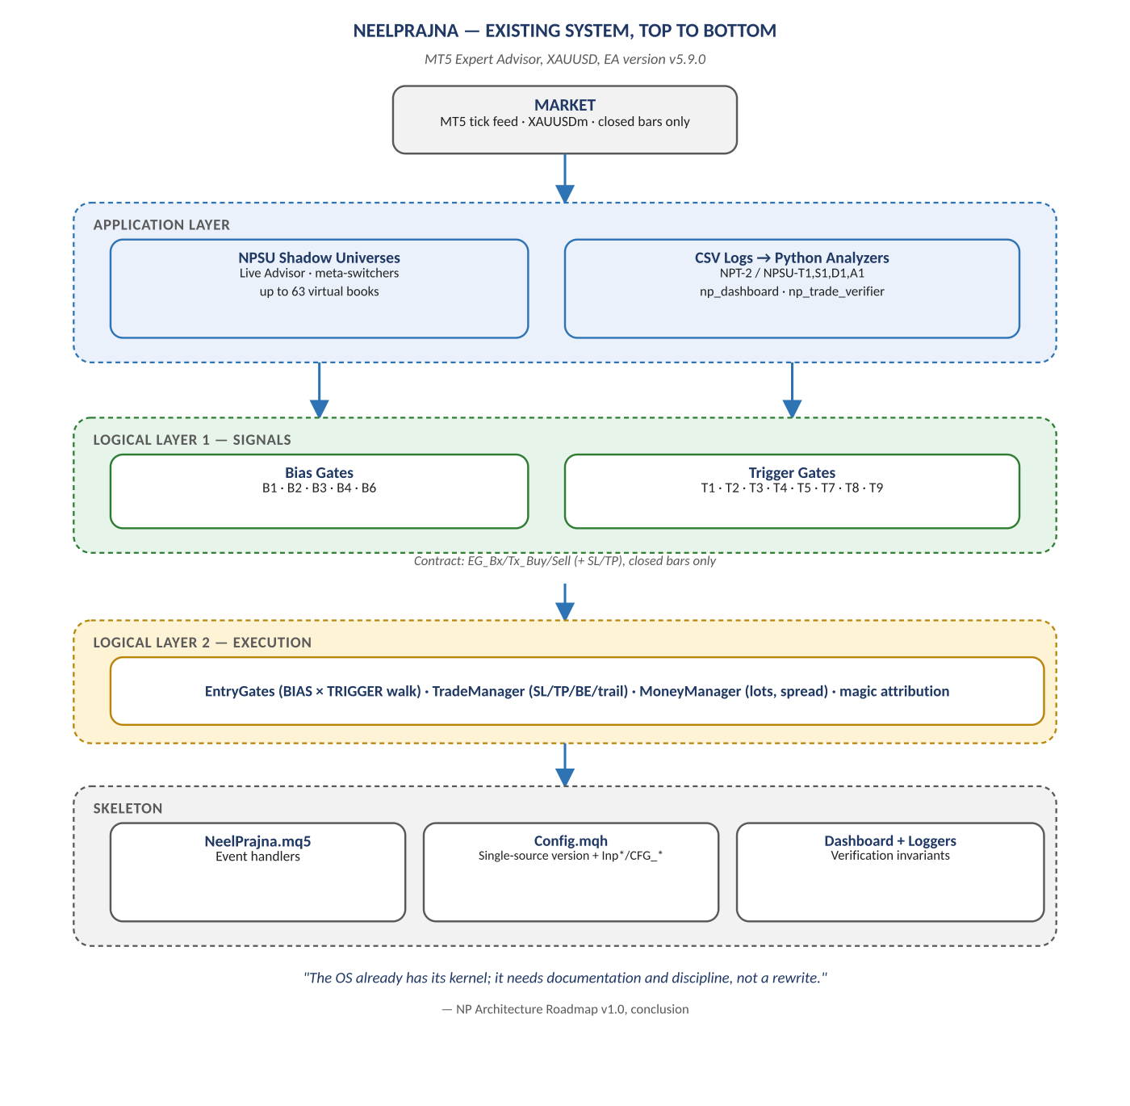
Figure 1. Market → Application → Signals → Execution → Skeleton, as documented and already shipping.

Diagram 2 — The Four-Layer Refactor (ADR-001)
The accepted, shipped restructuring of the EA into four layers with a strict downward-only include rule, plus the Phase 5 exit check exactly as it was actually re-scoped — not as it was originally (and unachievably) written. This is the architecture the rest of the diagrams in this companion sit inside.
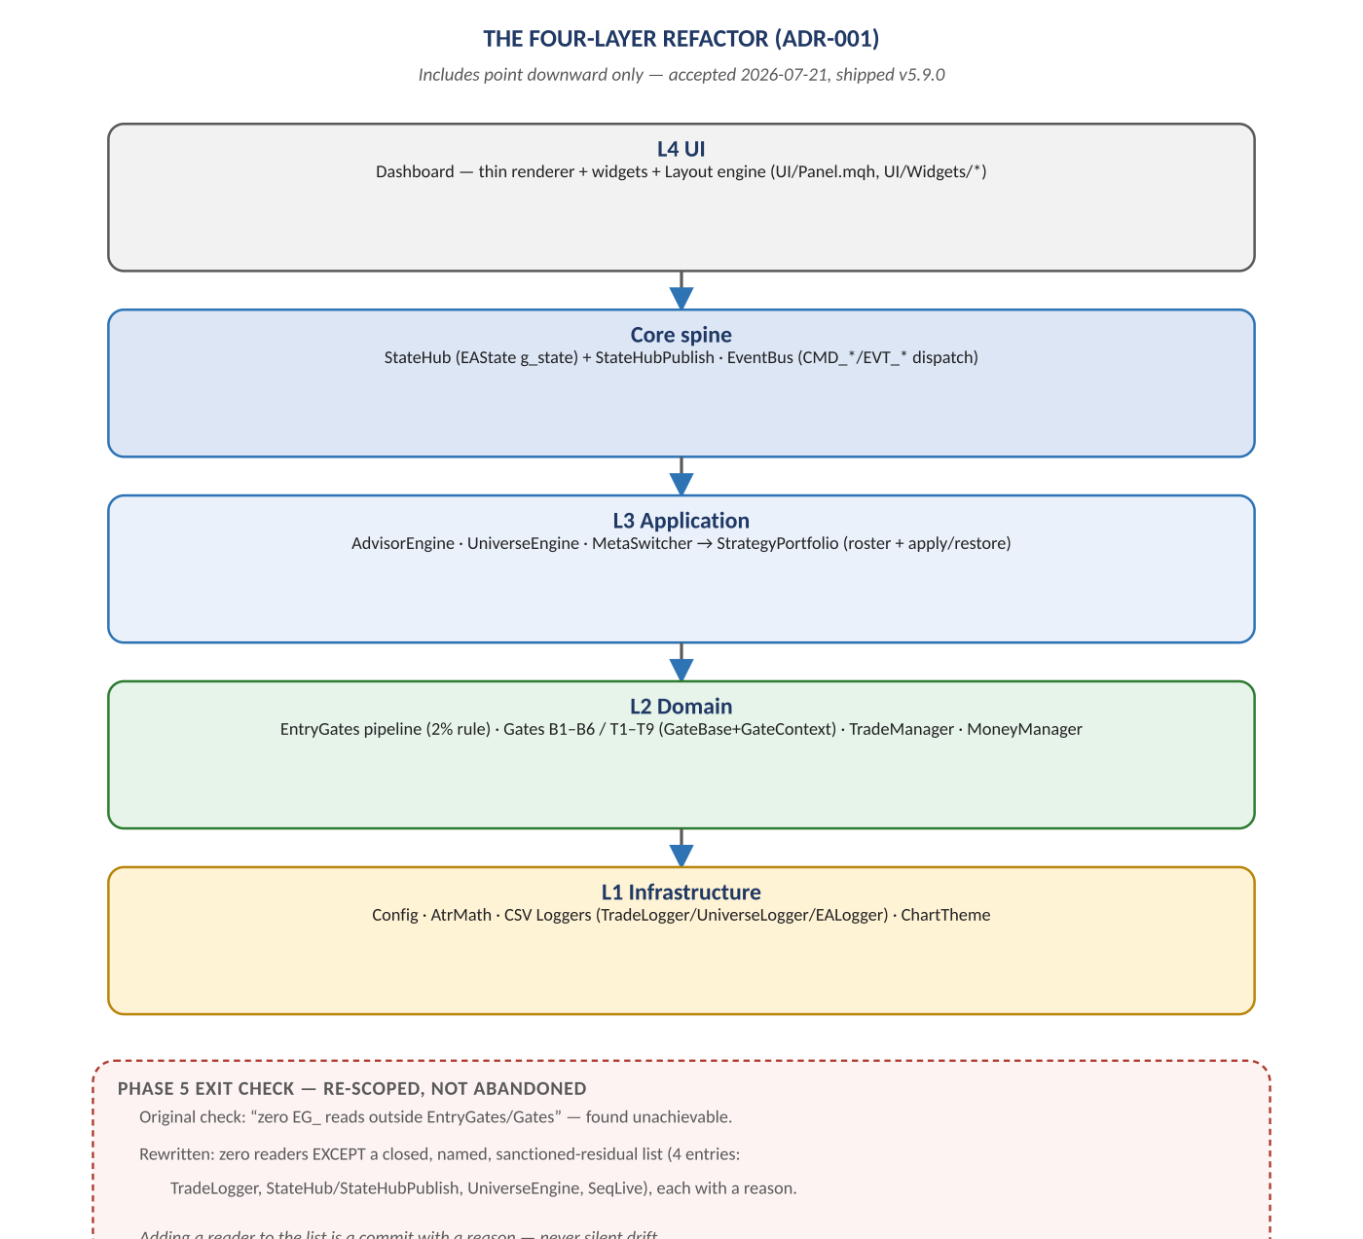
Figure 2. UI → Core spine → Application → Domain → Infrastructure, and the sanctioned-residual list that closed Phase 5.

Diagram 3 — The Signal Model: BIAS × TRIGGER
All thirteen live gates, grouped by role, with the exact entry formula that has held unchanged across five-plus major versions. The two retired gates at the bottom (T6, B5) are shown as a reminder that this model evolves by evidence — an A/B result, not an opinion — removing or adding a gate.
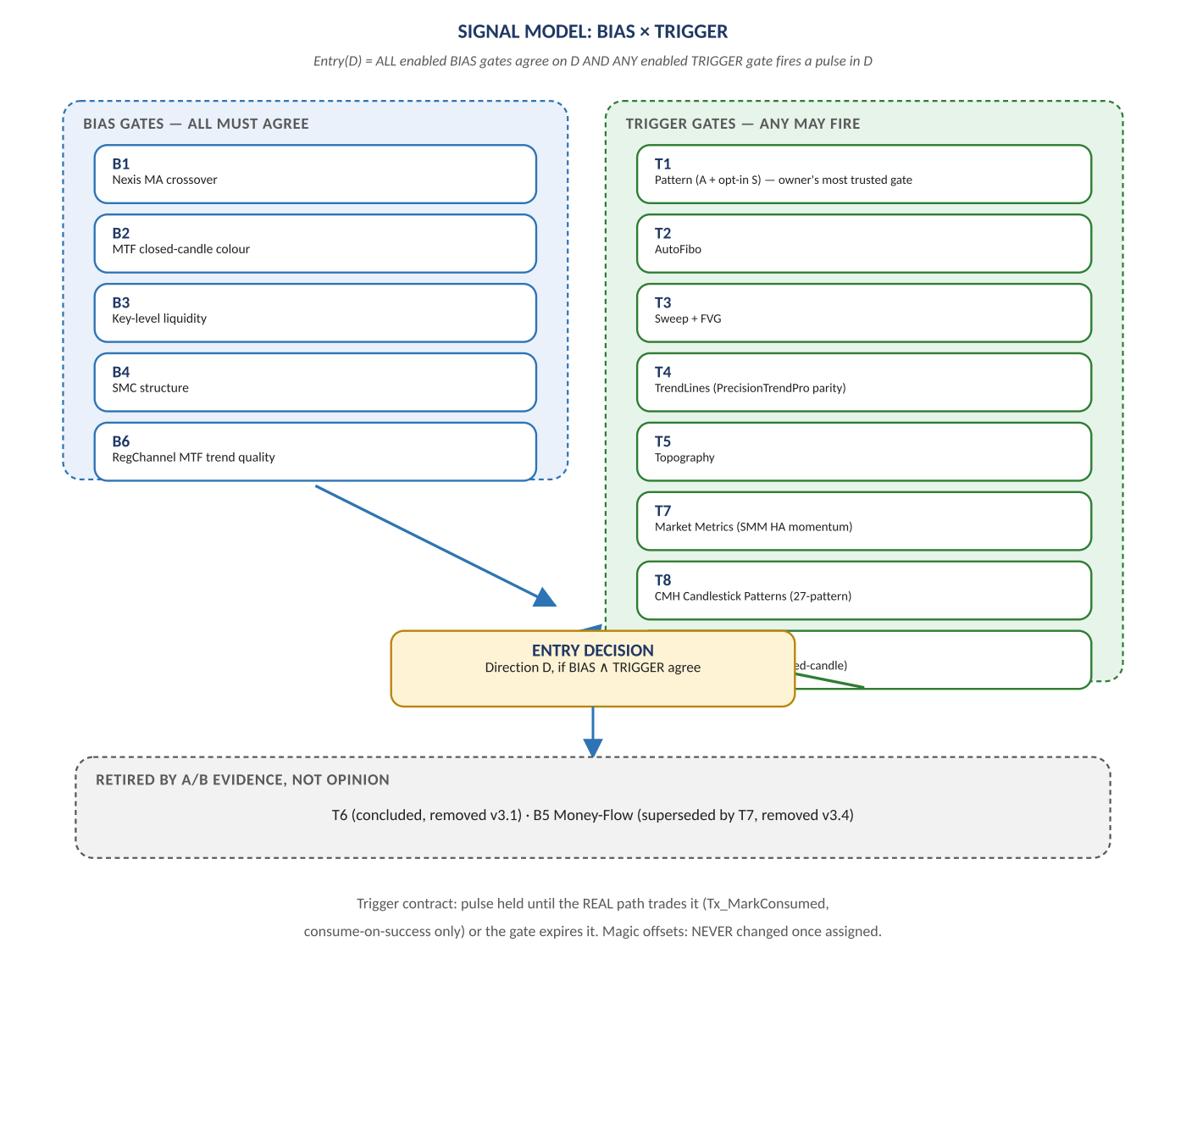
Figure 3. Five bias gates (ALL must agree) and eight trigger gates (ANY may fire), converging on one entry decision.

Diagram 4 — Trade Execution & Risk Pipeline
What happens after a direction is decided: the EntryGates registry walk enforces the 2% rule and publishes a blocker reason if a trade is refused; MoneyManager sizes the position; TradeManager owns SL/TP/break-even/trail; magic-offset attribution ties every fill back to the gate that produced it; and the result lands in a schema-versioned CSV row. The invariants at the bottom are enforced in code, not merely documented.
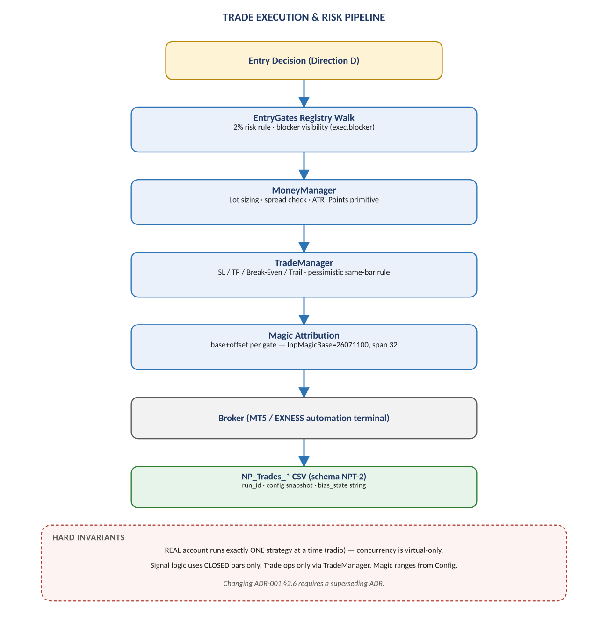
Figure 4. Entry decision → risk gate → money management → trade management → attribution → broker → log.

Diagram 5 — NPSU: The Shadow-Universe Research Subsystem
The most research-heavy part of the existing system: up to 63 virtual strategy universes run in parallel against the real feed, independently verified four ways, ranked by a survival-first Live Advisor, and connected to the real account only through one human-gated, session-only apply mechanism.
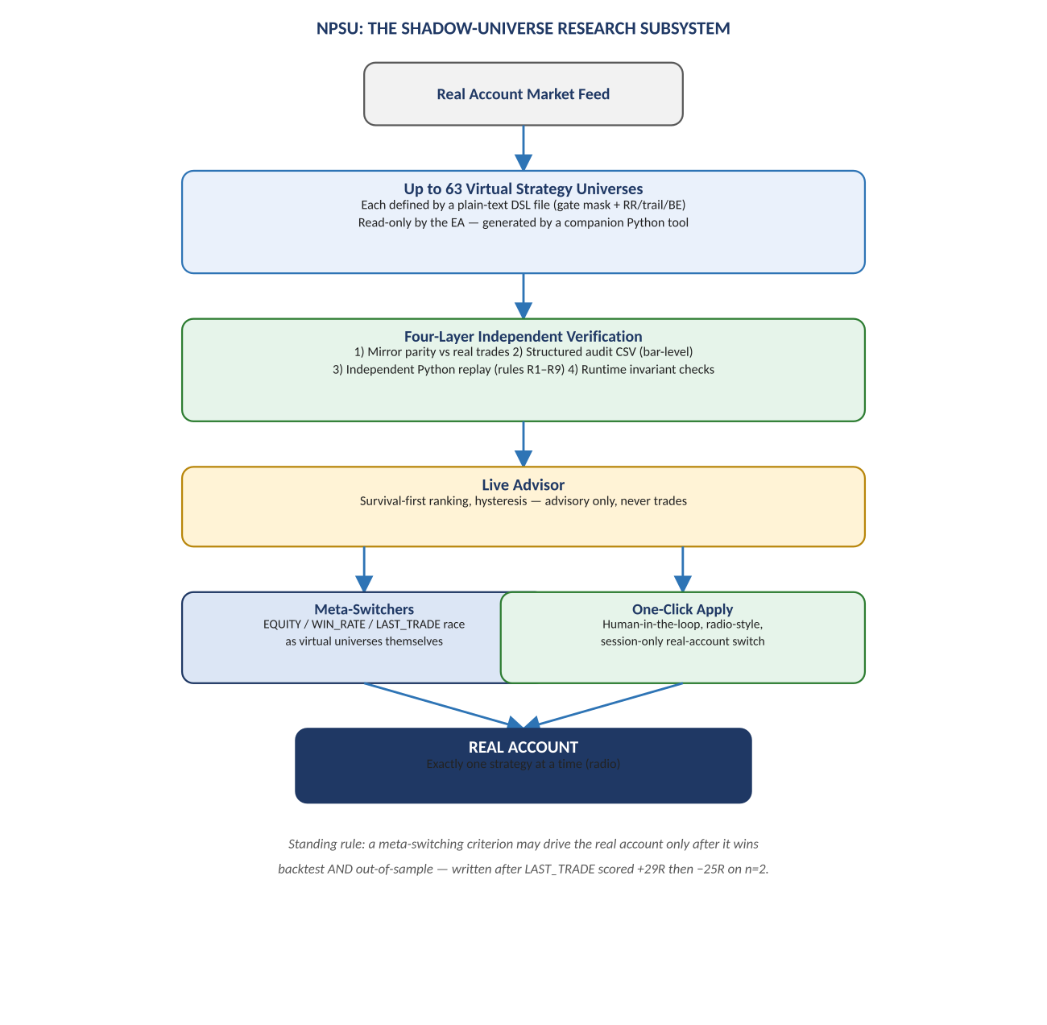
Figure 5. Shared market feed → virtual universes → verification → advisor → human-gated real account.

Diagram 6 — Four-Layer Independent Verification
The answer to “who verifies the virtual trades?”: mirror parity, a structured bar-level audit trail, an independent Python re-implementation of the trading rules, and runtime invariant checks that raise a loud violation banner rather than failing silently. This verification stack was tested against a deliberately corrupted trade before it was ever trusted on a real one.
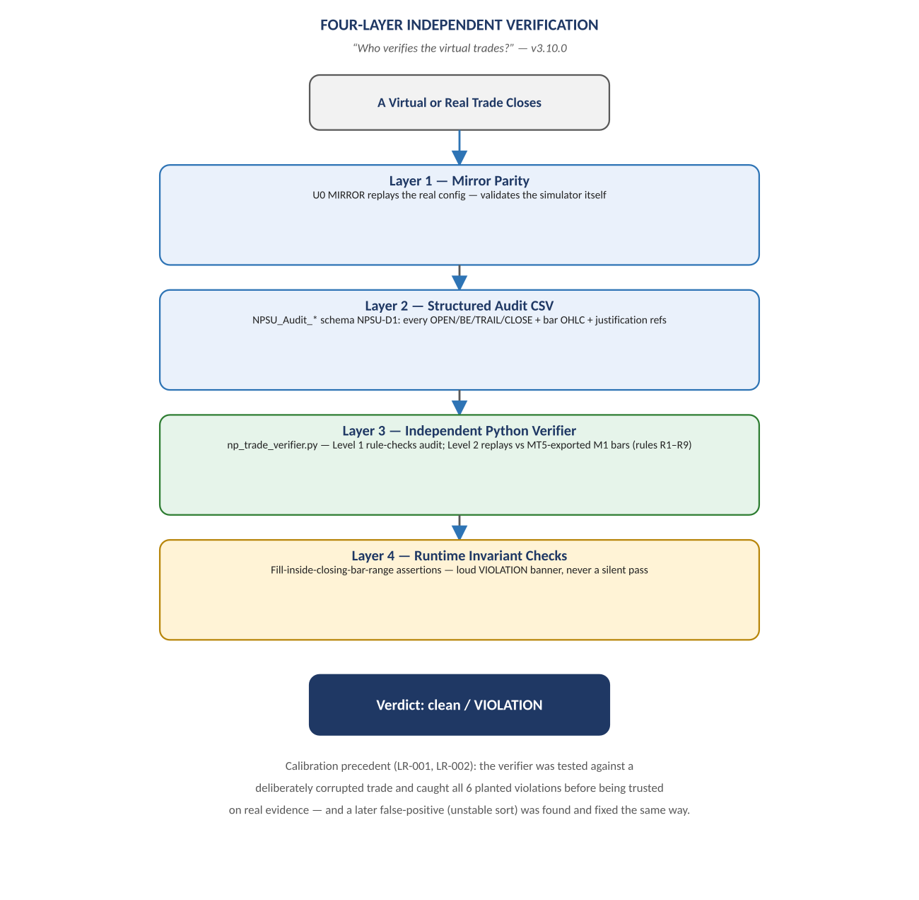
Figure 6. Trade close → mirror parity → audit CSV → independent replay → runtime invariants → verdict.

Diagram 7 — Governance: Supervisor / Runner Trust Split
The operational autonomy model actually ruled on and accepted (ADR-005, 2026-07-27): a frozen, owner-reviewed Supervisor; a mutable, self-adopting Runner; a measured autonomy ladder currently capped at L2 for recovery by a deliberate, recorded safety decision; and seven invariants that make “fail closed” and “silence is negative” real, not aspirational.
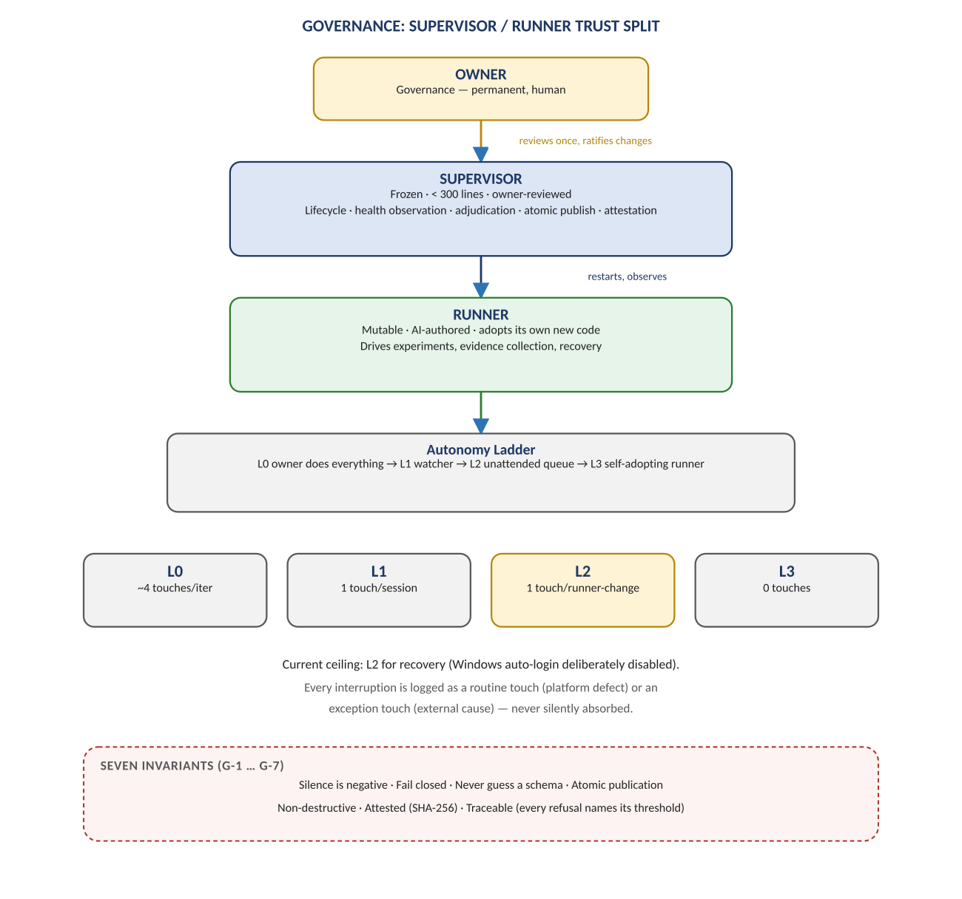
Figure 7. Owner → frozen Supervisor → mutable Runner → autonomy ladder → seven invariants.

Diagram 8 — Data, Logging & Analysis Architecture
The self-describing CSV schemas (NPT-2, NPSU-T1/S1/D1/A1) and the five Python analyzer tools that read them, ending at the one place every automated pipeline in this system ultimately reports to: an owner review and promotion decision. The rules at the bottom — shared run_id, streaming exports, UTF-16LE .set/.ini files — are the small, unglamorous disciplines that make the rest of this architecture trustworthy.
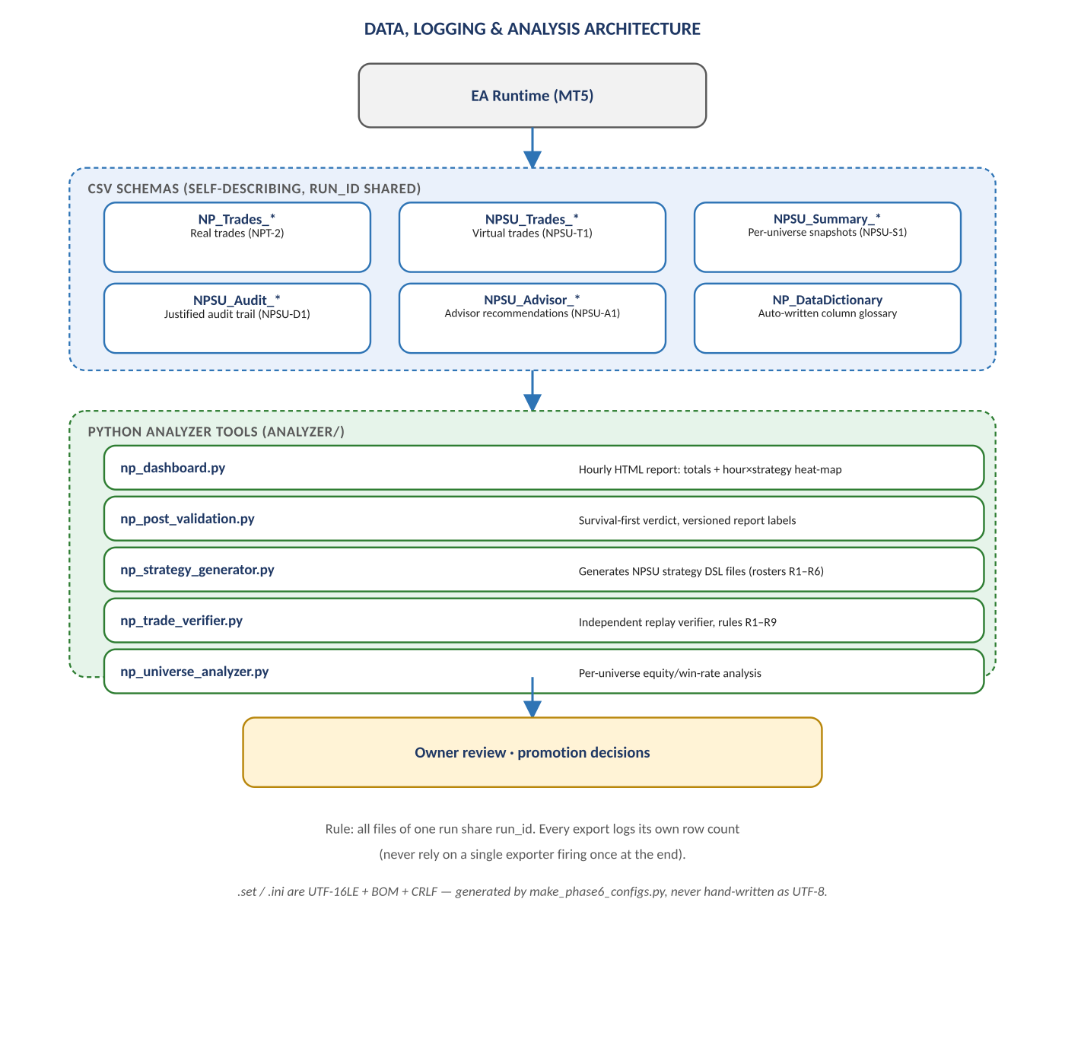
Figure 8. EA runtime → CSV schemas → analyzer tools → owner review and promotion.

Diagram 9 — Auto-Adopt Runtime & Meta-Switchers
The one place in the entire codebase where the EA can change what the real account trades without a human clicking anything, traced from its shared entry point (ADV_OnBar, every M1 bar) through two genuinely separate paths: Auto-Adopt, which applies to the real account the moment warm-up and cooldown are satisfied, with no hysteresis at all; and the Advisory Recommendation, which requires a challenger to win three consecutive evaluations before the recommendation even changes — and even then never applies itself. Meta-switchers race under the same three criteria but are structurally barred from ever being an Auto-Adopt candidate.
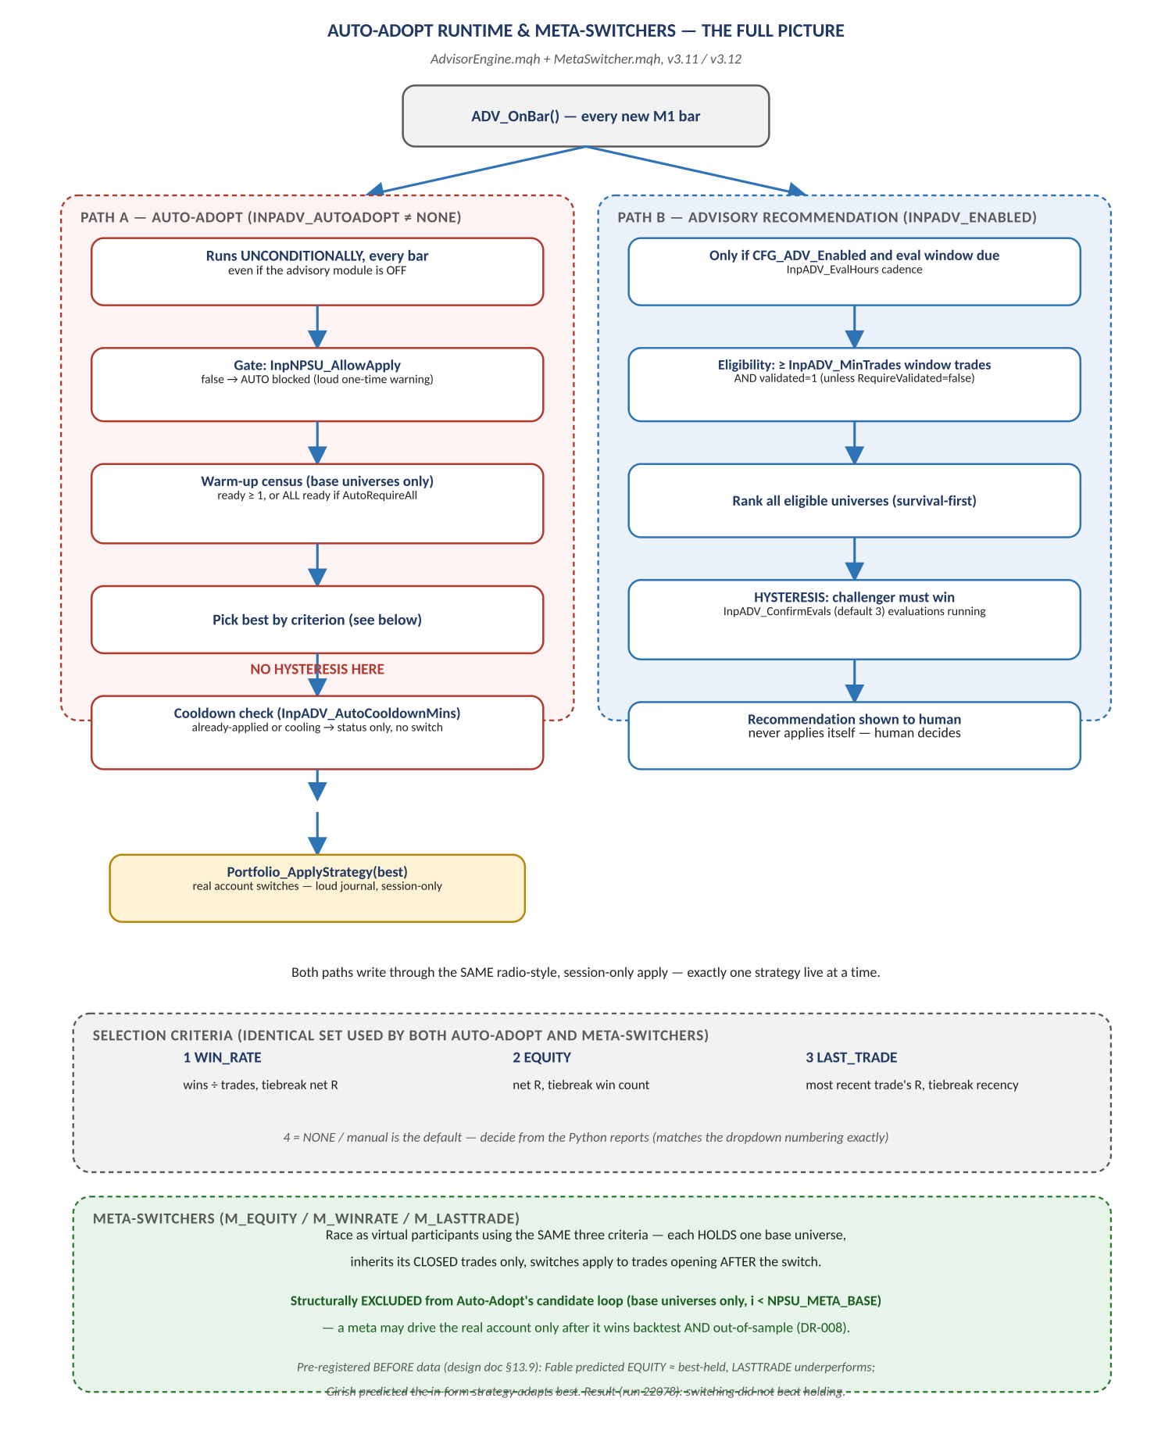
Figure 9. ADV_OnBar → Auto-Adopt (no hysteresis) / Advisory (hysteresis) → shared apply path → meta-switchers.

Appendix — Every Auto-Adopt Safety Gate Actually in the Code
Companion table to Diagram 9. Read as a whole, it shows the real protection against a bad Auto-Adopt decision today is entirely rate-based (warm-up, cooldown) rather than significance-based (a statistical test, an out-of-sample check, or the ConfirmEvals hysteresis the advisory path enjoys) — consistent with the feature's own design comment that “the auto-switcher is itself a strategy under test,” but worth stating explicitly rather than leaving implicit.
Input / Mechanism | What it actually guards against | What it does NOT guard against
InpNPSU_AllowApply (master gate) | Any apply at all, human or automatic, if left false | Nothing once true — it is a blanket on/off, not a per-criterion permission
InpADV_AutoWarmup (default 10 trades) | Adopting a universe with almost no track record | A universe that got lucky in exactly its first 10 trades — warm-up counts trades, not significance
InpADV_AutoRequireAll | Adopting before slower gates have any data, if set true | Off by default; can itself block adoption indefinitely on a slow gate if enabled
InpADV_AutoCooldownMins (default 60) | Rapid flip-flopping between strategies | A single bad switch happening at all — cooldown limits frequency, not correctness
Meta-switcher exclusion (i < NPSU_META_BASE) | A meta-switcher ever driving the real account directly via Auto-Adopt | Nothing once a meta wins backtest + OOS and is promoted — a human, governance-level decision, not a code gate
Radio / session-only apply | More than one strategy live on the real account at once; a setting surviving an EA restart unintentionally | The switch itself being wrong — it only bounds the blast radius, it does not validate the choice
InpADV_ConfirmEvals hysteresis | The human-facing recommendation flipping on one noisy window | Auto-Adopt — this gate does not apply to the auto-adopt path at all

Evidence this asymmetry is already being watched, not merely theorized: the LAST_TRADE criterion scored +29R on one evaluation window and −25R on the very next — n=2 evidence, exactly the failure mode a warm-up-and-cooldown-only gate cannot prevent — after which the real account was kept on manual B1|T1 and the rule was set that a criterion may only drive the real account after winning both backtest and out-of-sample. Meta-switcher predictions were pre-registered before data was examined; the recorded result (run 22078) was that switching did not beat holding, and LAST_TRADE was the best-performing criterion among the three.

