QRF
Architecture & Sprint History Diagrams

Seven diagrams of the real, as-built system — Kernel layers, the EvidenceBattery
pipeline, the ledger, the coordination protocol, and the gated Gen 1→4 roadmap
Visual Architecture Companion • Generation 1 Closed 2026-07-26 • July 2026

How to Read These Diagrams
This companion covers F:\QRF exactly as it exists today — a real, ten-sprint-old repository (not the speculative Platform Architecture sketch analyzed for NeelPrajna). Every box, arrow, and label corresponds to a named module, ADR, or ratified document already in the repository. Built following the same SVG-draw-and-rasterize workflow documented in HOW_THIS_DOC_WAS_BUILT.md.
Diagrams 1–4 cover the Kernel as implemented; Diagram 5 covers the multi-AI coordination protocol that built it; Diagram 6 is the sprint timeline; Diagram 7 is the gated roadmap governing what comes next.

Diagram 1 — QRF Idea Flow
The one-page Architecture Map's idea flow, exactly as documented: data through detectors, events, the composer/screener, the battery, a verdict, and into beliefs — which feed the next question. The four "only writers" are named because everything else in the system only proposes or reads.
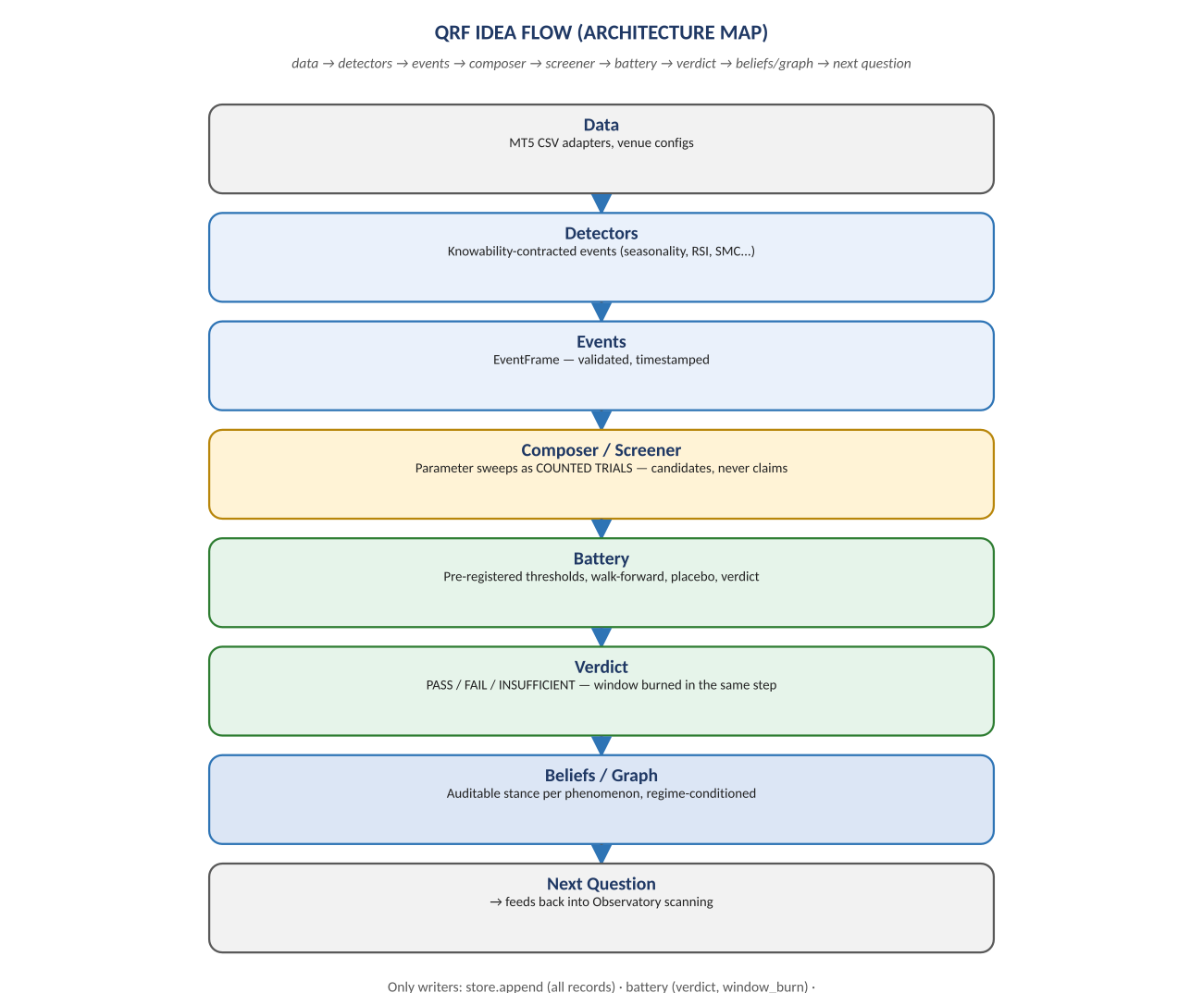
Figure 1. data → detectors → events → composer → screener → battery → verdict → beliefs → next question.

Diagram 2 — Kernel Layers, As Built
The real module tree: eight kernel packages (records, instruments, protocol, battery, corrections, belief, observatory, graph/registry reserved for Generation 2) and four trading-plug-in packages (adapters, concepts, simulator, utility). The kernel firewall is a real, CI-enforced test, not a design aspiration.
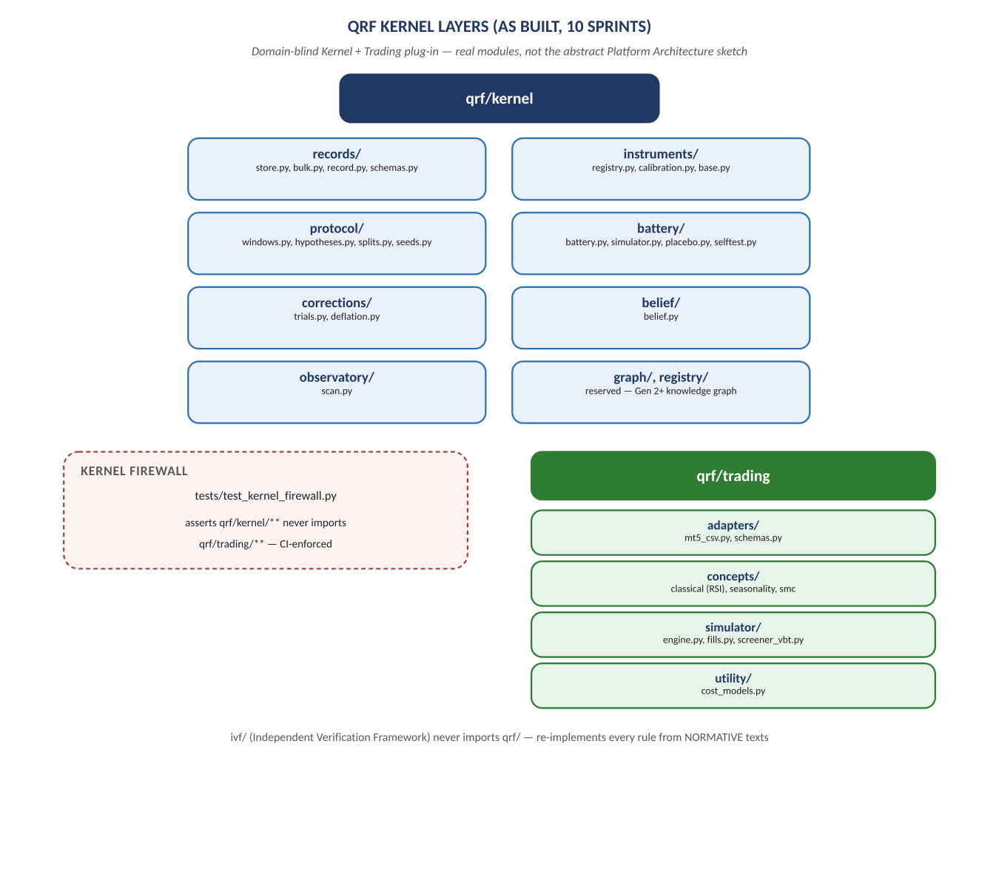
Figure 2. qrf/kernel's eight packages and qrf/trading's four, with the firewall test between them.

Diagram 3 — The EvidenceBattery Verdict Pipeline
battery.py's real nine-step pipeline, the only code path allowed to write a verdict or a window_burn record. Any single refusal — a bad selftest, a burned window, an unaudited simulator — stops the whole pipeline; there is no partial credit.
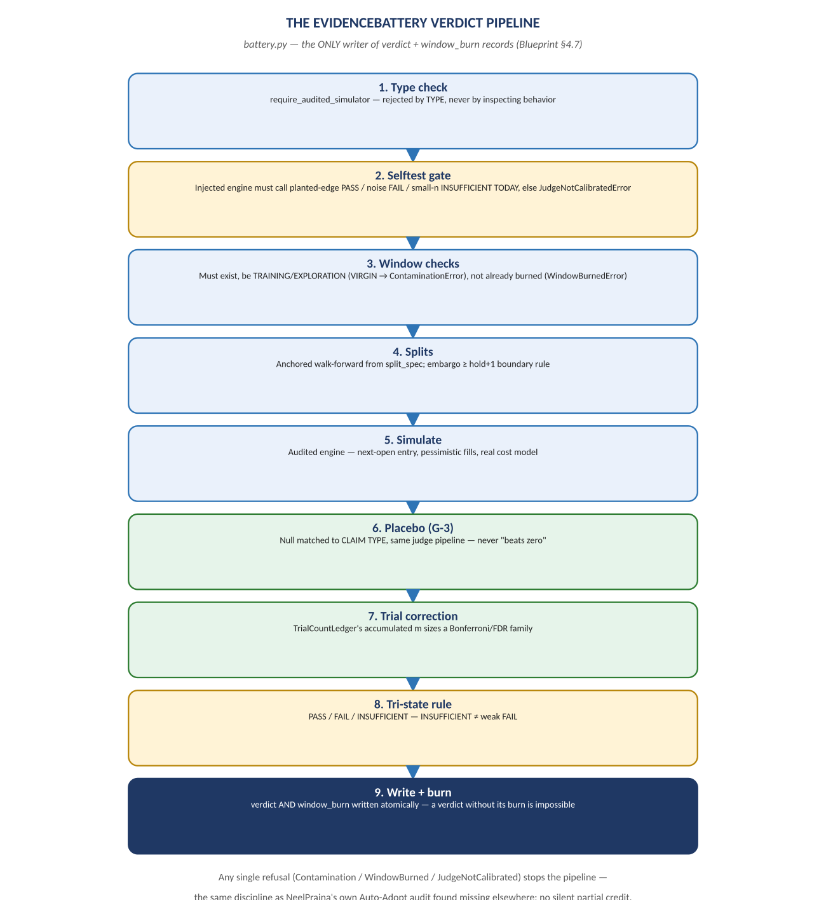
Figure 3. Type check → selftest gate → window checks → splits → simulate → placebo → trial correction → tri-state verdict → atomic write+burn.

Diagram 4 — The Append-Only Ledger & Window-Burn Mechanism
How QRF makes reusing out-of-sample data structurally impossible: RecordStore's single write path, WindowLedger's TRAINING/EXPLORATION/VIRGIN designations, and the burn mechanism that refuses any later claim touching an already-burned interval for the same lineage.
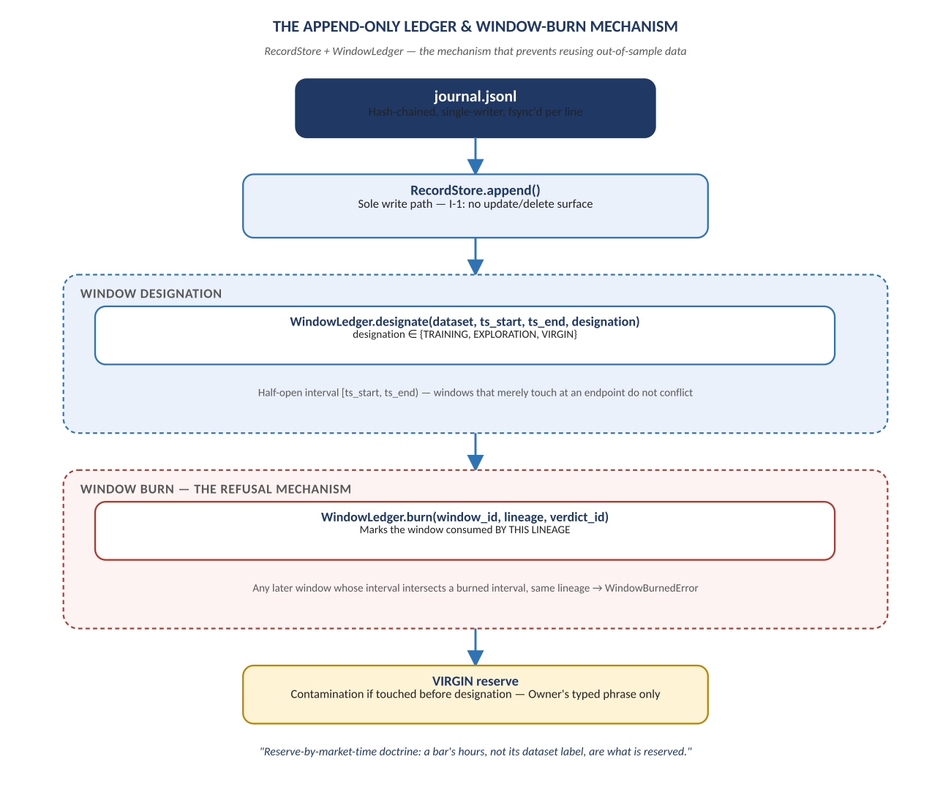
Figure 4. journal.jsonl → RecordStore.append → window designation → burn → refusal on reuse → VIRGIN reserve.

Diagram 5 — Multi-AI Coordination Protocol (ADR-008)
The Owner/Architect/Developer loop, proven across all ten Generation 1 sprints: ARCH instructions down, DEVQ questions at boundaries, GO/REV sign-offs, and a findings tally kept by humans about every party including the machines — 21 findings in ten sprints, all caught before harm.
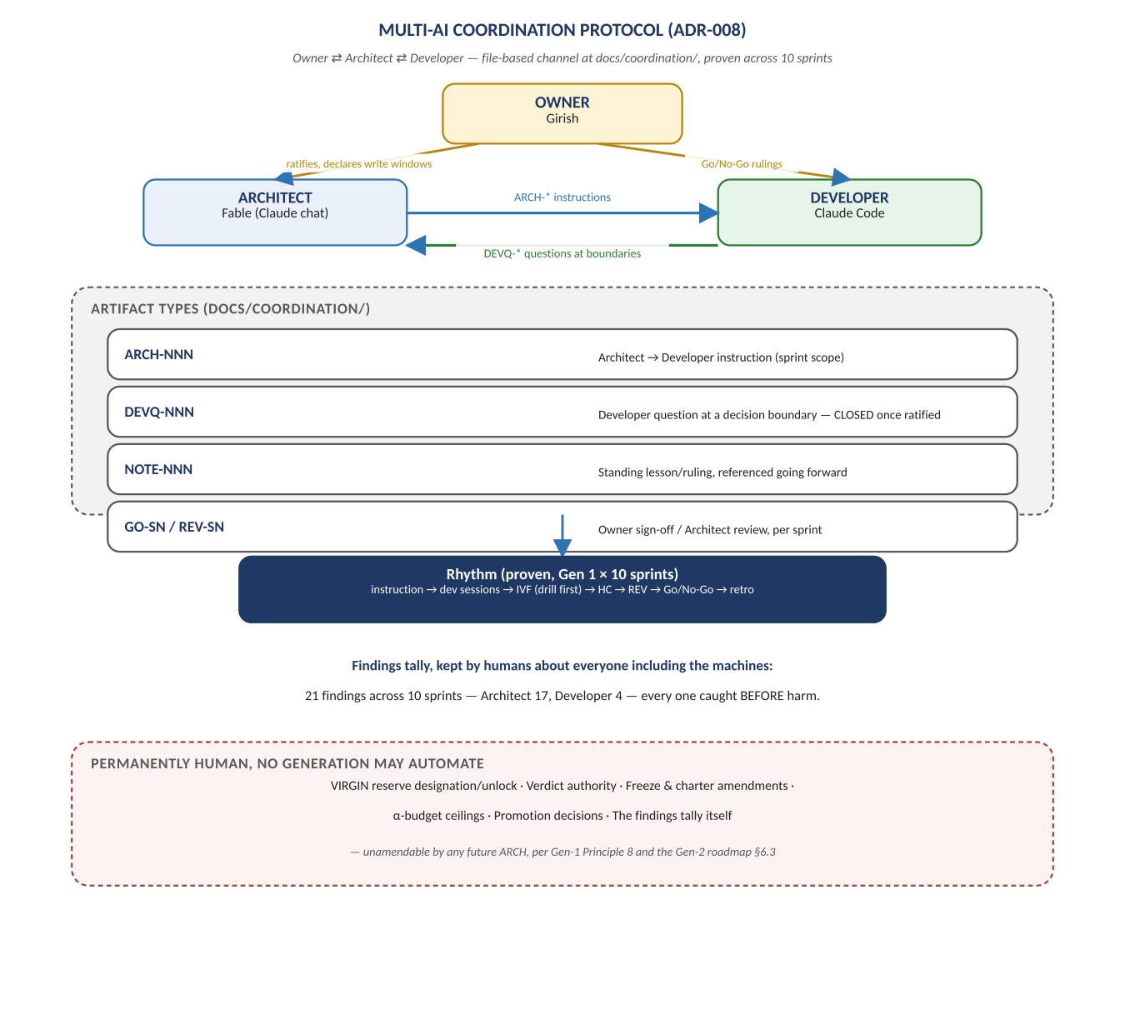
Figure 5. Owner ⇄ Architect ⇄ Developer, the artifact types between them, and what stays permanently human.

Diagram 6 — Generation 1: Ten Sprints, Closed
The real sprint sequence from ledger core to trial accounting, and the scientific record it produced: four hypotheses judged, zero promoted. Every FAIL and INSUFFICIENT verdict is treated as a genuine result, not an absence of one.
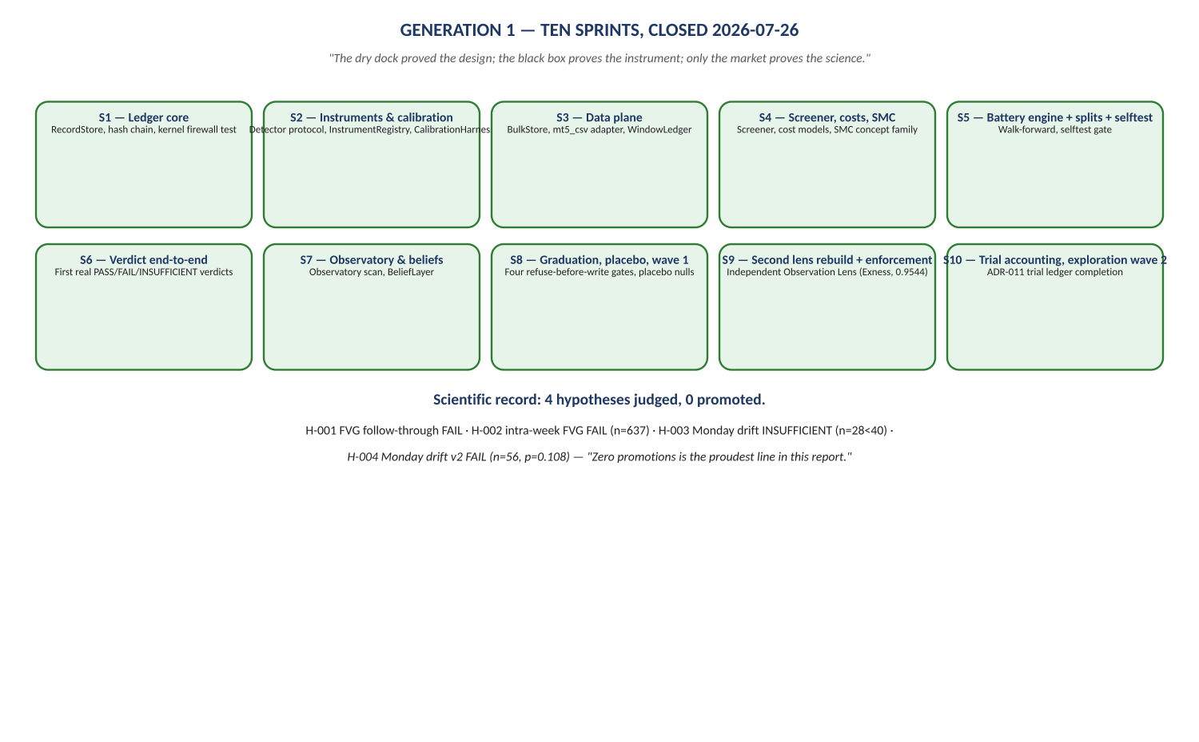
Figure 6. S1 Ledger core → ... → S10 Trial accounting; H-001 through H-004, all FAIL or INSUFFICIENT.

Diagram 7 — The Gated Roadmap: Generation 1 → 2 → 3 → 4
The central rule governing everything QRF builds next: no layer of autonomy is built until the layer below it has produced results that prove the need. Generation 3 requires Gate A; Generation 4 requires Gate B. A short list of powers stay permanently human regardless of generation.
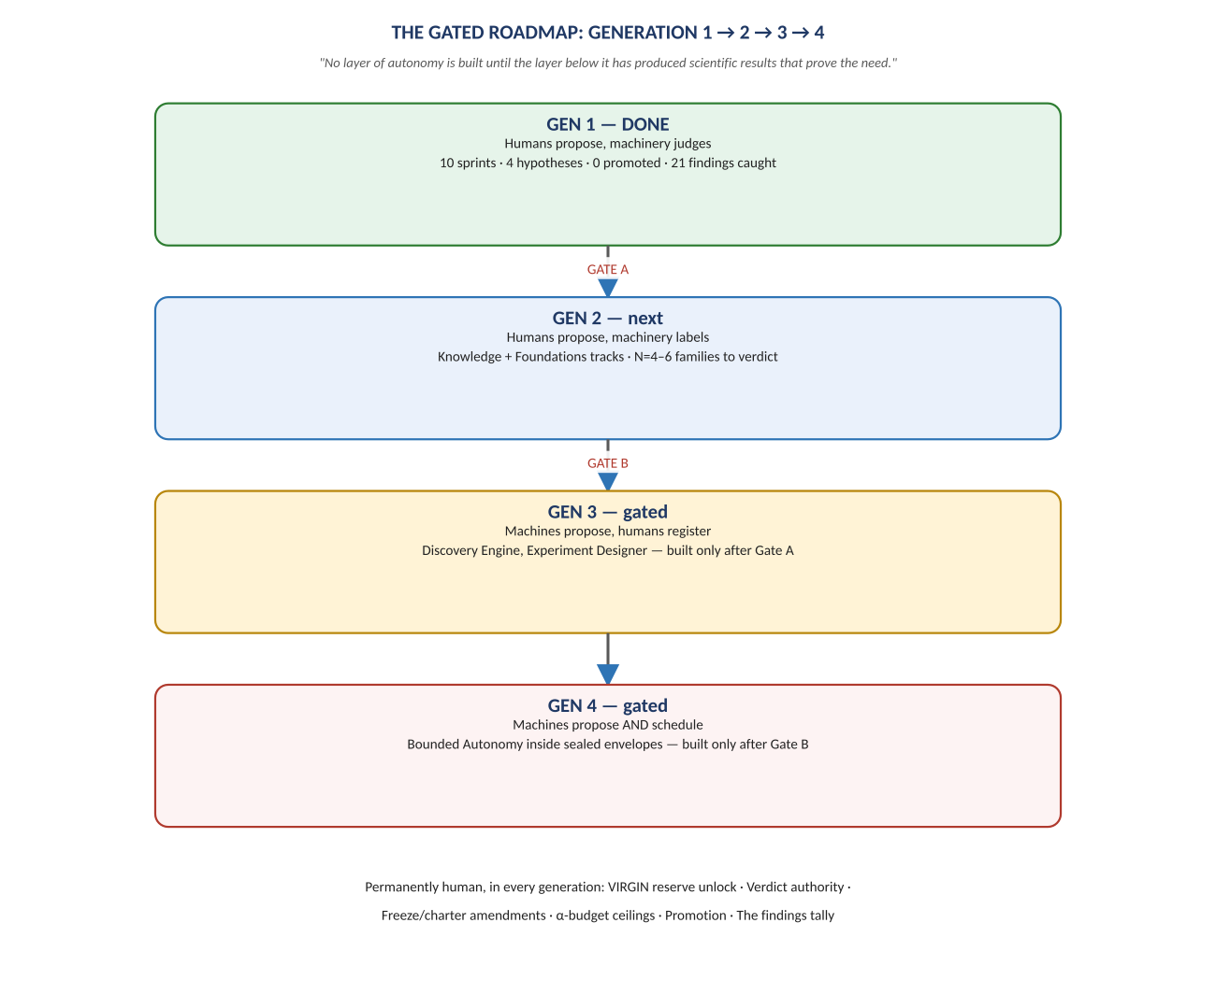
Figure 7. Gen 1 (done) → Gate A → Gen 2 → Gate B → Gen 3 → Gen 4, with the permanently-human powers listed beneath.

