NeelPrajna Programme
From Vision to Verified System

A Combined Analysis of the Platform Architecture v1.0 (QRF Kernel / Trading Plug-in)
and the Live NeelPrajna MQL5 Repository, Governance Model, and Evidence Base
Research Architecture Document, Volume II • July 2026

Table of Contents

1. Executive Summary
This volume extends the earlier architectural analysis (“QRF × NeelPrajna: Architecture of a Living Scientific Ecosystem”) by incorporating two additional primary sources: the formal Platform Architecture v1.0 document (authored as “Document 4” in a five-document constitutional series, successor to a Constitution and a Scientific Model), and a full export of the live NeelPrajna repository — 410 files spanning MQL5 source, ADRs, phase plans, Python validation scripts, and evidence archives. Together these sources show that the conceptual vision analyzed previously is not merely aspirational: substantial parts of it are already implemented, tested, and operating under a live governance regime, while other parts remain explicitly design-frozen for a future phase.
The Platform Architecture formalizes the QRF/NeelPrajna split into a domain-blind Kernel (the scientific method in code) and a Trading plug-in (the domain-specific implementation for markets), joined by the same six-object Communication Contract described in Volume I. The repository export shows a mature, five-and-a-half-major-version MQL5 Expert Advisor (13 signal gates, a sequential strategy engine, a shadow-universe research subsystem called NPSU, a live advisor, and meta-switchers) built under an unusually rigorous evidentiary discipline: architecture decision records, a reconciled phase ledger, a supervisor/runner trust split for autonomous operation, and an active Python validation pipeline that has already produced feasibility and cost-threshold reports for two named hypotheses (H-07, H-16).
The central finding of this volume is that the programme is running two clocks at once: an operations clock, which has shipped a verified, disciplined trading EA through v5.9.0 with governance formalized in ADR-005; and a research-infrastructure clock, which is mid-construction of the domain-blind QRF Kernel described in the Platform Architecture. The Phase Ledger's reconciliation of three competing roadmaps into one ladder, and the repository's own supersession notes, show the team is actively aware of — and managing — the risk that these two clocks drift apart.

1.1 What Is New in This Volume
- The Kernel / Trading plug-in split is now a formal contract, not just a philosophy: a CI-enforced firewall (AST import scan + forbidden-token scan) prevents the Kernel from ever importing trading vocabulary.
- Governance has been separated from operations by ADR, with a Supervisor/Runner trust split, an autonomy ladder (L0–L3), and a frozen constitution for the Supervisor that only a written ADR can amend.
- An evidentiary pipeline already exists and has produced results: Hypothesis Zero (cost-feasibility envelope over 38 million ticks), Stage 3 feature stability validation, and Stage 4 cost-threshold analysis for two named trading hypotheses.
- Epistemic discipline is written down as reusable rules (R1–R3), distinguishing deterministic claims from statistical ones, enforcing single-variable A/B comparisons, and forbidding cross-run comparisons — rules earned from a real measurement incident, not imposed abstractly.
- A reconciled Phase Ledger resolves three previously-conflicting roadmaps into one authoritative ladder, explicitly naming what was superseded, re-scoped, or promoted.

2. Document Landscape and Provenance
The three source materials analyzed across both volumes form a single trajectory, best understood as three altitudes of the same programme.
Source | Altitude | Character | Status
“new 4.txt” vision notes (Volume I) | Philosophical / conceptual | Free-form architectural reasoning: Observation Space, Generation 1→2, concept-after-observation | Informal, exploratory
Platform Architecture v1.0 (“Document 4”) | Formal specification | Kernel/plug-in decomposition, component tables, code-level contracts, CI firewall rules | DRAFT — awaiting owner ratification
NeelPrajna repository export (410 files) | Implementation reality | MQL5 EA source, ADRs, phase ledger, Python validation scripts, evidence archives | Live; EA at v5.9.0; QRF Kernel component pre-production

The Platform Architecture explicitly positions itself as Document 4 of a series, governed by a “TEACHING_AND_KNOWLEDGE_TRANSFER_STANDARD” and preceded by Document 1 (Constitution) and Document 2 (Scientific Model) — neither of which was included in the material reviewed here, and a Document 5 (Implementation Blueprint) that follows it. This document set corresponds to the “nine-document consolidation” proposed in the Architect's Response and Production Plan found in the repository's methodology folder, in which the Chief Research Architect role (“Fable”) persuaded the Director to replace an original fifteen-volume structure with nine documents plus a growing Core/Application-Book split — exactly the Core-versus-plug-in shape the Platform Architecture now embodies for NeelPrajna as the first Application Book.
This provenance matters for interpretation: the Platform Architecture is not a green-field proposal but the latest layer of a multi-month, multi-document, multi-model collaborative process (Claude implementing, “Fable” architecting, “ChatGPT” reviewing, the owner Girish Kumar governing) that has already produced a working trading system and a body of hard-won engineering lessons. The Kernel it specifies is meant to generalize patterns already proven inside NeelPrajna — the resurrection test, the independent verifier, the survival-first evaluation rule — rather than invent new ones from scratch.

3. The Platform Architecture: Kernel and Trading Plug-in
Volume I already covered the shared vision — one Observation Engine, the Chief Scientist Principle, the six-object Communication Contract. This section focuses on what the Platform Architecture adds beyond that shared vision: a concrete, code-level decomposition into a domain-blind Kernel and a domain-specific Trading plug-in.

3.1 The Kernel: Domain-Blind by Construction
The Kernel is the domain-blind core of the system. It contains no trading vocabulary — no price, bid, ask, spread, pip, lot, venue.
This is a stronger and more testable claim than Volume I's SEA (Scientific Ecosystem Architecture) sketch. Rather than asserting domain-generality as an aspiration, the Platform Architecture makes it a compile-time and CI-time invariant:
Rule | Enforced By
No import of qrf/trading/** | AST import scan
No identifiers: price, bid, ask, spread, pip, lot, venue | Token scan
Violation fails the build | CI

The Kernel's nine components give the abstract “scientific method in code” concrete shape: a hash-chained, append-only RecordStore; a Parquet-backed BulkStore; an InstrumentRegistry; a CalibrationHarness for planted-truth and silence tests; a WindowLedger that designates and burns evaluation windows to prevent data reuse; the EvidenceBattery itself (PASS/FAIL/INSUFFICIENT); a TrialCountLedger for multiplicity correction; a BeliefLayer; and an Observatory for anomaly scanning. Each maps directly onto a rung of the Reality→Instrument→Observations→…→Knowledge ladder described in Volume I — but now as a named Python module with a file path, not a philosophical stage.

3.2 The Trading Plug-in: Where Markets Become Measurable
The Trading plug-in contains everything the Kernel forbids — price, bid, ask, spread, pip, lot, venue — and is organized into adapters (data ingestion), detectors (phenomenon observation), a simulator, cost models, and concepts (domain-specific phenomenon families). Two design choices stand out as directly answering risks flagged in Volume I:
- The Anti-Hindsight Invariant: every emitted observation row must satisfy ts ≥ the timestamp of the last input needed to compute it, and this is property-tested by feeding data incrementally and asserting emissions never change retroactively. This is a concrete, testable answer to the “concept-after-observation” ordering discussed in Volume I — discovery is allowed to look backward at history, but never to let a later fact leak into an earlier observation's timestamp.
- Name Immutability for cost models: the moment a cost model name is cited by any ledger record, its definition is frozen; every change is a new name. This is the same discipline as the append-only RecordStore and the sealed evidence bundles described in ADR-005 — a recurring pattern in this codebase of treating names as promises that, once made, cannot be revised underneath existing evidence.

3.3 Two Simulation Modes
Mode | Purpose | Speed | Realism
Screener (vectorbt) | Parameter sweeps, candidate discovery | Very fast | Approximate
Audited Engine | Verdicts | Slower | High fidelity

The Audited Engine's rules are conservative by design — next-open entry rather than signal-bar close, a pessimistic tie rule (if stop and target are both touched, STOP wins), and pessimistic gap-through (gaps can only hurt, never help). This mirrors the Screener/Audited-Engine split that the repository's own NP Architecture Roadmap arrived at independently for the MQL5 EA (Python as “whiteboard,” MT5 as “physical experiment”) — the same intellectual pattern recurring at two different layers of the stack.

3.4 The Six Interface Contracts
Section 6 of the Platform Architecture makes an important epistemic distinction that Volume I's Communication Contract did not fully spell out: not every pipeline stage is allowed to produce a verdict.
Detector → EventFrame → BulkStore.write() → bulk_manifest
Hypothesis → EvidenceBattery.run() → Verdict + window_burn
Screener → Shortlist + trial_count bump (NO verdict, NO window_burn)
Observatory → anomaly_scan + question (NO verdict, NO burn)
Verdict → BeliefLayer.update() → belief state

Only the EvidenceBattery may produce a Verdict and only a Verdict may burn a window or update a belief. The Screener (candidate discovery, Generation 2's engine) and the Observatory (anomaly scanning, Generation 2's discovery mechanism) are explicitly barred from citing their own outputs as evidence — “beliefs never cite screener metrics, selftest results, or questions as evidence.” This is the concrete mechanism that makes autonomous hypothesis generation safe: the framework may discover as many candidates as it likes, but none of them acquire epistemic weight until they pass through the one gate that is allowed to grant it.

3.5 Extensibility Principles (Section 7)
- Origin grants no shortcuts. Human, machine, atlas-browse, or external-AI-sourced hypotheses run the identical pipeline.
- Trust follows demonstration. Every verifier must first catch planted frauds before judging anything real — the same calibration-before-trust discipline already implemented for np_trade_verifier in the live EA.
- Independence is a spectrum, declared not upgraded. Tier = broker / LP / venue, and a claim's independence tier is fixed at declaration time.
- Scoping is mandatory. Every claim carries its Observation Space; a claim without a scope is not a claim — the Kernel-level enforcement of Volume I's Observation Space concept.
- History is immutable. The ledger is append-only; corrections are new records, never rewrites — identical in spirit to ADR-005's sealed evidence bundles.
Taken together, Sections 3–7 of the Platform Architecture read less like new philosophy and more like a formal specification of disciplines the NeelPrajna repository was already practicing informally. This is a healthy sign: the Kernel is being asked to generalize proven habits rather than invent unproven ones.

4. The Live System: NeelPrajna as Built
The repository export reveals a mature, actively-versioned MQL5 Expert Advisor for XAUUSD (gold) on MetaTrader 5, currently at EA version v5.9.0, owned and architected by Girish Kumar with implementation carried out by Claude against the repository. This section summarizes what exists today, independent of the QRF Kernel ambition.

4.1 Signal Architecture: Bias × Trigger
Entry(D) = ALL enabled BIAS gates agree on direction D AND ANY enabled TRIGGER gate fires a pulse in D.
Class | Active Gates | Retired
Bias | B1 Nexis MA crossover · B2 MTF closed-candle colour · B3 key-level liquidity · B4 SMC structure · B6 RegChannel MTF trend quality | B5 Money-Flow (superseded by T7)
Trigger | T1 Pattern (owner's most trusted gate) · T2 AutoFibo · T3 Sweep+FVG · T4 TrendLines · T5 Topography · T7 Market Metrics · T8 CMH Candlesticks · T9 CCC Hidden Patterns | T6 (A/B test concluded)

Thirteen live gates, two retired by recorded A/B evidence — not by opinion. A trigger's pulse is held until the real path trades it or the gate expires it; magic-number offsets attributing trades to gates are treated as immutable constants, never to be changed once assigned.

4.2 The Four-Layer Refactor (ADR-001)
An architecture review of v3.16.4 (21,600 lines, 28 files) found four structural problems: an ungoverned global bulletin board (EG_* variables read or written by 18 of 28 files); a 3,506-line Dashboard file mixing UI with business logic; gates calling upward into execution modules, inverting the intended dependency direction; and scattered, sometimes-silent trade-blocking logic. ADR-001 answered with four layers and a downward-only dependency rule:
L4 UI Dashboard (thin renderer + widgets + layout engine)
Core spine StateHub · EventBus
L3 Application AdvisorEngine · UniverseEngine · MetaSwitcher → StrategyPortfolio
L2 Domain EntryGates pipeline · Gates B1-B6/T1-T9 · TradeManager · MoneyManager
L1 Infrastructure Config · Loggers (CSV) · ChartTheme

This is, in miniature, exactly the pattern the Platform Architecture later formalizes for QRF/NeelPrajna at the programme level: a domain-blind core (StateHub/EventBus know nothing about trading semantics), a firewall against upward coupling, and a single owner (StrategyPortfolio) for a concept that previously existed in three ungoverned fragments. The Phase 5 exit check — “zero EG_ readers outside Engine/Gates” — was later found to be unachievable as originally written and was re-scoped into a closed, explicitly sanctioned-residual list (four named exceptions, each with a stated reason), rather than silently declared complete. That re-scoping, recorded candidly in the Phase Ledger, is itself evidence of the programme's evidentiary discipline: an exit criterion that turned out to be wrong was fixed in the open, not quietly abandoned.

4.3 NPSU: The Shadow-Universe Research Subsystem
Perhaps the most direct existing implementation of Generation 2 ideas from Volume I is NPSU (“NeelPrajna Shadow Universes”): up to 63 virtual strategy “universes” run in parallel against the real account's live market feed, each defined by a plain-text DSL file (bias/trigger gate mask plus RR/trail/BE parameters), read-only by the EA and generated by a companion Python tool. Each universe accumulates virtual trades with gap-aware, pessimistic same-bar fill rules, and is verified through four independent layers: mirror parity against real trades, a structured audit CSV with bar-level justification, an independent Python re-implementation that replays every trade rule-by-rule against exported bars, and runtime invariant checks that raise a loud violation banner rather than failing silently.
A Live Advisor evaluates all universes on a rolling window using survival-first ranking with hysteresis (a strategy must win several consecutive evaluations before a recommendation changes) and is strictly advisory by default — it never trades or auto-switches on its own. A later, deliberate, owner-approved escalation (“runtime auto-adopt”) allows the EA to apply a recommended universe to the real account automatically under a bounded rate limit, itself treated as a strategy under test rather than an assumed improvement. Meta-switchers (criteria that choose between universes, such as best-equity or best-win-rate) race as virtual universes in their own right, and a standing rule — “a criterion may drive the real account only after its meta wins in backtest and out-of-sample” — has already been applied to reject one criterion (LAST_TRADE) after it scored +29R then −25R on n=2, an explicit, recorded guard against exactly the small-sample overconfidence risk flagged for Generation 2 discovery in Volume I.

4.4 Version History as a Discovery Log
The CHANGELOG-style version history embedded in HANDOVER.md functions as an informal but genuine Decision Register: each entry states what changed, who requested it, and — critically — what evidence justified it. Illustrative entries include the mirror-parity false-positive traced to an unstable sort algorithm reordering same-minute audit rows (fixed by switching to a stable sort), and the B6 RegChannel gate's recorded caveat that its regression slope correlates with an existing bias gate, so only the marginal information from the correlation cut and multi-timeframe agreement should be credited. This is precisely the kind of traceable “scar tissue” the Architect's Response identifies as the most valuable and most perishable asset the project owns, and argues should be captured in a formal Decision Register and Lesson Register before it evaporates.

5. Governance: Separating Operations from Authority
ADR-005 (“Operational autonomy and human governance,” accepted 2026-07-27) is the constitutional document underlying everything in Section 4. It draws a hard line between two categories that must never be traded against each other:
Category | Includes | Owner
Operations (target: zero human touches) | Writing code, compiling, deploying, launching terminals, running experiments, collecting and validating evidence, health monitoring, recovery | Automated
Governance (permanently human) | Approving architectural change, changing scientific methodology or acceptance criteria, defining what question an experiment answers, promoting/retiring a baseline, marking a window BURNED, arming real-account trading, approving a release | Owner only

5.1 The Supervisor / Runner Trust Split
The system resolves a genuine bootstrap paradox — “never needs a human restart” versus “the agent only runs code the owner has seen” — by splitting trust into two domains. The Supervisor is small (target under 300 lines), frozen, owner-reviewed, and does exactly five things: manage the runner's lifecycle, observe its health signals, adjudicate a status, publish that status atomically, and attest to its own and its config's SHA-256 hash. The Runner is everything else: mutable, Claude-authored, and free to evolve — including adopting its own new code with no human step, by hashing its own source each loop and exiting cleanly when it changes.
Seven invariants (G-1 through G-7) give this split teeth: silence is always treated as negative, never “unknown”; the system fails closed (low disk or a crash loop blocks the runner from starting at all); an unrecognized health-report schema is refused rather than guessed at; publication is atomic; the runner can never delete anything; every report is hash-attested; and every negative verdict must name the failing check, its observed value, and its threshold — never a bare “unhealthy.” The Freeze Criterion states the test plainly: no future NeelPrajna feature may require a change to the supervisor's code, only to its configuration; if a new capability seems to need supervisor code, that is a signal the boundary has drifted and the capability belongs in the runner instead.

5.2 The Autonomy Ladder
Level | Meaning | Routine Touches
L0 | Owner runs deploy, compile, tester, uploads results by hand | ~4 per iteration
L1 | Owner starts the watcher; Claude drives jobs | 1 per session
L2 | Supervisor starts at boot, recovers, self-tests; experiments queue unattended | 1 per runner change
L3 | Runner code changes adopt themselves behind the trust split | 0

Autonomy is capped honestly rather than claimed in full: Windows auto-login remains deliberately disabled pending further review, which caps recovery-time autonomy at L2 even though experiment-time autonomy can reach L3. Every environmental interruption — a power cut, a broker password change, a forced MT5 update — is logged as an “exception touch,” counted and reviewed, rather than absorbed silently or used to excuse a gap in the platform's self-sufficiency.

5.3 Immutable Evidence
Once an evidence bundle reaches COMPLETE status it is sealed: a SHA-256 is recorded for every artefact, files are marked read-only, and the runner is given no delete capability at all. Improvements are additive — a second, better analysis becomes analysis_v2, never a rewrite of analysis_v1 — and a bundle that fails validation is never repaired; it stays incomplete forever and a fresh run is made instead. This directly operationalizes ADR-005's stated principle that repairing evidence to make it pass “would make the whole archive worthless,” and is the runtime enforcement mechanism behind the Kernel's append-only RecordStore described in Section 3.

6. Epistemic Discipline: Rules Earned From Real Mistakes
ADR-004's amendment (“written 2026-07-23, after the v5.9.0 twin measurement”) is the clearest existing proof that the Kernel's abstract EvidenceBattery concept corresponds to real, hard-won practice rather than invented theory. Three rules were extracted from a single measurement episode:
- R1 — Separate deterministic claims from statistical ones. Three independent code paths returning bit-identical trade counts and R-multiples is a deterministic equivalence that a 22-day window is sufficient to prove; but the same run's 15–18 trades per strategy variant support no statistical claim whatsoever about which variant is better. The same dataset can fully support one kind of claim and not at all support the other — the rule is to ask which kind of claim is being made before quoting a number.
- R2 — A comparison is valid only when the arms differ in exactly one thing. An apparent 8.8R cadence cost turned out to be entirely explained by one arm having a break-even rule the other lacked — the instrument was measuring itself. The prescribed discipline: enumerate what differs between two compared arms and confirm the list has exactly one item on it before trusting any A/B result.
- R3 — Only compare within a run. Two runs with different bar and tick counts cannot be compared even when they appear to test the same question, because the underlying market data differs; a conclusion drawn across two such runs was found to be wrong and was explicitly withdrawn once traced to a dataset difference rather than an input change.
A closing heuristic from the same document captures the spirit of the entire evidentiary regime: “if the number was picked before seeing the outcome, it is design; if it was picked after, it is fitting.” This is the plain-language version of the Kernel's WindowLedger and TrialCountLedger components — pre-registration and multiplicity correction, expressed as a rule of thumb earned from an actual near-miss rather than imported from a textbook.
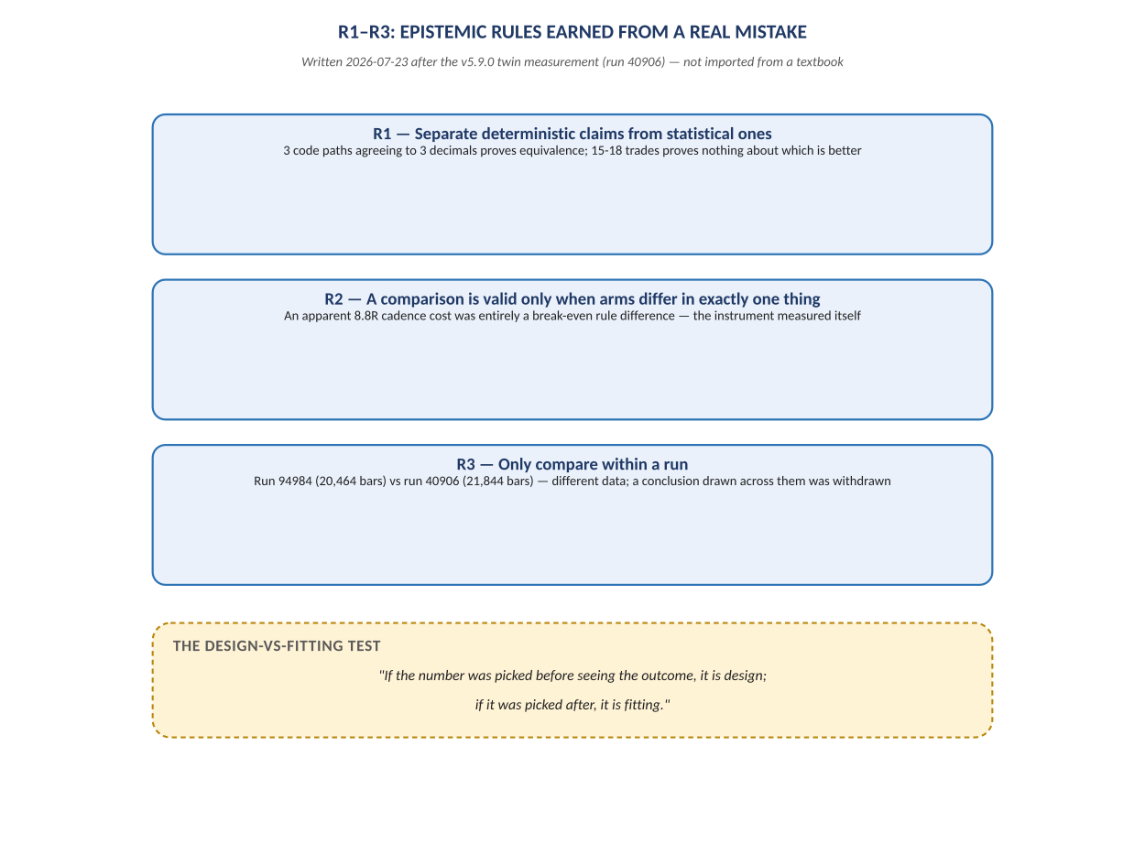
Figure A. R1–R3, the epistemic rules a real measurement incident produced — added 2026-07-29.

6.1 Evidence Already Produced: Hypothesis Zero and the Cost-Threshold Envelope
The repository's Validation folder shows the QRF-style pipeline is not purely theoretical — it has already produced results for two named hypotheses, H-07 and H-16. A Stage-1/2 “Hypothesis Zero” cost-feasibility analysis over 38,056,352 clean ticks (4.69 million one-second points) computed, for horizons from 5 seconds to 4 hours, the probability that price movement clears a stated round-trip cost threshold at multiples of 1×, 1.5×, 2×, and 3×. The feasibility frontier found the shortest horizon at which the median move clears the primary 1.5× gate to be 15 seconds, with clearance probability rising from 28.4% at 5 seconds to 88.7% at 5 minutes and 96.5% at 1 hour.
A Stage 3 feature-stability check on H-07's observables (465 liquidity pools, 325 sweeps over 80.7 days) found event rates stable across three non-overlapping sub-periods (ratios of 1.07–1.25) and returned an overall PASS verdict. A Stage 4 cost-threshold analysis then computed, for each hypothesis, the exact cost level at which gross expectancy crosses zero and the level at which it clears the 1.5× evidentiary gate:
Hypothesis | Trades | Gross Expectancy | Break-Even Cost | Gate-Clearing Cost (1.5×)
H-07 | 324 | +0.0763R | 19.0 ticks | 12.5 ticks
H-16 | 34,406 | +0.0467R | 2.0 ticks | 1.5 ticks

The report is explicit that this is “descriptive, not a verdict” — exactly the Screener/Observatory-versus-EvidenceBattery distinction formalized in the Platform Architecture (Section 3.4 above): a cost-threshold scan is allowed to describe a venue's feasibility envelope and issue a “shopping spec” for re-testing (all-in round-trip cost at or under 12.5 ticks for H-07, 1.5 ticks for H-16), but it explicitly does not carry the epistemic weight of an EvidenceBattery PASS/FAIL/INSUFFICIENT verdict. This is the Kernel's core discipline already operating in practice, before the Kernel's own code was necessarily complete.

7. Roadmap Reconciliation: One Ladder From Three
The Phase Ledger (written 2026-07-23, at EA v5.9.0) records that the repository had accumulated three disagreeing phase ladders — the original overhaul plan, the Fable-authored NP Architecture Roadmap, and the Sequential Strategy Engine (SSE) line — and reconciles them into one authoritative ladder, a useful model for how the broader QRF ambition should be tracked against delivery.
Ladder Item | What | Status
A. Restructure 0–4 | ADR-001 layering: StateHub/EventBus, GateBase registry, StrategyPortfolio, dashboard rewrite | DONE — ships in v5.9.0
A. Restructure 5 | Legacy EG_* removal | RE-SCOPED — closed sanctioned-residual list of 4 named exceptions
B. SSE Phase 6 | Sequential Strategy Engine | DONE, CLOSED at v5.9.0
C. Phase 7 | Gate Recorder + Python replay (absorbs the earlier “NP Lab” idea) | DESIGNED, not started
D. R6 long run | 3–6 months of real-tick data with an unseen OOS window | OPEN — highest-value pending item; files shipped, never run

Three supersession notes are worth surfacing because they show mature engineering judgment rather than scope creep. First, the original NP Architecture Roadmap's “NP Lab” Python research layer — approximate fills over exported bars — is superseded by the stronger Phase 7 Gate Recorder design, in which the EA records ground-truth gate state and Python replays it exactly, with a trade-for-trade acceptance gate; the roadmap's original key decision (“Python is research, never a second engine”) is preserved and strengthened rather than reversed. Second, an hourly/session filter feature was parked, not superseded — explicitly because every strategy-selection question is currently data-starved, and the honest fix is to gather more data before adding a new selection axis. Third, and most consequential, the R6 long run — three to six months of real-tick data with a withheld out-of-sample window — is identified as the single most valuable pending action ahead of any further architecture work, because every open statistical question in the system (does a given sequence beat its static equivalent, is a break-even rule net-positive, is the RegChannel gate additive) is currently unanswerable on samples of fifteen to twenty-three trades.

8. Synthesis: Where Vision and Reality Currently Stand
Volume I Concept | Status in the Live System
Single Observation Engine feeding both organs | Partially realized: StateHub/EventBus is the MQL5-side analogue; the Kernel-side Observation Engine for QRF is specified but not shown as implemented code in this export
Chief Scientist Principle (QRF never trades, NeelPrajna never self-learns) | Directly mirrored by ADR-001's dependency layering and ADR-005's operations/governance split; the EA's auto-adopt feature is the one deliberate, bounded, owner-approved exception, itself treated as a strategy under test
Six-object Communication Contract | Formalized at the Kernel/plug-in level in the Platform Architecture; the live EA's equivalent is the StateHub/EventBus contract plus the NPSU CSV schemas
Observation Space (context-scoped validity) | Directly implemented as the mandatory-scoping principle (Section 3.5) and as the run_id / session / regime fields already present in NPSU's CSV schemas
Generation 2 autonomous hypothesis discovery | Not yet evidenced in this export; the Screener/Observatory components exist as specified contracts (no-verdict, no-burn) but Stage 1–4 validation so far covers human-named hypotheses H-07 and H-16
Never fool yourself (Generation 1 discipline) | Fully operating: EvidenceBattery-style PASS/FAIL logic, independent verifiers, mirror parity, pre-registered predictions, and the R1–R3 rules are all in active use today

The overall picture is of a programme whose discipline has consistently outpaced its architecture diagrams: the team wrote independent verifiers, sealed evidence, and pre-registered predictions before the Kernel that formally names these practices existed as a specification. That ordering — practice before doctrine — is exactly the sequencing the Architect's Response argued for (“This one will be a record”, not an aspiration), and it is the strongest evidence that the Platform Architecture, once ratified, will describe a system the team already knows how to build rather than one it hopes to invent.

9. Additional Risks Surfaced by the Repository Evidence
Risk | Evidence From the Repository | Mitigation Already in Place / Recommended
Two-clock drift | EA continues to version (v5.9.0 and rising) while the QRF Kernel is specified but its code was not found in this export. [CORRECTED 2026-07-29 — see Errata: the Kernel is fully built in a separate repository, F:\\QRF, ten sprints in.] | Track both clocks on the same Phase Ledger; do not let plug-in feature velocity outrun Kernel firewall enforcement.
Data starvation blocking promotion decisions | Explicitly named in the Phase Ledger: candidate strategies carry 5–23 trades; “nothing can be promoted survival-first at n<100.” | R6 long run is already scheduled and correctly prioritized as the top open item.
Autonomy ceiling created by a deferred safety decision | Windows auto-login deliberately left disabled, capping recovery autonomy at L2 regardless of runner sophistication. | Named honestly as an open decision in ADR-005; revisit before hosting a real-money account on the same machine.
Sanctioned-residual coupling accumulating silently | Four EG_ readers already sit outside the intended layer boundary, each justified individually. | The list is explicitly CLOSED; any addition requires a same-commit justification — a good pattern, worth carrying into the QRF Kernel's own firewall exceptions if any arise.
Screener/Observatory outputs migrating into belief without a formal gate | The Platform Architecture explicitly forbids this (Section 6), but the enforcement mechanism (code-level, not just written rule) was not observed directly in this export. [CORRECTED 2026-07-29 — it exists: battery.py is the sole writer of belief-affecting verdicts; the Screener/Observatory code paths structurally cannot produce one.] | Confirm the BeliefLayer's update() path is programmatically restricted to Verdict-typed inputs, not merely documented as restricted.

10. Conclusion
Read together, the Platform Architecture and the live repository resolve the largest open question from Volume I: whether the QRF/NeelPrajna vision was a coherent plan or an untested philosophy. The evidence is that it is the former, substantially proven in miniature already. The four-layer ADR-001 refactor, the Supervisor/Runner trust split, the R1–R3 epistemic rules, and the Stage 1–4 validation pipeline for H-07/H-16 all show the same discipline the Platform Architecture now asks the Kernel to enforce everywhere: separate what is known from what is merely observed, separate who may act from who may learn, and never let a convenient result skip the one gate built to catch convenient results. The remaining work is less about inventing new principles and more about finishing the migration of proven MQL5-side discipline into the domain-general Kernel, running the R6 long run that the Phase Ledger already prioritizes, and keeping the operations and governance clocks from drifting apart as both continue to advance.

Errata — Added 2026-07-29
This volume was written from the NeelPrajna repository export alone, which does not contain the QRF Kernel's own source code — a separate repository, F:\\QRF, was not yet available at the time of writing. Two corrections are required now that F:\\QRF has been read directly, stated here rather than silently edited into the tables above, per this project's own append-only convention.

Correction 1: the Kernel is not merely specified — it is built, and closed
Section 9's “Two-clock drift” row and Section 8's synthesis table both treated the QRF Kernel as “specified but not shown as implemented code.” That was an accurate description of the evidence available at the time — the NeelPrajna export genuinely contains no Kernel code — but it understated reality. F:\\QRF is a real, ten-sprint repository: RecordStore, WindowLedger, TrialCountLedger, EvidenceBattery, and Observatory are all implemented, IVF-verified, and were used to close an entire Generation 1 (four hypotheses judged, zero promoted, 2026-07-26). The “two-clock drift” risk this volume raised is real, but the two clocks are further apart than assumed: one is a mature, closed Generation 1; the other is NeelPrajna's own v5.9.0-and-rising EA line. See QRF_Generation1_Deep_Analysis.docx for the full account.
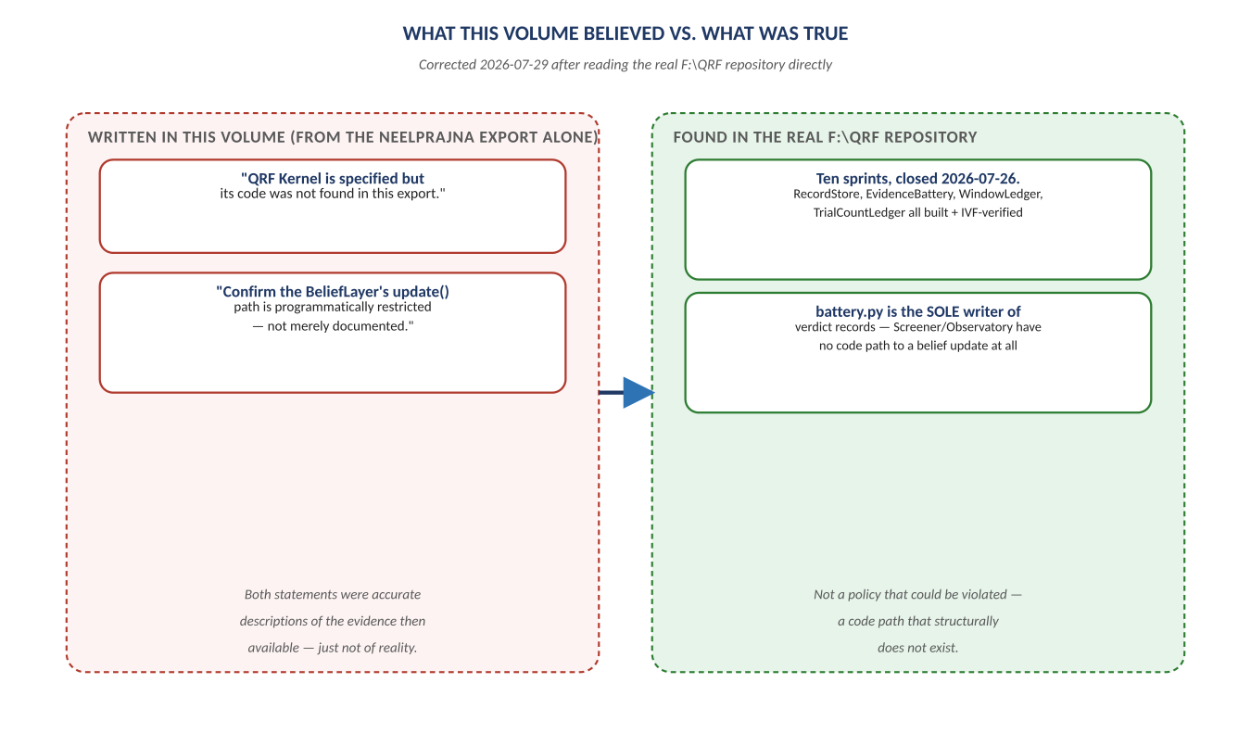
Figure B. What this volume believed vs. what the real repository showed — both original statements were accurate for the evidence then available.

Correction 2: the Screener/Observatory enforcement mechanism does exist, and is code-level
Section 9's final row recommended confirming that BeliefLayer.update() is “programmatically restricted to Verdict-typed inputs, not merely documented as restricted.” It is: battery.py is the sole writer of verdict and window_burn records by construction, and the Screener/Observatory code paths have no route to a belief update at all — not a policy that could be violated, a code path that does not exist. This recommendation can be marked satisfied rather than open.
Neither correction changes this volume's central finding — that NeelPrajna's own engineering discipline (independent verifiers, sealed evidence, pre-registered predictions) anticipated the Kernel's formal rules before the Kernel existed in reach. If anything, knowing the real Kernel now makes that finding stronger: two teams converged on the same disciplines independently, and the convergence is the evidence, not a coincidence to explain away. See NeelPrajna_QRF_Integration_Path.docx for the resulting recommendation — that NeelPrajna stop building its own parallel version of what QRF has already proven, and integrate with the real thing instead.

