NeelPrajna × QRF
The Real Integration Path — A Bigger System Than Either Was Alone

Why NeelPrajna should stop building its own miniature Kernel, and become instead
the second real concept family inside a scientific operating system already proven for ten sprints
Research Architecture Document, Volume IV • July 2026

Table of Contents

1. The Reframe
The QRF analysis in Volume III produced one finding that changes the shape of everything downstream of it: Generation 1 is not a proposal. It is built, drilled, IVF-verified, and closed — ten sprints, eleven ADRs, a signed-off scientific record of four hypotheses judged and zero promoted. That finding demands a second look at a decision this engagement made earlier without knowing it: NeelPrajna was given its own small research apparatus — np_knowledge_base.py, np_probability_engine.py, np_hypothesis_zero.py, np_cost_threshold.py — built independently, judged by its own bespoke battery, with no selftest-gate discipline, no IVF, no drill history, and no multi-AI governance record behind it.
That apparatus was reasonable to build in isolation. It stops being the right long-term answer the moment a more rigorous, already-proven instrument exists one repository away, on the same market, using the same cost-model convention. This volume makes the case, concretely, for retiring NeelPrajna's bespoke validation stack in favor of becoming the second real concept family inside QRF's Kernel — not a hypothetical future integration, but a move buildable today with real APIs that already exist on both sides.
This is the “bigger than anybody expected” move: not two systems racing in parallel, but one proven scientific operating system with two markets' worth of knowledge inside it.

2. The Redundancy This Corrects
Every function NeelPrajna's own research scripts perform already exists, more rigorously, in QRF's Kernel — built and hardened across ten sprints of adversarial drilling that NeelPrajna's own scripts have never been subjected to.
Function | NeelPrajna's own version | QRF's proven version
Hypothesis ledger | np_knowledge_base.py — hand-rolled JSON + journal, single author, no drill history | RecordStore — hash-chained, single-writer, fsync'd, torn-tail detection, ten sprints of production use
Evidence battery | np_probability_engine.py — bespoke B1–B7 checks, written once, never IVF-verified | EvidenceBattery — 9 enforced steps, a selftest gate re-checked on every single run, atomic verdict+window_burn
Multiplicity correction | Informal — no trial-count ledger; a sweep's attempts are not systematically counted | TrialCountLedger — registration spends the attempt (ADR-011); every sweep counted, family-deflated at judgment time
Data reuse prevention | None — no window designation or burn mechanism; a dataset can be re-queried without a structural refusal | WindowLedger — TRAINING/EXPLORATION/VIRGIN designation, burn-on-use, structural refusal on reuse
Independent verification | np_trade_verifier.py — a second implementation, but never itself drilled with a planted fraud | IVF — re-implements every rule from normative text, drilled with planted frauds every sprint, clean-control mandatory before judging real data
Governance record | Informal changelog prose in HANDOVER.md | ADR-008 multi-AI protocol — ARCH/DEVQ/NOTE/GO/REV artifacts, a findings tally (21 findings, 10 sprints, all caught before harm)

None of this is a criticism of the original NeelPrajna research scripts — they were built quickly, by necessity, before a more rigorous alternative existed in reach. The criticism, if there is one, is of continuing to invest in the bespoke version now that the rigorous one is real and reachable.

3. Diagram — Today: Two Parallel Stacks
Built independently, validating the same instrument, unaware of each other. NeelPrajna's H-07 (equal-high/low sweep reversal) was judged FAIL on cost sensitivity by an unaudited battery; the verdict is very likely correct, but it was reached by an instrument that has never itself been drilled against a planted fraud.
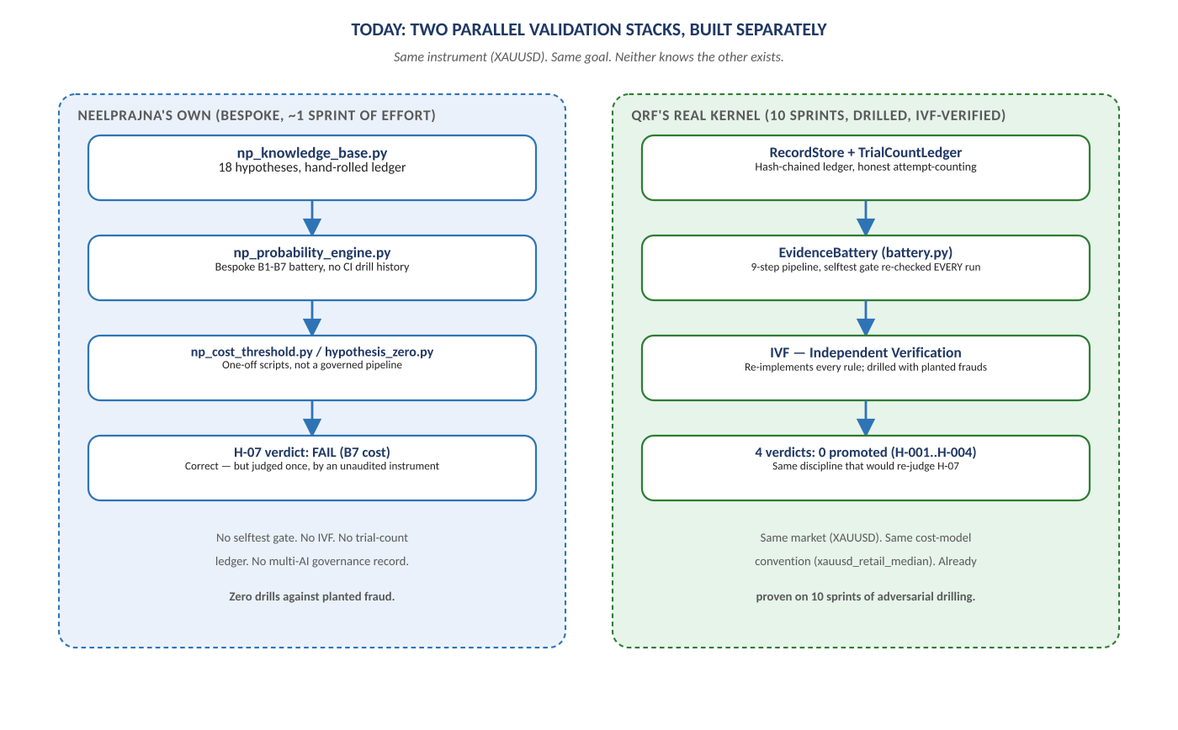
Figure 1. Two independently-built validation stacks, same market, no shared ledger.

4. What Actually Has to Move — Concretely, Not Hypothetically
This integration is buildable with APIs that exist today on both sides of the repository boundary, not a future design.
- NeelPrajna's CSV exports already match QRF's real adapter contract. qrf/trading/adapters/mt5_csv.py expects MT5 bar CSVs with an explicit timeframe parameter and OBS-4 close-time normalization — the same shape as NP_Trades_*/NPSU_Trades_* exports. No new adapter needs to be written; NeelPrajna's existing export path is very close to a direct feed.
- NeelPrajna's 18 founding hypotheses become real Hypothesis YAMLs. H-07 through H-18, currently rows in np_knowledge_base.py's FOUNDING list, become configs/hypotheses/h0NN_*.yaml files — exactly the format QRF's own h001_fvg_follow_through.yaml already uses. Each carries its own instrument_id and code_ref, the same fields QRF's InstrumentRegistry already requires.
- NeelPrajna's cost model is already speaking QRF's language. QRF's real xauusd_retail_median venue config (spread 0.30, round-trip $0.47/oz) and NeelPrajna's own cost-threshold analysis (26 ticks round-trip) are the same convention — a named, versioned, frozen-once-cited cost model. Reconciling the two numbers into one authoritative configs/venues.yaml entry is a single, bounded task, not an architecture change.
- qrf/trading/concepts/neelprajna/ becomes the new detector package, alongside the existing classical (RSI), seasonality, and smc families — a fourth concept family, not a fourth framework. NeelPrajna's LiquiditySweepGate.mqh logic (already partially ported to np_feature_service.py) becomes the detector; QRF's Kernel judges it.

5. Diagram — The Proposed Integration
NeelPrajna's execution side is untouched. Only the question “is this hypothesis real?” moves — from an unaudited bespoke battery to the same nine-step, selftest-gated pipeline that already produced QRF's four real verdicts.
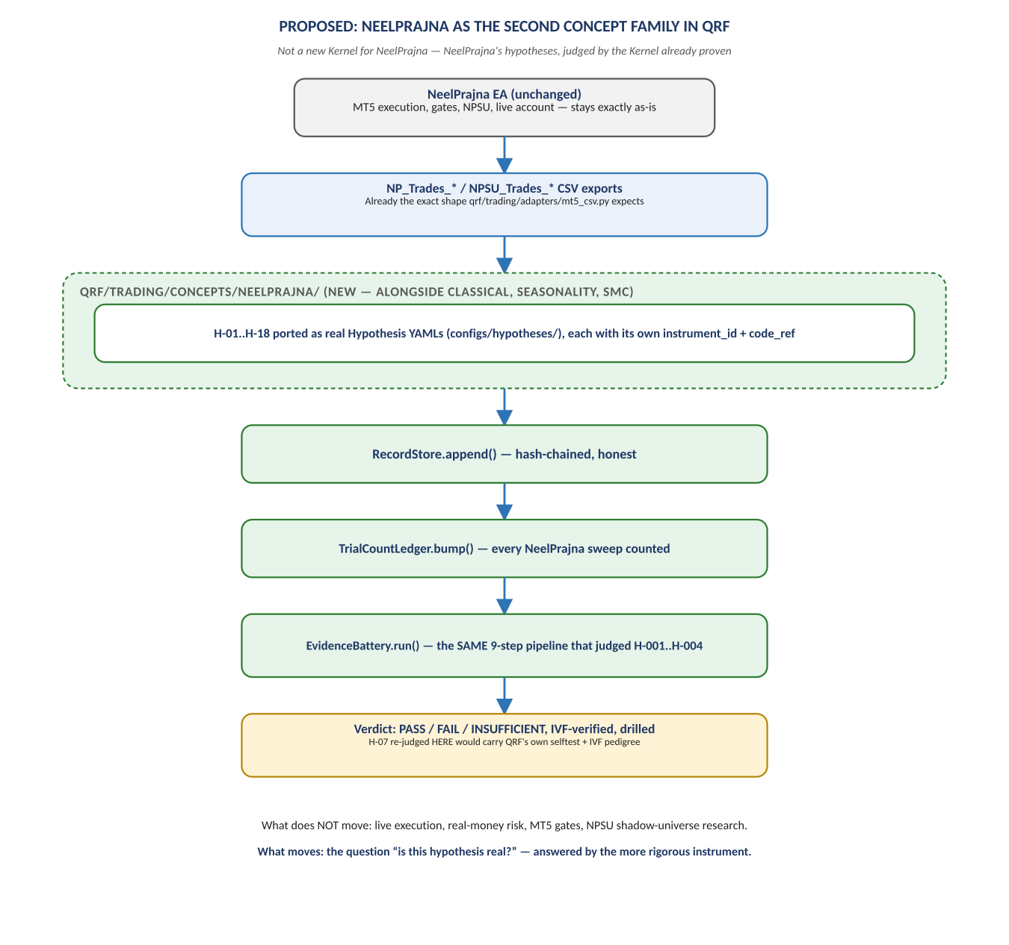
Figure 2. NP_Trades_* CSVs → qrf/trading/concepts/neelprajna/ → the real RecordStore/TrialCountLedger/EvidenceBattery.

6. The Concrete First Integration Sprint
Framed the way QRF frames its own sprints — an ARCH-style instruction, not a vague intention — the first integration sprint has a small, falsifiable scope:
- Scope: port H-07 only (the most evidence-rich NeelPrajna hypothesis: 324 trades, Stage-3 observability already recorded) into a real Hypothesis YAML; write the neelprajna.liquidity_sweep detector against qrf/trading/adapters/mt5_csv.py; register it; run the real EvidenceBattery against the same trade population NeelPrajna's own bespoke battery already judged.
- Acceptance criterion: the real Battery's verdict is compared, gate by gate, against NeelPrajna's own B1–B7 result. If QRF's real battery also reaches FAIL on cost sensitivity, that is strong independent corroboration of a verdict NeelPrajna's own tooling already suspected. If it diverges, the divergence itself is the most valuable output of the sprint — exactly the kind of finding QRF's own findings tally exists to capture.
- Non-goals: no change to NeelPrajna's live execution; no change to the real-account gates, TradeManager, or NPSU; no attempt to port all 18 hypotheses in the first sprint — H-07 alone, judged twice, by two instruments, is the whole point of sprint one.

7. Why This Is Bigger Than Either System Alone
The most important consequence of this integration is not that H-07 gets re-judged. It is that NeelPrajna stops needing its own Generation 2, 3, and 4.
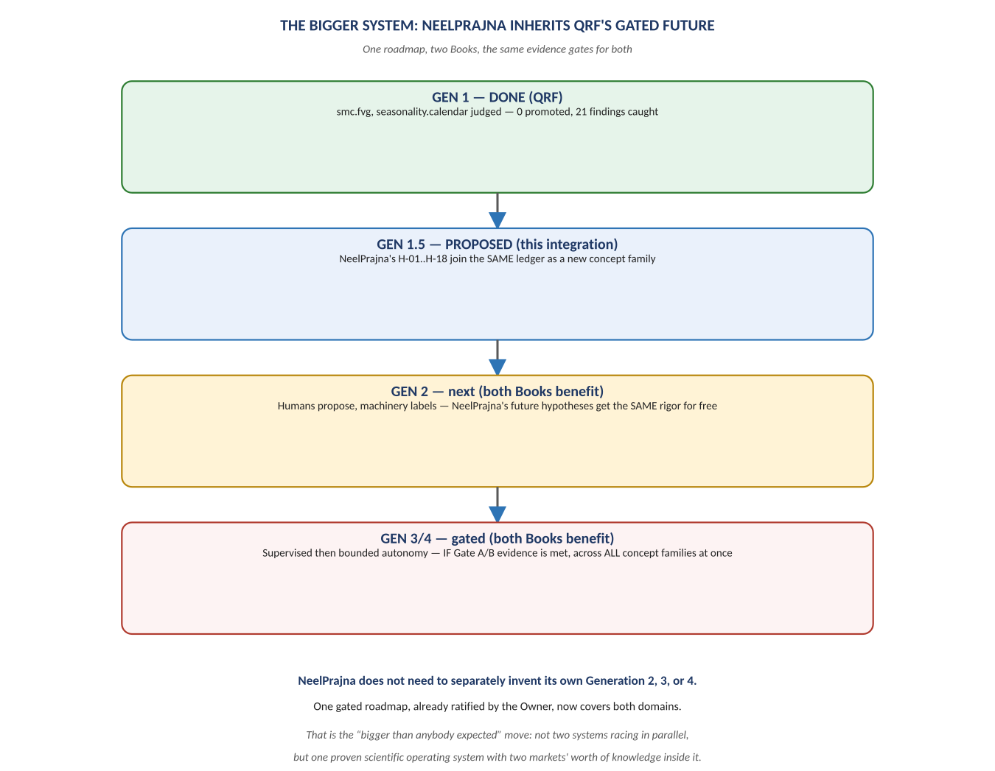
Figure 3. One gated roadmap, ratified once, now covering two markets' worth of knowledge.
QRF's Generation 2→4 roadmap is gated on evidence, not on calendar time — Gate A requires a documented track record of hand-work a future subsystem would mechanize; Gate B requires a certified Discovery Engine and a populated knowledge graph. Every concept family inside the Kernel benefits from those gates opening once, together — there is no separate Gate A for smc.fvg and a different Gate A for neelprajna.liquidity_sweep. NeelPrajna's own future hypotheses, once inside the ledger, inherit Generation 2's labeling discipline, Generation 3's supervised discovery, and Generation 4's bounded autonomy the same day any other concept family does, without NeelPrajna's own team ever having to design, drill, or govern that evolution a second time.

8. Governance: What Stays Separate, On Purpose
Not everything should merge. NeelPrajna's ADR-005 Supervisor/Runner trust split exists to govern real-money, real-time execution — a concern QRF's ADR-008 multi-AI research protocol was never built for and should not absorb. The proposed division of labor:
Stays with NeelPrajna (ADR-005) | Moves to QRF (this integration)
Live order execution, TradeManager, MoneyManager | Is this hypothesis statistically real? (EvidenceBattery)
The Supervisor/Runner autonomy ladder for the trading EA | Is this window contaminated or already burned? (WindowLedger)
NPSU's real-time shadow-universe research, Live Advisor | How many attempts has this family really made? (TrialCountLedger)
The 2% profit auto-close, per-trade risk sizing | Has this claim been independently reproduced? (IVF)

The dividing line is exactly the one QRF's own ADR-004 draws for its Kernel/trading-plugin split, applied one level up: NeelPrajna's execution machinery is domain-specific and stays where it is; the question of whether a claim about the market is true moves to the more rigorous, domain-blind judge.

9. Risks, Stated Honestly
- Re-judging H-07 could produce an uncomfortable divergence. If QRF's real battery reaches a different verdict than NeelPrajna's own B1–B7 result, that is not a failure of the integration — it is the integration doing exactly what it is for. The response should be to trust the more rigorously verified instrument, not to average the two.
- This is real migration work, not a documentation exercise. Writing a real detector against qrf/trading/adapters/mt5_csv.py, registering a real Hypothesis YAML, and reconciling two cost-model numbers into one is engineering effort with its own sprint, its own IVF check, and its own Owner sign-off — the same discipline QRF applies to itself, now applied to onboarding a second domain.
- QRF's own Generation 1 report names its limitations plainly — one instrument, one timeframe, ~2 years of data, broker-tier independence only. Those limitations transfer to any NeelPrajna hypothesis judged inside this Kernel too, and should be restated alongside any verdict, not left implicit.

10. Recommendation
Propose the H-07-only integration sprint described in Section 6 as the concrete next action, framed exactly as a QRF ARCH instruction would frame it, and let its own acceptance criterion — does the real battery agree with the bespoke one? — be the evidence that decides whether the remaining 17 hypotheses follow the same path. This is the same trust-before-demonstration discipline QRF has applied to every subsystem it has ever built, now applied to the decision to integrate at all.

