QRF × NeelPrajna
Architecture of a Living Scientific Ecosystem

A Research and Design Analysis of the Universal Scientific Research Framework,
the Scientific Ecosystem Architecture, and the NeelPrajna Trading Runtime
Research Architecture Document • July 2026

Table of Contents

1. Executive Summary
This document analyzes and formalizes the architecture vision for QRF (Quantitative Research Framework) and NeelPrajna, presented in the source material as “two organs of the same living organism.” QRF is conceived as the scientific brain — responsible for observation, pattern learning, hypothesis validation, statistics, and a growing knowledge graph. NeelPrajna is the nervous system and hands — the live execution runtime responsible for orders, risk, position management, and the trading dashboard. Neither replaces the other; a strict communication contract binds them into one continuously learning ecosystem.
The central intellectual move in the vision is an evolution of purpose. Generation 1 of QRF answers a narrow, disciplined question: given a human-created trading concept, can it survive a rigorous evidence battery without self-deception? Generation 2 inverts the pipeline: the market itself becomes the source of concepts. Observation, pattern discovery, and hypothesis generation happen inside the framework, with humans elevated from idea generators to scientific reviewers. This transforms QRF from a validation platform into an autonomous scientific research platform — and, through the Scientific Ecosystem Architecture (SEA), into a domain-general engine whose first application book is markets, with biology, robotics, materials science, and climate research as future volumes.
The remainder of this document reconstructs the architecture in detail, evaluates its scientific foundations, identifies the strongest design decisions and the principal risks, and proposes a staged roadmap from the current validation-centric Generation 1 to the autonomous-discovery Generation 2 and beyond.

1.1 Key Findings
- Separation of knowledge and action is the load-bearing wall. The Chief Scientist Principle — QRF never trades, NeelPrajna never learns on its own — is the single most important safeguard in the design. It prevents both silent strategy drift in the runtime and execution bias in the research brain.
- The Observation Space concept is scientifically mature. Declaring that a hypothesis is never universal, only valid inside a defined observation space (timeframe, regime, instrument, market state), imports a core lesson from experimental science: external validity must be earned, not assumed.
- Concept-after-observation ordering is historically correct. The design's insistence that concepts (like “electron”) emerge after accumulated observations (sparks, static, lightning) — not before — correctly models how scientific vocabulary forms, and justifies the clustering-to-concept discovery pipeline.
- The communication contract is the ecosystem's immune system. Restricting inter-system traffic to six object types (Observation, Pattern, Knowledge, Recommendation, Execution Feedback, Performance) and forbidding internal-variable leakage keeps the two organs replaceable, testable, and honest.
- Autonomy is the largest opportunity and the largest risk. Machine-generated hypotheses multiply the multiple-testing problem enormously; the evidence battery, pre-registration, and human review gates must scale in rigor as hypothesis volume scales.

2. The Core Vision: One Living Organism
QRF and NeelPrajna are not two independent products. They are two organs of the same living organism. QRF is the brain. NeelPrajna is the nervous system and hands.
The vision rejects the conventional split between “research stack” and “trading bot” as two loosely coupled products. Instead, both systems consume a single stream of market observations, share a common memory, and communicate continuously — each specializing in what it alone is permitted to do.

2.1 Top-Level Architecture
MARKET → Tick / M1 / M5 / H1 / D1
↓
Observation Engine (single source of observations)
↓ ↓
QRF Brain NeelPrajna Runtime
Scientific memory Live execution
Pattern learning Risk management
Knowledge graph Order handling
Statistics & confidence Dashboard
Pattern evolution Position management
↑─── Continuous Communication ───↑

Three properties define this topology. First, there is exactly one Observation Engine: both organs see the same reality, eliminating the classic research/production data-divergence problem. Second, communication is continuous and event-driven — a shared heartbeat in which nobody waits, nobody blocks, and everybody reacts on every tick. Third, the arrows are asymmetric by design: knowledge flows toward the runtime, execution feedback flows toward the brain, and neither organ can perform the other's function.

2.2 Division of Intelligence
Capability | QRF (Brain) | NeelPrajna (Runtime)
Source of observations | Observation Engine (shared) | Observation Engine (shared)
Learning | Pattern learning, belief updates, statistics | None — forbidden by design
Trading decisions | None — forbidden by design | Sole decision-maker
Outputs | Pattern ID, win rates, confidence, regime, applicability | Orders, positions, execution feedback
Time horizon | Real-time stats + deep research mode | Live, tick-by-tick
Failure blast radius | Bad knowledge (filtered by review) | Bad trade (bounded by risk layer)

This division mirrors mature scientific institutions: laboratories generate validated knowledge, and practitioners apply it under operational constraints. Collapsing the two roles into one system historically produces overfitted “self-improving” strategies; the vision explicitly forbids that collapse.

3. Programme Structure: Three Projects, One Trajectory
The material organizes the effort as a three-project programme with future “application books” beyond markets.

Project 1 — QRF: Universal Scientific Research Framework
The domain-independent research engine, planned across Generations 1 through 10. Its mission statement evolves from the narrow “convert any trading concept into statistically honest evidence” to the broader “discover, formulate, validate, and continuously refine explanations of market behavior using reproducible scientific methods.” The evolution matters: validation is one stage of science; the revised mission spans the full observe–hypothesize–experiment–learn cycle.

Project 2 — SEA: Scientific Ecosystem Architecture
The connective tissue: Observation, Memory, Knowledge, Communication, Verification, Learning, and Domain Adapters. SEA is what makes QRF universal — the market is merely the first domain adapter. The same skeleton is intended to later host biology, robotics, medical research, drug discovery, materials science, and climate research as parallel application books.

Project 3 — NeelPrajna: The Market Application
The first embodiment: market knowledge, trading, execution, risk, and dashboard. NeelPrajna proves the ecosystem end-to-end, because markets provide fast, unforgiving feedback loops — an ideal proving ground for an autonomous research architecture before it is pointed at slower domains.

4. Scientific Foundations

4.1 The Observation Space
An Observation Space is the complete set of conditions under which a hypothesis is observed, generated, validated, and considered valid. A hypothesis is never universal — it is true or false only inside a particular Observation Space.
Every observation is stamped with its full context:
- Timeframe
- Time period
- Market state
- Market structure
- Market dynamics
- Market regime
- Instrument
- Observation source
This is the framework's defense against the most common failure in quantitative research: silent extrapolation. A pattern validated on Gold, M5, in a low-volatility regime, during 2023–2025 European sessions carries no automatic license to trade the S&P on H1 in a crisis regime. By making validity conditions first-class data, the knowledge graph can answer not only “is this pattern real?” but “where is it real, and does the current moment lie inside that region?” — which is exactly the “applicability” field QRF publishes to NeelPrajna.

4.2 Concepts Come After Observations
The material draws a deliberate parallel to the history of physics: humanity observed sparks, amber attracting dust, lightning, and static charge long before anyone introduced the concept “electron.” The concept compressed and unified pre-existing observations; it did not precede them. The architecture encodes this ordering directly:
Unknown observations → Clustering → Compression → Graph structures
→ Candidate concepts → Human review → Approved concept → Generated detector

The consequence is profound: detectors themselves become outputs of research rather than hand-coded inputs. Today a human writes a detector and the system emits events; tomorrow, clustering over raw observations proposes candidate concepts, humans approve them, and the detector is generated from the approved concept. The concept library (CRT, TBS, Liquidity Sweep, and successors) becomes a living, growing vocabulary discovered from the market rather than imposed upon it.

4.3 The Full Scientific Ladder
The end-to-end epistemic pipeline, from raw reality to durable knowledge:
Reality → Instrument → Observations → Patterns → Concepts → Events
→ Hypotheses → Evidence → Beliefs → Knowledge

Each rung is a distinct data type with distinct guarantees. Observations are immutable records of what happened. Patterns are statistical regularities. Concepts are named, reviewed compressions. Events are concept instances detected live. Hypotheses are falsifiable claims with pre-registered predictions. Evidence is the output of the battery. Beliefs carry calibrated confidence, and knowledge is the belief network that survives contradiction checks in the graph.
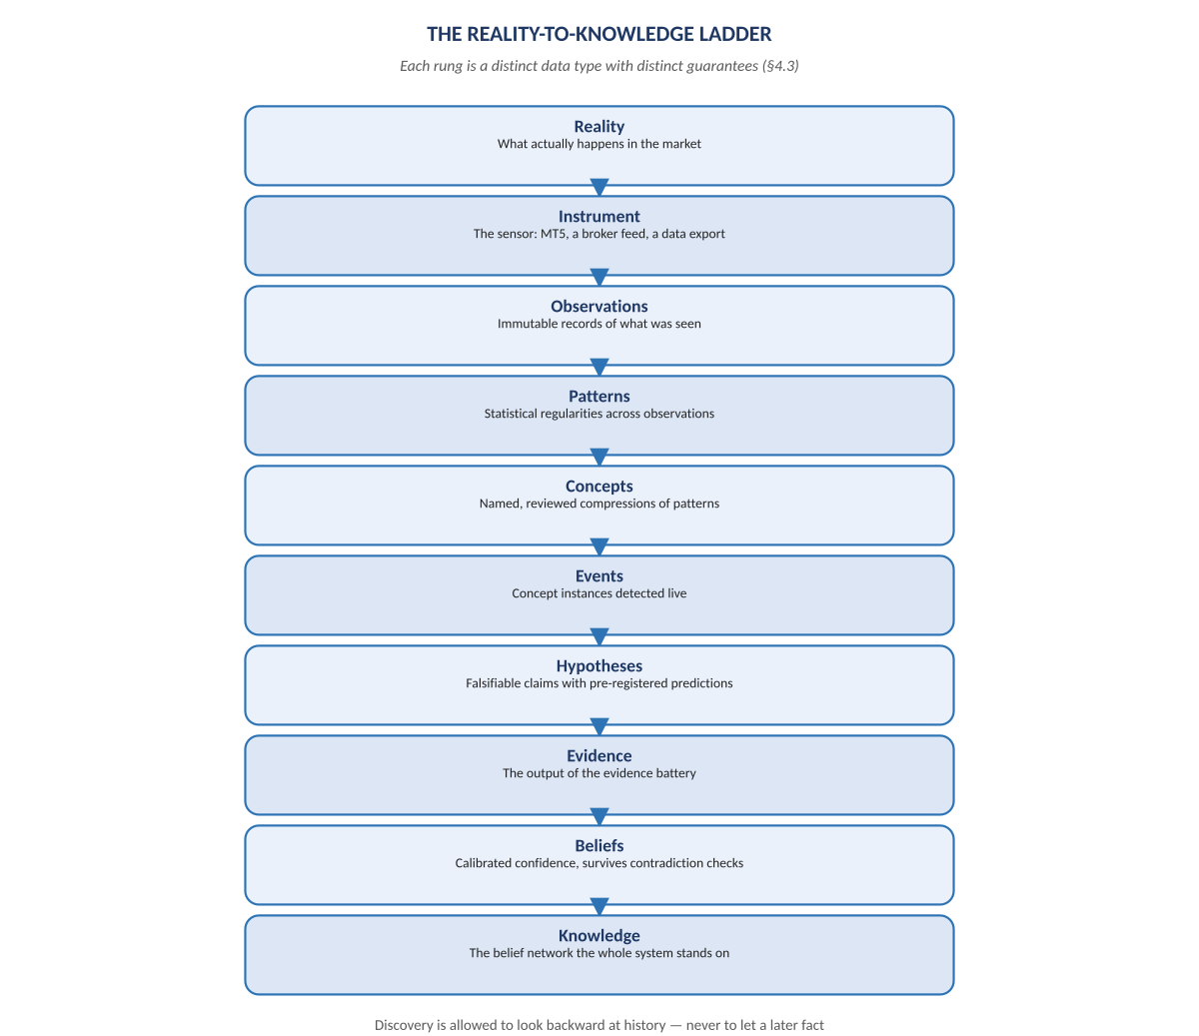
Figure A. The Reality-to-Knowledge ladder, one rung per data type — added 2026-07-29.

5. From Validation to Discovery: Generation 1 → Generation 2

5.1 Generation 1 — The Honest Judge
Human → Creates hypothesis → QRF → Evidence Battery → PASS / FAIL

Generation 1's purpose is captured in a single Feynman-flavored imperative: never fool yourself. A human proposes a concept; the Observatory Pipeline subjects it to calibration checks, placebo tests, and independent validation (IVF); a scientific verdict is issued. This is excellent discipline — but the human remains the sole source of ideas, which is identified in the source material as “perhaps the largest scientific weakness.”

5.2 Generation 2 — The Autonomous Scientist
Market data → Feature space → Pattern discovery → Hypothesis generator
→ Human review → Evidence battery → Knowledge graph → New questions

Generation 2 asks the pivotal question: why shouldn't the framework discover concepts? Humans are repositioned as reviewers — the peer-review layer of an otherwise autonomous cycle. The autonomous research loop requires only a minimal human-supplied mission and initial boot knowledge, then runs continuously: observe, discover, generate hypotheses, prioritize, validate, learn, update beliefs, publish reports, repeat forever.
Two illustrative discoveries from the material show what this looks like in practice. In the first, the framework notices that when spread contracts, tick rate increases, volatility compresses, and price sits near VWAP, a large breakout tends to follow — a four-condition conjunction no human specified. In the second, it detects that Gold behaves differently every Tuesday between 09:45 and 10:20 — where nobody coded “Tuesday,” nobody coded “10:20,” and nobody coded “Gold.” The framework surfaced the anomaly; humans investigate it.

5.3 The Knowledge Graph as Active Collaborator
The knowledge graph is not a passive archive. For any hypothesis it surfaces related hypotheses, contradictions, supporting evidence, missing evidence, and automatic recommendations for the next experiment. This converts the knowledge base from a filing cabinet into a research collaborator that proposes where to look next — the mechanism by which each answered question generates new questions and the loop becomes self-sustaining.

5.4 Historical Pattern
The design explicitly models itself on how science actually advanced: humans observed apples and Newton created gravity; humans observed species and Darwin created evolution; humans observed Mercury's orbit and Einstein created relativity. In each case, accumulated observation preceded theory. Generation 2 mechanizes the observation-accumulation stage and the candidate-explanation stage, while reserving theoretical judgment — the Newton/Darwin/Einstein role — for human review over machine-proposed candidates.

5.5 QRF at the Intersection of Four Fields
Research Area | What QRF Borrows | What QRF Adds
Autonomous science / discovery systems | Closed-loop observe–hypothesize–test cycles | A production runtime (NeelPrajna) consuming the output live
Statistical validation | Placebo tests, calibration, pre-registration | Machine-scale hypothesis throughput under the same rigor
Quantitative research | Market microstructure features, regimes | Observation-space-conditioned validity instead of global claims
Knowledge systems | Graphs, belief networks, contradiction detection | Active recommendation of next experiments

Most existing projects occupy one corner of this map; QRF's ambition is to connect all four corners into a single operating loop.

6. Runtime Architecture and the Three-System Design

6.1 Offline Science, Language-Independent Knowledge, Live Execution
OFFLINE: QRF Gen 1 (Python + offline data) → Evidence → PASS/FAIL
→ Detector Specification (language-independent)
→ Python implementation (verification)
→ MQL5 implementation (runtime) → NeelPrajna EA on MT5

Validated knowledge is exported as a detector specification that is deliberately language-independent. Two independent implementations are then produced: a Python reference used for verification and an MQL5 implementation used in the live MetaTrader 5 runtime. Architecture, implementation, an independent validator, a comparison report, and a final human decision form the release gate. This dual-implementation discipline catches translation bugs — the classic failure mode where a strategy that passed research silently differs in production code.

6.2 The Shared Data Plane
Market → MT5 live + daily CSV → Live Detector Engine / Daily Import
→ Observation Store → Scientific QRF → Knowledge + Evidence → NeelPrajna EA

Live detection and daily historical import both feed one Observation Store, ensuring research and production reason over identical data. Four shared stores with strict write permissions constitute the ecosystem's memory:
Store | Writer | Readers
Observation Store | Detector / Observation Engine | QRF, NeelPrajna, Dashboard
Knowledge Store | QRF only | NeelPrajna, Dashboard
Performance Store | NeelPrajna (execution feedback) | QRF, Dashboard
Pattern Store | QRF | NeelPrajna, Dashboard

A companion principle governs Market Memory: it never interprets, it only remembers. Interpretation is QRF's monopoly; storage is neutral. This keeps raw history replayable and audit-clean regardless of how theories evolve above it.

6.3 The Five-Layer Philosophy and the Closed Loop
Layer | Role | Owner
1. Observation | Record reality without interpretation | Observation Engine
2. Memory | Persist observations and outcomes | Shared stores
3. Knowledge | Validate, calibrate, and publish beliefs | QRF
4. Decision | Convert knowledge + live context into trades | NeelPrajna
5. Learning | Feed outcomes back into memory and belief updates | QRF (from feedback)

The closed learning loop — market → observations → memory → knowledge → decision → execution → outcome → memory — is what makes the ecosystem “living.” Every trade is simultaneously an economic act and an experiment whose outcome refines the knowledge that produced it.

6.4 QRF's Two Operating Modes
- Real-Time Mode: incoming observations drive rolling statistics, confidence updates, and continuous knowledge publication — lightweight, always-on.
- Research Mode: deep analysis, pattern mining, hypothesis generation, and full scientific reports — heavyweight, scheduled, and offline-tolerant.
Splitting the two prevents research workloads from ever delaying the live heartbeat, while ensuring real-time confidence numbers stay fresh between deep research cycles.

7. The Communication Contract
The interface between the organs is intentionally narrow. Only six object types are permitted to travel between systems — never internal variables:
- Observation
- Pattern
- Knowledge
- Recommendation
- Execution Feedback
- Performance
Two prohibitions give the contract its teeth. NeelPrajna never asks about QRF internals (“Is Gate B3 true?”); it receives semantically meaningful observations such as a Liquidity Sweep with price, time, strength, and confidence. Symmetrically, QRF never says BUY or SELL; it publishes a Pattern ID with historical win rate, recent win rate, confidence, regime, and applicability — and NeelPrajna alone converts that into (or against) a trading decision.
The architectural payoff is substantial. Either organ can be rewritten, upgraded, or replaced without touching the other, because the contract — not the implementation — is the dependency. Testing becomes tractable: each object type can be schema-validated, versioned, and replayed. And responsibility stays legible: if a bad trade occurs, the question “was the knowledge wrong or the decision wrong?” has a recorded, attributable answer.

7.1 The Chief Scientist Principle
NeelPrajna must never become smarter by itself. QRF must never execute trades by itself.
NeelPrajna's intelligence derives exclusively from validated knowledge plus live observations; QRF's intelligence derives from observations plus execution outcomes while remaining independent of trade execution. This is the constitutional clause of the ecosystem. A runtime that self-modifies drifts from its validated specification within weeks; a research brain with order-routing authority acquires incentives that corrupt its statistics. Keeping learning and acting in separate organs — connected only by the contract — is what makes the whole system a scientific ecosystem rather than merely a trading EA with analytics bolted on.

8. Critical Assessment

8.1 Strengths
- Epistemic honesty by construction. Pre-registered hypotheses, calibration, placebo testing, independent validation, and dual implementations attack every standard avenue of self-deception in quantitative research.
- Context-bounded claims. Observation Spaces make overgeneralization structurally difficult; applicability is data, not an afterthought.
- Replaceable organs. The narrow contract and shared stores mean the research brain and the runtime evolve on independent schedules.
- Domain generality with a hard first test. Proving the loop on markets — fast feedback, adversarial environment — is a demanding validation before expansion to slower scientific domains.
- Human-in-the-loop at the right altitude. Humans review concepts and hypotheses rather than hand-crafting every idea, preserving judgment where it adds most value.

8.2 Risks and Open Problems
Risk | Description | Mitigation Direction
Multiple-testing explosion | An autonomous hypothesis generator can propose thousands of candidates; some will pass any battery by chance. | False-discovery-rate control across the whole generator, not per hypothesis; holdout data the generator never sees; decaying trust in older validations.
Regime non-stationarity | A pattern validated in one regime may decay; markets adapt. | Recent-vs-historical win-rate divergence monitoring (already in the published knowledge object); automatic confidence decay and re-validation triggers.
Feedback contamination | Once NeelPrajna trades a pattern, its own executions alter the data QRF learns from. | Tag execution-influenced observations; separate impact-adjusted evaluation from raw pattern statistics.
Review bottleneck | Human review scales linearly; discovery scales super-linearly. | Prioritization scoring in the loop (already specified); tiered review where only high-impact concepts require deep human audit.
Spec–implementation drift | Python and MQL5 detectors can diverge subtly over time. | The comparison-report gate must run continuously on live data, not only at release.
Concept ontology sprawl | Machine-proposed concepts may fragment into near-duplicates. | Graph-level deduplication and contradiction checks before concepts enter the library.

8.3 Recommendations
- Freeze the contract schemas first. Version the six object types before Generation 2 work begins; every later component depends on their stability.
- Instrument the review queue. Track discovery throughput versus human review capacity from day one — it is the earliest signal of the bottleneck risk.
- Treat the Tuesday-anomaly class carefully. Time-of-week discoveries are exactly where data-snooping thrives; require larger observation counts and out-of-sample confirmation for calendar-conditioned hypotheses.
- Keep Generation 1 alive inside Generation 2. The human-proposed-hypothesis path should remain a first-class citizen; autonomy augments the pipeline, it does not replace the honest judge.
- Define the SEA domain-adapter interface early. Even before biology or robotics adapters exist, writing a second toy adapter forces the market-specific assumptions out of the core.

9. Staged Roadmap
Stage | Focus | Exit Criterion
G1 — Honest Judge | Evidence battery, calibration, placebo, IVF for human hypotheses | Human concepts receive reproducible PASS/FAIL verdicts
G1.5 — One Ecosystem | Observation Engine, shared stores, contract v1, detector spec + dual implementation | QRF knowledge drives NeelPrajna live via contract only
G2 — Autonomous Discovery | Feature space, clustering, hypothesis generator, prioritization, human review UI | First machine-discovered concept passes battery and trades live
G3+ — Active Collaborator | Knowledge-graph recommendations, contradiction resolution, self-directed experiment queues | The loop generates, answers, and archives questions with humans as reviewers
G-n — Application Books | SEA domain adapters: biology, robotics, materials, climate | A second domain runs the identical core loop unchanged

10. Conclusion
The QRF × NeelPrajna vision is coherent, historically literate, and unusually disciplined about the boundary between knowing and acting. Its most valuable ideas — the Observation Space, the concept-after-observation ordering, the six-object communication contract, and the Chief Scientist Principle — are not decorative philosophy; each one closes a specific, well-known failure mode of quantitative research systems. The transition from Generation 1's honest judge to Generation 2's autonomous scientist is the right ambition, provided the statistical rigor of the evidence battery is scaled to match the volume of machine-generated hypotheses. If that condition is met, the result is exactly what the source material claims: not a trading EA with a research add-on, but one living scientific ecosystem whose first laboratory happens to be the market — and whose architecture is deliberately ready for laboratories far beyond it.

Errata — Added 2026-07-29
This volume was written from the original architecture vision notes alone, before this engagement had access to the real F:\QRF repository. One correction is required now that the real repository has been read, stated here rather than silently edited into the body above — the same append-only discipline the source material itself argues for.

Correction: Generation 2 does not mean what Section 5 assumes
Section 5 ("From Validation to Discovery: Generation 1 → Generation 2") treats Generation 2 as the point where the Kernel begins autonomously discovering hypotheses — a Screener and Observatory proposing candidates with only human review at the end. That is what the original vision notes describe, and this volume analyzed those notes faithfully.
The real, Owner-ratified roadmap (docs/architecture/ROADMAP_GENERATIONS_2-4.md, in the QRF repository) draws the line one generation later than the vision notes assumed:
Generation 2 — “Knowledge, on labeled foundations.” Humans propose, machinery labels. Generation 3 — “Supervised discovery.” Machines propose, humans register. Built only after Gate A: a documented track record of hand-work a Gen-3 subsystem would mechanize.
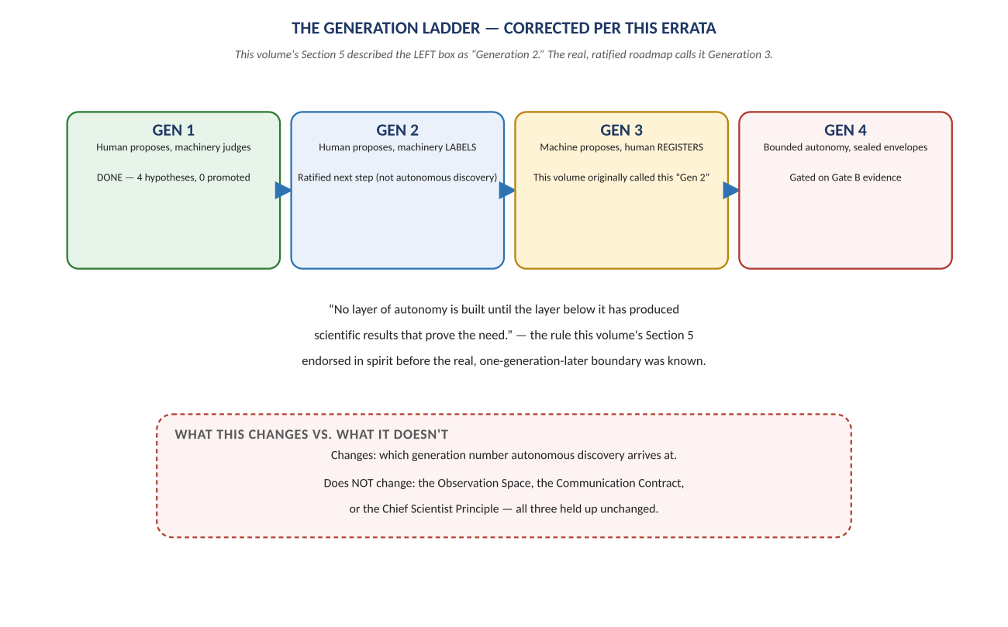
Figure B. The corrected generation ladder — what this volume called “Generation 2” is Generation 3 in the ratified roadmap.
In other words: the framework's own architects looked at the same ambition this volume analyzed, and deliberately slowed it down by one full generation — explicitly to avoid granting an undemonstrated subsystem the trust that Generation 1's own history shows must be earned first. Section 5's account of “Generation 2” in this volume should now be read as describing what the ratified roadmap calls Generation 3, gated on evidence this volume could not yet have seen.
This does not change the volume's core analysis of the Observation Space, the Communication Contract, or the Chief Scientist Principle — all three concepts held up unchanged in the real implementation. It changes only the timeline attached to autonomous discovery, and it changes it in a direction that strengthens, not weakens, the discipline this volume already praised in Section 8.3's recommendations. See NeelPrajna_QRF_Integration_Path.docx for the full, evidence-grounded picture of what Generation 1 actually built and what Generations 2–4 now mean.

