NeelPrajnaPro
Journal — v1.0
Whiteboard companion to docs\journal\NeelPrajnaPro_Journal.md — not what it says, but how it works.
Author: Fable (Architect) · 2026-07-29/30 · Twin rule applies: the .md is the normative text and living log; this .docx teaches its mechanics, not its contents

How to Read This Document
The Journal is different from every other document in this estate: it is a pure append-only stream, not a specification. There is nothing to diagram in its contents — J-001 doesn't relate to J-025 the way a phenomenon relates to a null construction. What genuinely has shape is its mechanics: the rule that governs how it grows, the anatomy every entry shares, and the tally it keeps of itself. These three diagrams teach the mechanics, not the log.
Every diagram carries an anchor sentence. The md twin is the actual, current, ever-growing journal; this document is a snapshot of how it works, as of the version stated above — it will read the same next year even as the journal itself grows by hundreds of entries.
Diagram | Answers
1 — The Append-Only Rule | How does the journal grow, and what happens when something in it was wrong?
2 — The Anatomy of One Entry | What shape does every single entry share, without exception?
3 — The Growing Tally | What has this one afternoon and evening's work actually added up to?

Diagram 1 — The Append-Only Rule
New entries append at the bottom; nothing above one is ever edited, no matter how wrong it turns out to have been. When an earlier entry needs correcting, the correction is a new entry that names the old one and says what was actually true — the same discipline P5 demands of the scientific record, applied to the record about the record.
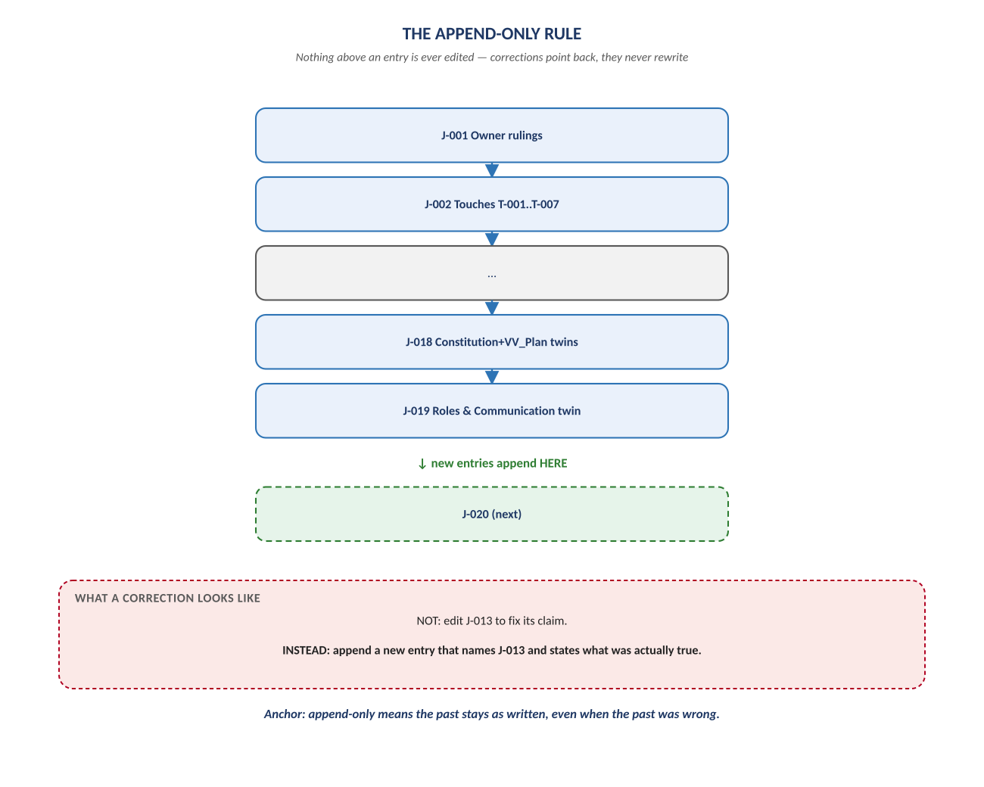
Figure 1. Figure 1. Entries stack downward only; a correction is a new entry, never a rewrite.

Diagram 2 — The Anatomy of One Entry
Every entry in this journal — whether it's a ruling, a finding, a touch, or a correction — shares the same four-part shape. Here it's shown with a real worked example: F-18/F-20, the day a script's own honesty check needed fixing, told exactly the way the standard demands: factually, and against a name.
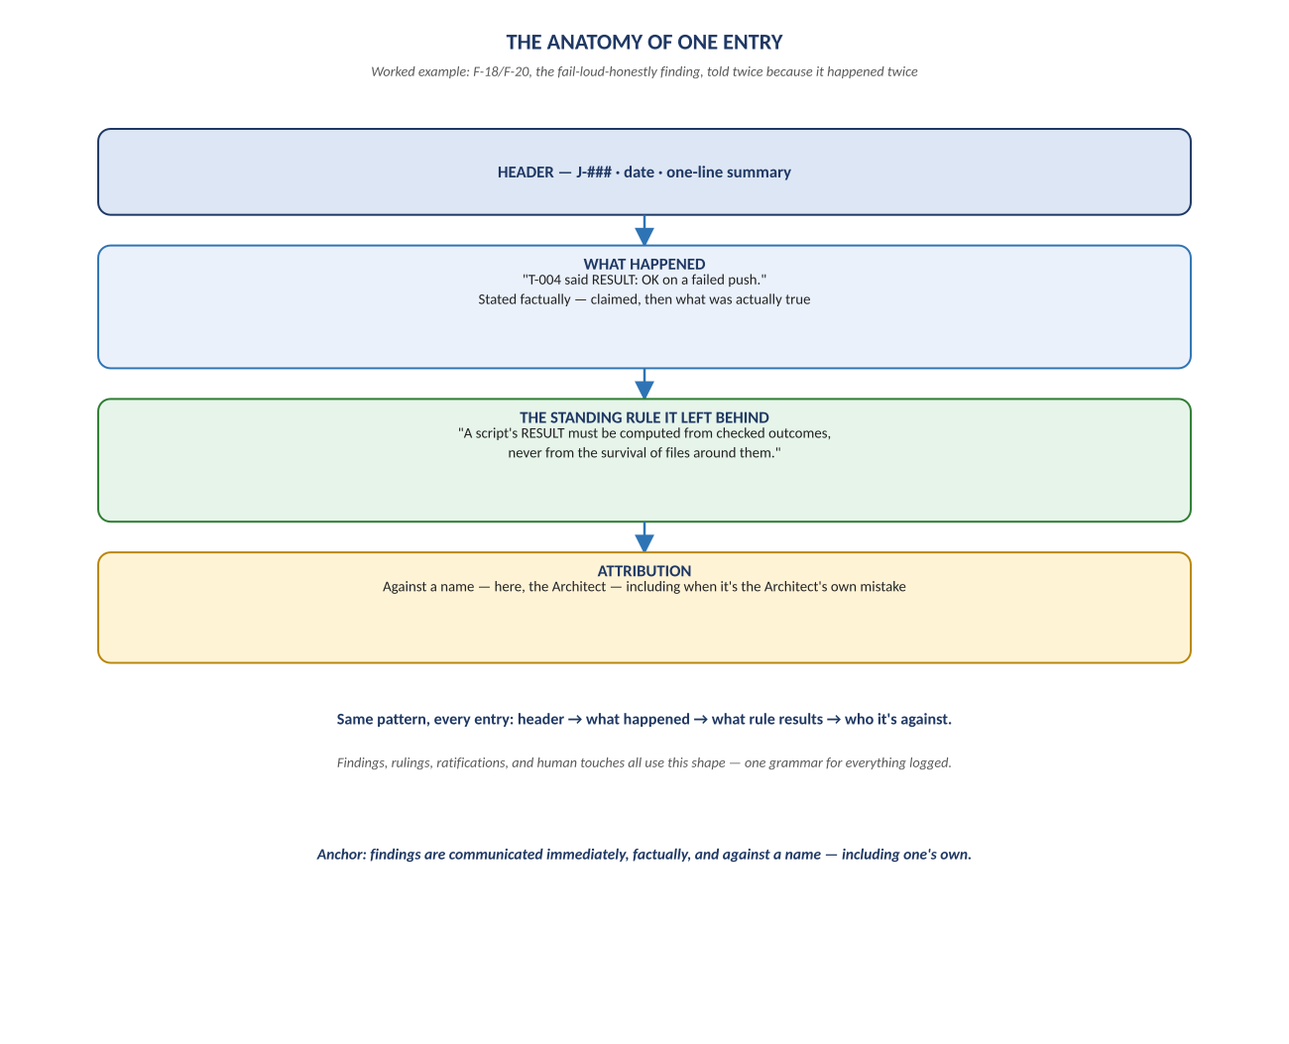
Figure 2. Figure 2. Header → what happened → the standing rule it leaves → who it's attributed to.

Diagram 3 — The Growing Tally
The journal doesn't just record what happened — it counts itself doing it. Every number in this figure came from reading the journal's own entries, which is the point: what gets counted here is exactly what the estate's own standing rule says must be counted, so that nothing stays invisible long enough to become a habit.
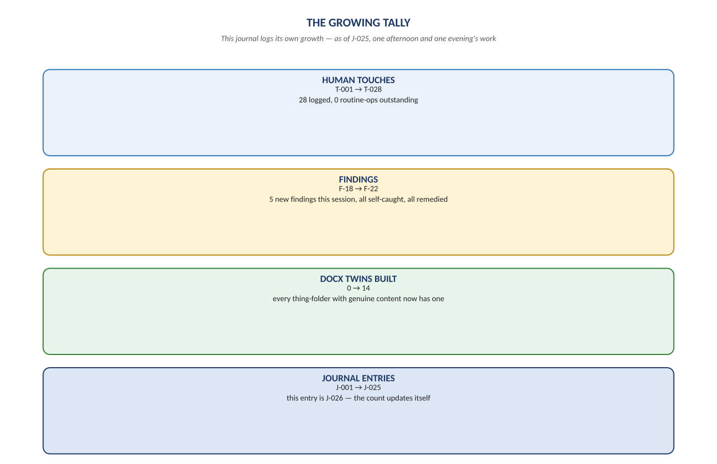
Figure 3. Figure 3. Touches, findings, and docx twins — the tally as of this document's own writing.

Change Record
v1.0 (2026-07-29/30): first whiteboard render of the Journal, built per docs\archive\governance\HOW_THIS_DOC_WAS_BUILT.md (hand-built SVG, rasterized, one diagram per page, PDF-verified). This is the fourteenth and final docx twin of this project — every thing-folder with genuine, non-redundant diagram content now has one. Companion to the normative docs\journal\NeelPrajnaPro_Journal.md, which is authoritative, live, and will always be longer than this document describes by the time anyone reads it — that's the point of an append-only log.
Anchor: what is not counted cannot be driven to zero — the journal is where counting happens.

