NeelPrajnaPro
Execution Plan — v2.0
Whiteboard companion to docs\execution_plan\NeelPrajnaPro_Execution_Plan-v2.0.md — the full path from one judged hypothesis to the ratified architecture.
Author: Fable (Architect) · 2026-07-30 · Twin rule applies: the .md is the normative text and living record (§0/§12 update every sprint); this .docx teaches the plan's durable shape

How to Read This Document
Version 1.0 of this plan stopped at acceptance — it showed how to judge one family well, but never how the two-organ architecture actually gets built. Version 2.0 carries the path all the way to the destination, and makes the claim checkable rather than asserted: every sprint names which architecture box it turns from TARGET to BUILT, so when no TARGET boxes remain, the architecture is built.
The five diagrams go in the order a reader needs them: the phase ladder, then what happens to each existing NeelPrajna component, then the box-by-box acceptance test, then the three decisions that unblock everything, and finally the sealed definition the first sprint runs on.
Diagram | Answers
1 — The Five-Phase Ladder | What are the phases, and what does each one leave behind?
2 — The Component Map | What happens to EntryGates, TradeManager, AdvisorEngine, the rest?
3 — The TARGET → BUILT Ladder | Which sprint delivers each architecture box?
4 — The Owner's Three Typed Lines | What exactly is the Owner deciding, and what are the options?
5 — The H-07 Event Chain | What, exactly, does the first detector watch for?

Diagram 1 — The Five-Phase Ladder
Five phases, each gated by the one before it: the pipeline works, the family is real, the organs connect, humans can see it, and then it accumulates. Phase 3 — the nervous system, where Contract v2 actually goes live — was missing entirely from v1.0 of this plan, which is why the architecture had no visible route to being built.
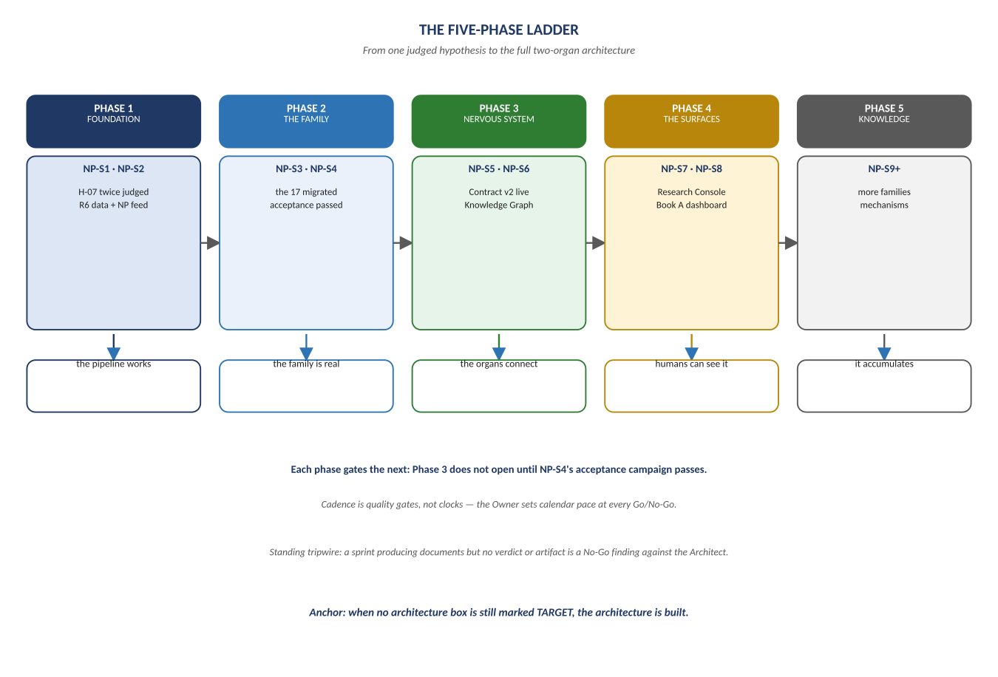
Figure 1. Figure 1. Foundation → The Family → The Nervous System → The Surfaces → Knowledge.

Diagram 2 — The Component Map
This is the table v1.0 never had, and it carries one correction worth stating plainly. An earlier roadmap draft described this migration as replacement — EntryGates becoming a Detector, AdvisorEngine becoming the BeliefLayer. Read literally that dissolves the runtime into the Kernel and breaks the wall the whole architecture rests on. The truth is narrower and better: every component keeps doing its job, and what changes is that its claims become judgeable.
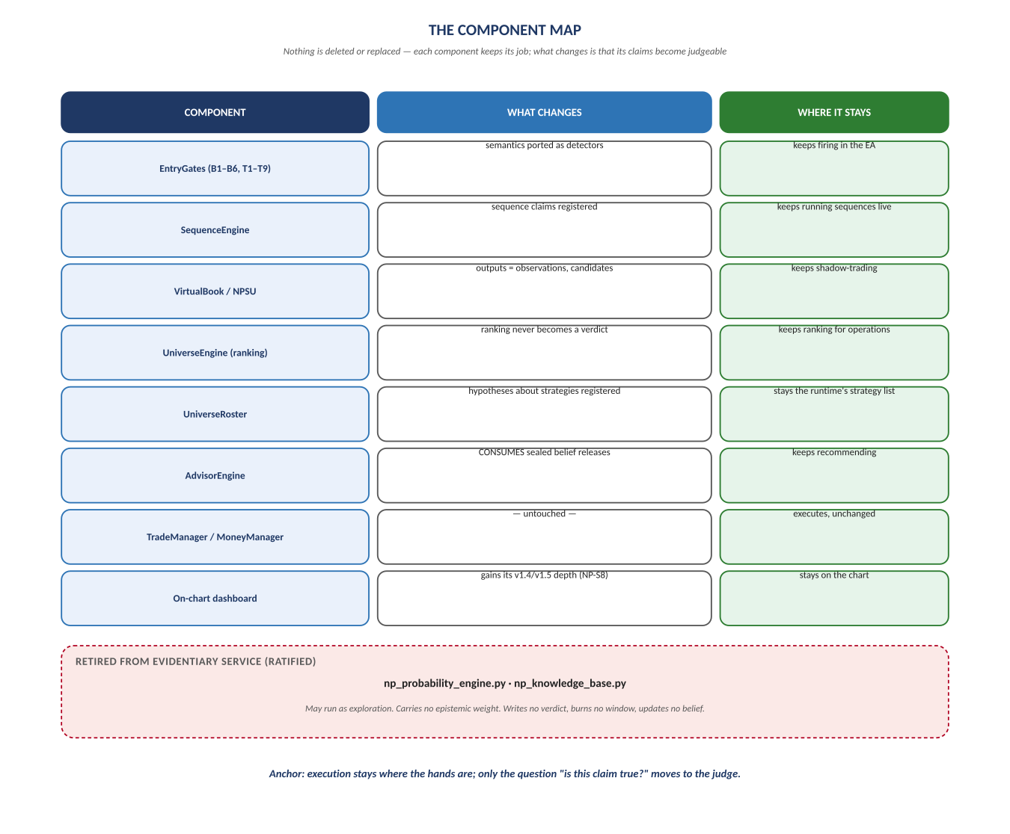
Figure 2. Figure 2. Nothing deleted, nothing replaced — execution stays where the hands are.

Diagram 3 — The TARGET → BUILT Ladder
This is the plan's own acceptance test. Three boxes are already BUILT from Generation 1. Nine are TARGET, and each one now has a named sprint that pays for it — including both dashboards, which until this version were fully specified but scheduled nowhere at all.
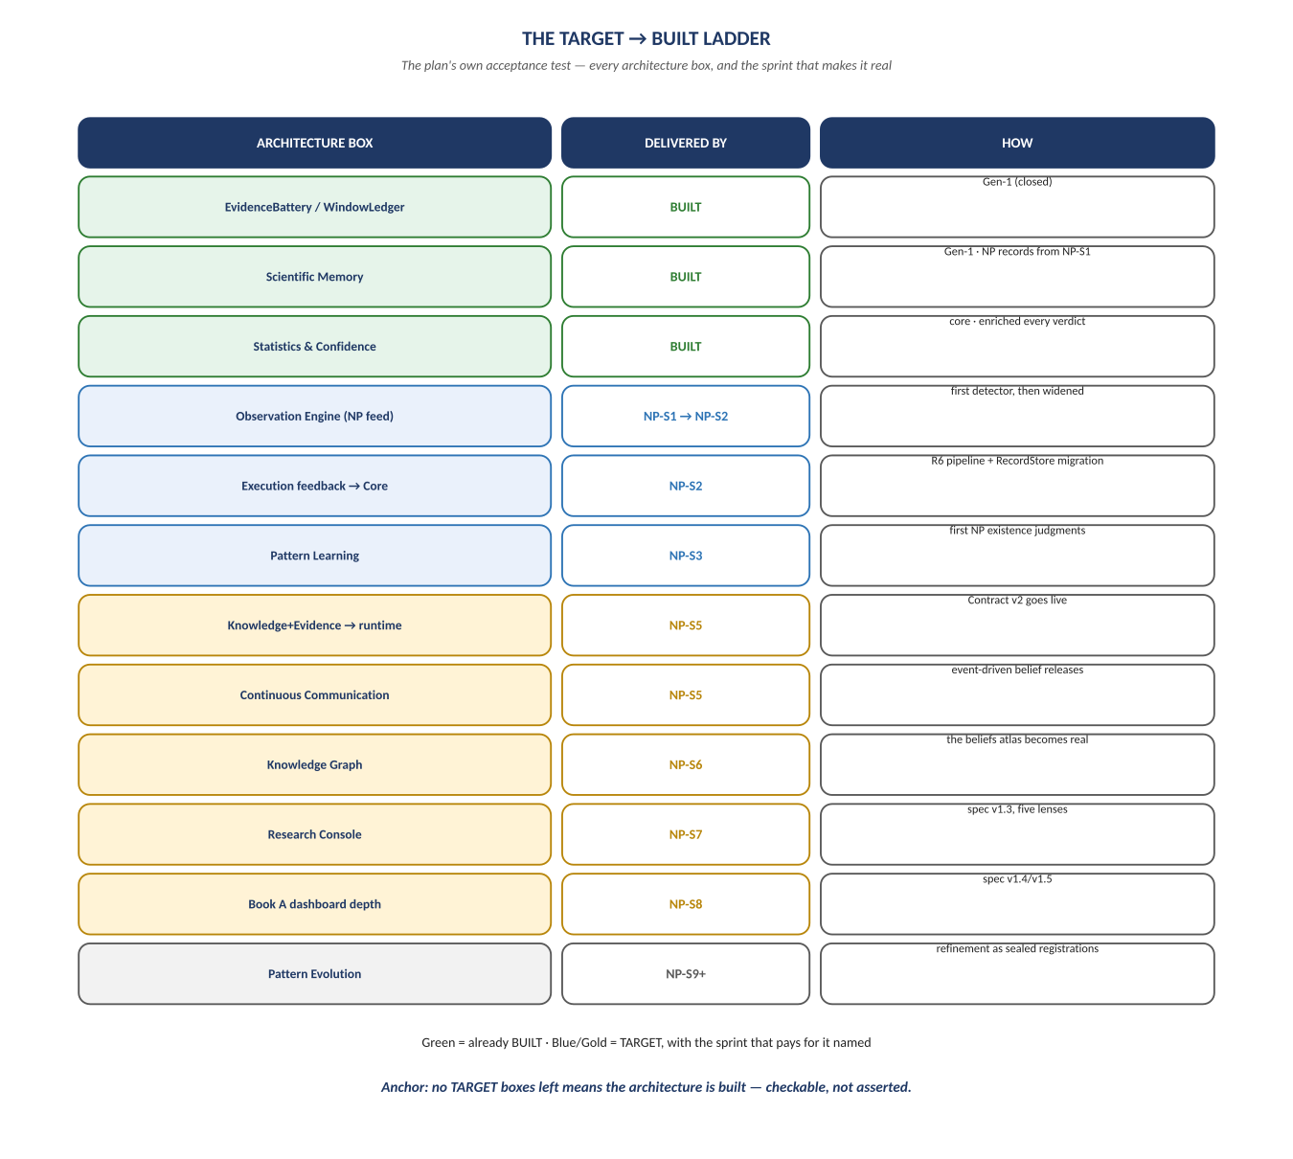
Figure 3. Figure 3. Every architecture box, and the sprint that turns it from TARGET to BUILT.

Diagram 4 — The Owner's Three Typed Lines
Three decisions, all permanently human by Constitution §6, and all that stand between here and the first real science this integration produces. The first two are irreversible in a specific sense: designation burns market time, and the α-budget is spent rather than renewed. The third — Go or No-Go — costs nothing to withhold; the machine holds its state indefinitely.
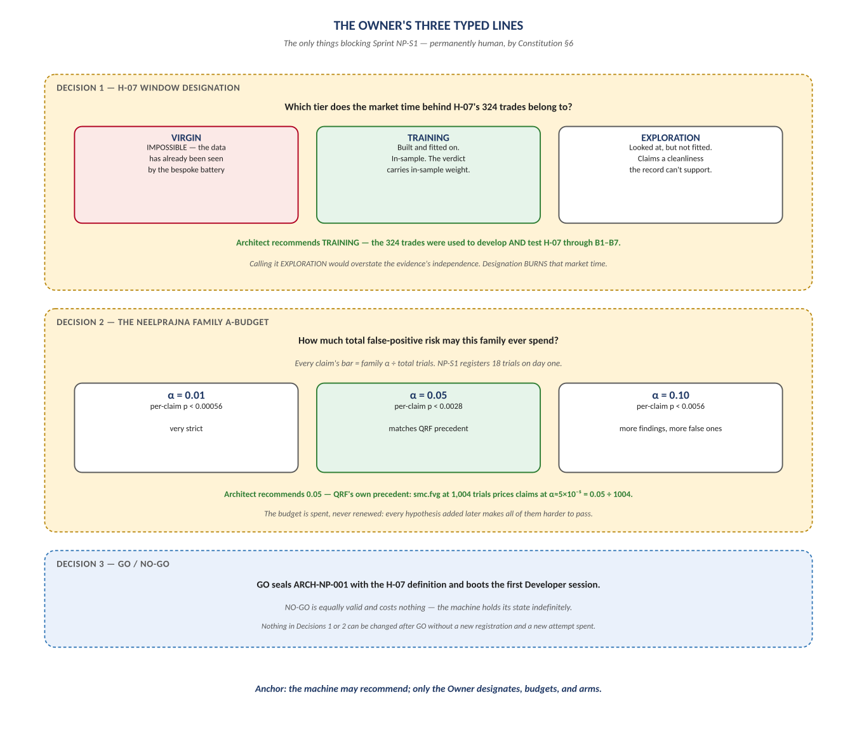
Figure 4. Figure 4. Window designation · α-budget · Go/No-Go, with each option's consequence stated.

Diagram 5 — The H-07 Event Chain
The sealed mechanical definition reduces to three events computable from closed bars alone, with no interpretation: a pool forms, a sweep tests it, a reversal confirms it. This definition is frozen — any change is a v1.1 by NP-ADR, never an edit.
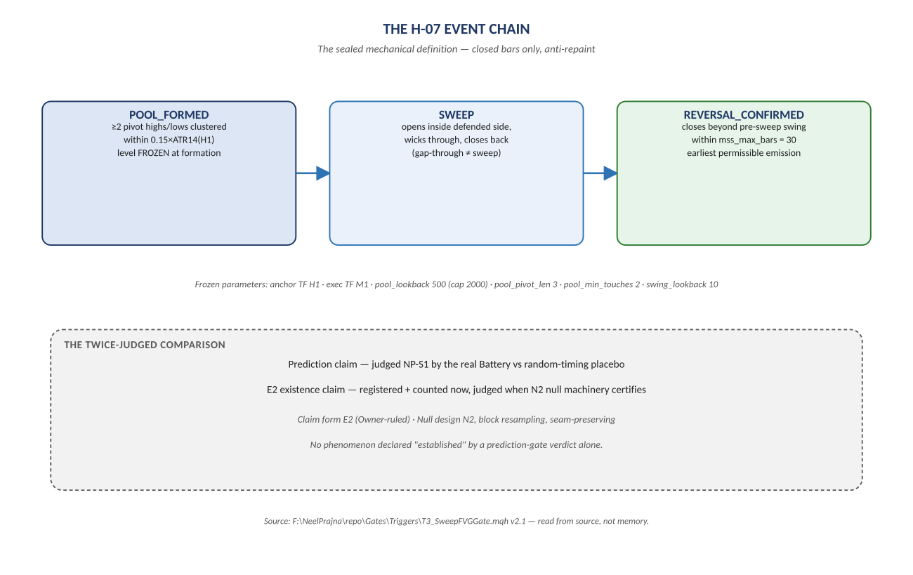
Figure 5. Figure 5. POOL_FORMED → SWEEP → REVERSAL_CONFIRMED, and the twice-judged comparison it feeds.

Change Record
v2.0 (2026-07-30): rebuilt after the Owner found v1.0 out of sync with the ratified architecture. New diagrams: the five-phase ladder, the component map, the TARGET → BUILT acceptance ladder, and the Owner's three typed lines. The H-07 event chain is carried forward unchanged from the v1.0 twin, its definition being frozen. Built per docs\archive\governance\HOW_THIS_DOC_WAS_BUILT.md; the v1.0 md and its docx twin are archived together in docs\archive\execution_plan\.
Anchor: when no architecture box is still marked TARGET, the architecture is built — and the wall between the organs is exactly where it started.

