NeelPrajnaPro
Writing Standard — v1.0
Whiteboard companion to docs\writing_standard\NeelPrajnaPro_Writing_Standard-v1.0.md — how this whole estate is taught, in four diagrams.
Author: Fable (Architect) · 2026-07-29 · Twin rule applies: the .md is the normative text; this .docx is its human render

How to Read This Document
This is the teaching form of the standard that governs how everything else in this estate gets taught — including, recursively, this very document. The four diagrams go in the order a reader needs them: the mandatory sequence for introducing any idea, the nine principles that govern how, the one skill of knowing when to stop explaining, and the toolkit proven on a real document.
Every diagram carries an anchor sentence. The md twin is normative; if this document and the md ever disagree, the md wins and the disagreement is a finding.
Diagram | Answers
1 — The Teaching Order | In what sequence must a new idea be introduced?
2 — The Nine Principles | What governs the telling, not the reasoning?
3 — Adaptive Depth | How much explanation is actually enough?
4 — The Field-Tested Techniques | What concrete toolkit is proven, not just theorized?

Diagram 1 — The Teaching Order
Eight steps, in this order, always: the question first, then why it matters, then a concrete example, then the plain-word intuition — and only then, the fifth step, the technical term. By the time the label arrives, it costs the reader nothing.
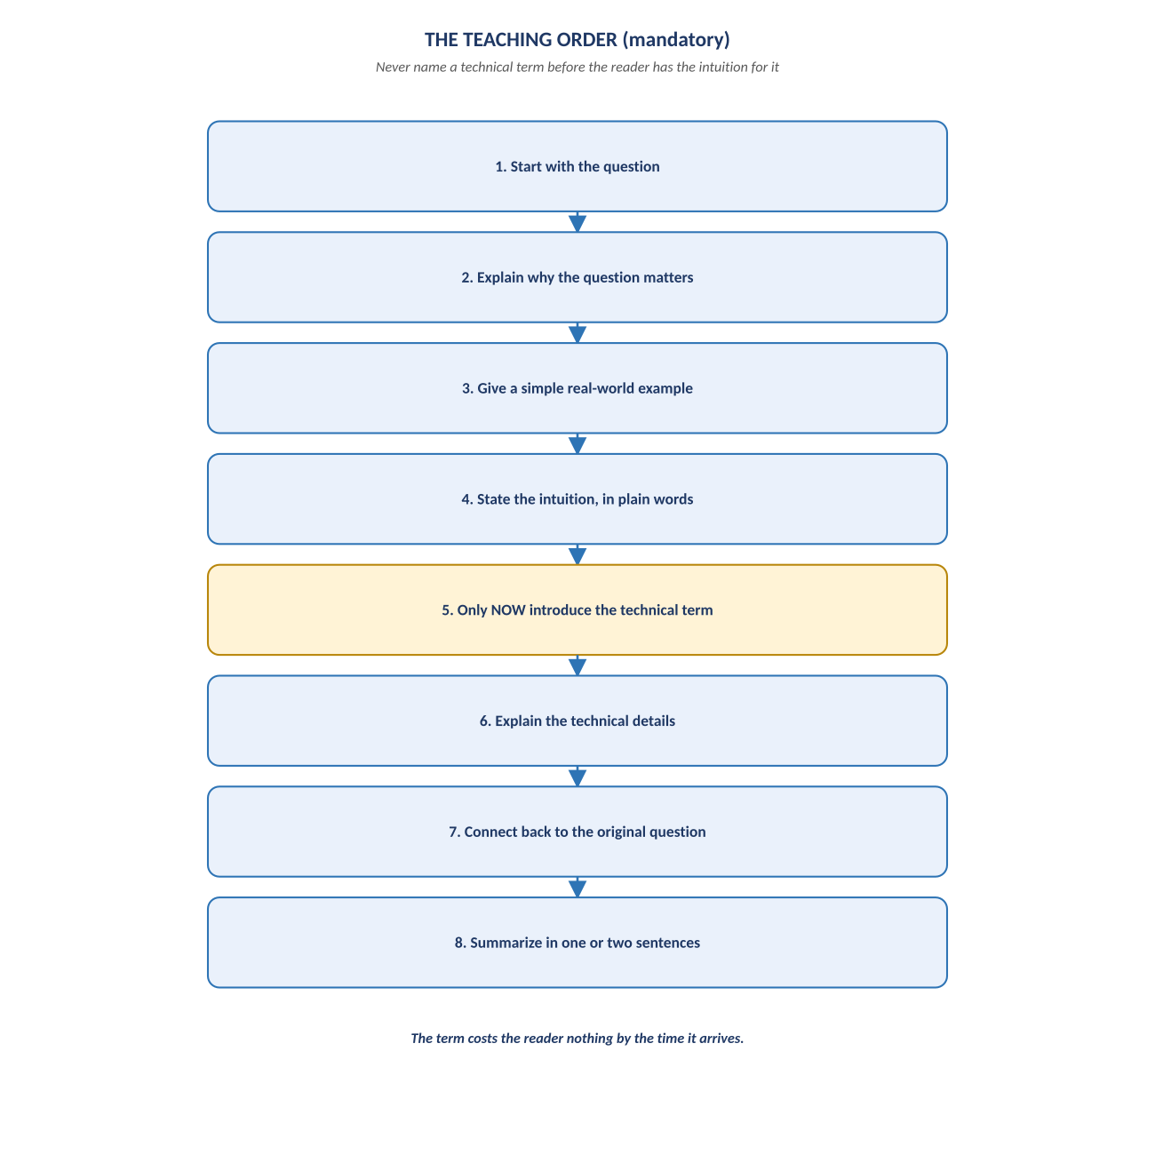
Figure 1. Figure 1. Question → why it matters → example → intuition → TERM → details → connect back → summarize.

Diagram 2 — The Nine Principles
These nine principles govern how an idea is revealed, never what the idea is. Two of them are about knowing when to stop — Adaptive Depth (stop explaining) and the Editorial Finish Line (stop rewriting) — and they are, by a wide margin, the hardest to actually practice.
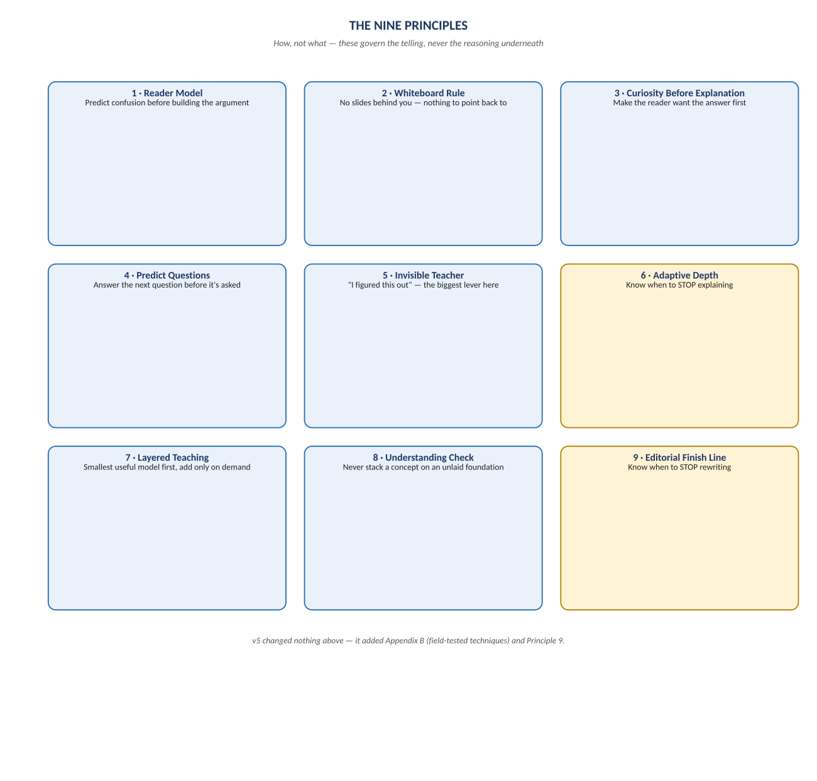
Figure 2. Figure 2. Reader Model through the Editorial Finish Line — nine principles, unchanged since v4 except for the ninth.

Diagram 3 — Adaptive Depth
The same question can have four correct answers at four different depths, and giving the reader the wrong one is a failure whichever direction it errs in. Over-explaining past what's needed is not a safe default — it's its own kind of failure to serve the reader.
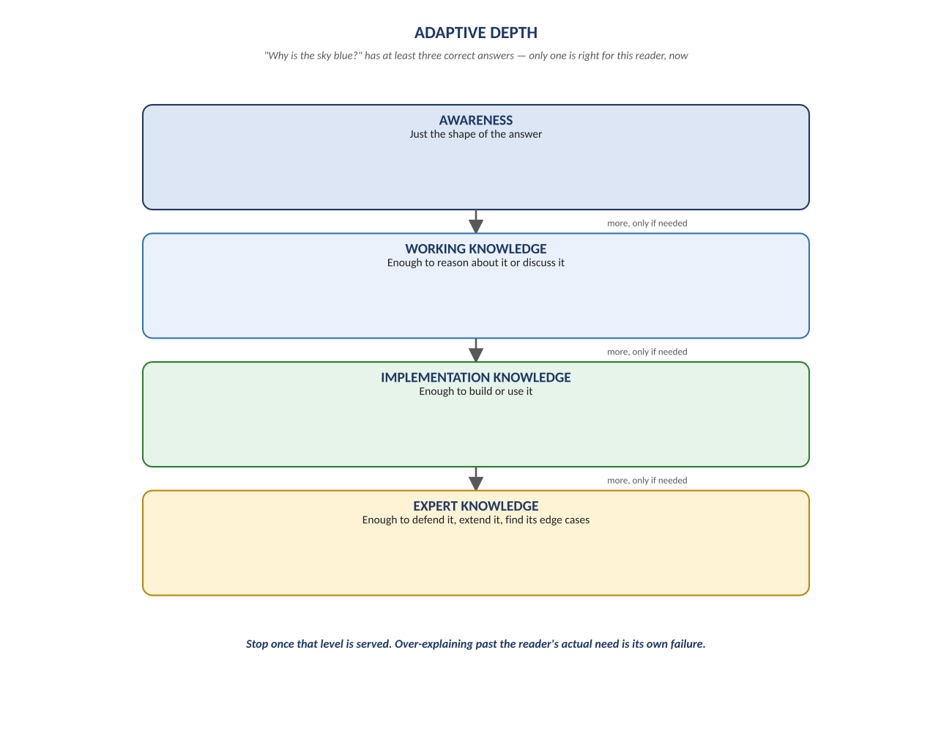
Figure 3. Figure 3. Awareness → Working Knowledge → Implementation Knowledge → Expert Knowledge — stop once the level is served.

Diagram 4 — The Field-Tested Techniques
Six techniques, none of them new philosophy — each is an existing principle made concrete, and each earned its place by being tested on a real document and confirmed by its review. B3, mid-stream questions, was the single most repeated finding across every review this estate has produced.
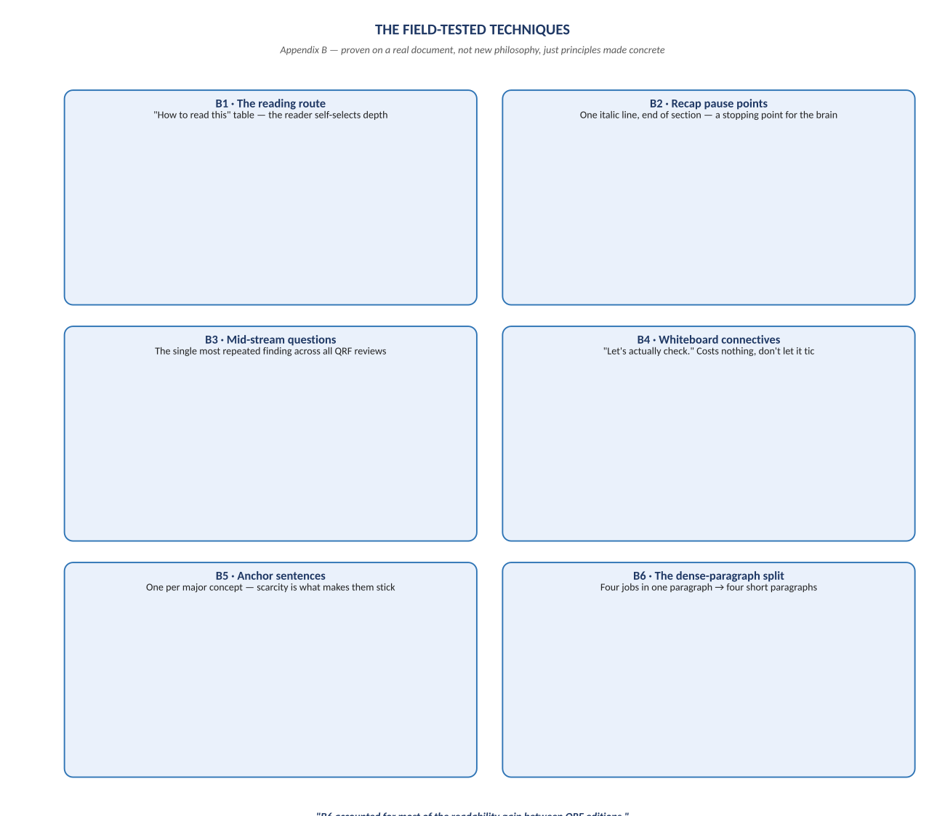
Figure 4. Figure 4. B1 through B6 — the reading route, recap points, mid-stream questions, whiteboard connectives, anchor sentences, the dense-paragraph split.

Change Record
v1.0 (2026-07-29): first whiteboard render of the Writing Standard, built per docs\archive\governance\HOW_THIS_DOC_WAS_BUILT.md (hand-built SVG, rasterized, one diagram per page, PDF-verified). Companion to the normative docs\writing_standard\NeelPrajnaPro_Writing_Standard-v1.0.md — that file is authoritative; this document teaches it, and was itself built by following it.
Anchor: the reader should feel they figured it out, not that they were told it.

