NeelPrajnaPro
Research — v1.0
Whiteboard companion to docs\research\NeelPrajnaPro_Research-v1.0.md — the living RQ backlog, in three diagrams.
Author: Fable (Architect) · 2026-07-29 · Twin rule applies: the .md is the normative text and living register; this .docx teaches its shape as of this version

How to Read This Document
This is the teaching form of the Research backlog — the questions this programme has decided are worth asking, but has not yet let change anything. The three diagrams go in the order a reader needs them: the whole landscape at once, the two questions born from this week's integration work specifically, and finally which questions are actionable today versus waiting on data that doesn't exist.
Every diagram carries an anchor sentence. The md twin is normative and living — new RQs append there, not here; if this document and the md ever disagree on content, the md wins and the disagreement is a finding.
Diagram | Answers
1 — The RQ Landscape | Where does every open question sit, by priority and by generation?
2 — The Two New Integration Questions | What did the integration work itself teach us to ask?
3 — What's Blocked, What's Open | Which questions can move today, and which are waiting on data?

Diagram 1 — The RQ Landscape
Fifteen open questions, none yet permitted to change a line of ratified architecture — QRF-ADR-009a's rule holds them all to the same standard: evidence and an approved decision, or the interfaces stay frozen and the thinking stays free. Two of them, marked in gold, are new — born the same day the integration work began.
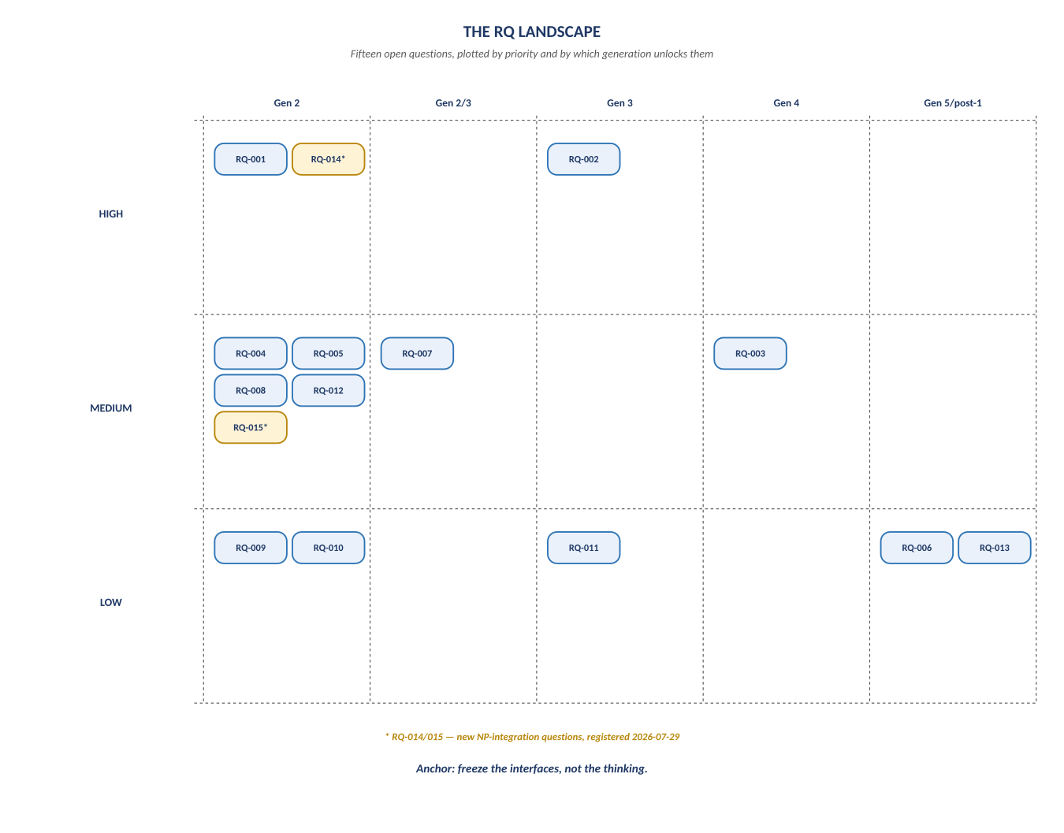
Figure 1. Figure 1. Priority (rows) × generation gate (columns) — all fifteen RQs at a glance.

Diagram 2 — The Two New Integration Questions
RQ-014 and RQ-015 didn't exist a week ago — they were born from doing the work, not from planning it. Both are already load-bearing: NP-S1's own central deliverable is RQ-014's first evidence, and RQ-015 feeds the null certification an entire class of NP-S3 judgments is waiting on.
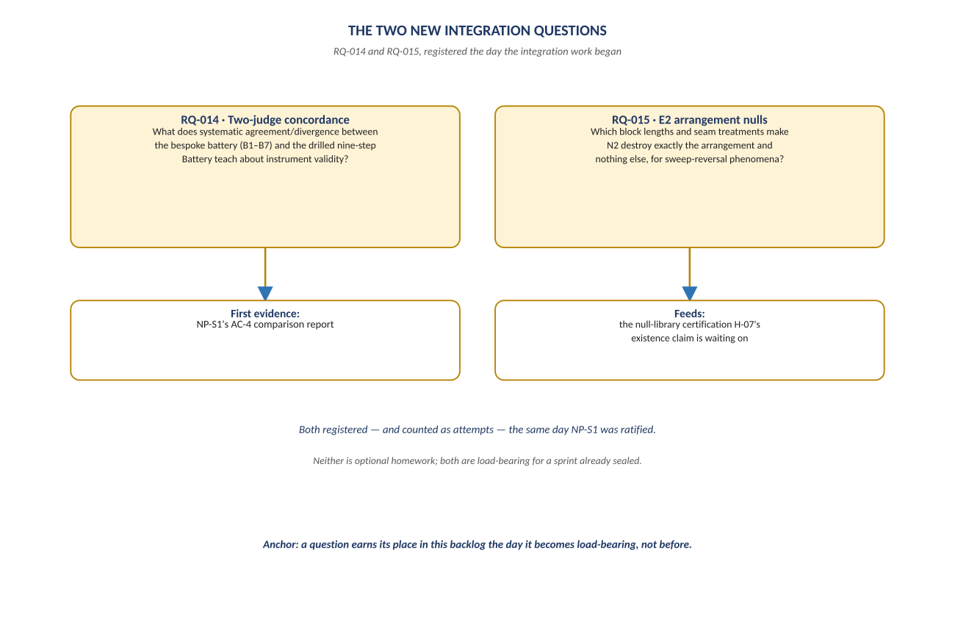
Figure 2. Figure 2. RQ-014 (two-judge concordance) and RQ-015 (E2 arrangement nulls) — registered and already load-bearing.

Diagram 3 — What's Blocked, What's Open
Twelve of fifteen questions can move today with no new data. Three — all touching order-flow microstructure — are gated on L3 data this programme doesn't have, and stay honestly marked as gated rather than quietly dropped. A backlog entry, whatever its priority, is never itself a license to spend a reserved window.
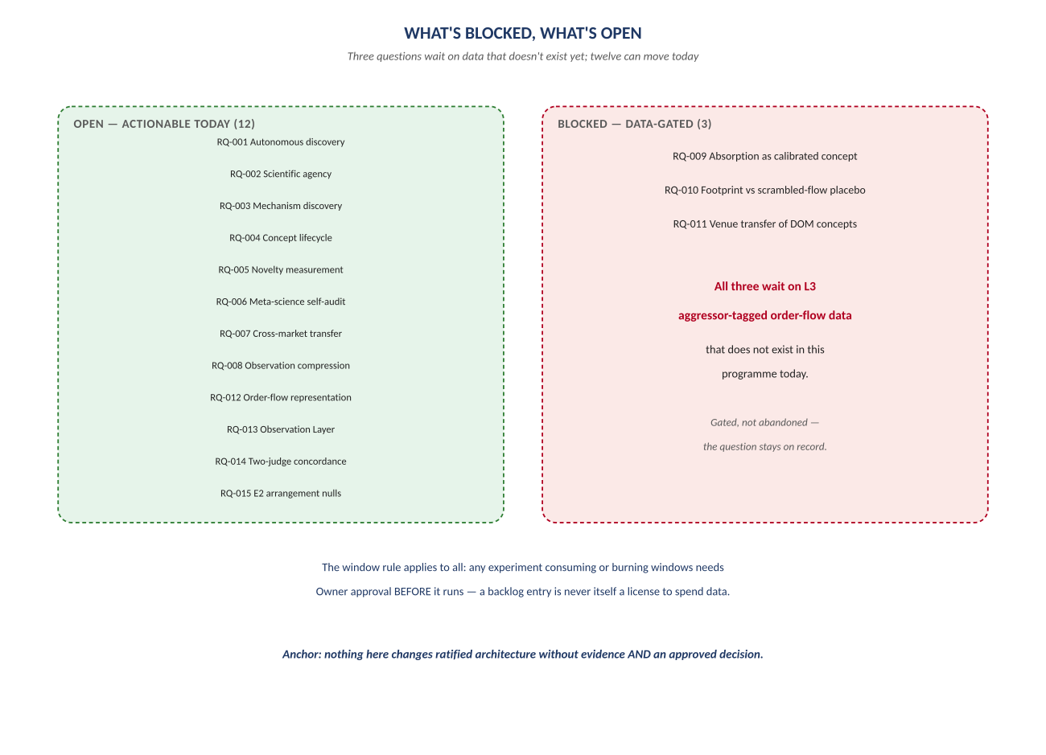
Figure 3. Figure 3. Twelve open, three gated on L3 order-flow data — gated, not abandoned.

Change Record
v1.0 (2026-07-29): first whiteboard render of the Research backlog, built per docs\archive\governance\HOW_THIS_DOC_WAS_BUILT.md (hand-built SVG, rasterized, one diagram per page, PDF-verified). Companion to the normative docs\research\NeelPrajnaPro_Research-v1.0.md — that file is authoritative and living; this document teaches its shape as of this version, and will need a v1.1 render whenever the backlog changes enough to warrant one.
Anchor: freeze the interfaces, not the thinking.

