NeelPrajnaPro
Decisions — v1.0
Whiteboard companion to docs\decisions\NeelPrajnaPro_Decisions-v1.0.md — every architectural decision, in three diagrams.
Author: Fable (Architect) · 2026-07-29 · Twin rule applies: the .md is the normative text; this .docx is its human render

How to Read This Document
This is the teaching form of the Decisions register — every architectural decision the programme has made, consolidated into one document per the Owner's one-doc-per-folder ruling. The three diagrams go in the order a reader needs them: the chronology first, then the reusable test behind every rejection, and finally what the twenty-two decisions actually govern, grouped by theme rather than by date.
Every diagram carries an anchor sentence. The md twin is normative; if this document and the md ever disagree, the md wins and the disagreement is a finding.
Diagram | Answers
1 — The Decision Timeline | When was each decision made, and in what order?
2 — The Three Gates | What test does a concept have to fail before it's rejected?
3 — Decision Categories | What do these twenty-two decisions actually govern?

Diagram 1 — The Decision Timeline
Eleven Gen-1 decisions closed the QRF Kernel over three days in July; five days later, nine NeelPrajnaPro decisions opened the integration in a single afternoon of ratification. The register grows in one direction only — every future decision appends here as a new NP-D-###, never a second file.
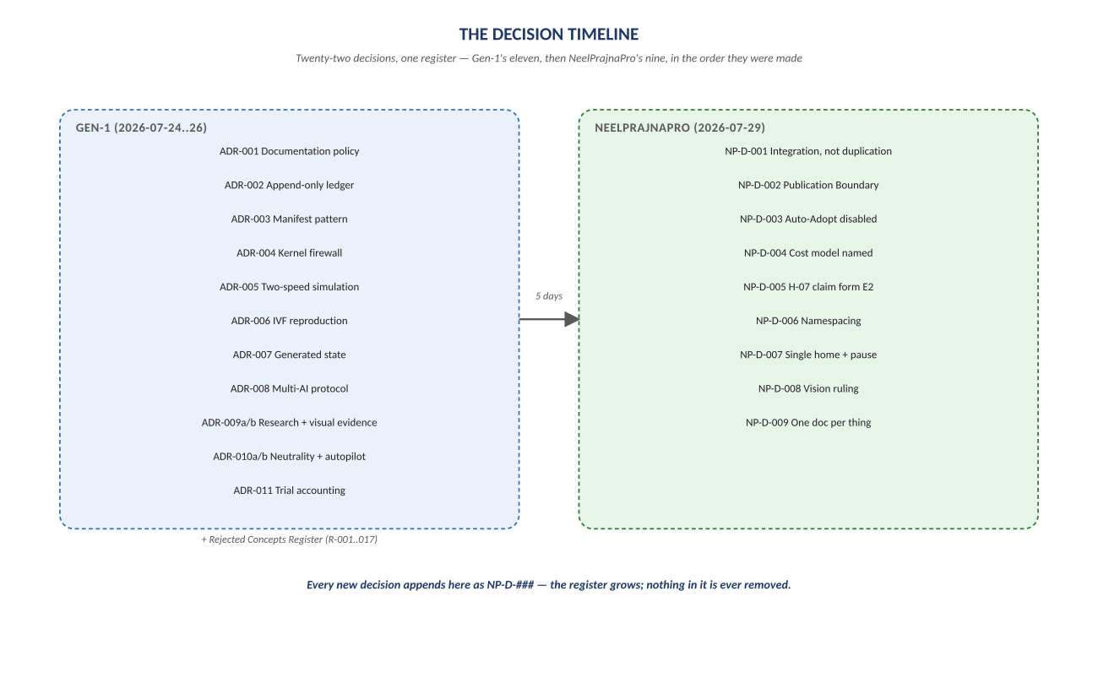
Figure 1. Figure 1. QRF-ADR-001..011 (Gen-1) then NP-D-001..009 (NeelPrajnaPro) — one register, chronological.

Diagram 2 — The Three Gates
Every rejected or deferred concept in the register passed through the same test: is it scientifically necessary, is it architecturally unique, and — critically — implementation difficulty is never itself a reason to reject. Seventeen ideas failed one of these gates in Gen-1 alone, and each rejection is preserved with its origin and its failing gate, because rejection is knowledge too.
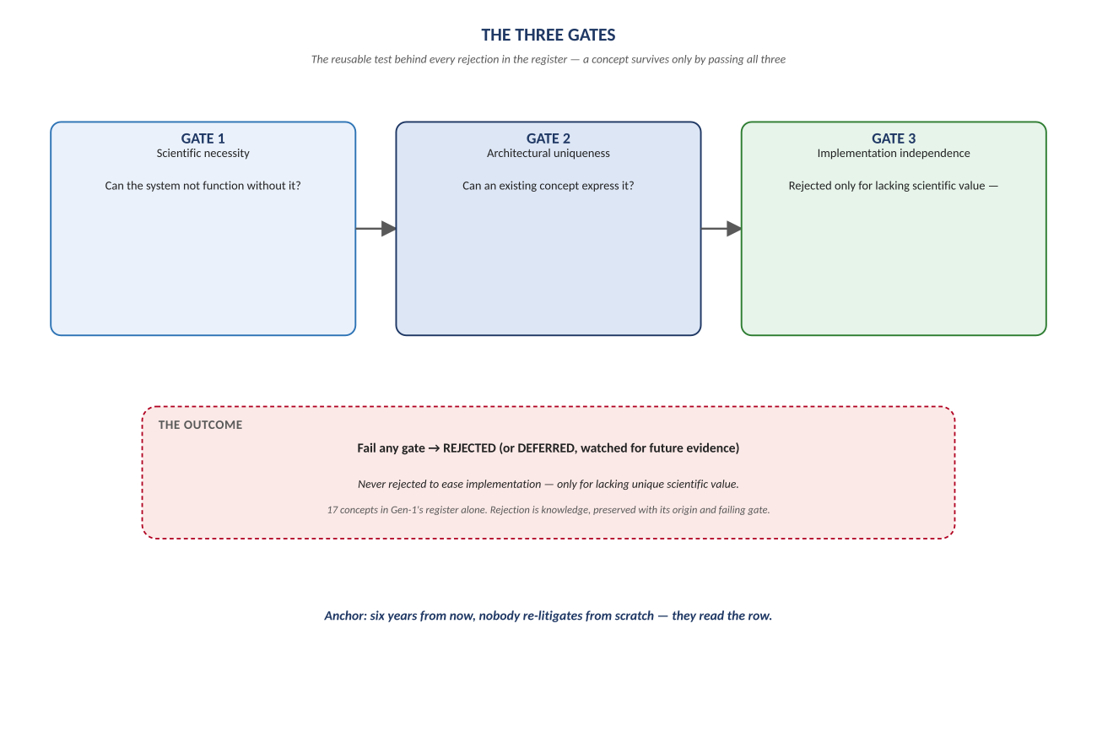
Figure 2. Figure 2. Scientific necessity → architectural uniqueness → implementation independence — fail any one, and it's rejected or deferred, never silently dropped.

Diagram 3 — Decision Categories
Read chronologically, the register is a timeline. Read by theme, it's five things: what counts as truth, how claims get verified, how the team and its automation operate, how the two systems integrate, and where the hard safety boundaries sit. Every rule in the estate traces back to one of these twenty-two decisions, by name and by date.
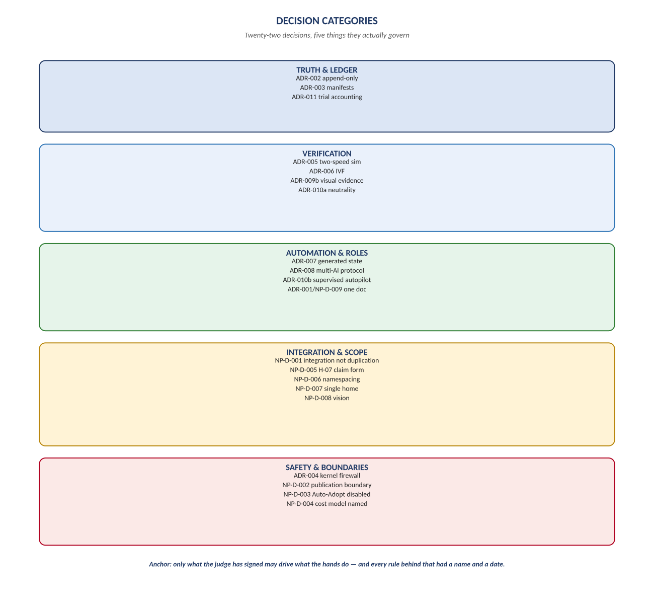
Figure 3. Figure 3. Truth & Ledger · Verification · Automation & Roles · Integration & Scope · Safety & Boundaries.

Change Record
v1.0 (2026-07-29): first whiteboard render of the Decisions register, built per docs\archive\governance\HOW_THIS_DOC_WAS_BUILT.md (hand-built SVG, rasterized, one diagram per page, PDF-verified). Companion to the normative docs\decisions\NeelPrajnaPro_Decisions-v1.0.md — that file is authoritative and living (new decisions append there, not here); this document teaches the register's shape as of this version.
Anchor: only what the judge has signed may drive what the hands do — and every rule behind that had a name and a date.

