NeelPrajnaPro
VV Plan — v1.0
Whiteboard companion to docs\vv_plan\NeelPrajnaPro_VV_Plan-v1.0.md — four levels of assurance, taught in four diagrams.
Author: Fable (Architect) · 2026-07-29 · Twin rule applies: the .md is the normative text; this .docx is its human render

How to Read This Document
This is the teaching form of the Verification, Validation & Acceptance Plan — how the neelprajna family earns trust, level by level. The four diagrams go in the order a reader needs them: first how the four levels nest, then the one comparison that is NP-S1's own particular risk, then the six drills the family must survive as one black box, and finally the rule every failure at any level must obey.
Every diagram carries an anchor sentence. The md twin is normative; if this document and the md ever disagree, the md wins and the disagreement is a finding.
Diagram | Answers
1 — The Four Levels, Nested | How do L1 through L4 depend on each other?
2 — The Bespoke-Battery Comparison | What is NP-S1's own particular risk, and how is it judged?
3 — The Six Acceptance Drills | What must the whole family survive, blinded, as one campaign?
4 — The Grading Rule | What happens, exactly, when something fails?

Diagram 1 — The Four Levels, Nested
Assurance builds in four levels, and they are not independent: an L1 failure invalidates whatever L2 ran on top of it, and any component that gets re-certified re-triggers every level above it. L4 is the only level with a name for its own conditions — it may only run once L1 through L3 are green, and it only passes as a single unbroken campaign.
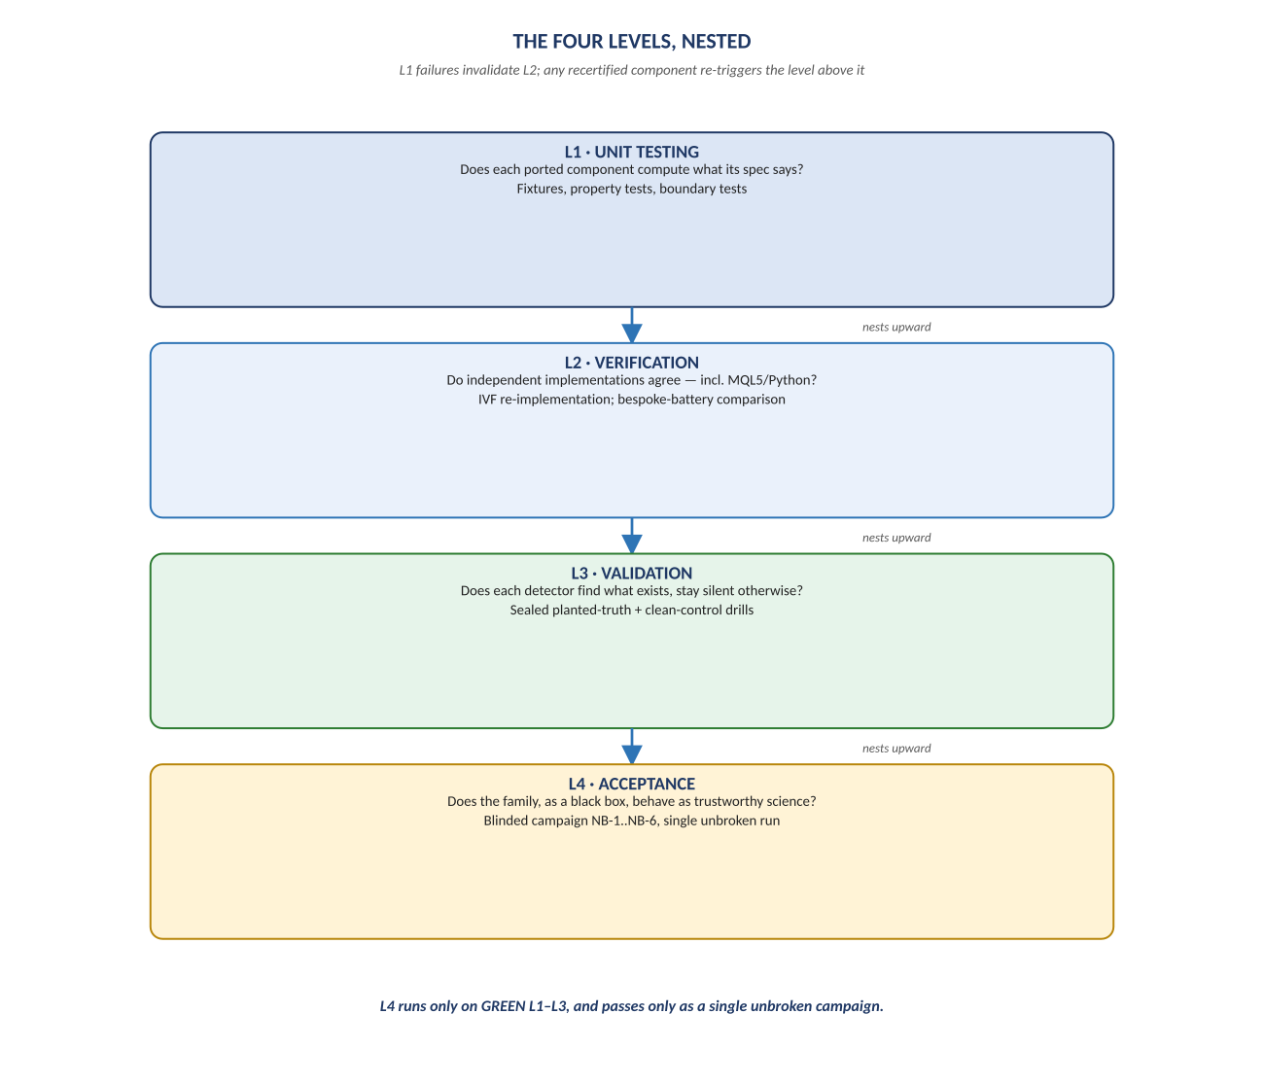
Figure 1. Figure 1. L1 Unit Testing → L2 Verification → L3 Validation → L4 Acceptance.

Diagram 2 — The Bespoke-Battery Comparison
This is NP-S1's central deliverable and its own particular risk: the ported Python detector must agree with its MQL5 original event-for-event, and the real nine-step Battery's fresh verdict on H-07 is compared, gate by gate, against the bespoke B1–B7 battery's recorded FAIL. Both mappings are sealed before either run — nothing about how to read the outcome is decided after seeing it.
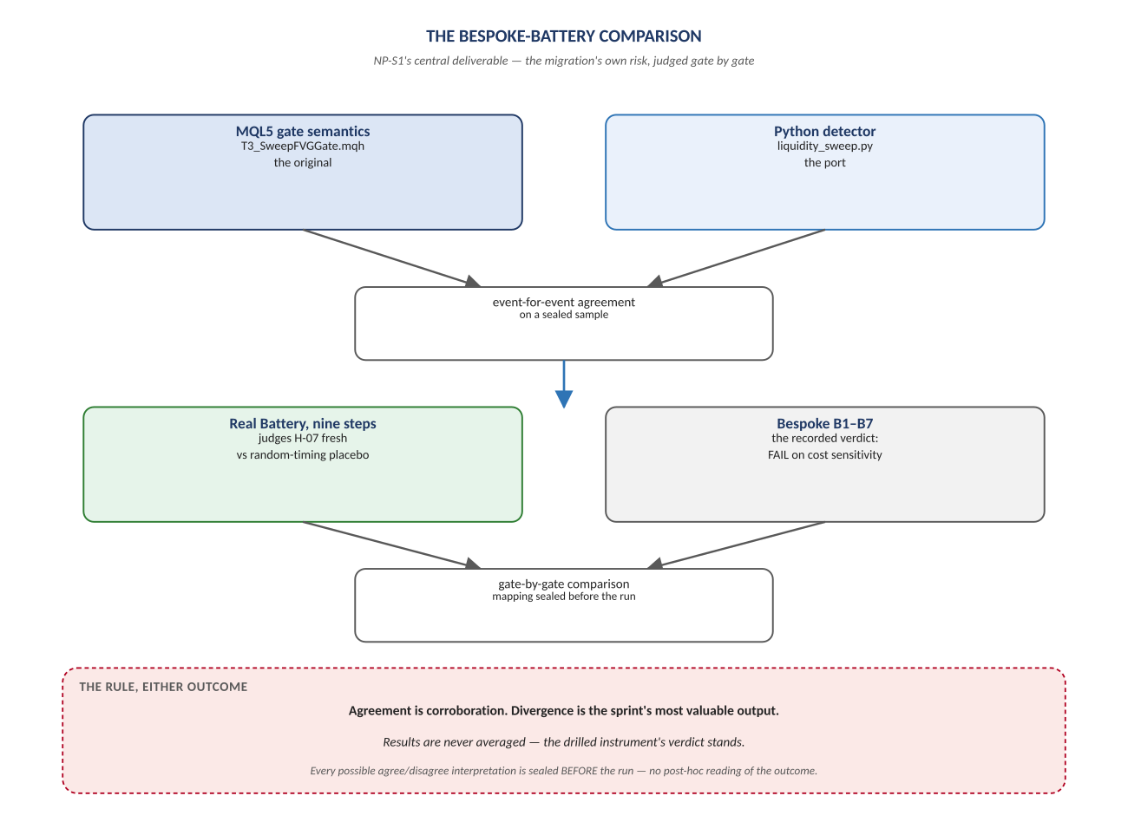
Figure 2. Figure 2. MQL5 vs Python; real Battery vs bespoke B1–B7 — agreement is corroboration, divergence is data.

Diagram 3 — The Six Acceptance Drills
At NP-S4 the whole family is treated as a black box and fed six classes of blinded input, the Owner alone holding the answer keys. NB-2's veto is absolute — a system that cannot stay silent in silence is not a scientific instrument, and its failure fails the family outright regardless of how the other five drills went.
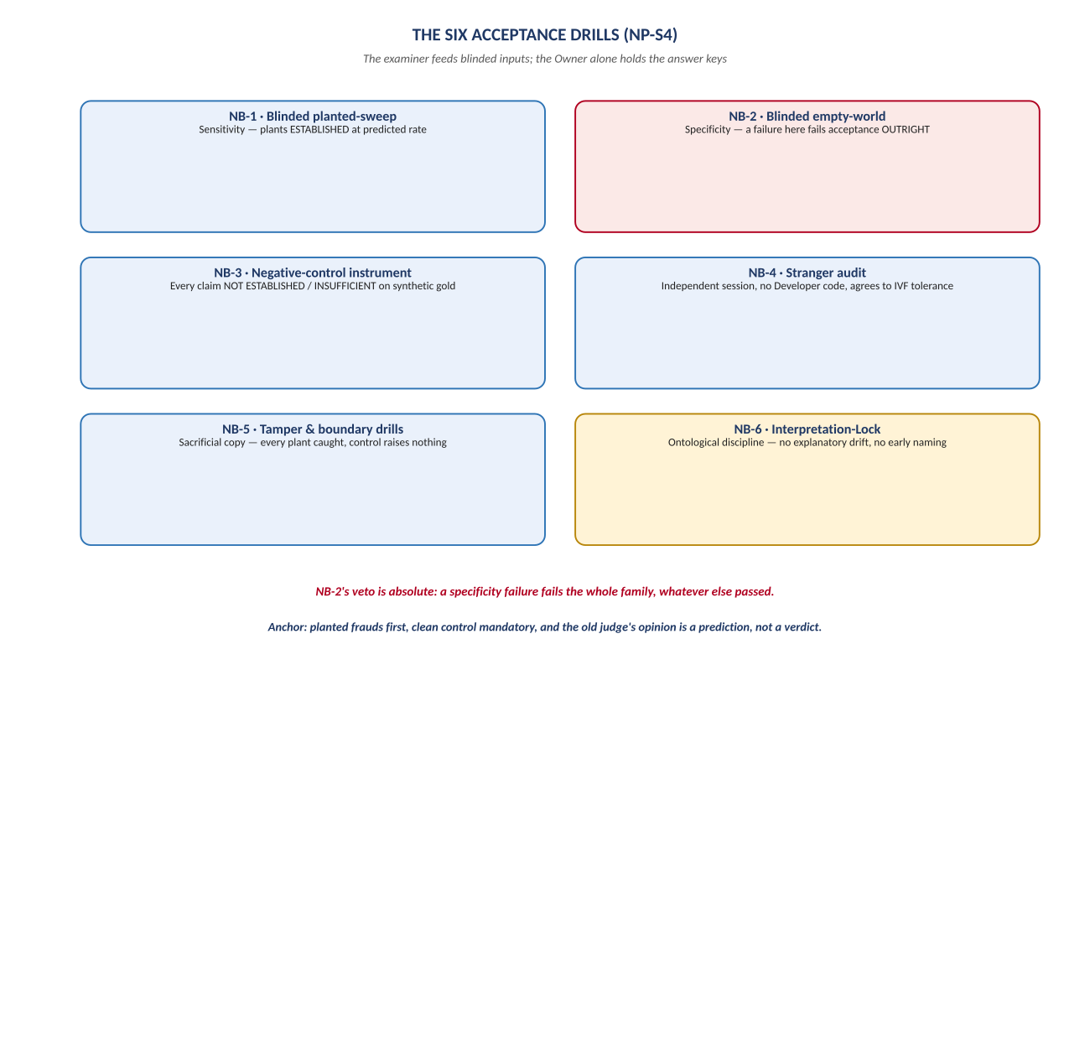
Figure 3. Figure 3. NB-1 through NB-6 — sensitivity, specificity, negative control, stranger audit, tamper, and interpretation-lock.

Diagram 4 — The Grading Rule
Whatever level a failure occurs at, it enters the same loop: a tallied finding, a root cause, a fix, and a full re-run from a clean state — never a patch applied in place. At Level 4 specifically, the campaign passes only as a single unbroken run across all six drill classes; there is no cherry-picking across separate attempts.
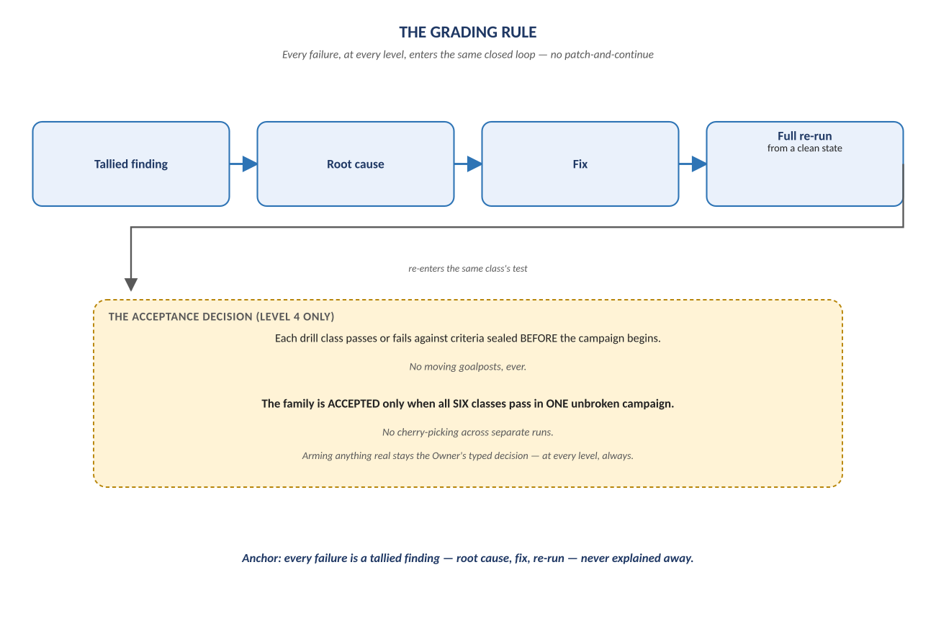
Figure 4. Figure 4. Tallied finding → root cause → fix → re-run — the loop every failure enters, at every level.

Change Record
v1.0 (2026-07-29): first whiteboard render of the VV Plan, built per docs\archive\governance\HOW_THIS_DOC_WAS_BUILT.md (hand-built SVG, rasterized, one diagram per page, PDF-verified). Companion to the normative docs\vv_plan\NeelPrajnaPro_VV_Plan-v1.0.md — that file is authoritative; this document teaches it. Includes NB-6 (Interpretation-Lock), added 2026-07-29 from cross-review with an external IVF document.
Anchor: planted frauds first, clean control mandatory, and the old judge's opinion is a prediction, not a verdict.

