NeelPrajnaPro
Vision — v1.0
Whiteboard companion to docs\vision\NeelPrajnaPro_Vision-v1.0.md — the destination architecture, taught in four diagrams.
Author: Fable (Architect) · 2026-07-29 · Twin rule applies: the .md is the normative text; this .docx is its human render

How to Read This Document
This is the teaching form of the Vision — the Owner's ruling on what this development cycle is building toward. The four diagrams go in the order a reader needs them: first the picture itself, then which parts of that picture are real today versus still owed, then which sprint pays each debt, and finally the one line in the whole picture that is never up for negotiation regardless of how much gets built.
Every diagram carries an anchor sentence. The md twin is normative; if this document and the md ever disagree, the md wins and the disagreement is a finding.
Diagram | Answers
1 — The Destination Architecture | What are we actually building toward?
2 — The Readiness Map | Which boxes are real today, and which are still owed?
3 — The Delivery Timeline | Which sprint pays which debt?
4 — The Permanent Boundary | What never changes, no matter how much gets built?

Diagram 1 — The Destination Architecture
This is the picture the Owner ruled as this development cycle's target: one shared reality feeding two organs — the domain-blind QRF Brain and the NeelPrajna Runtime — joined only by validated knowledge flowing one way and execution feedback flowing the other, closed by event-driven communication that never blocks either side.
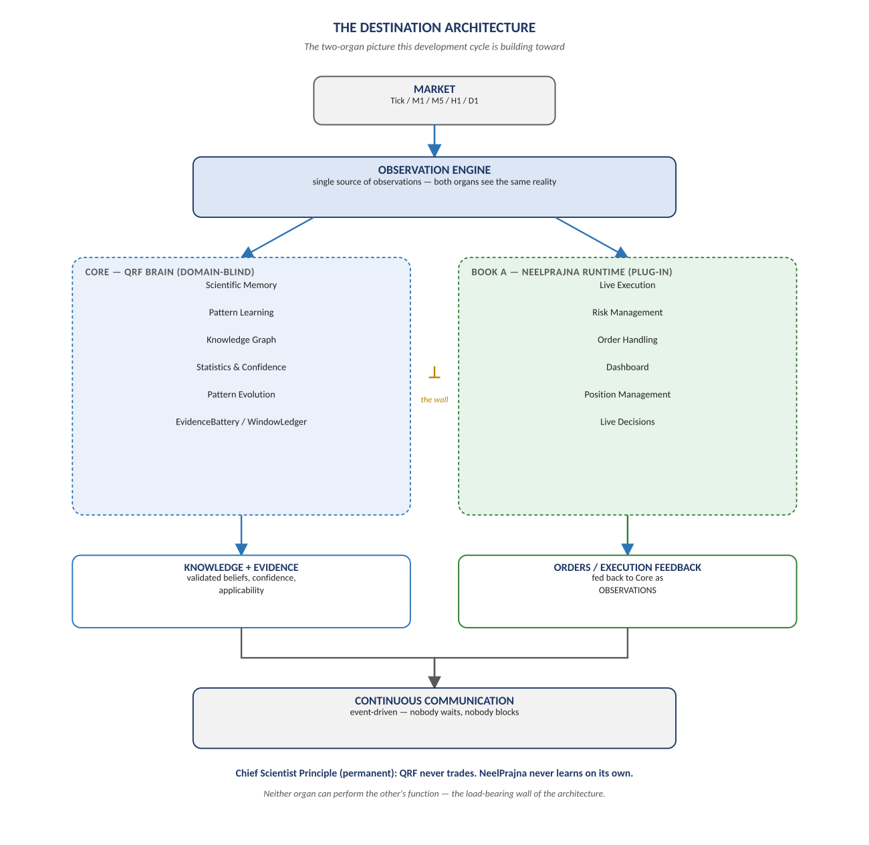
Figure 1. Figure 1. Market → Observation Engine → the two organs → Knowledge+Evidence / Orders+Feedback → Continuous Communication.

Diagram 2 — The Readiness Map
Four boxes in the destination picture are BUILT today — the entire Gen-1 Kernel machinery. Six are TARGET: real only when a named sprint produces a verdict-bearing artifact for them. No box may be claimed done on the strength of this diagram alone.
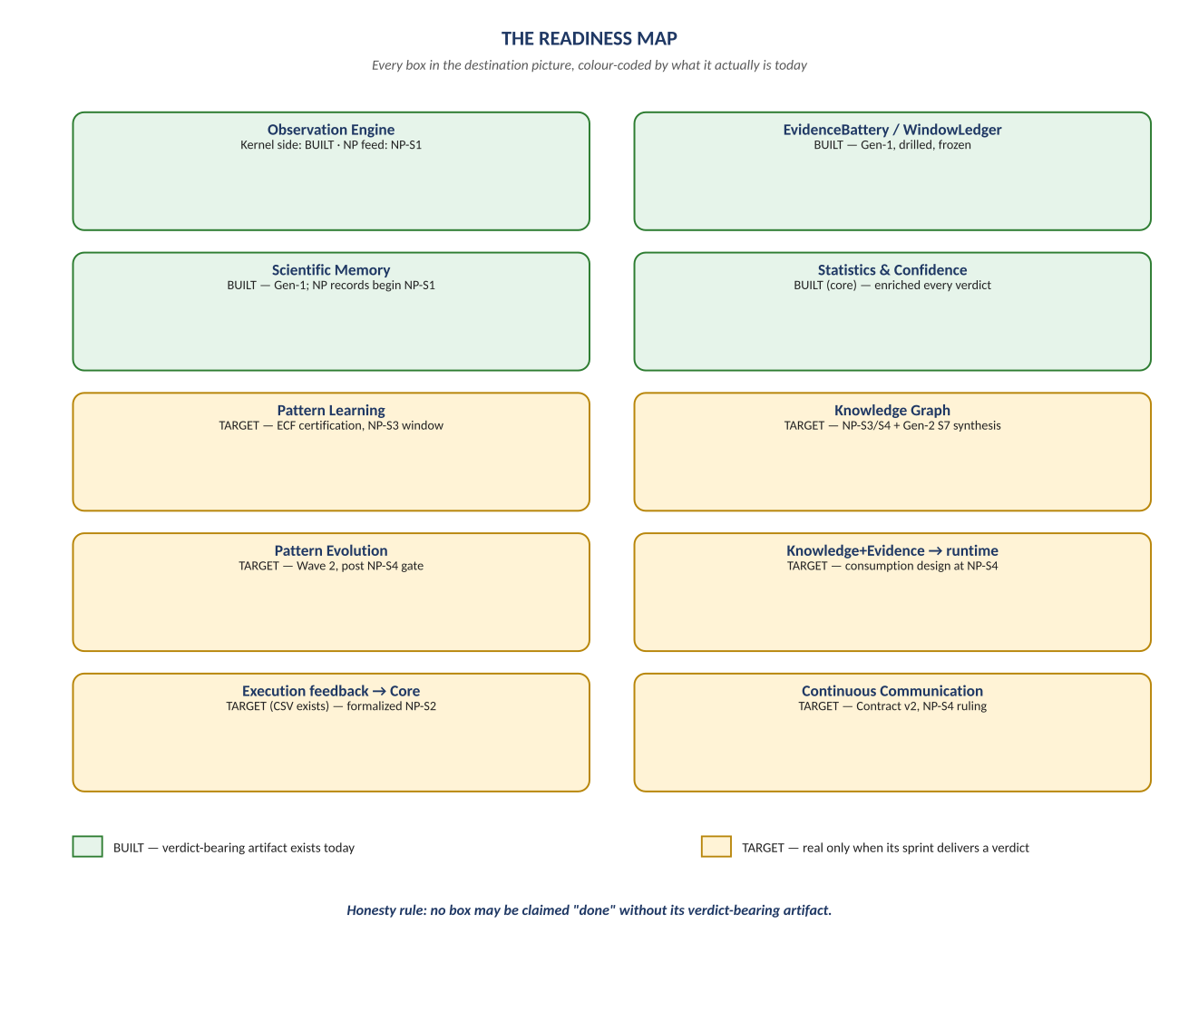
Figure 2. Figure 2. Ten boxes, colour-coded BUILT (green) or TARGET (gold) — the honest scorecard.

Diagram 3 — The Delivery Timeline
Every TARGET box has a named sprint that pays for it, in order, and none pays for itself early. NP-S1 through NP-S4 each retire a specific debt from the readiness map; two items borrow certification from the parallel Gen-2 track.
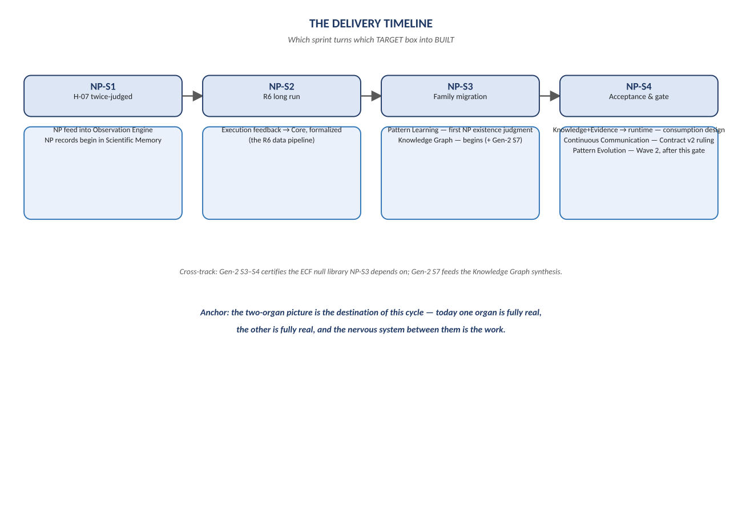
Figure 3. Figure 3. NP-S1 → NP-S2 → NP-S3 → NP-S4, each sprint's box-by-box delivery.

Diagram 4 — The Permanent Boundary
Every box above can eventually turn from TARGET to BUILT — except this one, which was never on the ladder to begin with. No sprint, no acceptance campaign, no accumulated trust ever moves arming authority away from the Owner's typed hand.
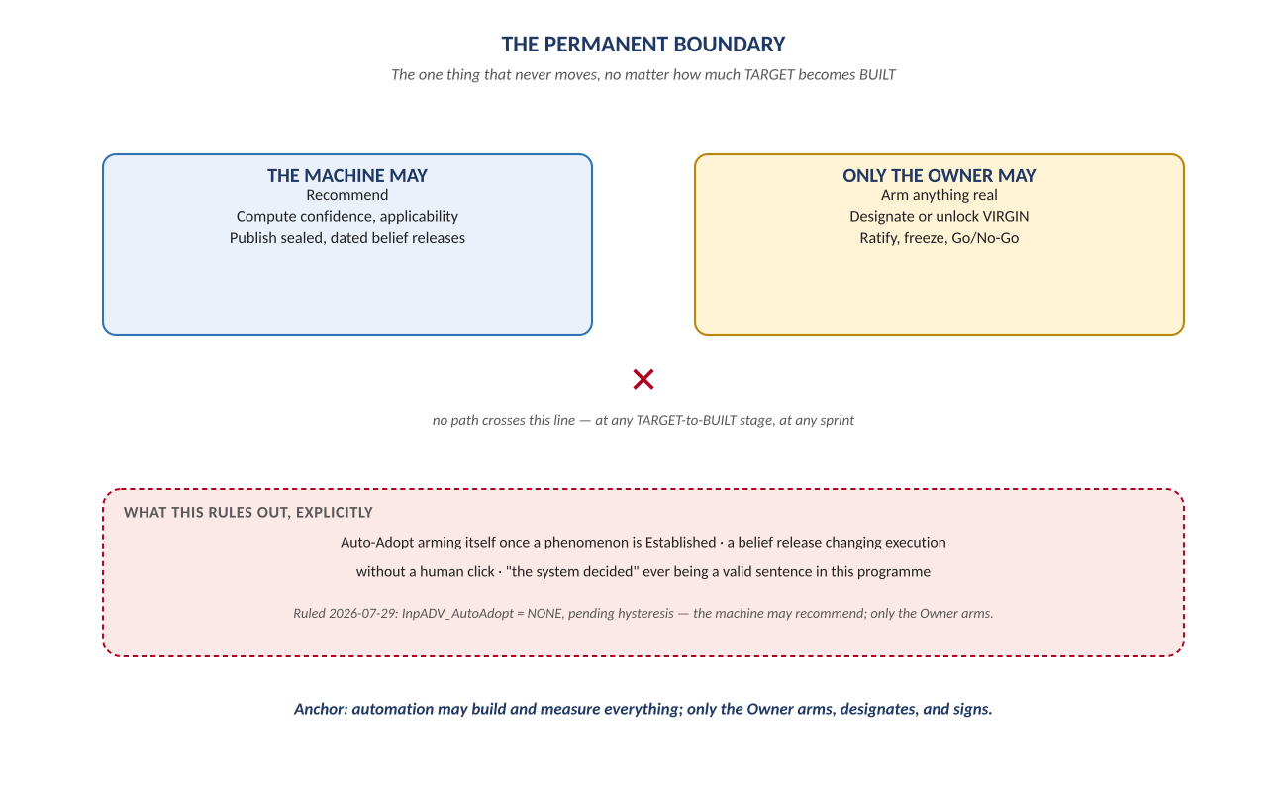
Figure 4. Figure 4. The machine may recommend; only the Owner arms, designates, and signs — permanently.

Change Record
v1.0 (2026-07-29): first whiteboard render of the Vision, built per docs\archive\governance\HOW_THIS_DOC_WAS_BUILT.md (hand-built SVG, rasterized, one diagram per page, PDF-verified). Companion to the normative docs\vision\NeelPrajnaPro_Vision-v1.0.md — that file is authoritative; this document teaches it.
Anchor: the two-organ picture is the destination — today one organ is real, the other is real, and the nervous system between them is the work.

