NeelPrajnaPro
Architecture — v1.0
THE one architecture document of the programme (Owner ruling, 2026-07-29: one document per thing; versions maintain history).
Merges: the ratified Platform & Integration Architecture v2.0 (Charter, RATIFIED 2026-07-29) · the corrected Architecture Diagrams volume (8 diagrams) · the VISION target mapping.
Author: Fable (Architect) · 2026-07-29 · Location: docs\architecture\ (only the current version lives here; prior versions auto-archive)

How to Read This Document
Part A is the destination — the two-organ architecture the Owner ruled as this development cycle's target, with every box mapped to the sprint that makes it real. Part B is the binding law — the ratified normative architecture (what exists, what integrates, what may never happen). Part C is the visual atlas — all eight diagrams with honest status captions. If you read one part, read Part A; if you build, Part B binds you; if you explain the system to anyone, Part C is the whiteboard.
Honesty rule carried from the charter: every diagram and every box carries its true status — BUILT (verdict-bearing artifacts exist), TARGET (evidence-gated, sprint-mapped), or DESIGNED (specified, not started). Nothing in this document may be cited as existing before its artifact does.

Part A — The Destination (Owner Vision Ruling, 2026-07-29)
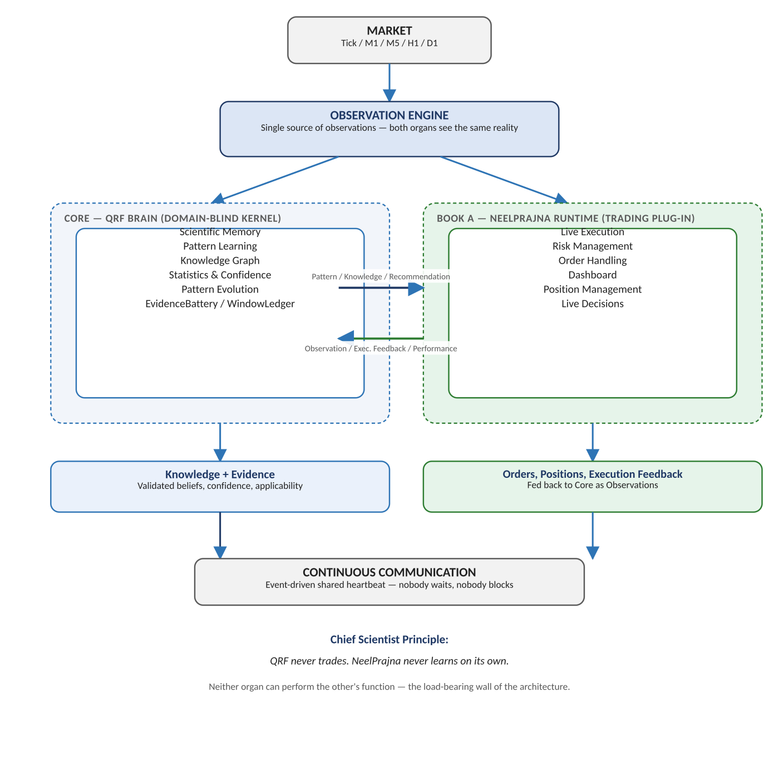
Diagram 1 — Programme architecture, top-down: Market → Observation Engine → the two organs (Core QRF Brain · Book A NeelPrajna Runtime) → Knowledge+Evidence / Orders+Feedback → event-driven communication.
The load-bearing wall (Chief Scientist Principle, permanent): QRF never trades. NeelPrajna never learns on its own. Neither organ can perform the other's function.

Every box, mapped to the sprint that delivers it
Box | What it concretely is | Status | Delivered by
EvidenceBattery / WindowLedger | The drilled judge + human-held reserves | BUILT | Gen-1 (closed)
Scientific Memory | Append-only RecordStore, verdicts, beliefs | BUILT | Gen-1; NP records from NP-S1
Observation Engine | Detectors + adapters + EventFrames, one shared reality | BUILT (Kernel side) | NP feed: NP-S1, widened per family
Statistics & Confidence | Battery statistics + belief layer (sealed figures only) | BUILT (core) | Enriched every verdict
Pattern Learning | Candidate discovery + ECF establishment of phenomena | TARGET | ECF certification track; first NP existence judgment in the NP-S3 window
Knowledge Graph | Beliefs document + atlas: scoped, linked stances | TARGET | NP-S3/S4 + Gen-2 S7 synthesis
Pattern Evolution | Refinement as new sealed, priced registrations | TARGET | Wave 2, post NP-S4 gate (machine-proposed only after Gate A)
Knowledge+Evidence → runtime | Versioned belief releases across Contract v2 | TARGET | Consumption design ruled at NP-S4; arming stays permanently human
Execution feedback → Core | Fills/outcomes as observations (Performance Store) | TARGET (CSV exists) | Formalized NP-S2 (R6 pipeline)
Continuous Communication | Event-driven releases & observations — nobody waits; a release is an event, freshness is its date; never tick-streaming of unsealed statistics | TARGET | Contract v2 implementation; NP-S4 ruling

Part B — The Binding Architecture (ratified 2026-07-29)

B.1 The frozen basis
Integration into the real, proven QRF Kernel carried forward into this repository. NeelPrajna is the second concept family (qrf/trading/concepts/neelprajna/) inside that Kernel — an application, never a parallel research apparatus. The bespoke research stack (np_knowledge_base, np_probability_engine, and kin) is retired from evidentiary service: it may run as exploration; its outputs carry no epistemic weight, write no verdicts, burn no windows, update no beliefs.

B.2 The Kernel, as actually built (write authority is a closed list)
Component | Location | Role
RecordStore | qrf/kernel/records/store.py | Hash-chained, single-writer, append-only ledger
WindowLedger | qrf/kernel/protocol/windows.py | TRAINING/EXPLORATION/VIRGIN; burn-on-use; reserve-by-market-time
EvidenceBattery | qrf/kernel/battery/battery.py | Sole verdict writer; nine steps; selftest gate; atomic verdict+burn
TrialCountLedger | qrf/kernel/corrections/trials.py | Registration spends the attempt; family deflation at judgment
BeliefLayer | qrf/kernel/belief/ | Updates from Verdict-typed inputs only
Instruments/Calibration | qrf/kernel/instruments/ | Registration; planted-truth and silence tests
Observatory | qrf/kernel/observatory/ | Anomaly scans → questions only
Kernel firewall | tests/test_kernel_firewall.py | CI-enforced: kernel never imports trading
Write authority (closed): store.append · Battery (verdict, window_burn) · Screener (trial_count) · belief.update (from Verdicts only). Everything else proposes or reads.

B.3 NeelPrajna as the second concept family
- Detectors: qrf/trading/concepts/neelprajna/ — first: liquidity_sweep per the sealed H-07 definition (EXECUTION_PLAN §3), certified against planted-truth and clean-control cases before observing anything real.
- Data path: NP_Trades_*/NPSU_Trades_* exports → existing mt5_csv adapter (explicit timeframe; OBS-4 close-time). No new adapter.
- Hypotheses: configs/hypotheses/h0NN_*.yaml, hashed at registration; the 18 founding hypotheses register as ≥18 counted attempts; family α-budget is Owner-set.
- Cost model: xauusd_retail_h07 (Owner-named, 2026-07-29) — one authoritative configs/venues.yaml entry; FROZEN once cited; changes require a new name.
- Windows: seen NeelPrajna market time designated honestly (TRAINING/EXPLORATION, never VIRGIN) by the Owner's typed phrase before registration.

B.4 The Communication Contract v2 and the Knowledge Publication Boundary
Six object types cross, nothing else: Observation · Pattern · Knowledge · Recommendation · Execution Feedback · Performance. Two prohibitions: the runtime never asks about Kernel internals; the Kernel never says BUY or SELL. Publication is batch release, not tick-time: a release is an event with a date, and a stale release is stale knowledge, never extrapolated.
The boundary (Owner ruling): QRF publishes what it knows, never how it knows. Publishes: Pattern ID, applicability, regime conditioning; verdict-sealed statistics (win rate, expectancy, confidence) frozen at release date; Recommendations (advisory); validated Knowledge (Battery-verdicted, versioned, dated). Keeps internal: belief state and update mechanics; raw observations and event streams; calibration and drill state; decision processes; knowledge-in-progress. No rolling or unsealed statistic ever crosses; execution feedback enters as observations only and updates no belief directly.

B.5 What stays separate, on purpose
Live execution (TradeManager, MoneyManager, EntryGates, the 2% rule), the Supervisor/Runner trust split and autonomy ladder, NPSU shadow universes and dashboards stay with the runtime at F:\NeelPrajna (paused; execution home). The question of whether any claim is TRUE lives only in the Kernel. The dividing line is QRF-ADR-004 applied one level up: execution stays where the hands are; truth moves to where the judge is.

B.6 Real-account switching safety (permanent)
Owner ruling 2026-07-29: Auto-Adopt DISABLED pending hysteresis (InpADV_AutoAdopt = NONE). Any mechanism that changes what the real account trades without a human click requires, before arming: hysteresis ≥ the advisory path's consecutive-win requirement; OOS-validated eligibility; and an Owner arming decision on the record. Re-enable is per strategy, only after ECF survival + a Battery-passed pre-registered hypothesis + explicit Owner enablement. The machine may recommend; only the Owner arms — forever.

B.7 Verification duties this architecture creates
Every family detector ships with planted-truth and clean-control cases and passes them before observing for a registered claim. The IVF re-derives every NeelPrajna-family verdict from normative texts, drilled first — origin grants no shortcuts. Every sprint follows the ratified rhythm ending in the Owner's Go/No-Go. Full assurance detail: docs\VV_PLAN.md.

Part C — The Visual Atlas (eight diagrams, honest captions)
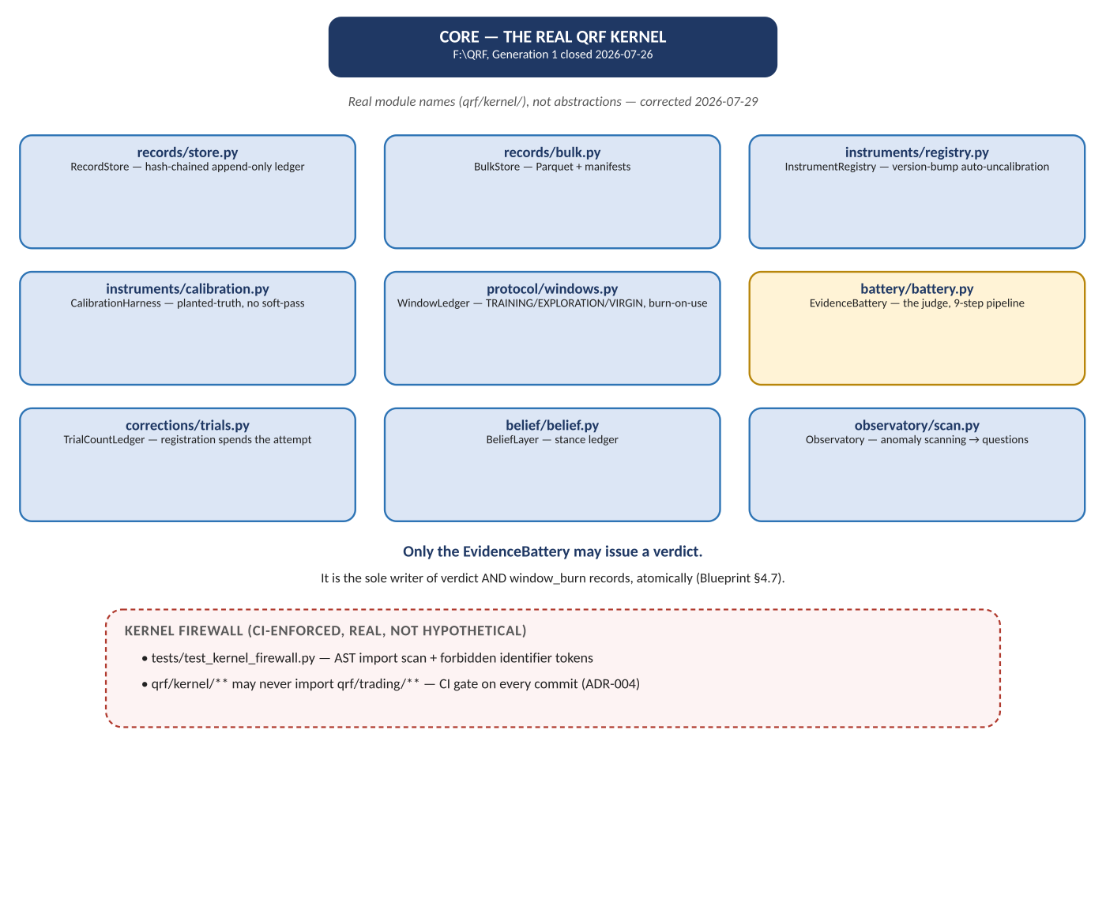
Diagram 2 — Core Kernel components (regenerated against real module paths in the corrected volume). Status: BUILT — every box exists in qrf/kernel/ and is exercised by the 853-test suite.
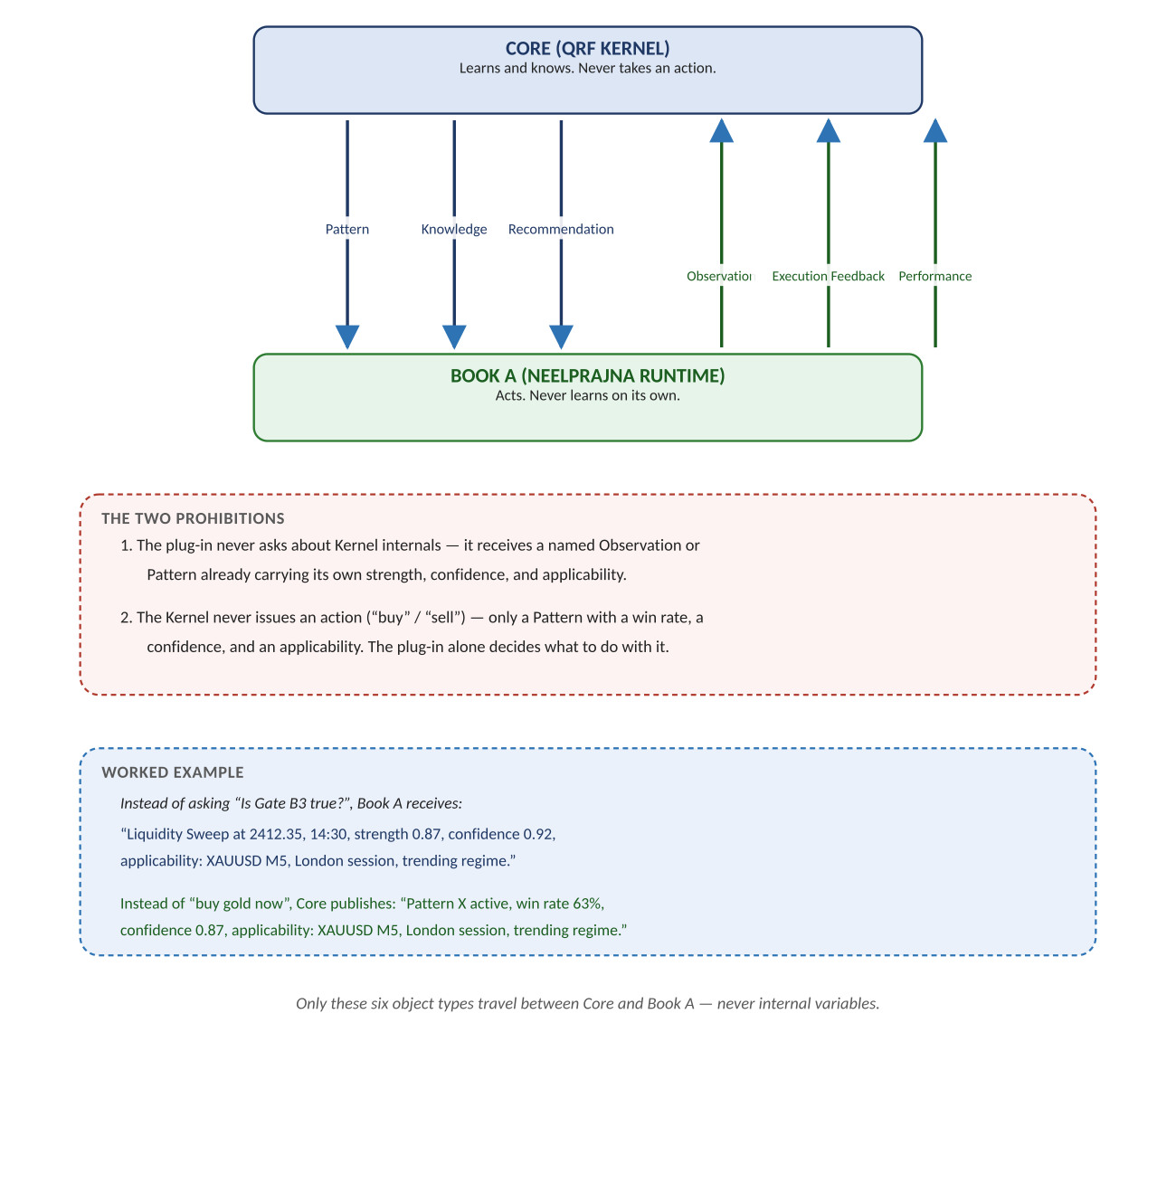
Diagram 3 — The Communication Contract. Status: DESIGNED/TARGET — a design sketch (the corrected volume says so honestly); implemented via Contract v2 with the Publication Boundary of Part B.4; consumption ruled at NP-S4.
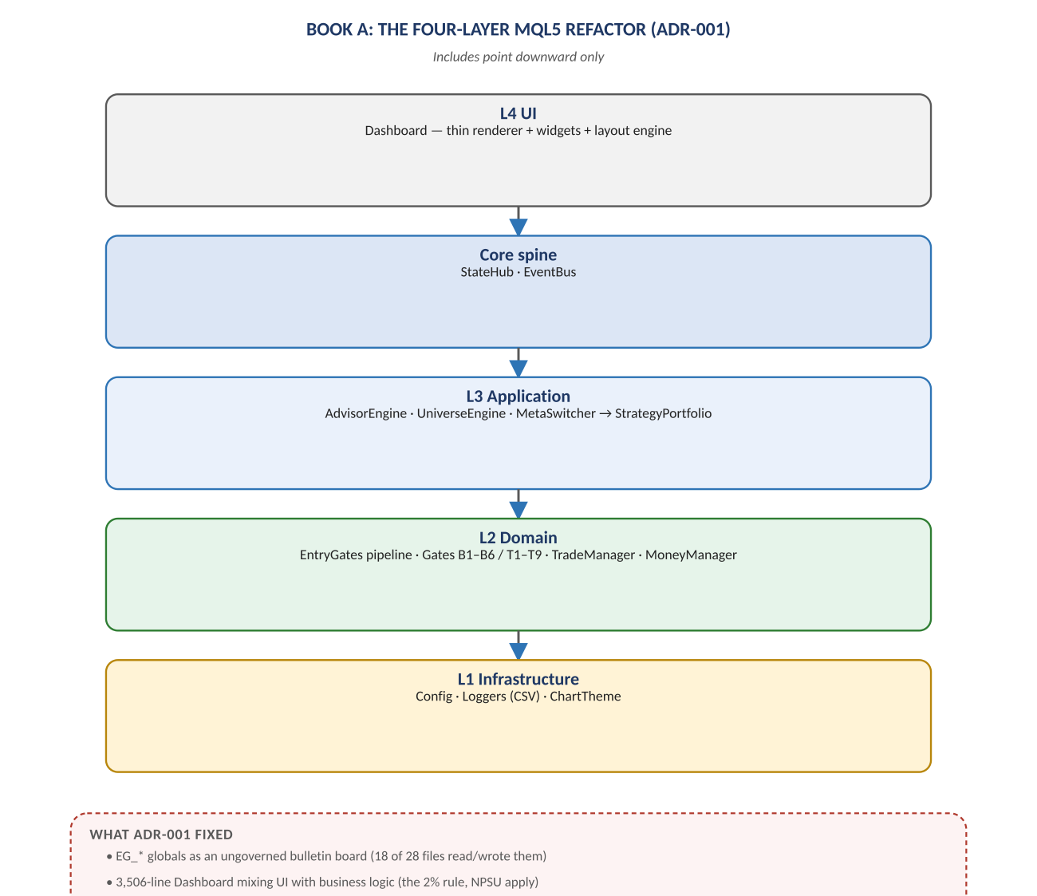
Diagram 4 — Book A: the four-layer MQL5 refactor of the runtime. Status: BUILT — the live EA at F:\NeelPrajna (paused; execution home).
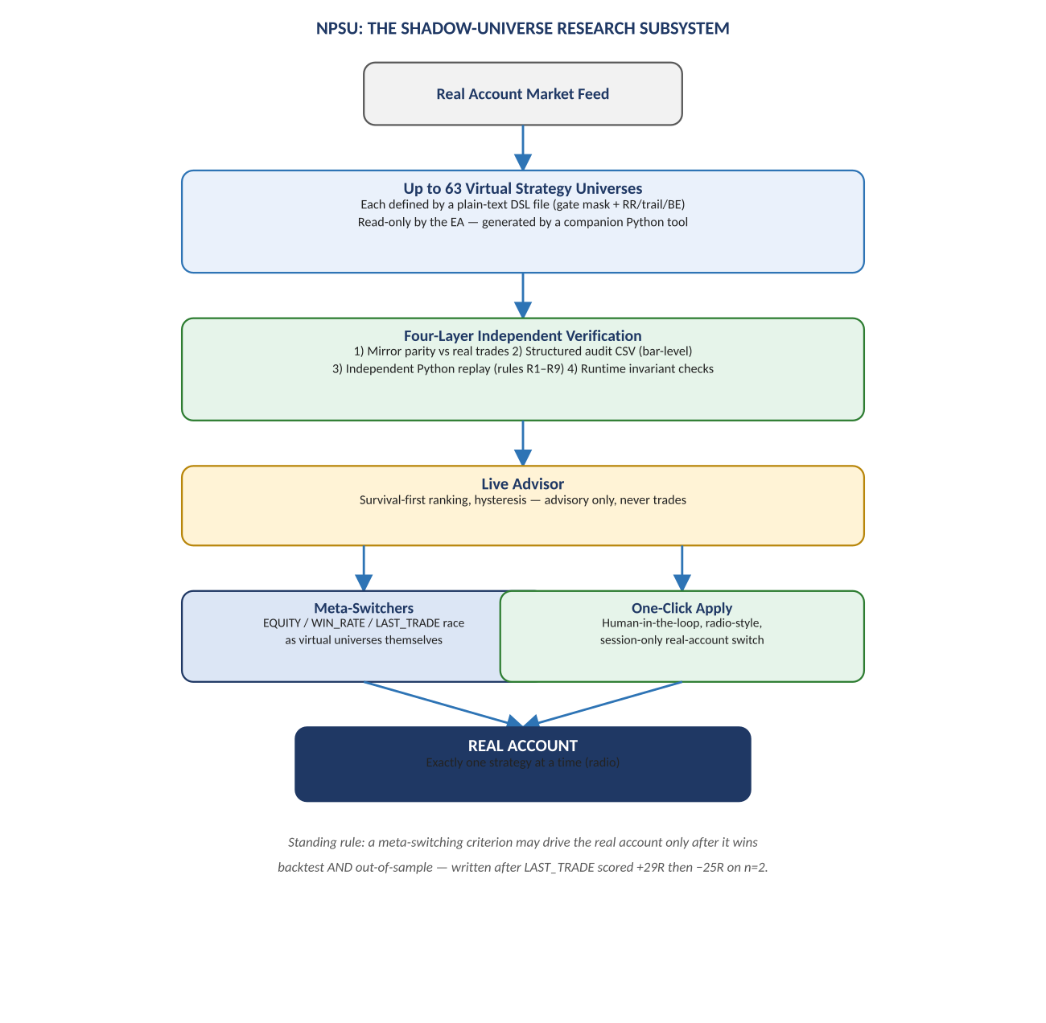
Diagram 5 — NPSU shadow-universe research subsystem. Status: BUILT — runtime-side; its outputs are observations/candidates, never evidence.
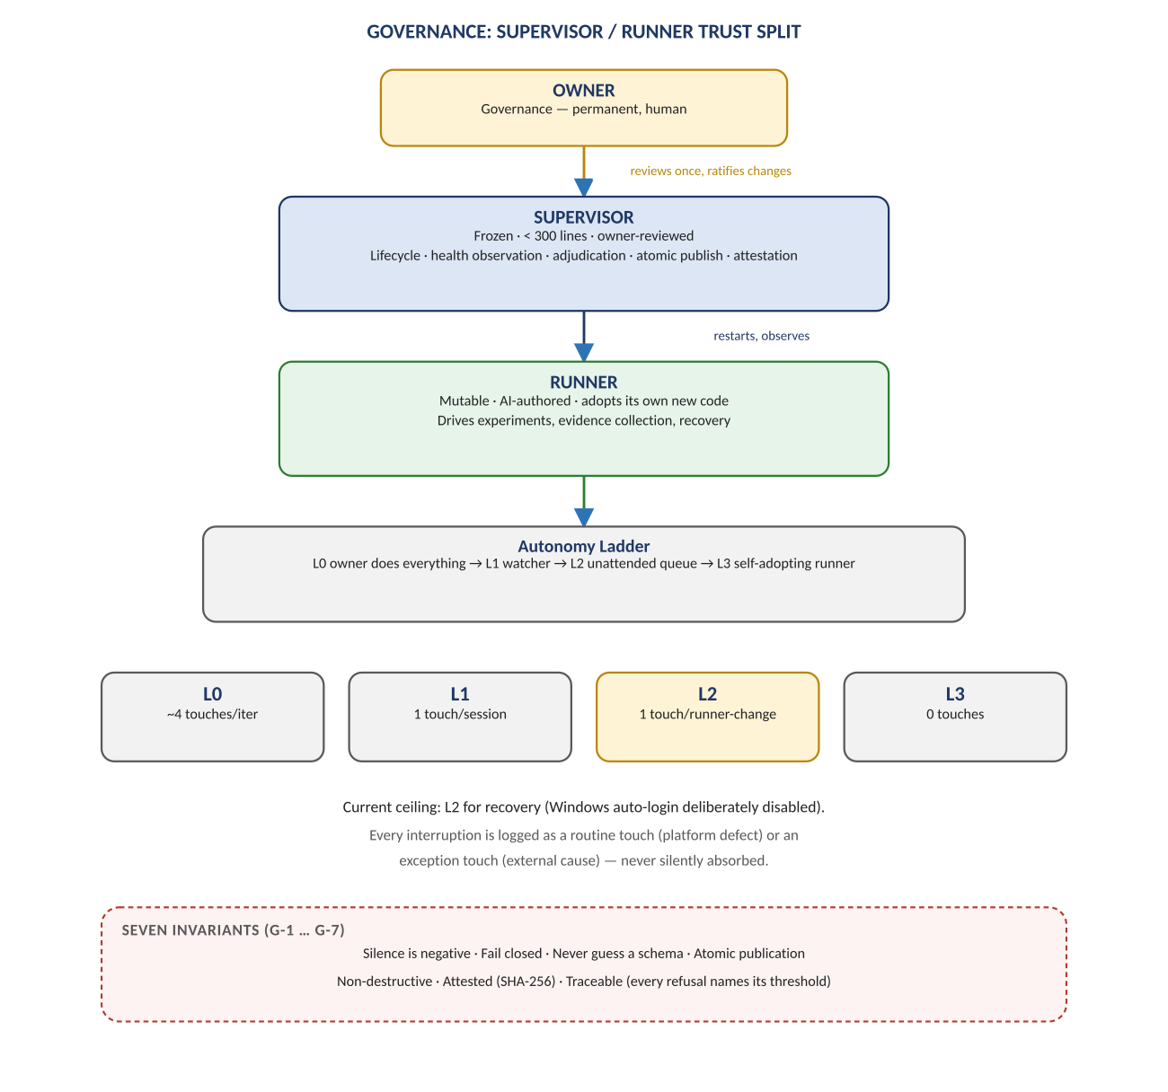
Diagram 6 — Governance: Supervisor/Runner trust split (contract v1.1, owner-signed; live-verified HEALTHY 2026-07-29). Status: BUILT.
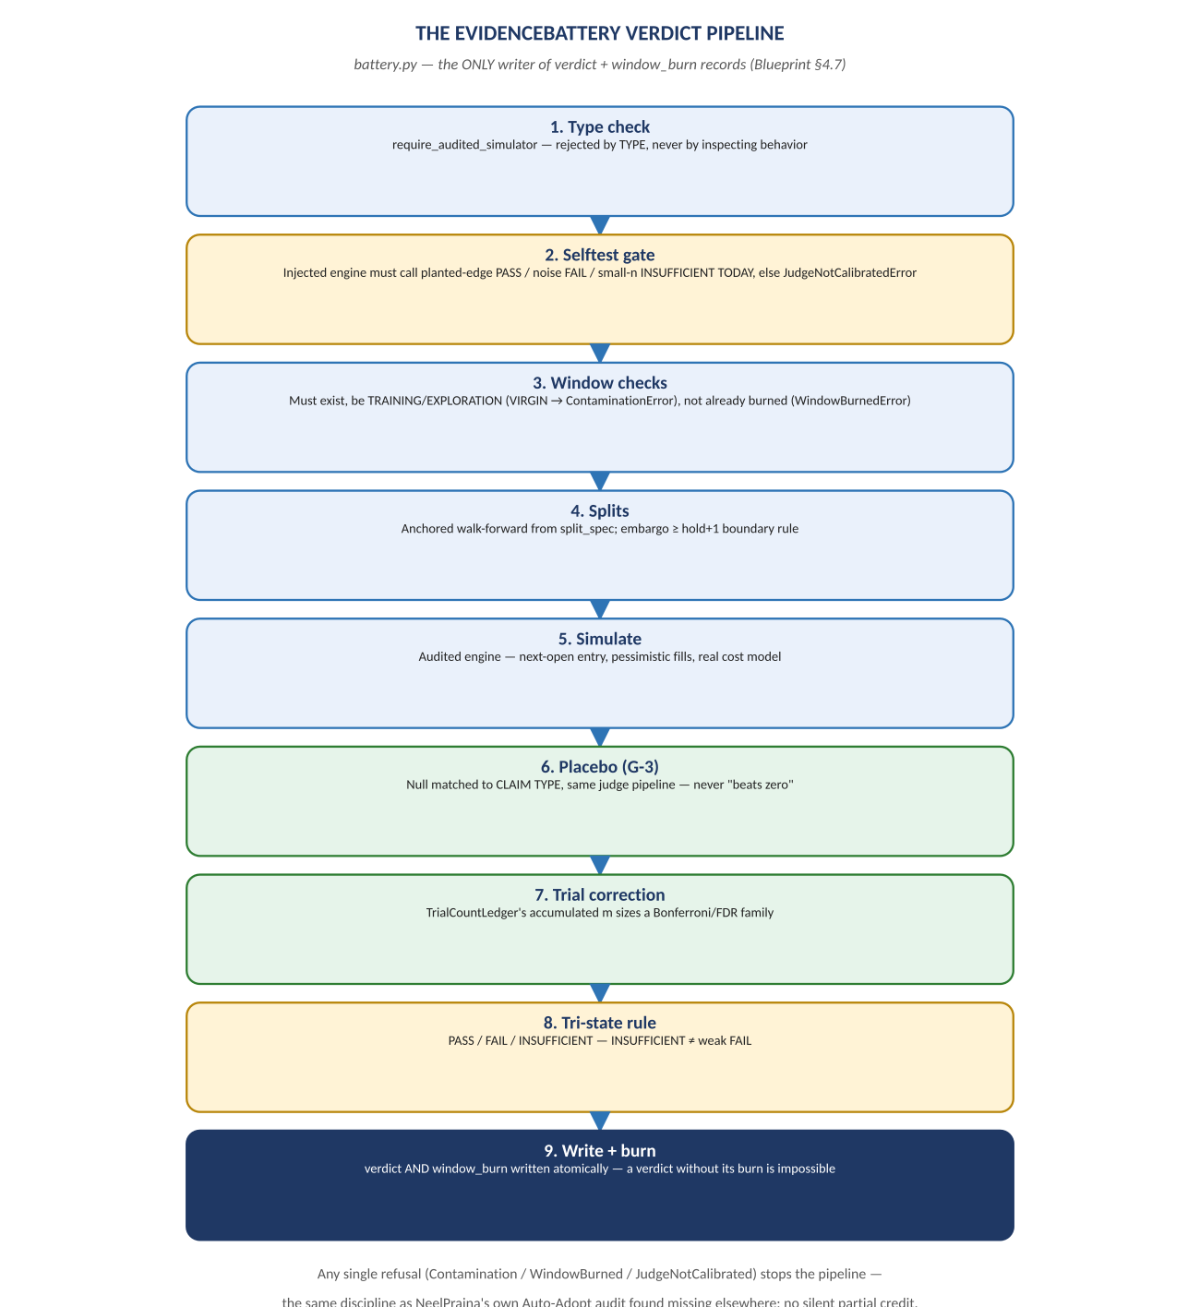
Diagram 7 — The evidence pipeline that any future autonomous discovery must pass through. Status: BUILT (Battery core) + TARGET (ECF null library, per certification track).
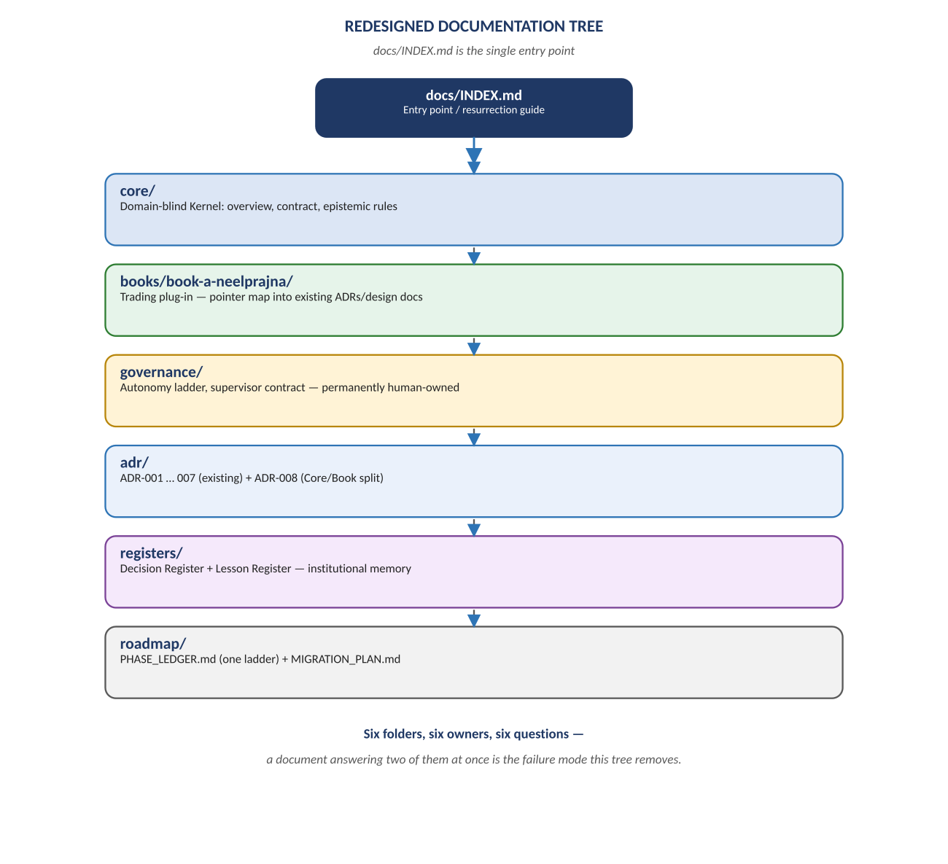
Diagram 8 — The redesigned documentation tree. Status: SUPERSEDED with honor by the Owner's one-doc-per-thing law (docs\README.md, 2026-07-29); its two Registers' spirit lives in JOURNAL.md.

Change Record
- v1.0 (2026-07-29): created per Owner ruling — one architecture document for the programme. Merges the ratified Platform & Integration Architecture v2.0 (now archived as this document's predecessor), the corrected Architecture Diagrams volume, and the VISION target mapping. Versioning law: only the current version lives in docs\architecture\; on supersession the old version moves to docs\archive\ automatically; git preserves everything regardless.
Anchor: one document, two organs, one wall — QRF never trades, NeelPrajna never learns on its own.

