NeelPrajnaPro
Automation — v1.0
Whiteboard companion to docs\automation\NeelPrajnaPro_Automation-v1.0.md — the two surfaces, the touch budget, and the work orders.
Author: Fable (Architect) · 2026-07-29 · Twin rule applies: the .md is the normative text; this .docx is its human render

How to Read This Document
This is the teaching form of the Automation plan — operations automated to the maximum the machine allows, governance permanently human. The three diagrams go in the order a reader needs them: first the two surfaces this programme actually runs on, then the honest scorecard of how many touches each sprint costs the Owner, and finally the small sequenced work orders that pay down what's still owed before the automation is complete.
Every diagram carries an anchor sentence. The md twin is normative; if this document and the md ever disagree, the md wins and the disagreement is a finding.
Diagram | Answers
1 — The Two Execution Surfaces | What runs where, and how automated is each?
2 — The Owner Touch Budget | How many times does the Owner actually have to act, per sprint?
3 — The Work Orders | What small, sequenced debts remain before the automation is trustworthy?

Diagram 1 — The Two Execution Surfaces
The programme runs on exactly two surfaces: the Python side at F:\QRF, already zero-touch for execution through fresh Claude Code sessions, and the MT5 lab, running under a live bridge that starts at boot and needs nothing but one open window. The joint sprint loop chains both together, and every arrow but the last is machine-executed — the last one is Owner Go/No-Go, and it stays that way on purpose.
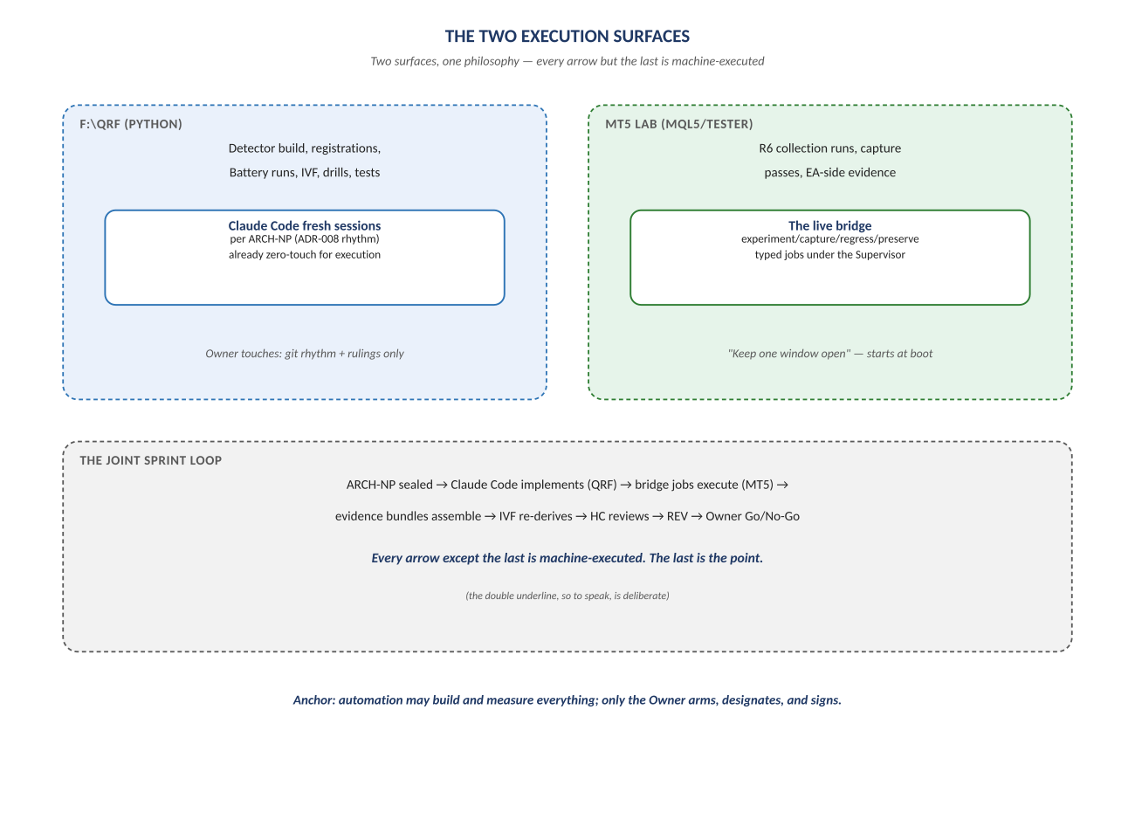
Figure 1. Figure 1. F:\QRF and the MT5 lab, joined by the joint sprint loop.

Diagram 2 — The Owner Touch Budget
This is the honest definition of "minimal human involvement": routine operational touches at zero, every sprint, without exception — and governance touches counted openly rather than hidden, because they are not overhead to eliminate, they are the point of the whole system.
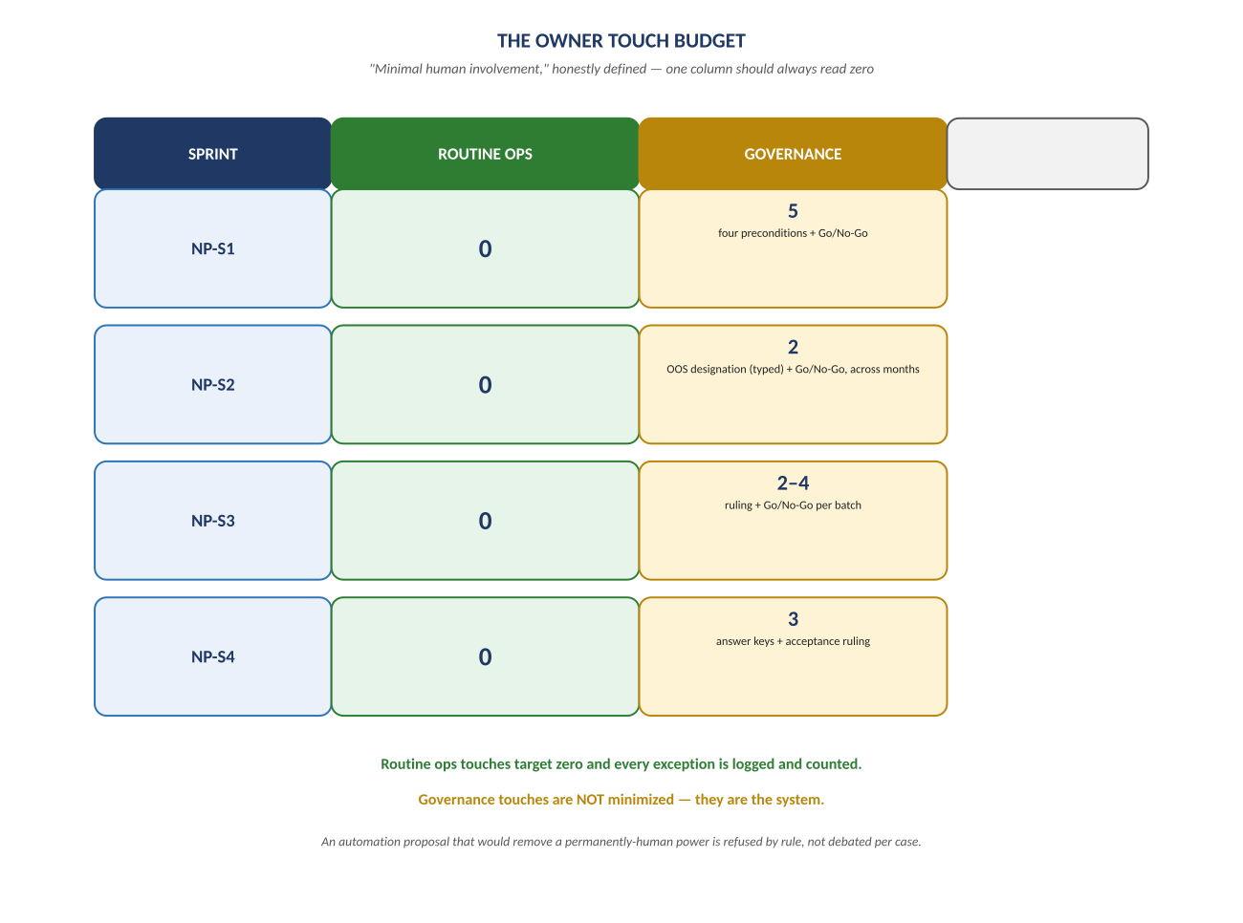
Figure 2. Figure 2. NP-S1 through NP-S4 — routine ops (always zero) vs. governance touches (counted, never minimized).

Diagram 3 — The Work Orders
Four small, sequenced debts stand between today's automation and full trust in it — from a documentation truth pass that closes a real staleness finding, to a thirty-minute spike that gates every visual evidence bundle downstream of it. Each has a named exit condition; none is optional busywork.
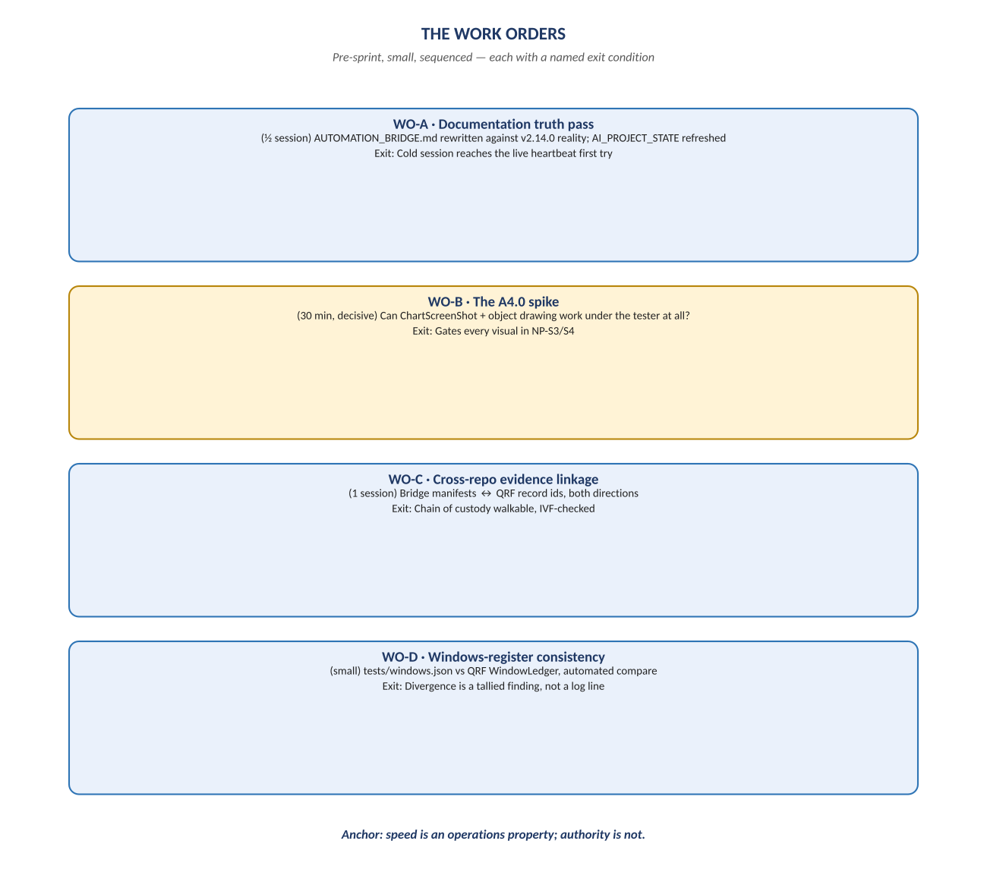
Figure 3. Figure 3. WO-A through WO-D — pre-sprint, small, sequenced, each with its own exit.

Change Record
v1.0 (2026-07-29): first whiteboard render of the Automation plan, built per docs\archive\governance\HOW_THIS_DOC_WAS_BUILT.md (hand-built SVG, rasterized, one diagram per page, PDF-verified). Companion to the normative docs\automation\NeelPrajnaPro_Automation-v1.0.md — that file is authoritative; this document teaches it.
Anchor: automation may build and measure everything; only the Owner arms, designates, and signs — and the day that line blurs is the day the automation has failed, however fast it runs.

