NeelPrajnaPro
Reports — v1.0
Whiteboard companion to docs\reports\NeelPrajnaPro_Reports-v1.0.md — the Gen-1 close, and the ladder still growing.
Author: Fable (Architect) · 2026-07-29 · Twin rule applies: the .md is the normative text and living register; this .docx teaches its shape as of this version

How to Read This Document
This is the teaching form of the Reports register — one closed report so far, two reserved slots waiting on sprints that haven't happened yet. The three diagrams go in the order a reader needs them: the Gen-1 scorecard itself, the four recommendations that report left behind and where each is now being executed, and the ladder structure this whole document is built to grow along.
Every diagram carries an anchor sentence. The md twin is normative and living — future reports append there, not here; this document teaches its shape as of this version and will need a fresh render once Report 2 closes.
Diagram | Answers
1 — The Gen-1 Scorecard | What did the first closed generation actually produce?
2 — The Four Recommendations | Where, right now, is each of Gen-1's recommendations being executed?
3 — The Report Ladder | What is this document's own growth pattern?

Diagram 1 — The Gen-1 Scorecard
Ten sprints built a complete, adversarially drilled evidence pipeline and judged four hypotheses — all four came back FAIL or INSUFFICIENT. Zero promotions is the proudest line in the whole report: the instrument refused to flatter the very team that built it.
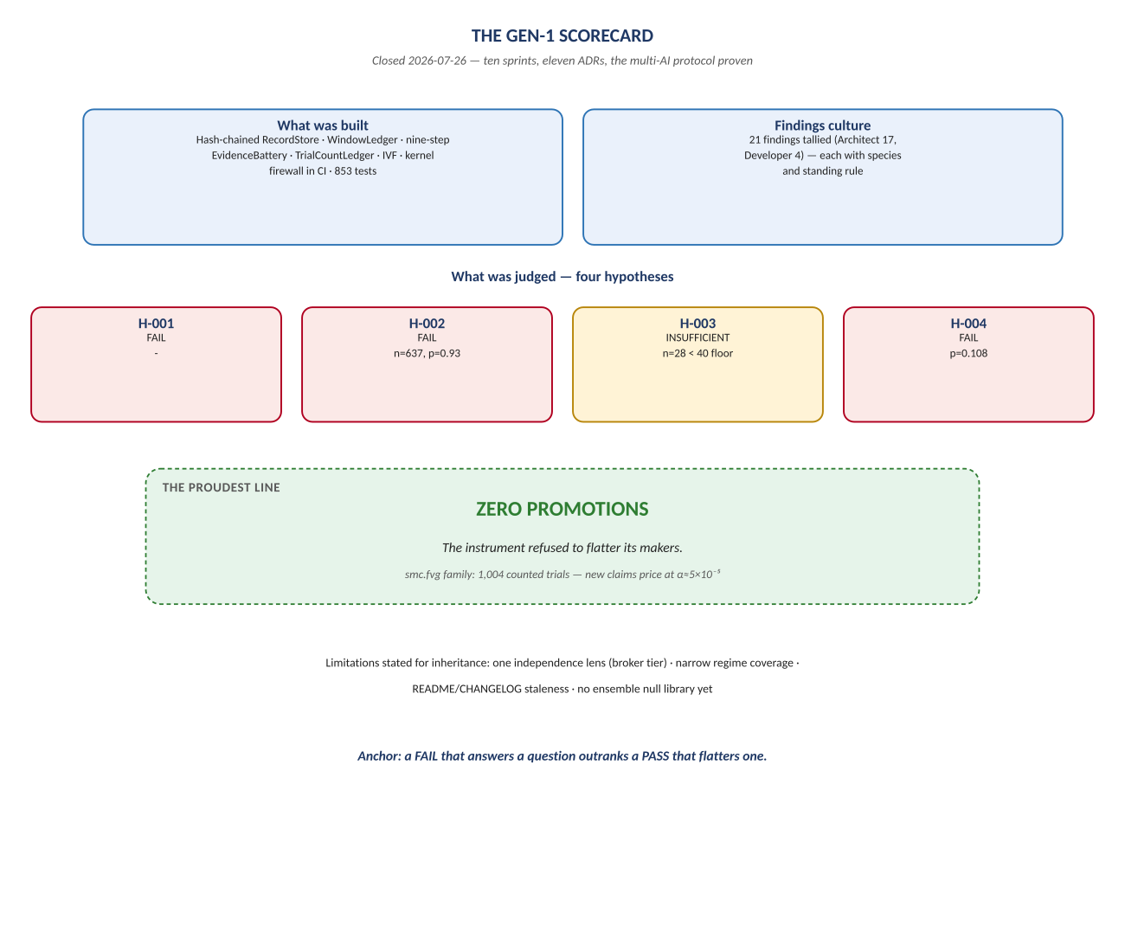
Figure 1. Figure 1. What was built, what was judged, and the line the report is proudest of.

Diagram 2 — The Four Recommendations
These aren't historical advice sitting in an archived report — they're this programme's actual marching orders, and each one is traceable to exactly where it's executing today. Recommendation 2 in particular is worth pausing on: the neelprajna family isn't inspired by that recommendation, it IS that recommendation, executed.
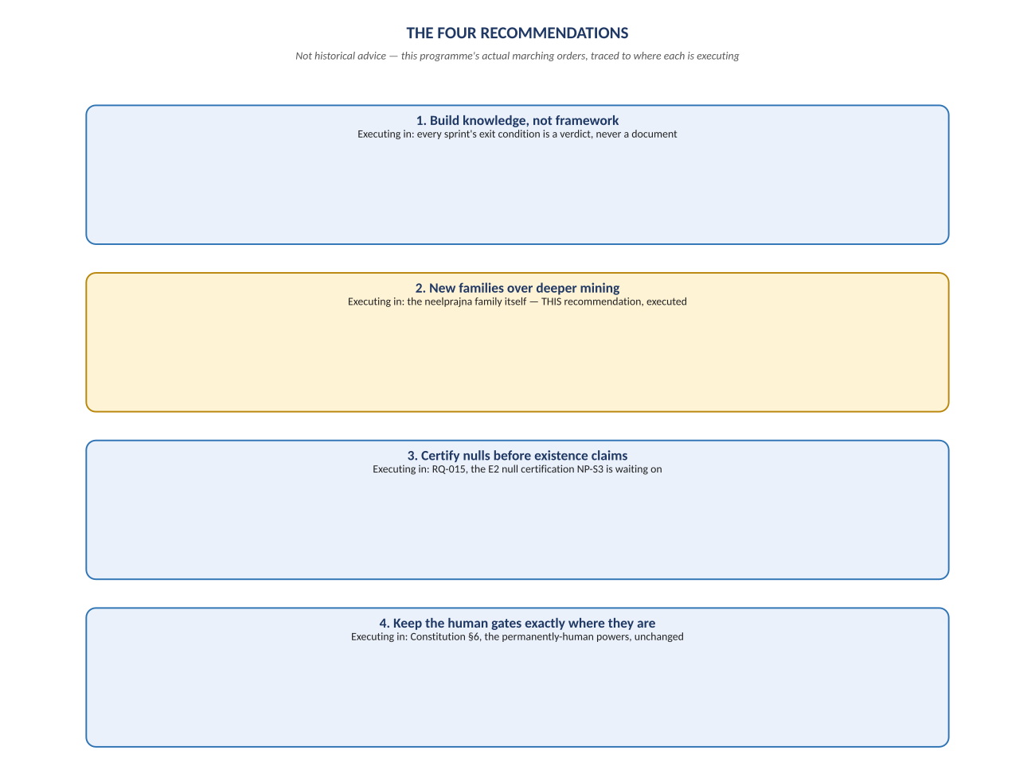
Figure 2. Figure 2. Build knowledge not framework · new families over deeper mining · certify nulls first · keep the human gates.

Diagram 3 — The Report Ladder
One report is closed; two slots sit reserved and empty, waiting on sprints that haven't happened yet. An empty reserved section here isn't a gap begging to be filled early with speculation — it's the same honesty the rest of this estate practices, just applied to reporting itself.
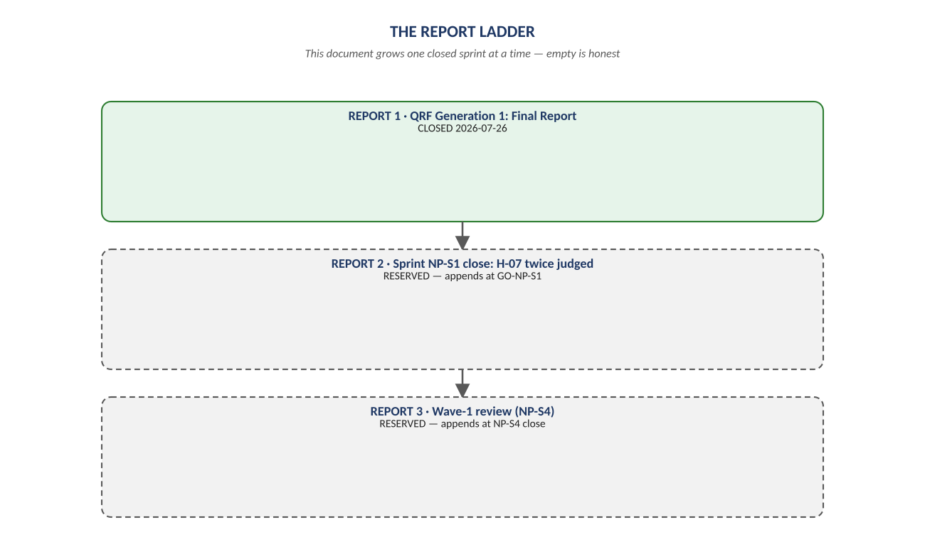
Figure 3. Figure 3. Report 1 (closed) → Report 2 (reserved, NP-S1) → Report 3 (reserved, NP-S4).

Change Record
v1.0 (2026-07-29): first whiteboard render of the Reports register, built per docs\archive\governance\HOW_THIS_DOC_WAS_BUILT.md (hand-built SVG, rasterized, one diagram per page, PDF-verified). Companion to the normative docs\reports\NeelPrajnaPro_Reports-v1.0.md — that file is authoritative and living; this document teaches its shape as of this version.
Anchor: a FAIL that answers a question outranks a PASS that flatters one.

