NeelPrajnaPro
Scientific Model — v1.0
Whiteboard companion to docs\scientific_model\NeelPrajnaPro_Scientific_Model-v1.0.md — the same document, taught in seven diagrams.
Author: Fable (Architect) · 2026-07-29 · Twin rule applies: the .md is the normative text; this .docx is its human render

How to Read This Document
This is the teaching form of the Scientific Model — the rules that turn a market observation into knowledge. Each of the seven diagrams below is one load-bearing idea, in the order a reader needs them: first the question the whole method answers, then the two things it never confuses, then how raw numbers become a name, then the lifecycle a phenomenon must climb, then the two frameworks that do the judging (the ECF for existence, the MML for shape), and finally the ladder knowledge climbs once it's earned.
Every diagram carries an anchor sentence — the one line worth remembering if nothing else survives. The md twin is normative; if this document and the md ever disagree, the md wins and the disagreement is a finding.
Diagram | Answers
1 — The Order of Inquiry | In what order may a claim be made?
2 — The Two Roots | What may never be stored together?
3 — The Observation Model | How do raw numbers become a name, and what must every claim declare?
4 — The Phenomenon Lifecycle | What must happen, in order, before a phenomenon is real?
5 — The ECF | How is 'does this exist?' actually judged?
6 — The MML | How is a candle's shape described without opinion?
7 — The Graduation Ladder | How does an observation become a theory?

Diagram 1 — The Order of Inquiry
Every inquiry in this programme answers three questions, in this order, and never out of it: does the thing exist, why does it happen, and only then, does it pay. A claim licensed at one stage may never borrow the authority of a later one.
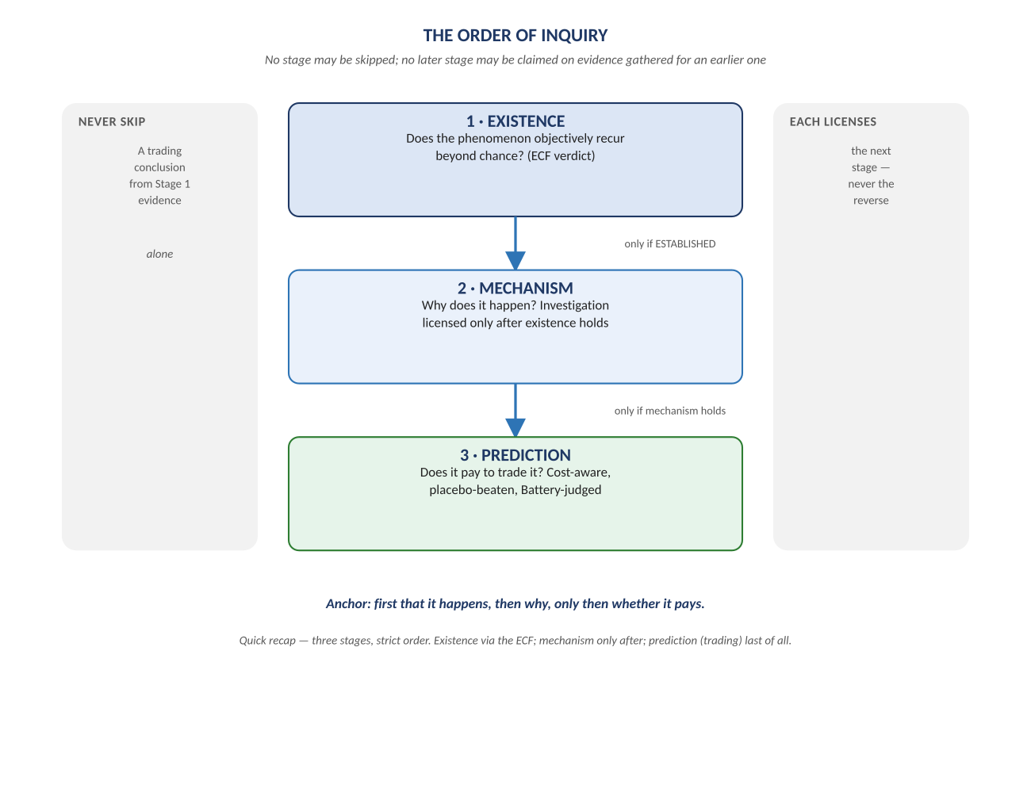
Figure 1. Figure 1. Existence → Mechanism → Prediction — each stage licenses the next; none may be skipped or reversed.

Diagram 2 — The Two Roots
Everything the system knows traces back to exactly two kinds of thing, and they are never mixed. Records are what happened — immutable, hash-chained, append-only. Scientific Objects are what we currently think it means — versioned, evidence-gated, always pointing at the evidence that changed them.
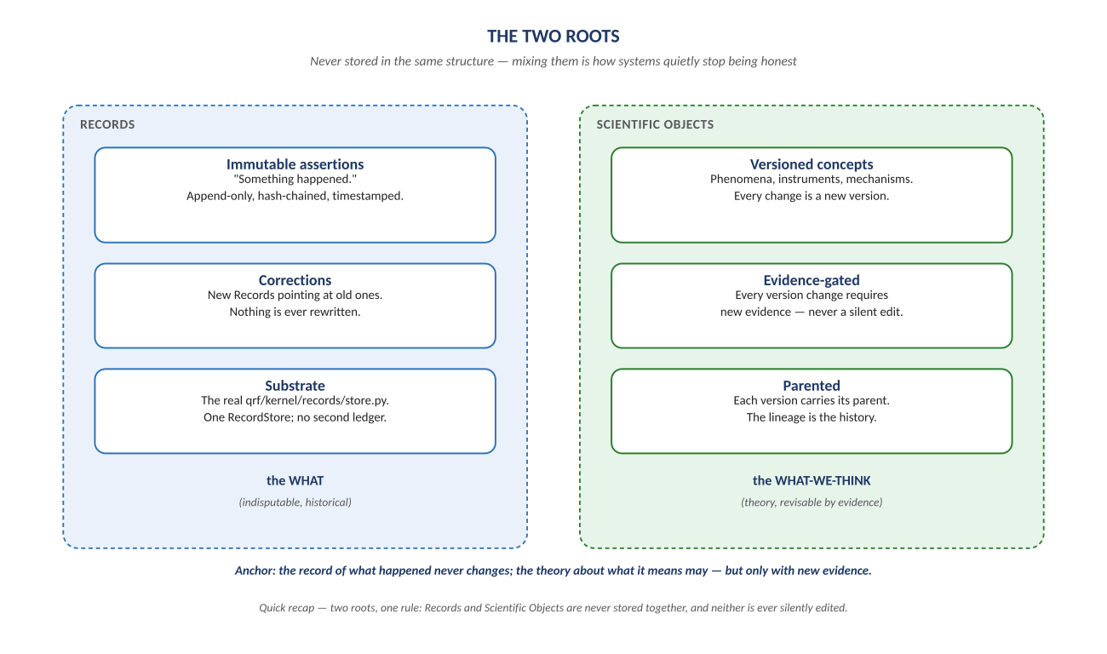
Figure 2. Figure 2. Records (the WHAT) and Scientific Objects (the WHAT-WE-THINK) — stored separately, on purpose.

Diagram 3 — The Observation Model and the Observation Space
Raw numbers become a name through exactly three layers, strictly ordered — theory is forbidden below the top. And whatever name eventually gets used, every claim must declare its scope across twelve layers before it is a claim at all.
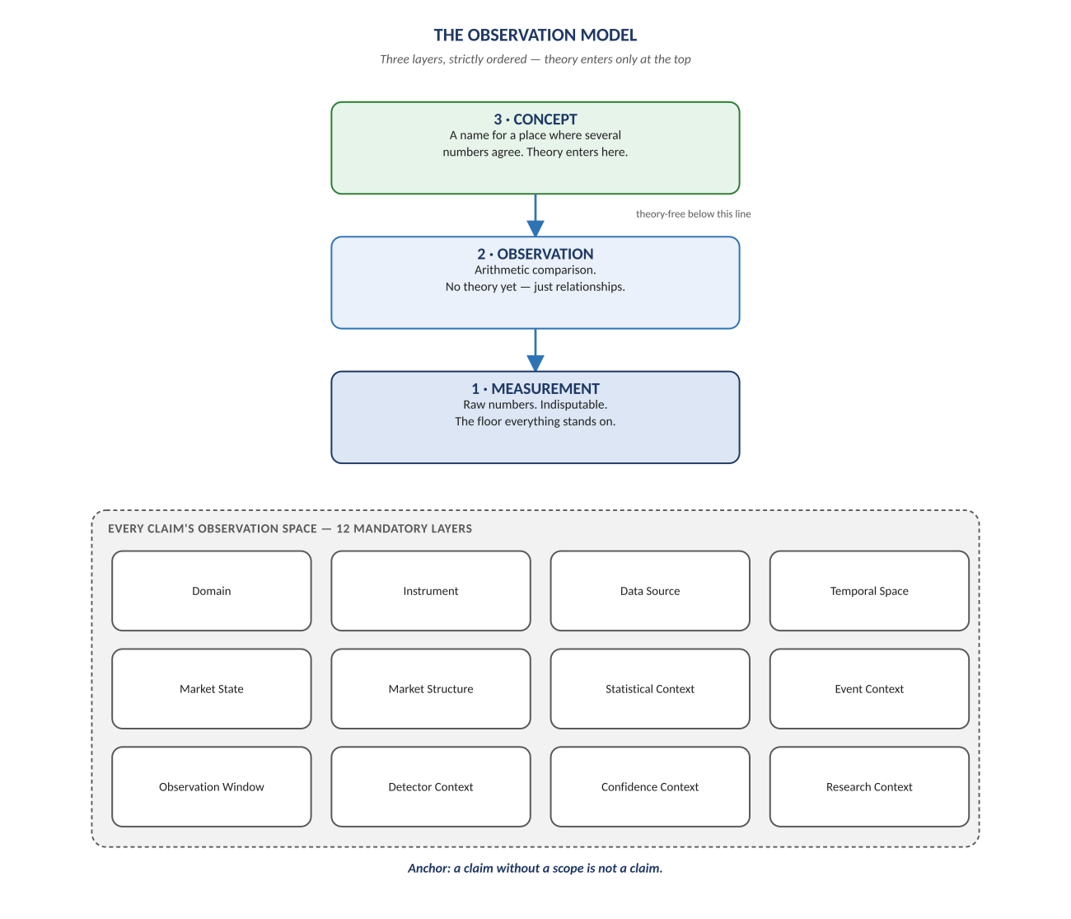
Figure 3. Figure 3. Measurement → Observation → Concept, and the twelve-layer Observation Space every claim must scope itself against.

Diagram 4 — The Phenomenon Lifecycle
A candidate idea becomes real knowledge only by climbing this exact ladder, one rung at a time. Skipping a rung — judging before drilling, predicting before establishing — is the single most common way research quietly stops being honest.
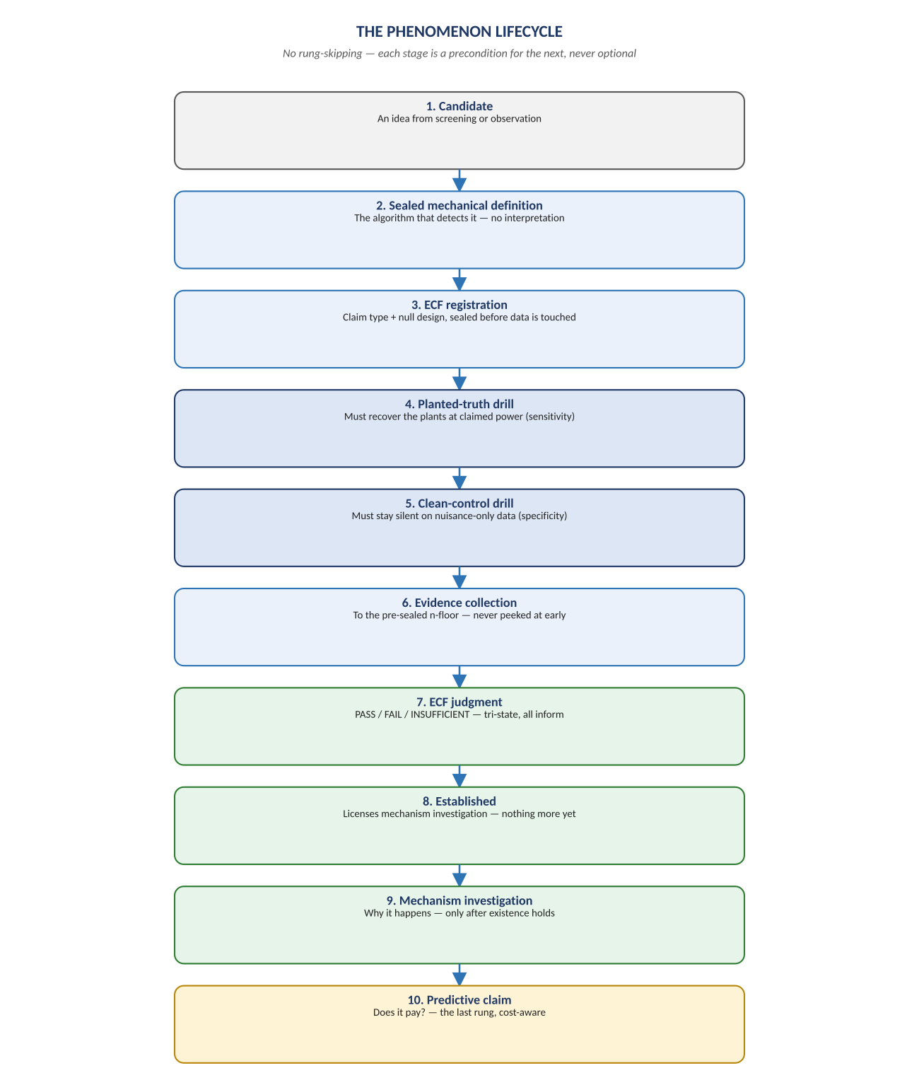
Figure 4. Figure 4. Ten rungs, Candidate to Predictive Claim — no rung may be skipped.

Diagram 5 — The Existence Claim Framework (ECF)
Existence itself is judged by one of three claim forms, each paired with the null construction built to destroy exactly that claim and nothing else. The definition-trap rule is the framework's own immune system: a rate purchased by the definition itself is never evidence.
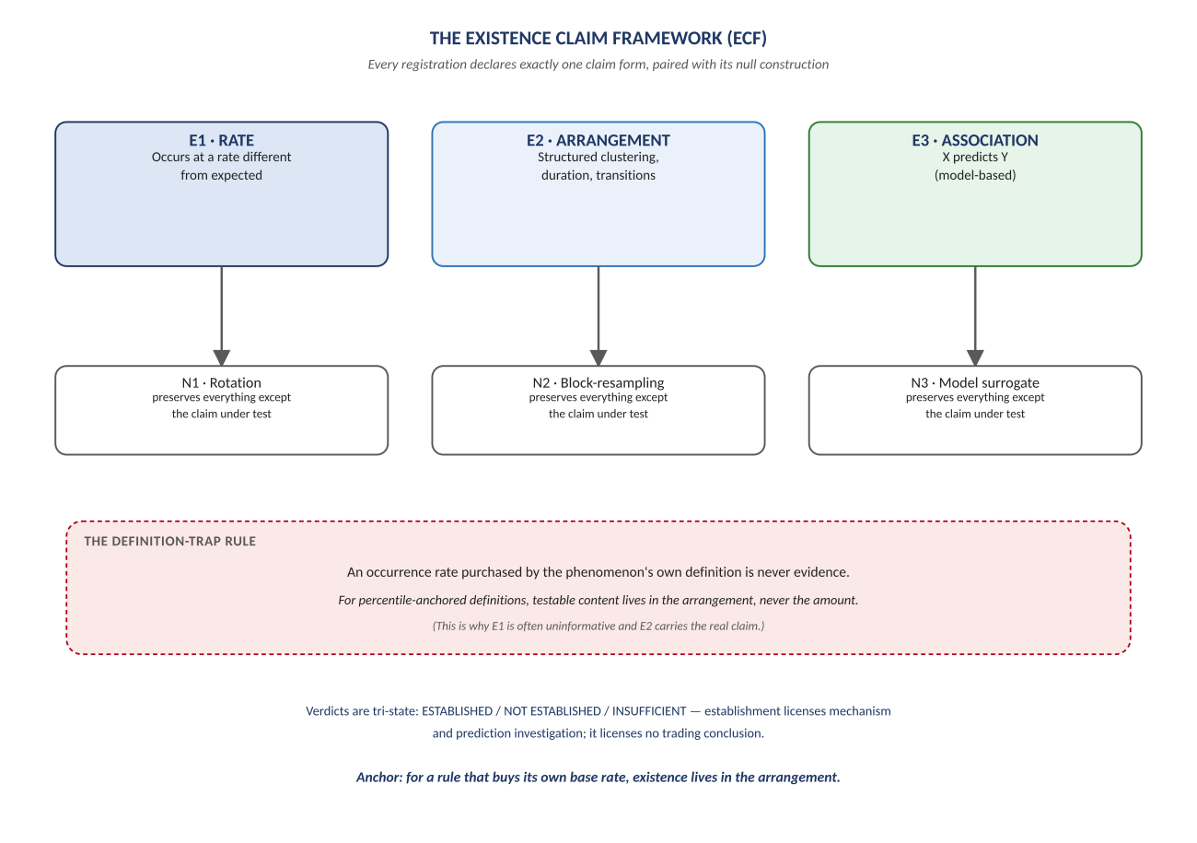
Figure 5. Figure 5. E1/E2/E3 claim forms with their null families N1/N2/N3, and the definition-trap rule that guards E1.

Diagram 6 — The Market Morphology Language (MML)
Any candle decomposes into three non-negative fractions that sum to one — a point on a triangle, not a judgment. The MD-UBL descriptor names the shape arithmetically; the merge operator and the zero-range convention close the two gaps a naive version of this language would fall into.
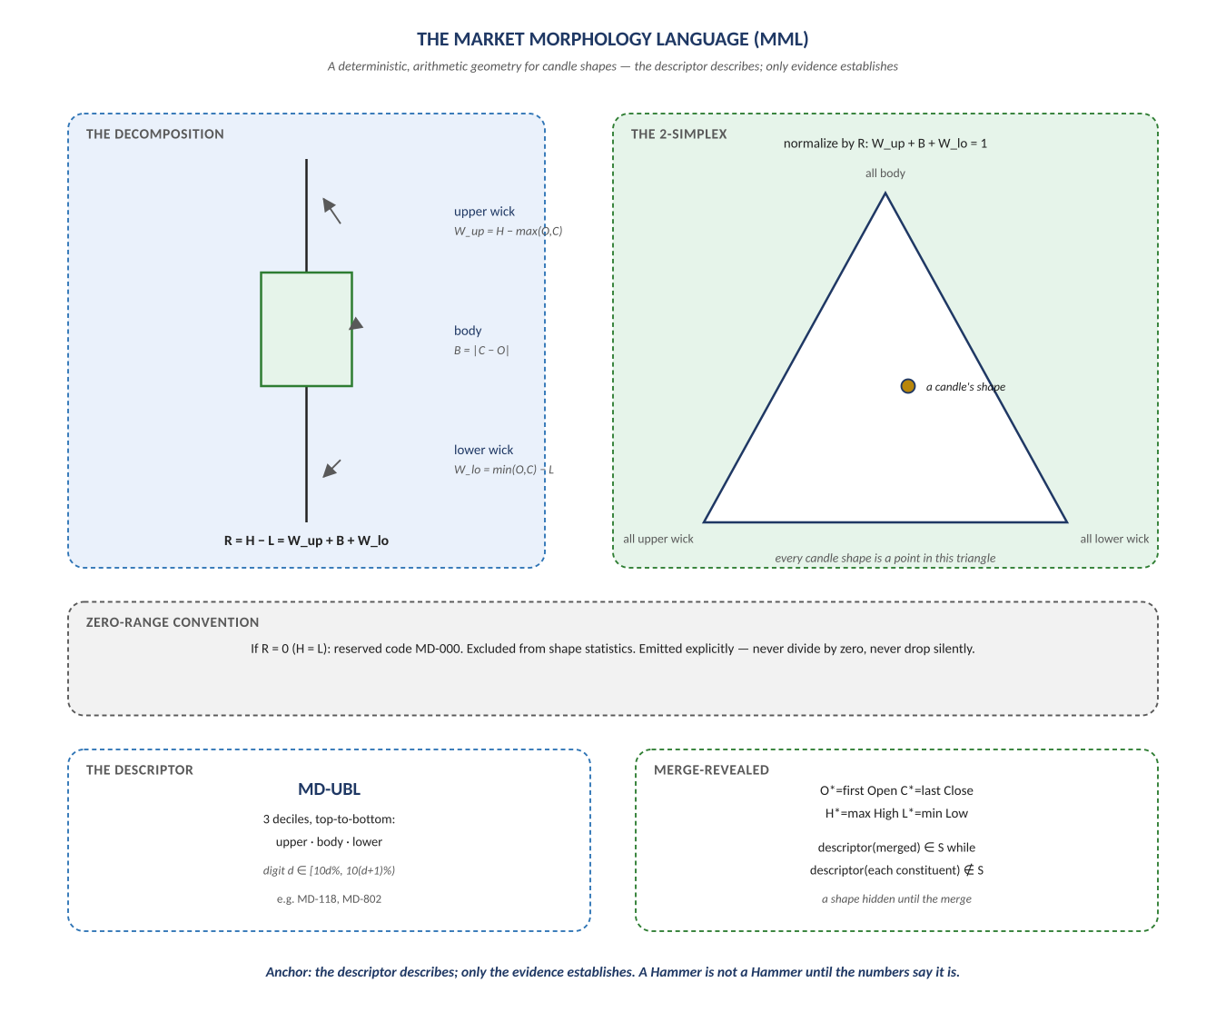
Figure 6. Figure 6. The candle as a 2-simplex point, the MD-UBL descriptor, the merge operator, and the zero-range convention.

Diagram 7 — The Graduation Ladder
Knowledge itself has a lifecycle, seven rungs from a bare observation to a named theory. A Theory is not a promise of certainty — it is multiple surviving Principles, joint explanatory power, novel pre-registered predictions, and falsifiers named in advance.
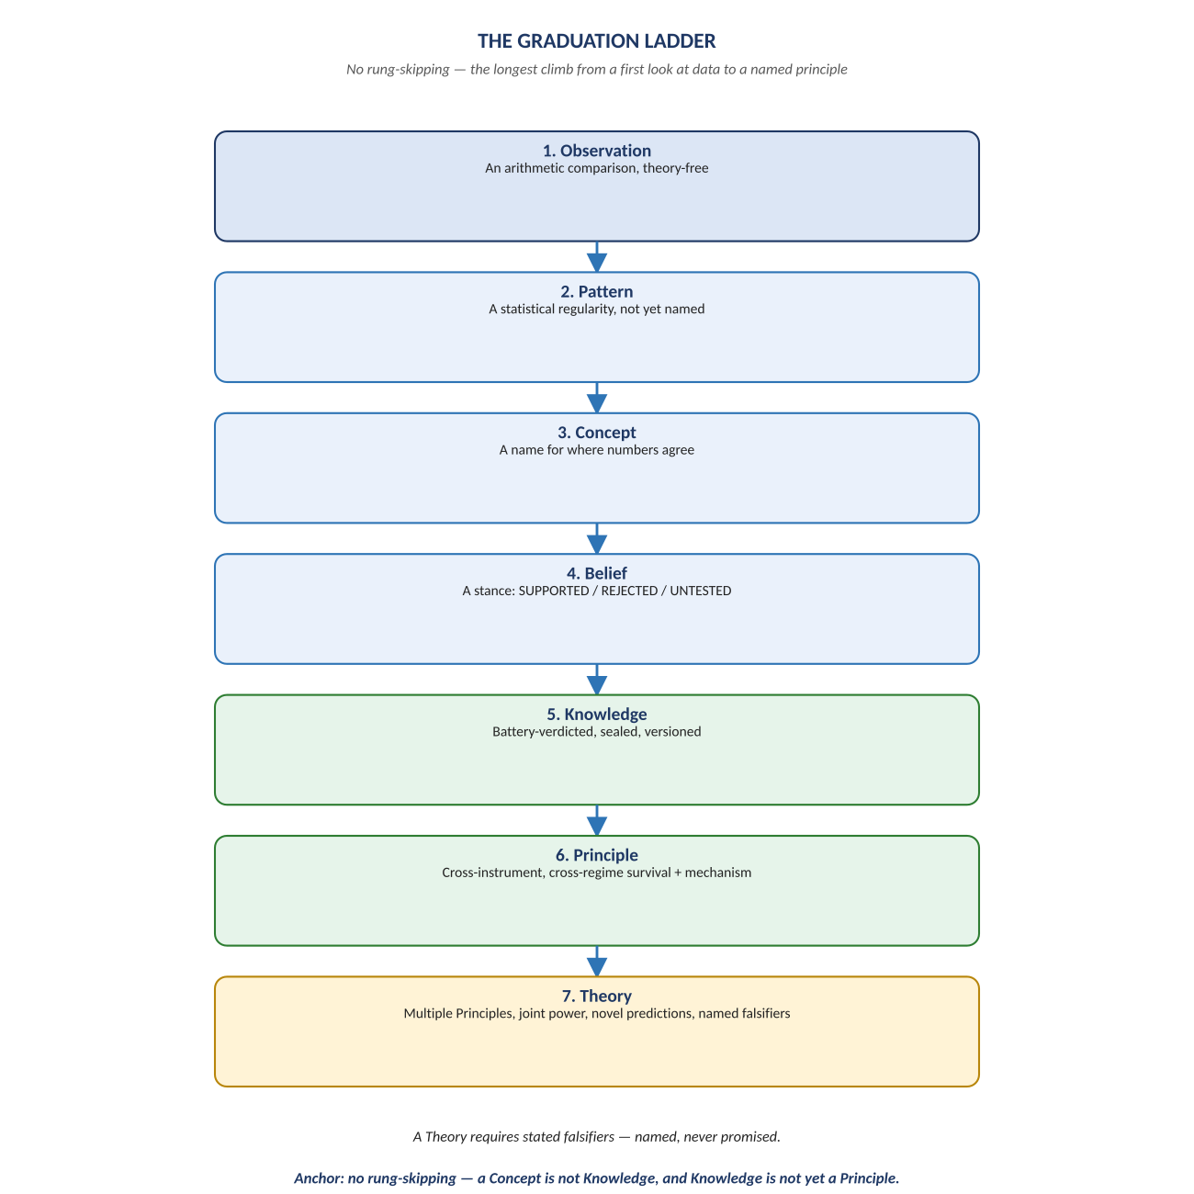
Figure 7. Figure 7. Observation → Pattern → Concept → Belief → Knowledge → Principle → Theory — the longest climb in the document.

Change Record
v1.0 (2026-07-29): first whiteboard render of the Scientific Model, built per docs\archive\governance\HOW_THIS_DOC_WAS_BUILT.md (hand-built SVG, rasterized, one diagram per page, PDF-verified). Companion to the normative docs\scientific_model\NeelPrajnaPro_Scientific_Model-v1.0.md — that file is authoritative; this document teaches it.
Anchor: the descriptor describes, the ECF judges, and nothing graduates a rung it hasn't earned.

