NeelPrajnaPro
Execution Plan — v1.0
Whiteboard companion to docs\execution_plan\NeelPrajnaPro_Execution_Plan-v1.0.md — phases, one sprint's anatomy, the H-07 chain, and the rhythm that repeats.
Author: Fable (Architect) · 2026-07-29 · Twin rule applies: the .md is the normative text (and the living record — §0/§8 update every sprint); this .docx teaches the shape, not the day's state

How to Read This Document
This is the teaching form of the Execution Plan — the phases, one sprint's anatomy in full, the H-07 phenomenon's own event chain, and the seven-step rhythm every sprint repeats. Because the md master is a living document (its §0 and §8 change at every sprint boundary), this docx teaches the durable shape of the plan, not today's checkbox state — for the current state, the md master is where to look.
Every diagram carries an anchor sentence or standing tripwire. The md twin is normative; if this document and the md ever disagree on anything but the day's current-state checkboxes, the md wins and the disagreement is a finding.
Diagram | Answers
1 — The Phase Ladder | What are the five phases, and what does each one exit on?
2 — NP-S1's Sprint Anatomy | What shape does a sealed sprint instruction actually take?
3 — The H-07 Event Chain | What, exactly, does the detector watch for?
4 — The Sprint Rhythm | What repeats, unchanged, every single sprint?

Diagram 1 — The Phase Ladder
Five phases, quality-gated rather than calendar-gated: Bootstrap is done; NP-S1 through NP-S4 each exist to retire a specific class of ignorance, and none may open before the one above it exits on a verdict.
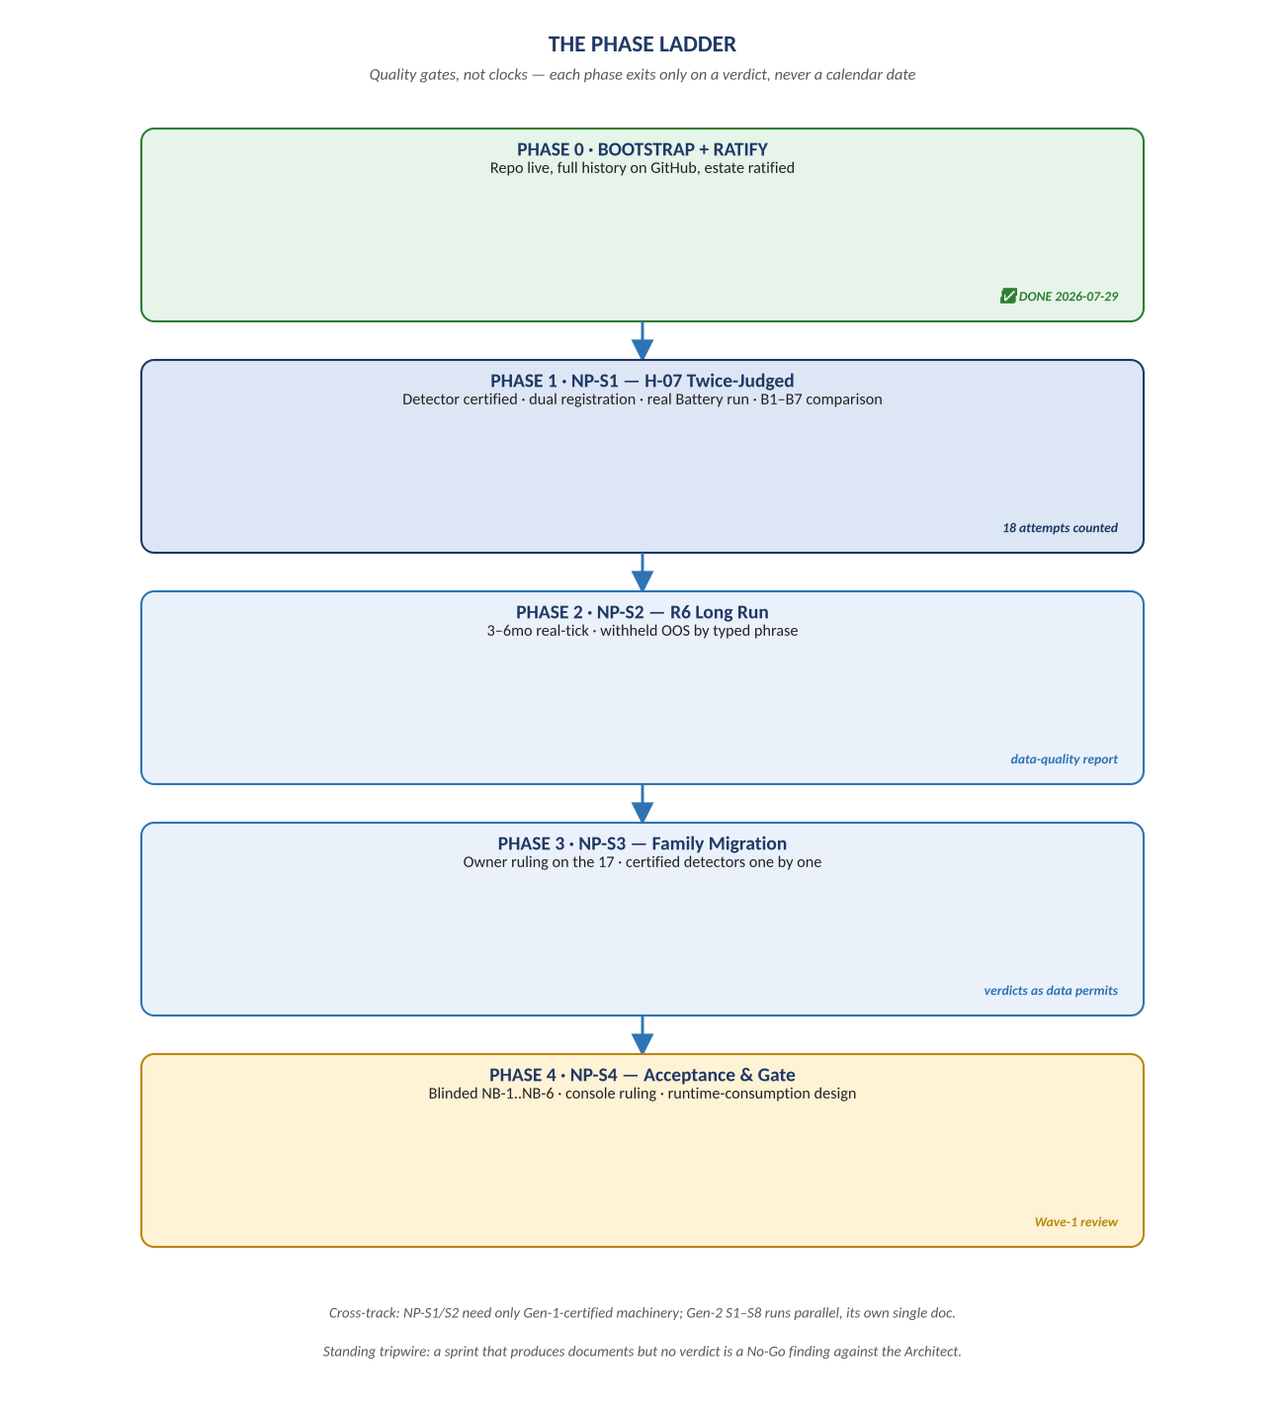
Figure 1. Figure 1. Bootstrap → NP-S1 → NP-S2 → NP-S3 → NP-S4, each phase's exit condition.

Diagram 2 — NP-S1's Sprint Anatomy
Every sealed sprint instruction in this programme takes this same shape: preconditions that must be checked before a line of code is written, deliverables that are concrete and falsifiable, acceptance criteria sealed in advance, and explicit non-goals whose violation is itself a finding.
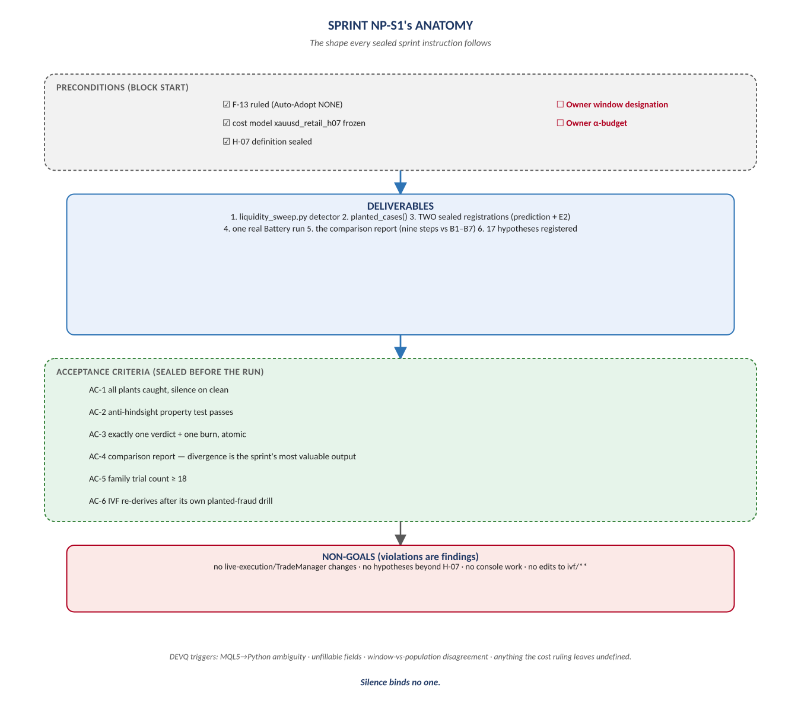
Figure 2. Figure 2. Preconditions → Deliverables → Acceptance Criteria → Non-Goals — the anatomy of ARCH-NP-001.

Diagram 3 — The H-07 Event Chain
The sealed mechanical definition reduces to three events a detector can compute from closed bars alone, with no interpretation: a pool forms, a sweep tests it, a reversal confirms it. Everything downstream — the trade-blueprint playbook — is excluded from this definition on purpose.
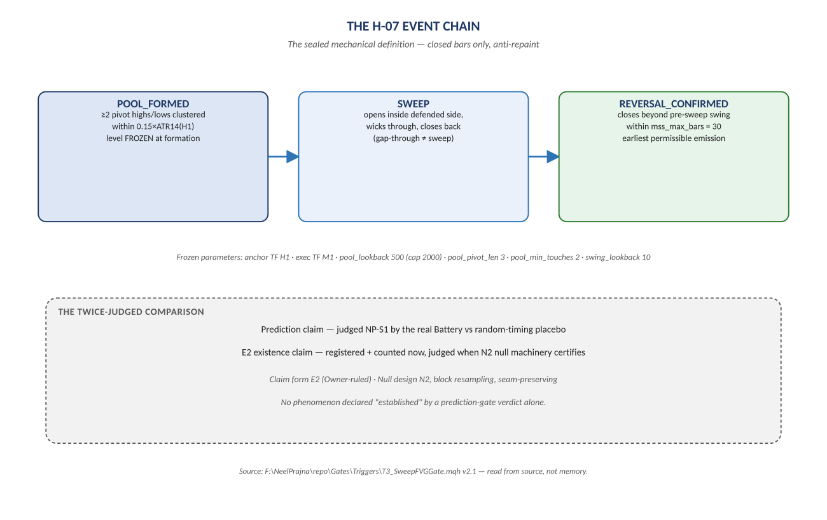
Figure 3. Figure 3. POOL_FORMED → SWEEP → REVERSAL_CONFIRMED, and the twice-judged comparison structure it feeds.

Diagram 4 — The Sprint Rhythm
Ten Gen-1 sprints proved this cycle, and every NP sprint runs it unchanged: an instruction, independent implementation, independent verification that drills before it judges, a human check, an independent review, and exactly one vote that matters before the loop closes and rewrites the state for the next lap.
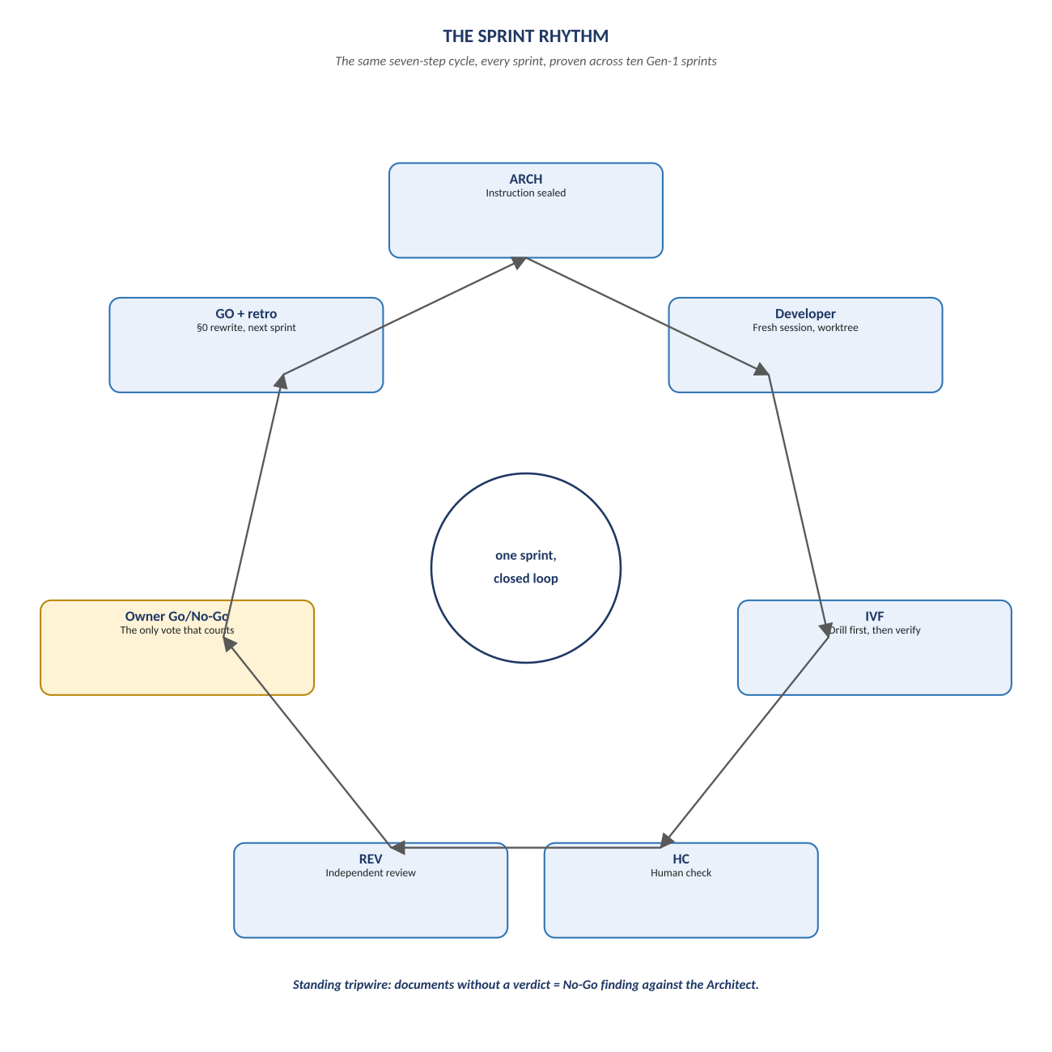
Figure 4. Figure 4. ARCH → Developer → IVF → HC → REV → Owner Go/No-Go → GO + retro — a closed loop, not a checklist.

Change Record
v1.0 (2026-07-29): first whiteboard render of the Execution Plan, built per docs\archive\governance\HOW_THIS_DOC_WAS_BUILT.md (hand-built SVG, rasterized, one diagram per page, PDF-verified). Companion to the normative docs\execution_plan\NeelPrajnaPro_Execution_Plan-v1.0.md — that file is authoritative and living (§0/§8 rewrite every sprint); this document teaches the plan's durable shape.
Anchor: documents without a verdict are a finding against the Architect — the rhythm exists so that never happens quietly.

