NeelPrajnaPro
Reference Handbook — v1.0
Whiteboard companion to docs\reference\NeelPrajnaPro_Reference-v1.0.md — the vocabulary, and where it really comes from.
Author: Fable (Architect) · 2026-07-29 · Twin rule applies: the .md is the normative text; this .docx is its human render

How to Read This Document
This handbook's own job is to point, not to duplicate — its ECF, MML, and Architecture panels are already taught in full elsewhere in this estate, so this render deliberately does not repeat those diagrams. Instead it draws the two things genuinely specific to a reference document: how the working vocabulary actually connects, and the epistemic rule that keeps a convenience summary from quietly becoming a second truth.
Every diagram carries an anchor sentence. The md twin is normative; if this document and the md ever disagree, the md wins and the disagreement is a finding — and if this handbook and a ratified canonical document differ, the canonical document wins over both.
Diagram | Answers
1 — The Vocabulary Map | How do the thirteen working terms actually connect to each other?
2 — Where to Look | When this handbook and a canonical document disagree, which one wins?

Diagram 1 — The Vocabulary Map
Read as a flat glossary, these thirteen terms look like a word list. Read as a chain, they're not: a Record becomes an EventFrame, which spends a Trial, which a Drill certifies before it's allowed to inform a Verdict, which alone may become a Belief release. The scoping terms on the right constrain what may be claimed; they never touch what the left column proves.
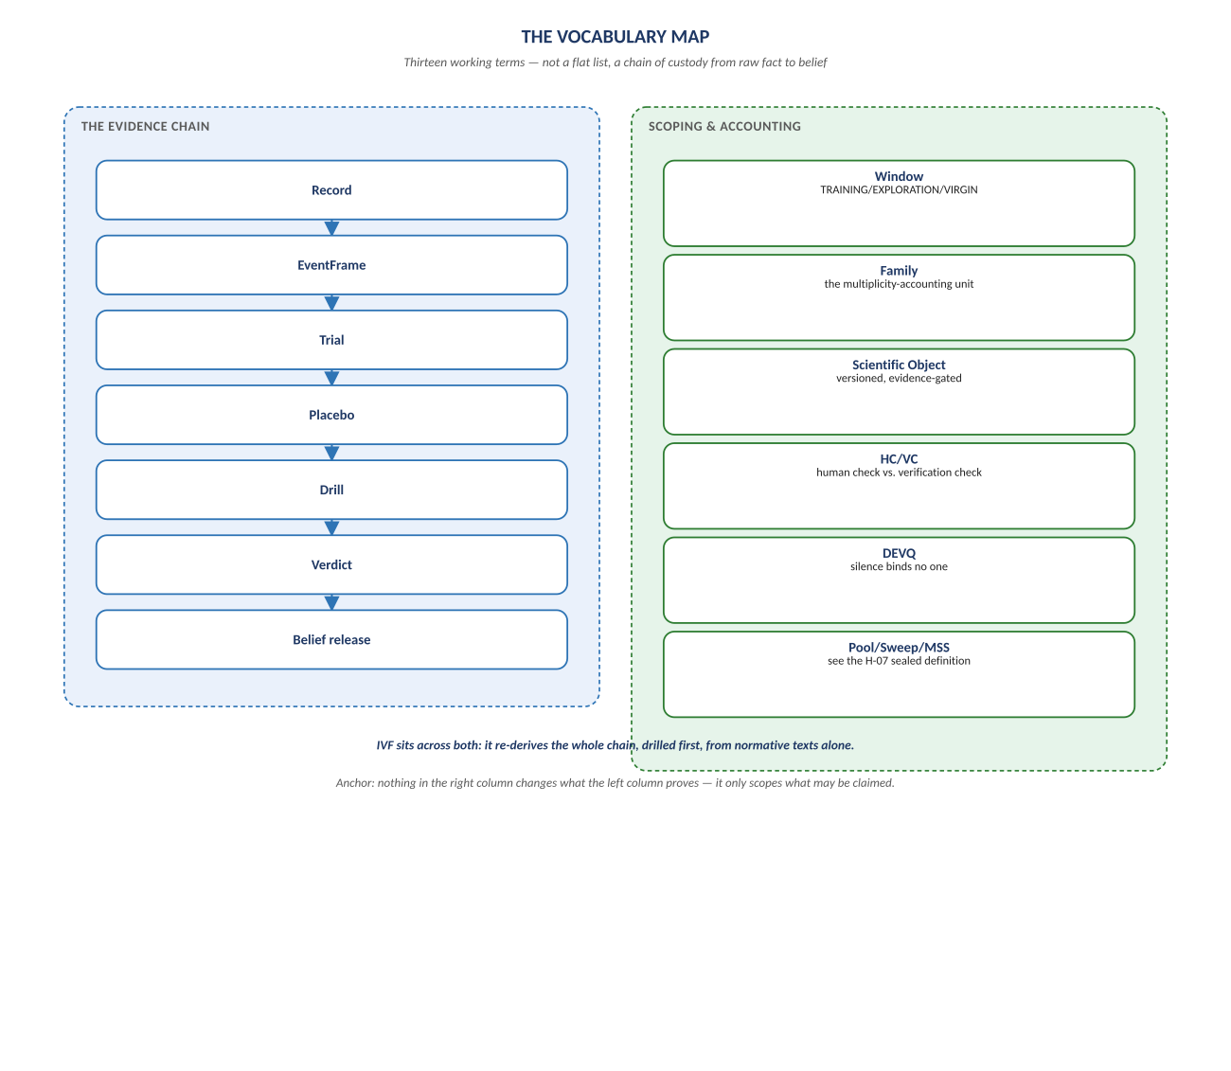
Figure 1. Figure 1. The evidence chain (Record → ... → Belief release) alongside the scoping and accounting terms that bound it.

Diagram 2 — Where to Look
Every panel in this handbook is a condensed pointer, not an independent source — QRF-ADR-001's rule made visible. If this document and a canonical master ever disagree, the master wins, and the disagreement itself becomes a finding rather than a quiet correction.
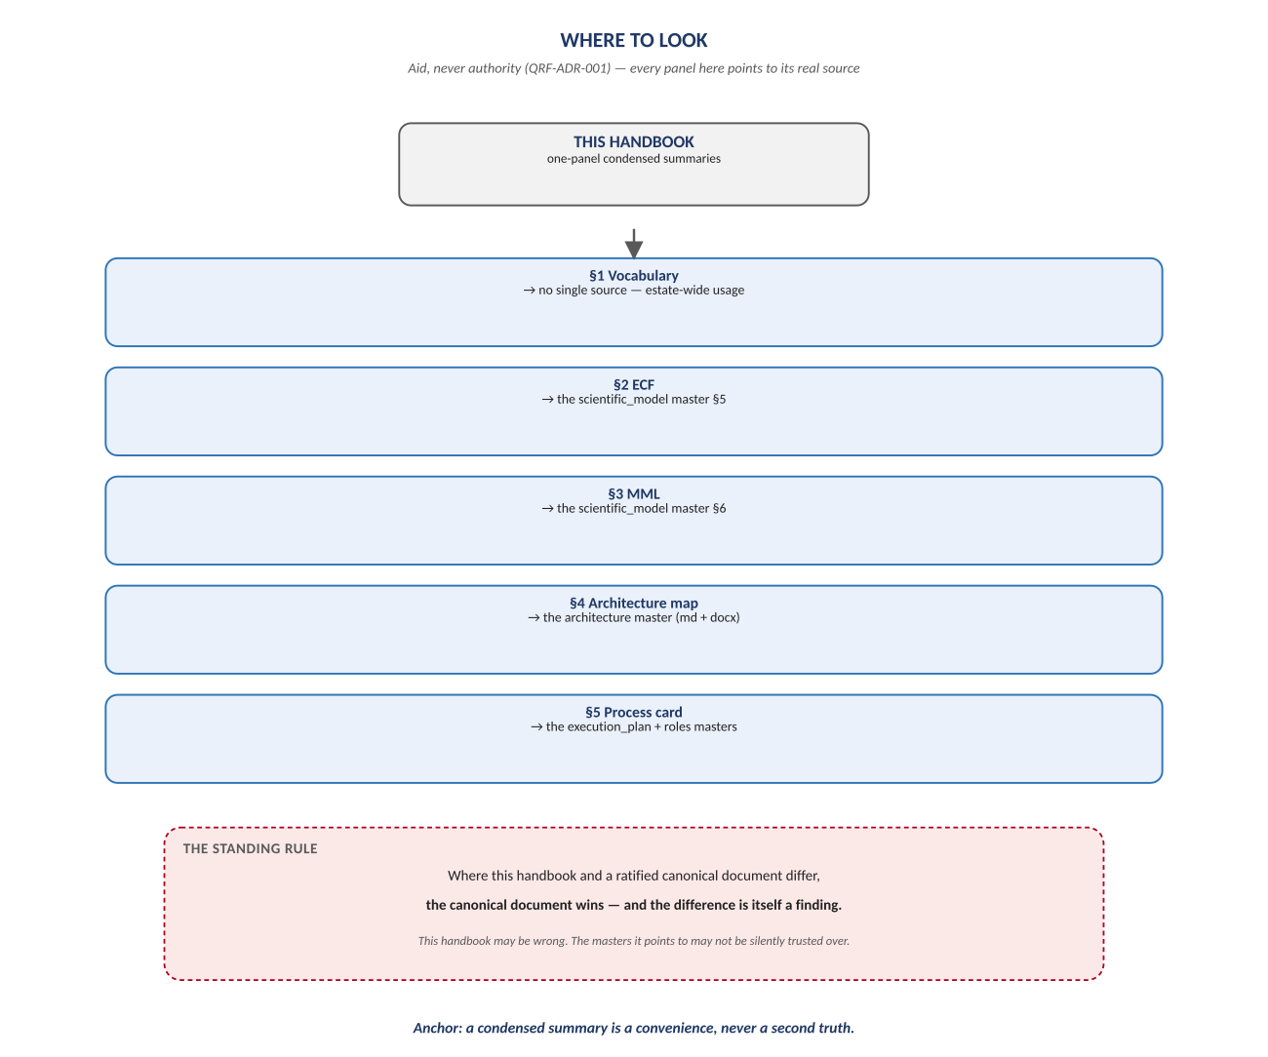
Figure 2. Figure 2. Every section names its real normative source; the canonical document always wins a disagreement.

Change Record
v1.0 (2026-07-29): first whiteboard render of the Reference Handbook, built per docs\archive\governance\HOW_THIS_DOC_WAS_BUILT.md (hand-built SVG, rasterized, one diagram per page, PDF-verified). Deliberately two diagrams, not more — the ECF, MML, and architecture-map content this handbook condenses already has full renders in the Scientific Model and Architecture twins, and repeating them here would be padding, not teaching. Companion to the normative docs\reference\NeelPrajnaPro_Reference-v1.0.md.
Anchor: a condensed summary is a convenience, never a second truth.

