04 module homework

Q1 – standard deviation -6.24

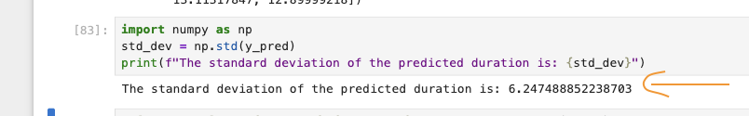

Q2 . size 65.46 mb – new parquet file size  
  
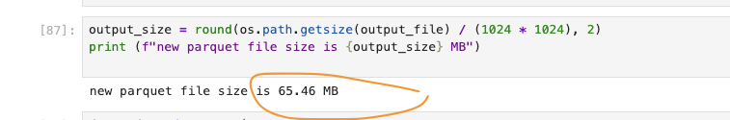

Q3 . jupyter nbconvert --to script starter.ipynb

Q4 . What's the first hash for the Scikit-Learn dependency?

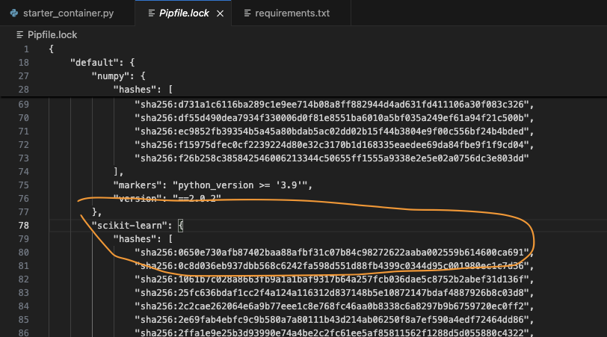

Q5. Mean – 14.29

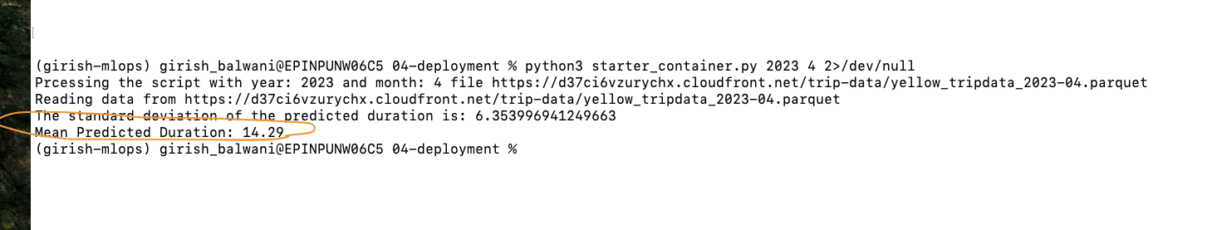

Q6. Mean Pred - 0.19

