05_monitoring

Q1 - What is the shape of the downloaded data? How many rows are there?

* Ans - 57457

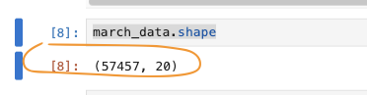

Q2. Metric – ColumnQuantileMetric and ColumnSummaryMetric on fare_amount

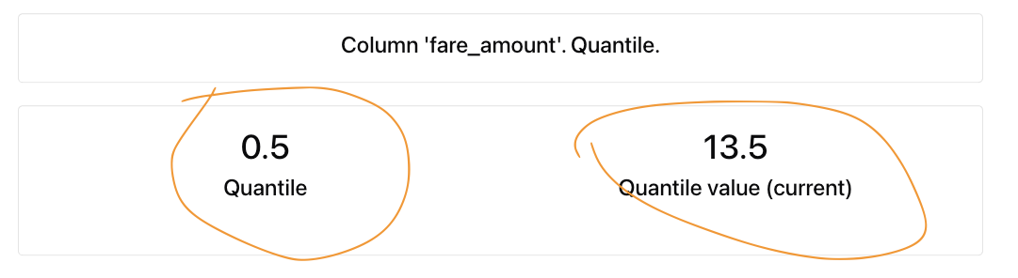

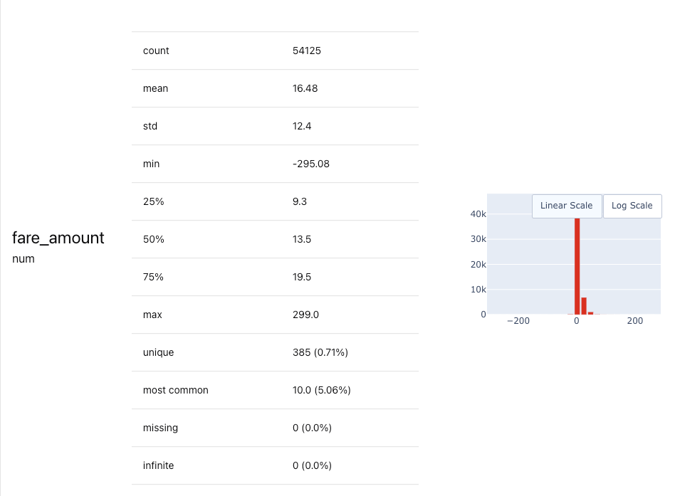

Q3. Monitoring - What is the maximum value of metric quantile = 0.5 on the "fare_amount" column during March 2024 (calculated daily)?

Ans : 14.2

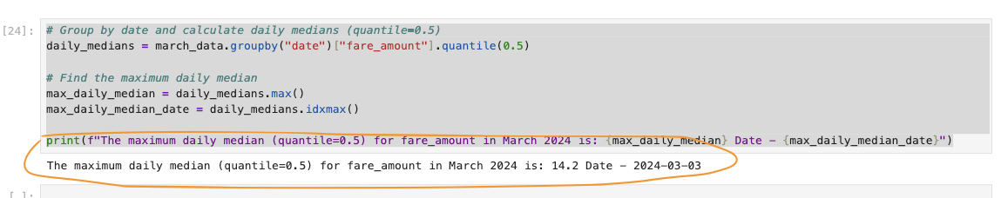

Q4. Dashboard – Pushed the data with dummy metrics and saved the files locally so that new start can fetch the already created dashboard

