06-Best Practices

Q1- output after refactoring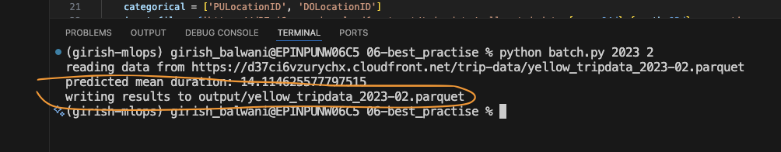

Q2- second file will be __init__.py

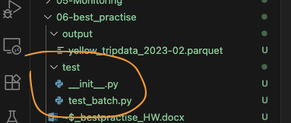

**Q3- 2 rows**

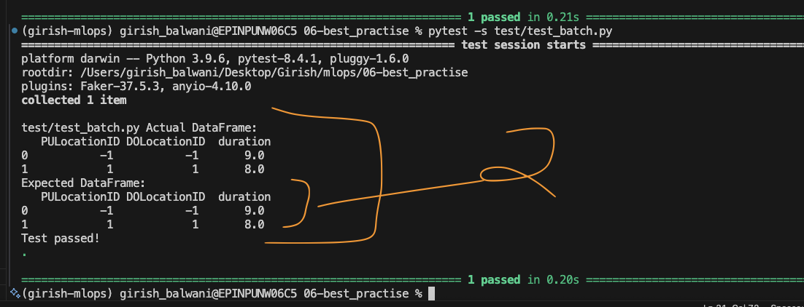

**Q4 –**

**A - --endpoint-url=http://localhost:4566**

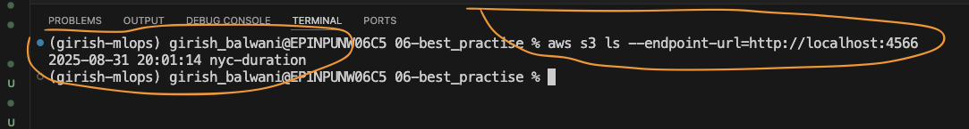

**B- Storing output in localstack S3**

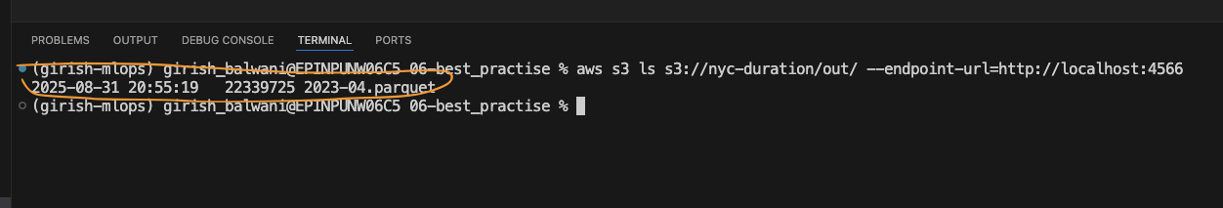

**C- downloaded the parquet from https to s3 in folder  
read the input from S3**

**Saved the output in S3**

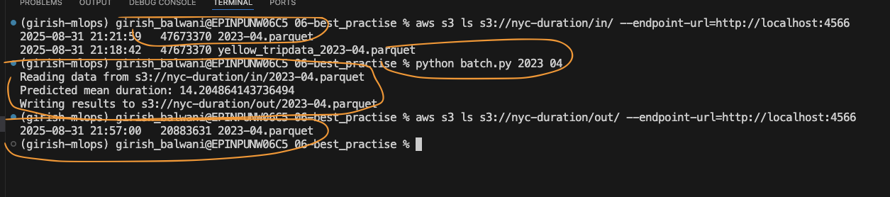

**Q5- 3231 is the size of the file**

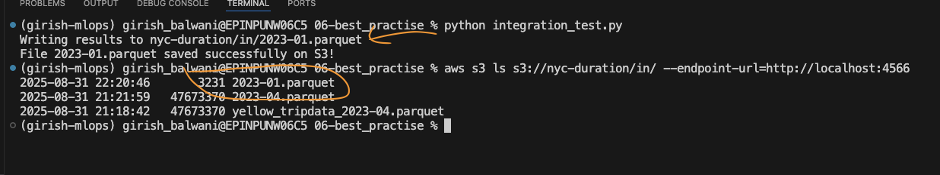

**Q6 – Sum of predicted duration = 36.28**

