**Mobile No: 9700724233**

**9666145446**

MANU COSTUME DESIGNER

**Kuchipudi, Bharathanatyam, Oodisi, Kathak And All Types Of Costumes Available**

**H.No.3-344/9/1, Road No. 12, Thirumala Hills, Meerpet, Hyderabad-500097.**

**Email ID:** [**erukondanagesh14@gmail.com**](mailto:erukondanagesh14@gmail.com)

**DANCE DRESS MEASUREMENTS**

**Name: Mobile No.:**

**Job No.: _**

KACHAM/PANT TYPE OF THE DANCE DRESS

1. **Length (Waist to Ankie) :**
2. **Waist (Round) :**
3. **Hip (Round) :**
4. **Thigh (Round) :**
5. **Knee (Round) :**
6. **Ankle (Round) :**
7. **Kista (Round) :**
8. **Waist to Knee :**

Delivery Date : Kacham Color : Blouse Color : Back Piece Color : Fan Color: Ooni/Pyta Color:

Specifications:

BLOUSE FAN: Regular/Cross/3Fan

1. **Length (Shoulder to Waist) :**
2. **Chest Round :**
3. **Waist Round :**
4. **Shoulder :**
5. **Neck Deep :**
6. **Arm Length :**
7. **Armpet Round :**
8. **Arm Round : BACK PIECE**
9. **Waist :**
10. **Length (Waist to Bullocks) : PYTA/OONI**
11. **Length Front :**
12. **Length Back :**
13. **Chest :**

Blouse: Full/Regular PYTA/Blouse with Fan/Both

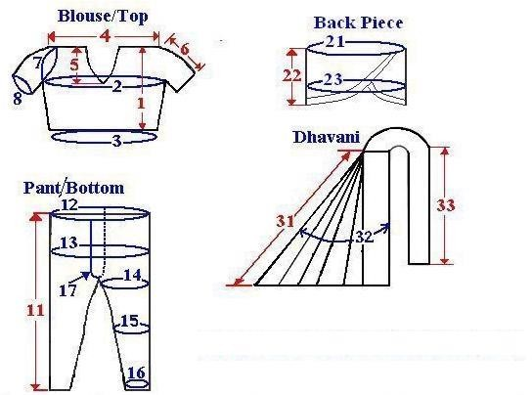

Advance: Balance :